|  |  |  |  |  |  |  |
| --- | --- | --- | --- | --- | --- | --- |
| **Name:** | | **ARMAGEDDON**  *A Teller World* | | | | Spieler: |
| **Charakterklasse:** | | | |  |  | Charakterpunkte:  Power: |
| **Stärke (St)** |  | Wundschwelle (St÷2↑) |  |  | | |
| Todesschwelle (St×2) |  |
| **Geschicklichkeit (Ge)** |  | Wahrnehmung (Int) |  |
| Initiative (Int) |  |
| **Intelligenz (Int)** |  | Gehen (Ge÷2↑)) |  |
| **Bewegung** (Ge) |  |
| **Seele (Se)** |  | Laufen (Ge×2) |  |
| Sprinten (Ge×4) |  |

|  |  |  |
| --- | --- | --- |
| **Fertigkeiten und Fähigkeiten** | **Stufe** (Würfel) | **Praxis × Schwierigkeit** |
| Athletik △ |  | × |
| Auftreten △ |  | × |
| Ausweichen |  | × |
| Empathie △ |  | × |
| Heimlichkeit △ |  | × |
| Klettern |  | × |
| Nahkampfwaffen △ |  | × |
| Waffenloser Kampf |  | × |
| Wahrnehmung △ |  | × |
| Werfen und Fangen △ |  | × |
| Sprachen: |  | × |
|  |  | × |
|  |  | × |
|  |  | × |
|  |  | × |
|  |  | × |
|  |  | × |
|  |  | × |
|  |  | × |
|  |  | × |
|  |  | × |
|  |  | × |
|  |  | × |

|  |  |  |  |
| --- | --- | --- | --- |
| **Stufe** | **Würfel** | **Stufe** | **Würfel** |
| 1 | W3-1 | 21 | 2W20 |
| 2 | W4-1 | 22 | 2W20+1 |
| 3 | W4 | 23 | 2W20+2 |
| 4 | 2W4-1 | 24 | 2W20+3 |
| 5 | 2W4 | 25 | 2W20+4 |
| 6 | W4+W6 | 26 | 2W20+2W4 |
| 7 | 2W6 | 27 | 2W20+2W4+1 |
| 8 | W6+W8 | 28 | 2W20+2W6 |
| 9 | 2W8 | 29 | 2W20+2W6+1 |
| 10 | W8+W10 | 30 | 2W20+2W8 |
| 11 | 2W10 | 31 | 2W20+2W8+1 |
| 12 | W10+W12 | 32 | 2W20+2W10 |
| 13 | 2W12 | 33 | 2W20+2W10+1 |
| 14 | 2W12+1 | 34 | 2W20+2W12 |
| 15 | 2W12+2 | 35 | 2W20+2W12+1 |
| 16 | 2W12+3 | 36 | 2W20+2W12+2 |
| 17 | W12+W20 | 37 | 2W20+2W12+3 |
| 18 | W12+W20+1 | 38 | 3W20+W12 |
| 19 | W12+W20+2 | 39 | 3W20+W12+1 |
| 20 | W12+W20+3 | 40 | 3W20+W12+2 |

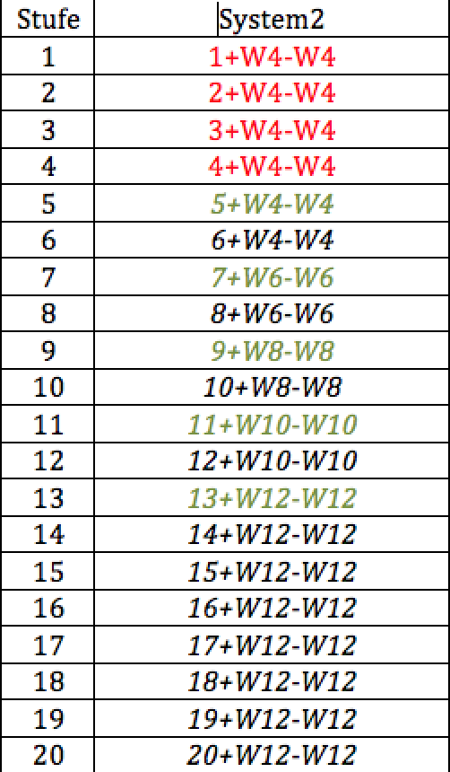

|  |  |  |  |  |  |  |
| --- | --- | --- | --- | --- | --- | --- |
|  |  | Durchschnitt Rüstungsschutz: | | |  |  |
| **W12** | **Trefferzone** | **Rüstung/Kleidung (Last)** | | **Rüstungsschutz** | **Schaden** | Erschöpfungen: |
| 12 | Kopf |  |  |  |  |
| 10-11 | rechter Arm |  |  |  |  |
| 8-9 | linker Arm |  |  |  |  |
| 5-7 | Torso |  |  |  |  |
| 3-4 | rechtes Bein |  |  |  |  |
| 1-2 | linkes Bein |  |  |  |  |

|  |  |  |  |  |  |  |  |
| --- | --- | --- | --- | --- | --- | --- | --- |
| **Waffe** | **Angriff** | **Parade** | **Schaden** | Größe | Last | MEUS / RW | Sonstiges |
|  |  |  |  |  |  |  |  |
|  |  |  |  |  |  |  |  |
|  |  |  |  |  |  |  |  |
|  |  |  |  |  |  |  |  |
|  |  |  |  |  |  |  |  |