#1. TABLE CREATED WITH CONSTRAINTS PRIMARY KEY,UNIQUE,CHECK,DEFAULT,NOT NULL
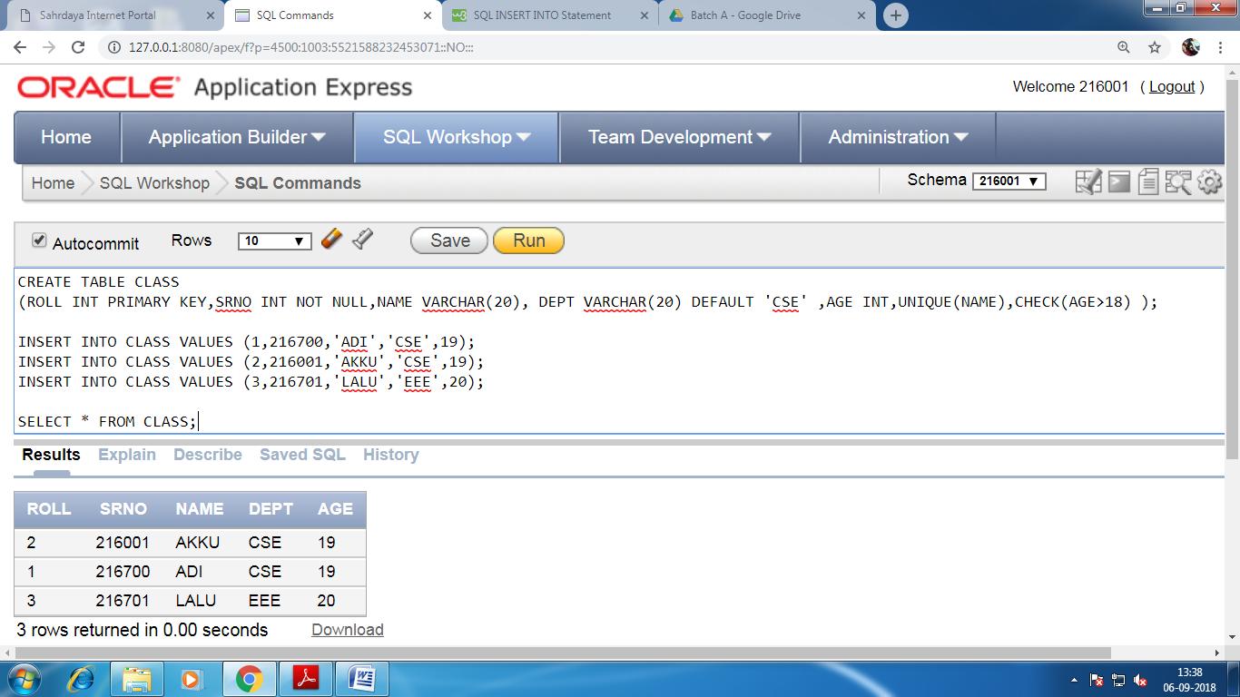
#2. NOT NULL CONSTRAINT :
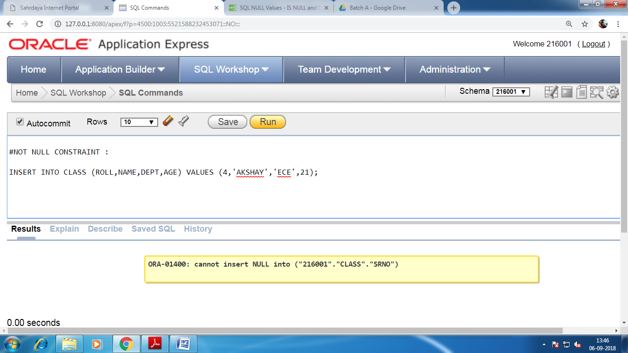

#3. UNIQUE CONSTRAINT
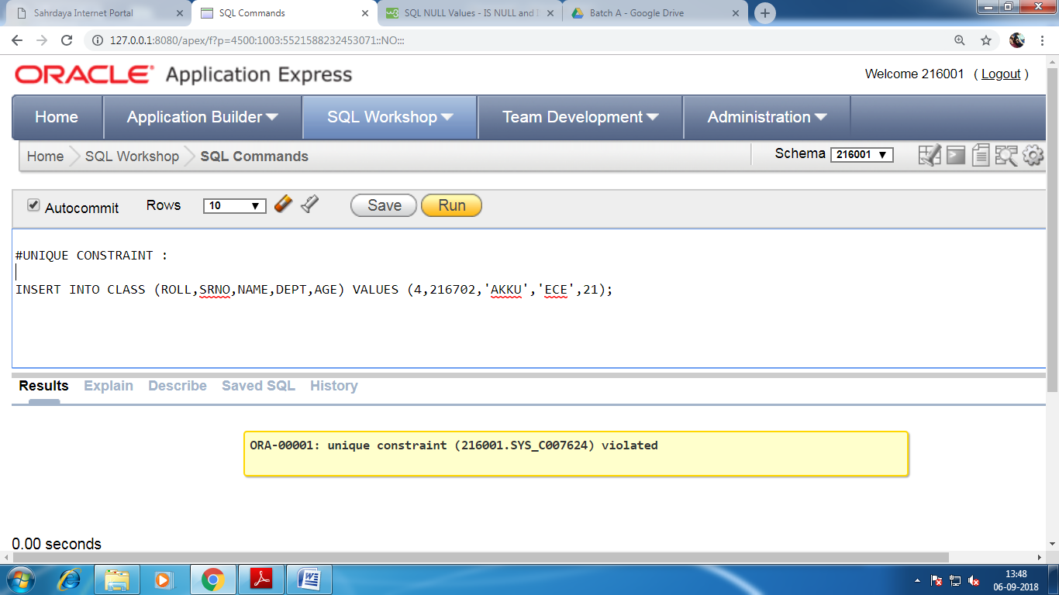
#4. PRIMARY KEY CONSTRAINT :
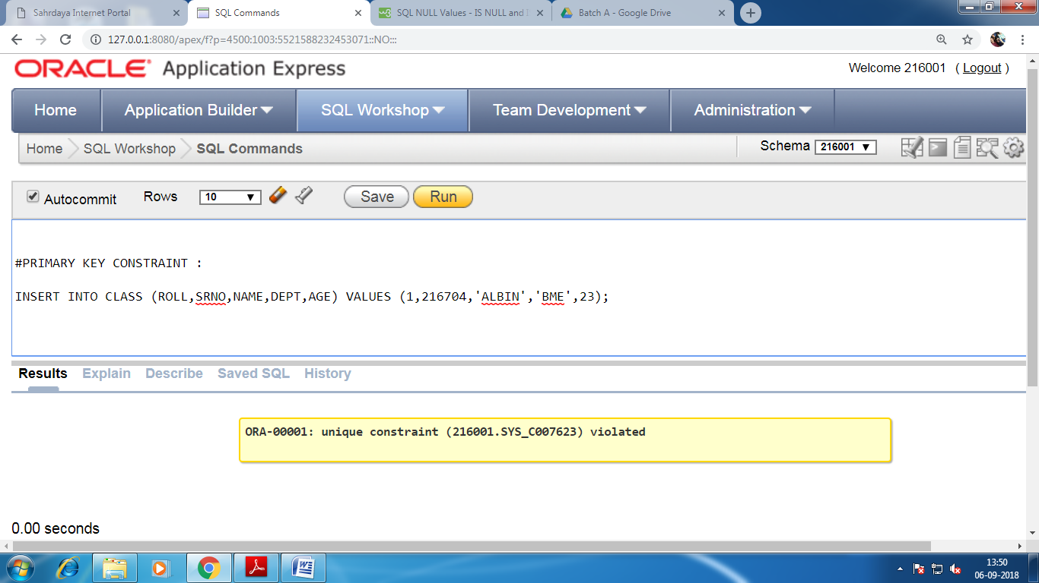

#5. FOREIGN KEY CREATE TABLE
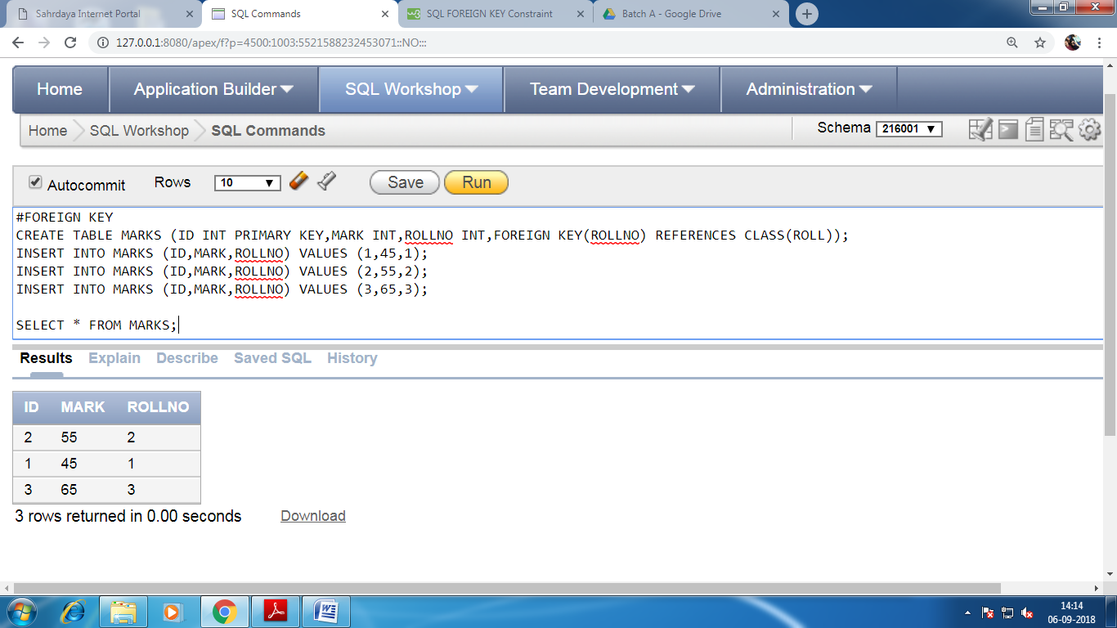
#6. FOREIGN KEY INSERTION CONSTRAINT
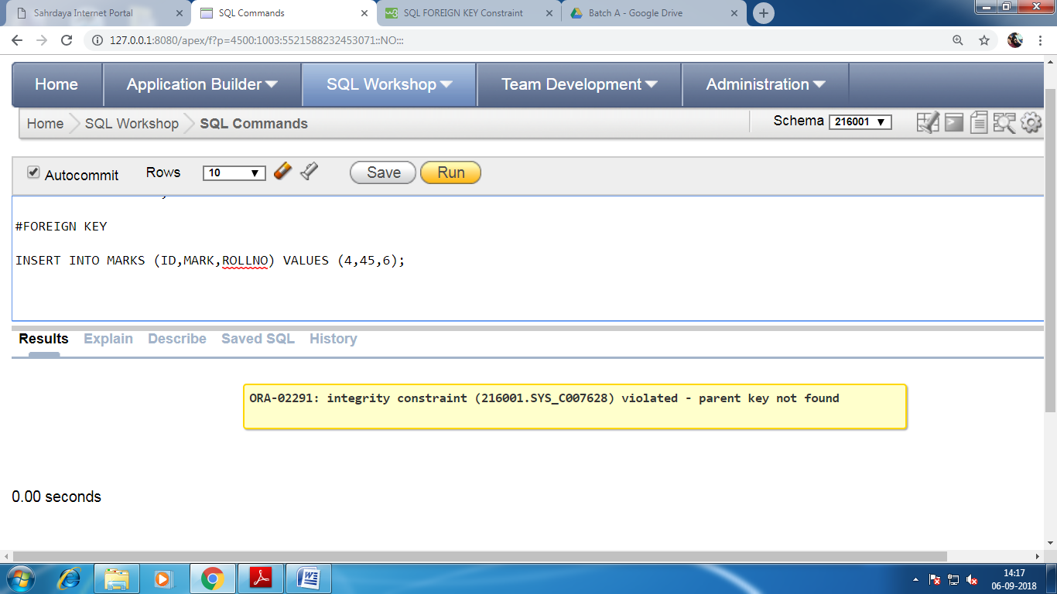

#7. FOREIGN KEY DELETION CONSTRAINT
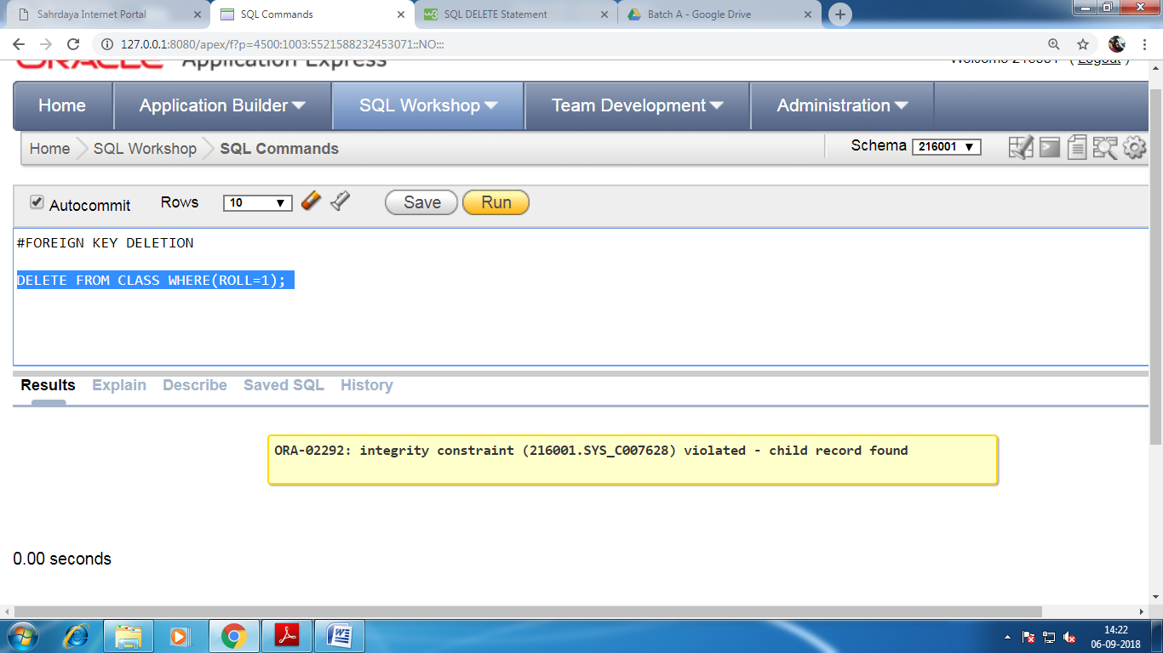
#8. CHECK CONSTRAINT
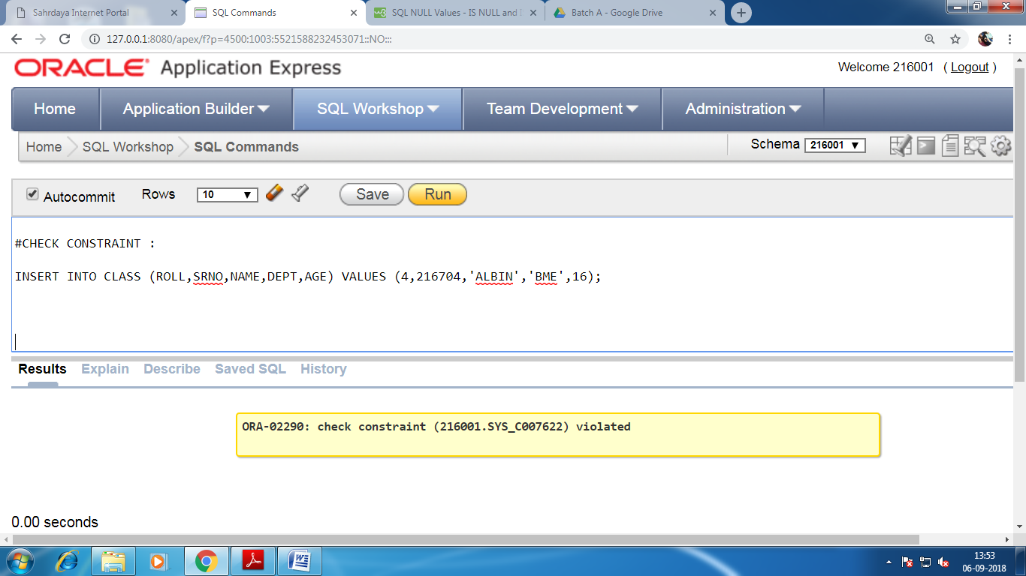

#9. DEFAULT CONSTRAINT
