1. metamask.io chrom extension
slim rare hobby tired fringe flock actor amused because future magnet day
2.download the phrase and type exactly.
3.view accpont
----------------------------
ethereum network
smart contracts;self executing code&activated by sending it
block size ,time,reward are factors
gas etyehrium coin value

etherium virtual machine
environment for running

Accounts:`1External(public&private),2internal(smart contract)

Etherum stnds are ERC
erc -20 for coding tokens

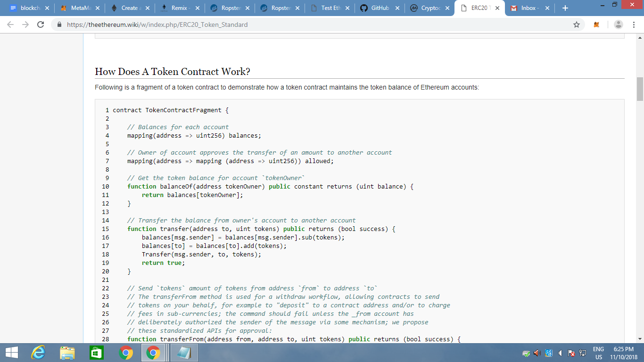

search ethereum remix ide
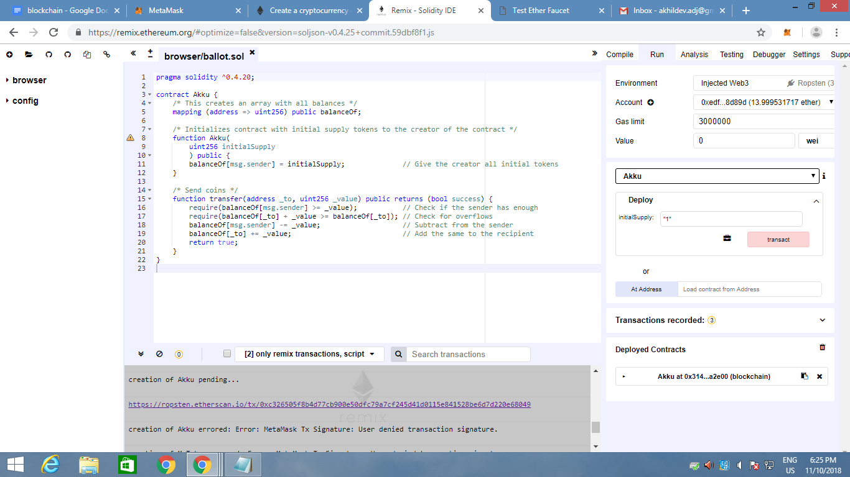
language is solidity

TOOLS
wallets - mist,parity,metamask
interface- web3.js,web3.py
testnet testRpc Kovan,Rinkeby,Ropsten
Developement - Geth,Truffle,Remix IDE
Frameworks-zeppelin,embark

from,to
from,to if threre transaction of values and datas :first transaction
2nd transaction :if only from is there its transaction of data only and the transaction fee is gas.

GAS
1.gas price
2.gas limit
ethereum medium weight is 15 seconds but due to the traffic its 34
ethgasstation.info

https://github.com/OpenZeppelin/openzeppelin-solidity

https://www.ethereum.org/token

ropsten faucet

https://faucet.metamask.io/

pragma solidity ^0.4.20;

contract MyToken {
/* This creates an array with all balances */
mapping (address => uint256) public balanceOf;

/* Initializes contract with initial supply tokens to the creator of the contract */
function MyToken(
uint256 initialSupply
) public {
balanceOf[msg.sender] = initialSupply; // Give the creator all initial tokens
}

/* Send coins */
function transfer(address _to, uint256 _value) public returns (bool success) {
require(balanceOf[msg.sender] >= _value); // Check if the sender has enough
require(balanceOf[_to] + _value >= balanceOf[_to]); // Check for overflows
balanceOf[msg.sender] -= _value; // Subtract from the sender
balanceOf[_to] += _value; // Add the same to the recipient
return true;
}
}

copy paste to ide
auto compile -> start to compile
click on details

run
injected web3 means metamask is controlling
Ropsten means the selected in metamask network

under mytoken deploy which is our constructor all theases unserstand from abi code(see details
)

RUN
give value and deploy
confirm
a link will come
and green tick will appear

click on link
and click on 'to" link
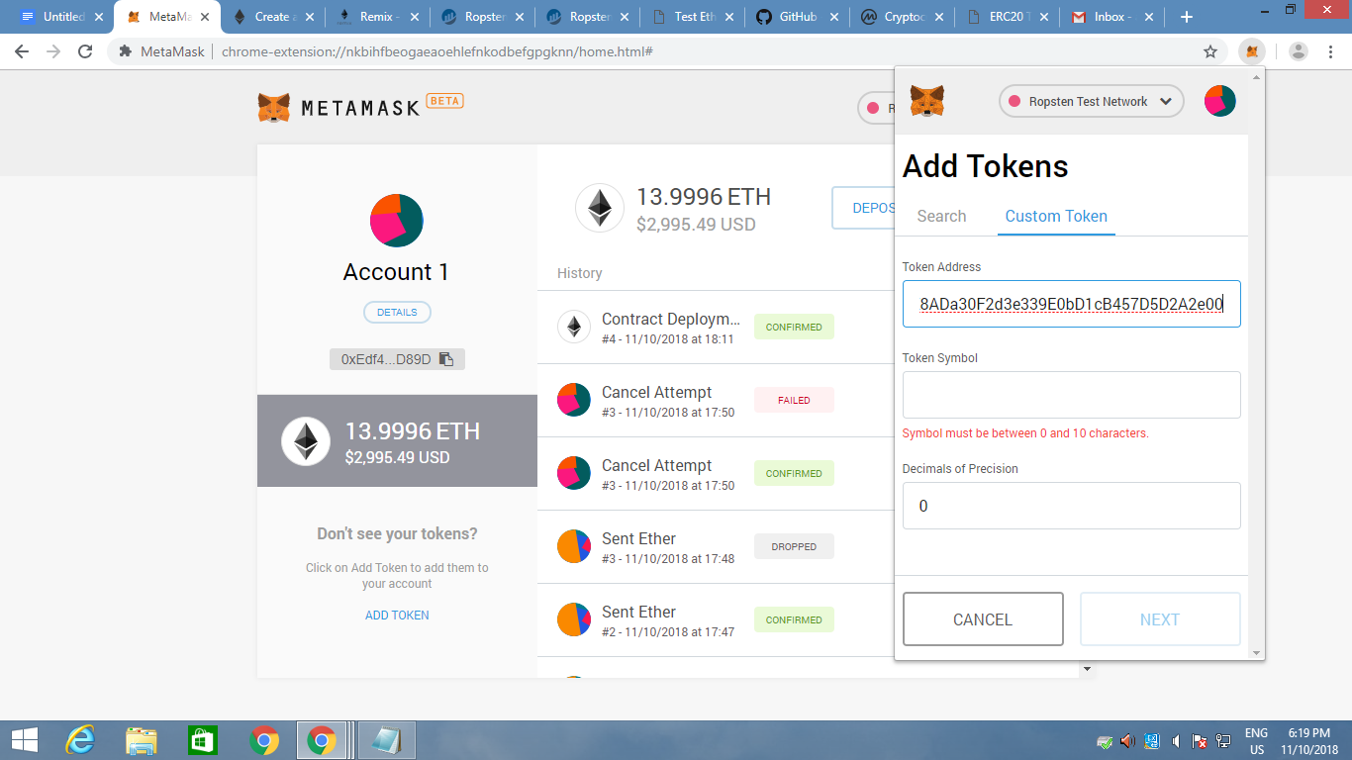
Get contract address from here
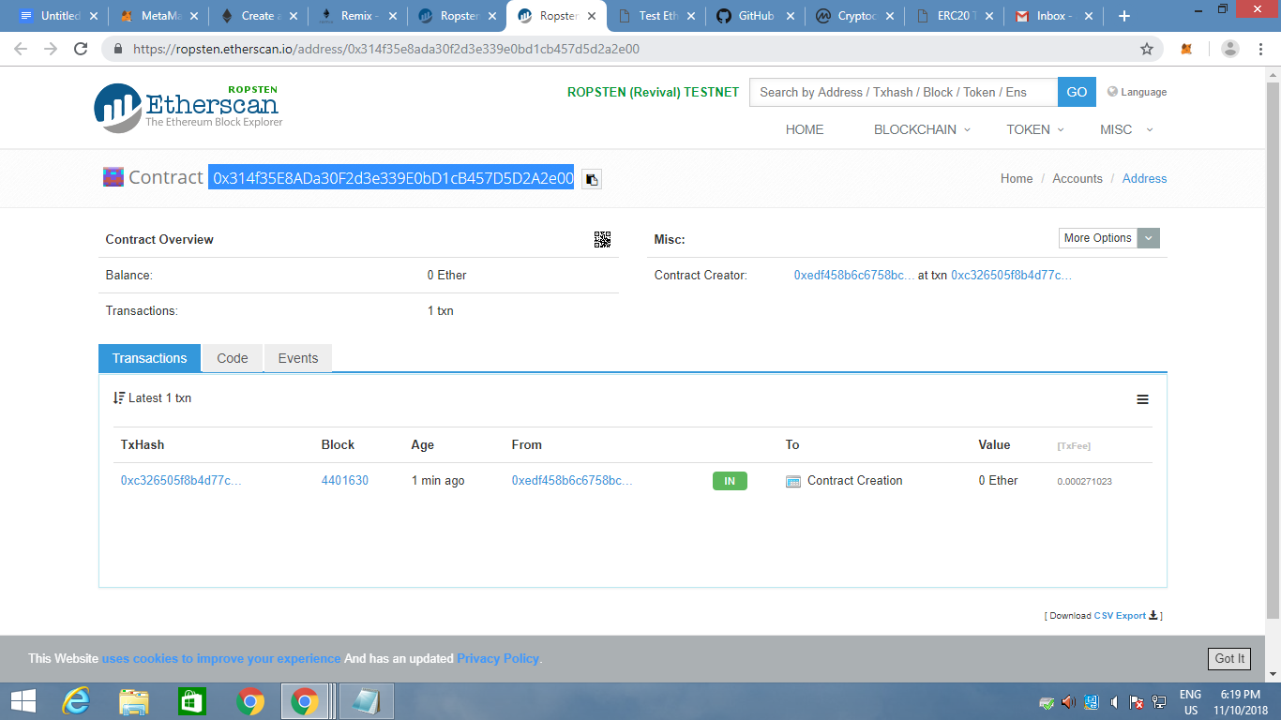
Create new token add symbol paste contact address
Send token
view token on etherscan
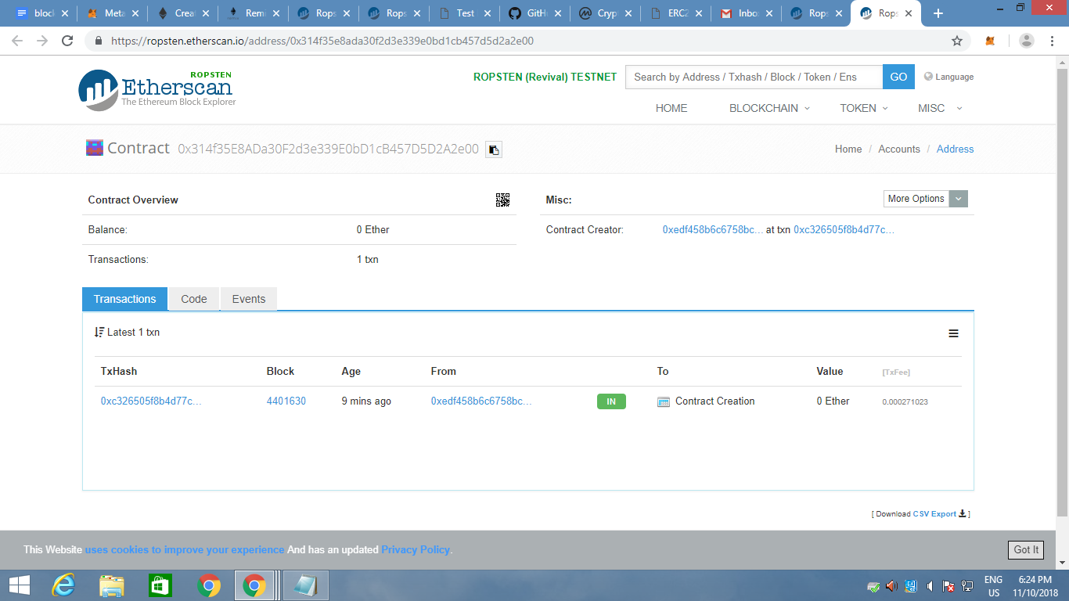

Crypto note
Asics special chips can multithread speeds.
To prevent Asics egalitarian proof of work

Cryptonotestarter.org
Start creating coins and concepts
Goto remix ide

Paste the code on code day2 bc into remix ide
Copy abi code right side
Give parameters to the deploy section
Deploy
And confirm a green tick with link aBove will appear.

Get contract address
In run under deployed contracts u can see the contracts
Click
See getuaer details
Under add
Get address/from
Call
Output can be viewed
Return value 2 on type means approved

Create another mask account

In request new user add new user and paddress as new account id from mask
Deploy from admin account means first account

In getuserdetails add new account id
The type will seem as 1 means pending so we have to approve the user

In approve user paste new user if
And deploy
Again getuserdetails for the new user the type will change to 2 means the user is verified...😎

Google script login start script
Create 3 HTML files index,new-user,app
Cpy codes from bc

Var abi= delete all from app.html paste

