|  |  |  |
| --- | --- | --- |
| **New simpler model**  **(no dimerization, choice of symbols consistent with Andrew’s code )** | **Old Model (Dixit et al 2020)**  **(choice of symbols consistent with my .py code and Purushottam’s .mat code)** | **Index in the original .py code** |
| Kpa (rate of receptor production) | Ksyn (EGFR delivery rate) | K[16] |
| k1 ( rate of ligand binding) | k1 (EGF binding to EGFR monomer) | K[0] |
| kn1 ( rate of ligand unbinding ) | Kn1 (EGF unbinding from EGFR) | K[1] |
| k2 ( rate of phosphorylation) | Kap (receptor phosphorylation) | K[4] |
| kn2 ( rate of dephosphorylation ) | Kdp (receptor dephosphorylation) | K[5] |
| kda (rate of receptor degradation) | ~~Kdeg (degradation of inactive) +~~  Ki (internalization of inactive receptors) | ~~K[6] +~~  K[8] |
| Kdf (rate of phosphorylated receptor degradation) | ~~Kdegs (degradation of active (phosphorylated)) +~~  Kis (internalization of active receptors) | ~~K[7] +~~  K[9] |

**Correspondence between parameters of the bigger model (including dimerization Dixit et al 2020) and the simpler model (no dimerization)**

This is needed to get the correct biological ranges from the data (parameter ranges Supplementary table 1 )

Kpa = r0 * Kda

R0 receptor level at steady state with no ligand present

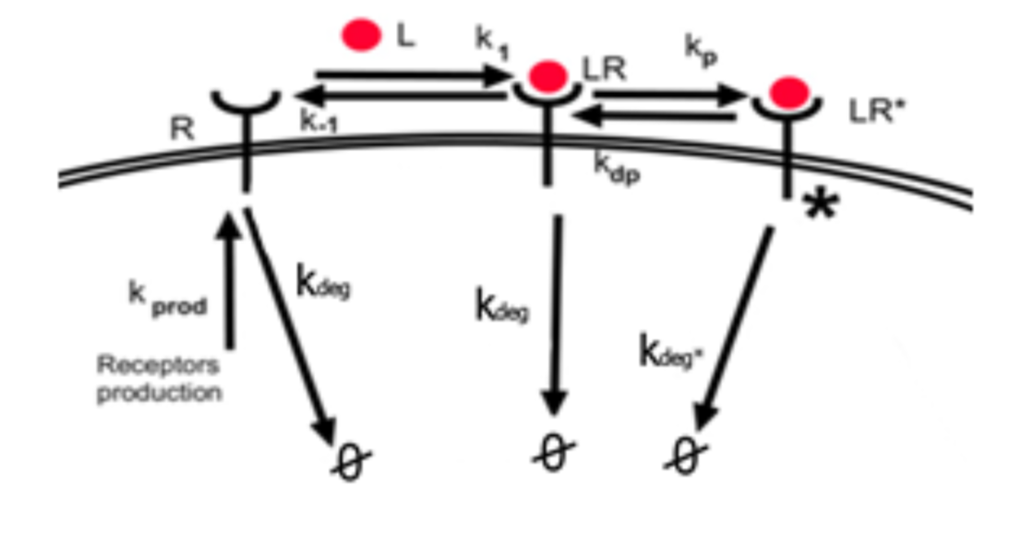

Figure Simpler Model (no dimerization)

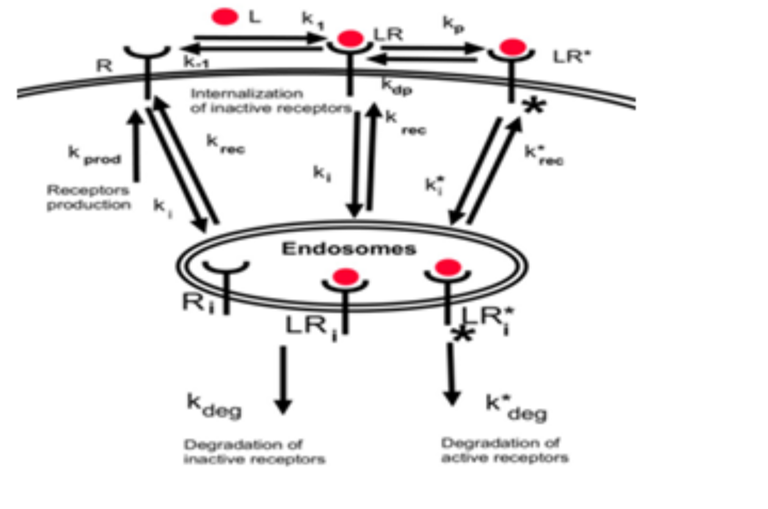

Figure Dimerization model used in Dixit 2020