Todo Documentation
Functional Requirements
Requirement ID | Requirement Statement | Comments
1 | Users will be allowed to add tasks to the task list.
2 | User will be able to view all of their submitted tasks.
3 | User can freely delete any task from the task list.
4 | User can filter tasks by clicking on status type.
5 | Application keeps track of total tasks currently in system.
6 | Application keeps tracks of total tasks of each status type currently in the system.

Non Functional Requirements
Requirement ID | Requirement Statement | Comments
1 | Response time when data is submitted and displayed is within 2 seconds.
2 | Application runs on a localhost.
3 | Application sends data to MYSQL database for storage.
4 | Data being deleted from the task list is also deleted from the database at the same time.
5 | Application has the capacity to store over 50 given tasks.
6 | The application is easy to use because of its simple UI only containing one button and four text input areas.

System Architecture Diagram
ODBC
s
HTTP
s
Client-Side
User
Localhost
XAMPP Web server
MYSQL
Database

Data Flow
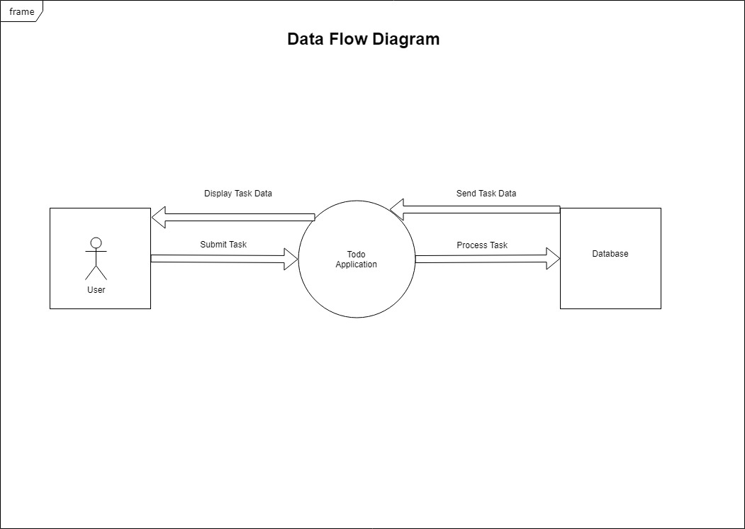

Use Cases
Use Case ID | Use Case Statement
1 | Users of the application will have the ability to submit their tasks after filling out the forms in the correct format and clicking the submit button. This will result in adding a new task.
2 | Users of the application will automatically view all of their submitted tasks upon entering the application.
3 | Users of the application can freely delete any desired task from the task list by clicking on the red X button. This will remove the task from view.
4 | Users of the application can filter tasks based on any of the four types of status types by clicking on them. This will open a new window and display corresponding tasks to that status type clicked.
5 | The application displays a table of total tasks currently in the system at the bottom of the screen.
6 | The application displays a table of each type of task based on status at the bottom of the screen.

Sequence Diagrams
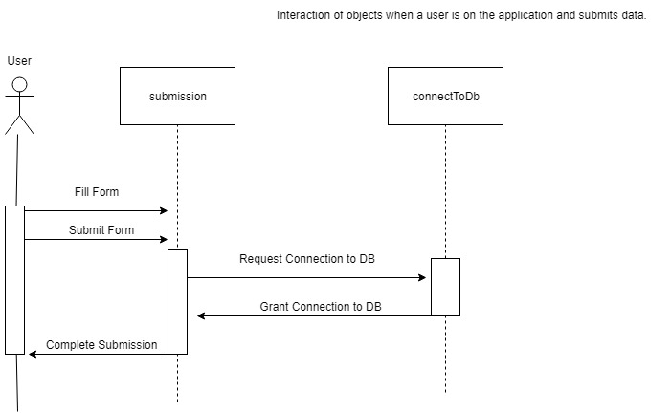
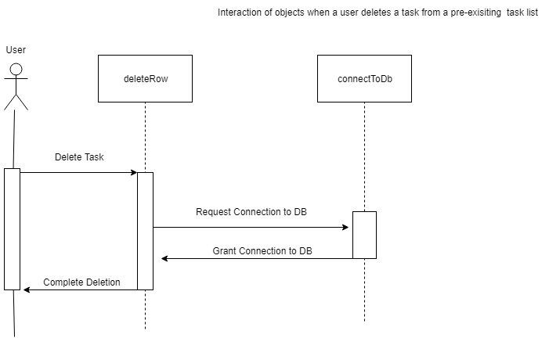

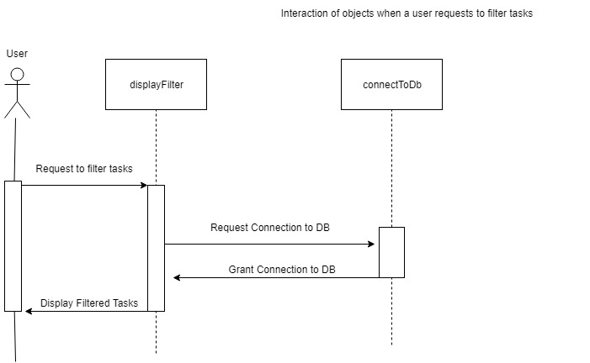
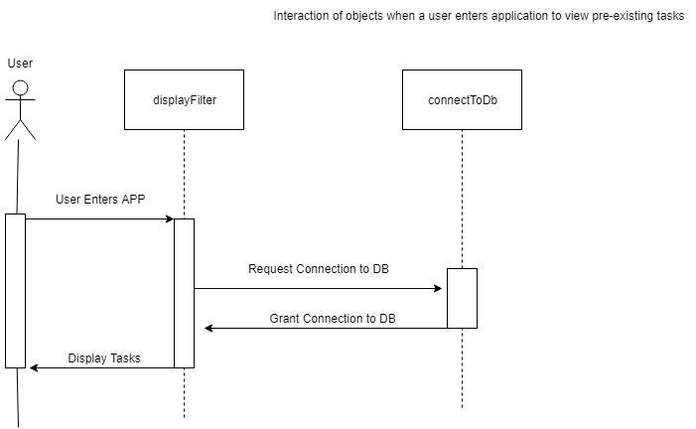

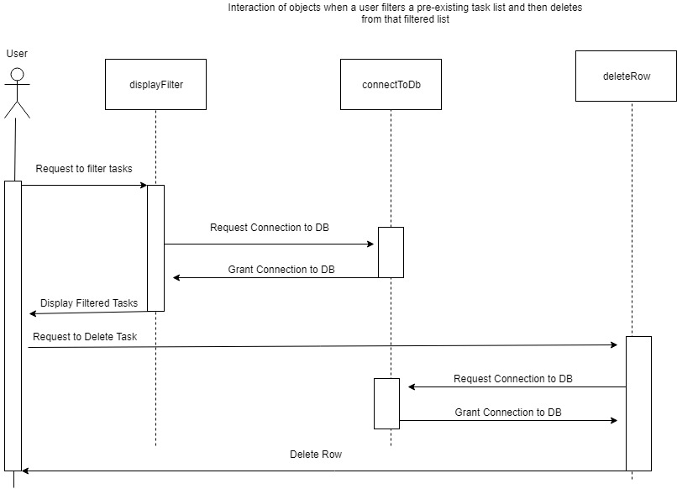
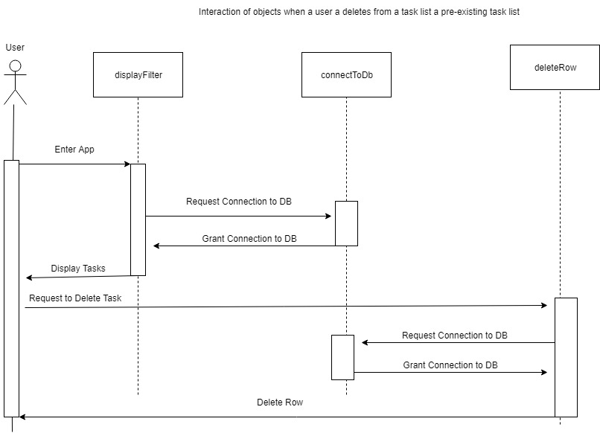

Database Tables
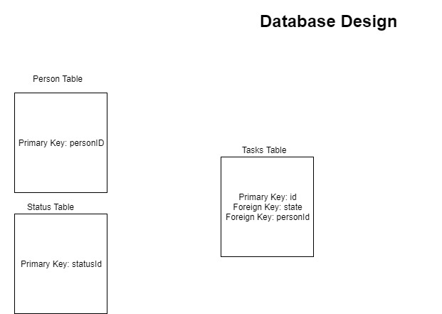

Test Cases

Test ID | Test Description | Steps | Result
1 | Test the applications ability to submit tasks properly after users enter their data. | Fill out form data while following listed guidelines.  Click submit button. | Submits data to database successfully.
2 | Test to see if application displays information correctly upon entering application and after submitting a task. | Fill out form data. Click submit button. Exit page then reopen. | Successfully displays tasks after submitting a task and after exiting a page.
3 | Test to see if application can delete tasks from the task list after clicking the delete button. | Click on a task’s Remove button | Removes selected task from task table and database.
4 | Test to see if status button correctly filters tasks based on their states. | Click on a task’s status. | Successfully links to a new tab and displays a filtered table.
5 | Verify that task count is correct when adding tasks and after deleting tasks. | Add or delete tasks | Correctly displays total task count query.
6 | Verify that task filter count is correct when adding tasks and after deleting tasks. | Add or delete tasks | Correctly displays count task query for all status.

