FIFA WORLD CUP 2026 · STADIUM OPERATIONS
PULSE26
A GenAI Command Layer for Navigation, Crowd Management,
Accessibility, Transportation and Sustainability
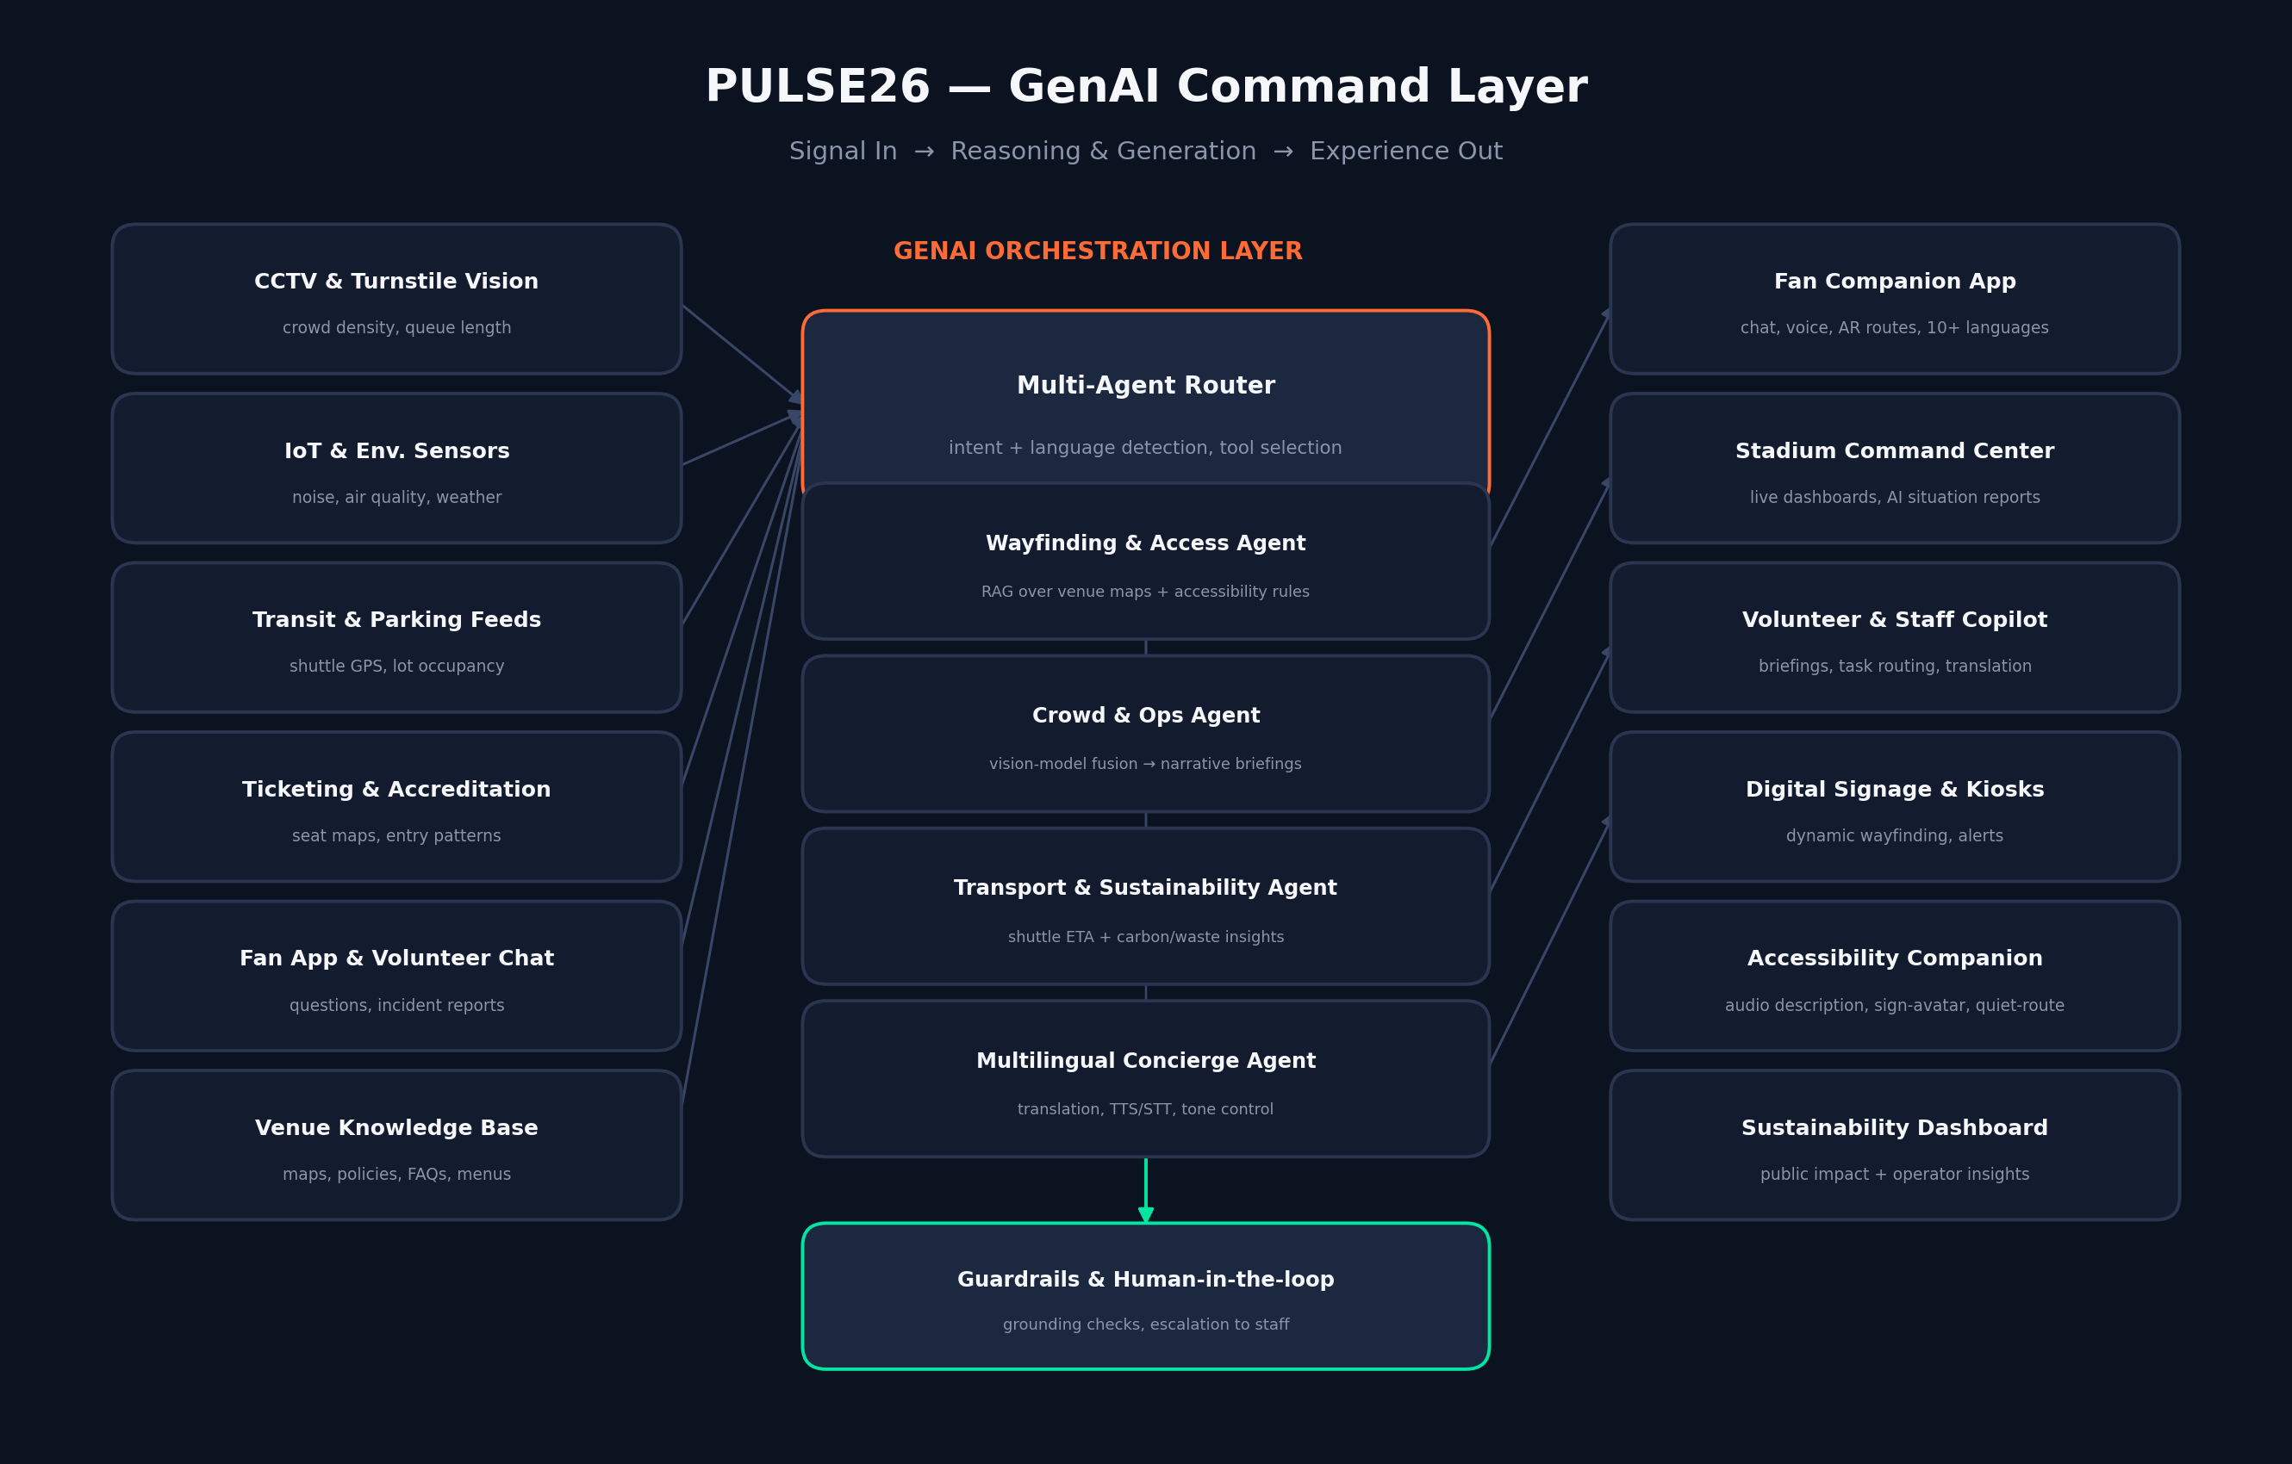
Solution Proposal & Reference Architecture
Prepared for: Tournament Organizers, Host-City Venues & Volunteer Programs
July 2026

Executive Summary
PULSE26 is a GenAI orchestration layer that sits across a FIFA World Cup 2026 host stadium's existing sensors, ticketing systems, transit feeds, and staff channels, and turns raw operational data into plain-language guidance for four audiences at once: fans, volunteers, venue staff, and tournament organizers.
Rather than a single chatbot, PULSE26 is a small team of purpose-built AI agents — wayfinding, crowd and operations, transportation and sustainability, and multilingual concierge — coordinated by a router agent and grounded by retrieval over each venue's own maps, policies, and live signals. The result is faster answers for fans, earlier warnings for organizers, and a more accessible, lower-friction matchday for everyone in between.
This document outlines the problem the tournament's scale creates, the solution architecture, the eight functional modules mapped to the categories most relevant to matchday operations, the underlying GenAI techniques, a phased rollout plan, and the metrics that would demonstrate impact.

1. The Problem: Operating at World Cup 2026 Scale
The 2026 tournament is the largest FIFA World Cup ever staged: 48 teams, 104 matches, and 16 host cities across three countries (the United States, Canada, and Mexico). Stadiums will host crowds that speak dozens of languages, arrive through a patchwork of transit systems, and expect the same standard of accessibility and responsiveness regardless of host city.
That scale exposes recurring operational pain points that traditional systems — static signage, printed guides, radio-dispatched staff — are not built to solve in real time:
- Fans from different countries struggle to get quick, accurate answers in their own language about gates, seating, transit, and food options.
- Crowd bottlenecks at entry gates, concourses, and transit hubs are often noticed only after they have already formed.
- Accessibility support (wayfinding for wheelchair users, sensory-friendly routes, sign-language or audio-described content) is inconsistent across host venues.
- Volunteers, often trained in days rather than months, need instant, reliable answers to unfamiliar questions from fans.
- Sustainability commitments (waste, water, transit emissions) are hard to track and communicate during a live event.
- Organizers must fuse video, sensor, transit, and social signals into a single situational picture — currently a manual, slow process.

2. Solution Overview
PULSE26 does not replace existing venue systems (turnstiles, CCTV, ticketing, transit control rooms). It sits above them as an interpretation and communication layer: ingesting their signals, reasoning over them with generative AI, and producing the right output for the right audience — a translated answer for a fan, a route suggestion for a wheelchair user, a narrative briefing for a control-room operator, or a task alert for a volunteer.

Figure 1: PULSE26 reference architecture — live signals flow into a multi-agent GenAI orchestration layer, which routes intent to specialized agents and publishes results to fan, staff, and public-facing channels, all under a guardrail layer that keeps a human in the loop for anything safety-critical.

3. Functional Modules
Each module below is mapped directly to a category of matchday operations, and each is powered by a specific generative AI capability rather than a static rules engine.

3.1 Navigation & Wayfinding Assistant
A conversational and visual guide that turns a static venue map into a live, personalized route.
- Natural-language queries ("How do I get from Gate C to my seat, section 214, avoiding stairs?") answered with turn-by-turn text, and optionally an AR overlay on a fan's phone camera.
- Generative AI writes routes dynamically by combining a retrieval index of the venue's floor plans with live congestion data, rather than relying on a fixed set of pre-written directions.
- Kiosk and digital-signage versions regenerate wording and highlighted routes automatically when a corridor closes or a gate reassigns.

3.2 Crowd Management & Predictive Flow
Computer-vision models estimate density and flow at gates, concourses, and transit platforms; a generative agent turns that numeric signal into a plain-language situational read for staff.
- Instead of a raw heatmap, control-room staff receive a short, auto-generated brief every few minutes: "Gate D queue is 40% above the 30-minute average and trending up; recommend opening auxiliary lane 3."
- Predictive alerts are generated ahead of half-time and full-time surges, based on patterns learned from prior matches at that venue.
- Fans receive gentle nudges ("Gate B is quieter right now") through the app and signage, easing pressure before it becomes a bottleneck.

3.3 Accessibility Companion
A dedicated mode that gives fans with disabilities the same quality of information as anyone else, generated on demand rather than pre-recorded for a handful of scenarios.
- On-demand audio description of what's on screen or on a sign, generated and read aloud in the fan's chosen language.
- An AI sign-language avatar renders key announcements (gate changes, delays, safety notices) for Deaf and hard-of-hearing fans, alongside captioned audio.
- Step-free and low-sensory route generation for wheelchair users or fans with sensory sensitivities, factoring in live elevator or ramp closures.

3.4 Smart Transportation Planner
A conversational planner that unifies shuttle, rideshare, transit, and parking information across host-city systems that don't otherwise talk to each other.
- Fans ask in plain language ("What's the fastest way back to downtown after the match?") and get a generated, ranked plan blending shuttle ETAs, transit schedules, and live parking-lot occupancy.
- Post-match departure load is smoothed by generating staggered pickup-point suggestions rather than sending every fan to the nearest exit.

3.5 Sustainability Intelligence
Generative summarization turns sensor and procurement data most fans and staff would never read into a story anyone can act on.
- A public-facing dashboard auto-generates a plain-language daily summary: water refill stations used, waste diverted from landfill, estimated transit emissions avoided by shuttle and transit uptake.
- Operators receive AI-generated recommendations ("Recycling contamination is up at Concourse 2 — signage refresh suggested") instead of raw bin-weight data.

3.6 Multilingual Fan Concierge
A chat and voice assistant available in the tournament's most common fan languages, tuned to local slang and matchday vocabulary rather than generic machine translation.
- Speech-to-text and text-to-speech let fans speak naturally and hear answers back, useful at noisy kiosks or for fans who prefer voice to typing.
- The same underlying agent powers volunteer-facing "translate for me" mode, so a volunteer who doesn't share a fan's language can still help in real time.

3.7 Volunteer & Staff Copilot
A pocket assistant for the tens of thousands of volunteers and staff who keep a World Cup venue running, most of whom are trained in a matter of days.
- Instant, grounded answers to "where is...", "what's the policy on...", and "who do I call if..." questions, sourced from the venue's own operations manual.
- Incident reports typed or spoken by a volunteer are auto-summarized and routed to the right team, cutting the time between an observation and a response.

3.8 Real-Time Decision Support for Organizers
A command-center view that fuses every module above into one narrative situation report, refreshed continuously rather than assembled by hand.
- A generated executive brief every 15 minutes: crowd status by zone, transport load, open incidents, sustainability snapshot, and a short list of recommended actions.
- What-if queries ("If we open Gate E now, what happens to Gate D's queue in the next 10 minutes?") answered using the same predictive models that drive the crowd alerts.

4. Underlying GenAI Techniques
PULSE26's modules share a common technical foundation rather than being built as isolated point solutions:
Technique | Where it's used | Why generative AI (not a fixed rules engine)
Retrieval-Augmented Generation (RAG) | Wayfinding, staff copilot, concierge | Answers stay grounded in each venue's own maps and policies, and update the moment source documents change.
Multi-agent orchestration | Router agent + specialist agents | Each domain (transport, accessibility, crowd) gets a focused agent instead of one overloaded prompt.
Multimodal fusion (vision + language) | Crowd management, decision support | Turns camera/sensor numbers into a narrative a human can act on in seconds.
Function calling / tool use | Transportation planner, signage updates | Lets the model query live systems (shuttle GPS, parking counts) instead of guessing.
Speech-to-text / text-to-speech | Multilingual concierge, accessibility | Removes the literacy and typing barrier for voice-first or visually impaired fans.
Generative summarization | Sustainability, incident reports, briefings | Condenses large operational data streams into something a person can read in one glance.

5. Who Uses What
Persona | Primary touchpoint | What PULSE26 changes for them
Fan (any language) | Mobile companion app / kiosk | Gets instant, correct answers about gates, seats, food, and transit in their own language.
Fan with a disability | Accessibility mode in-app | Gets step-free routes, audio description, and sign-language announcements without asking a staff member.
Volunteer | Staff copilot on a handheld device | Answers unfamiliar questions confidently and reports incidents in seconds, not minutes.
Venue staff / stewards | Digital signage + alerts | Receives early, specific warnings instead of noticing a bottleneck after it forms.
Tournament organizer | Command-center dashboard | Reads one generated situation report instead of six separate raw data feeds.

6. Implementation Roadmap
Phase 1 — Foundation (Months 1–2)
- Stand up the RAG knowledge base per venue: maps, policies, transit schedules, accessibility routes.
- Integrate read-only feeds from existing CCTV/crowd-analytics, ticketing, and transit systems.
- Ship the multilingual concierge and wayfinding assistant as the first fan-facing modules.
Phase 2 — Operational Intelligence (Months 3–4)
- Launch the crowd and operations agent and the command-center dashboard for one pilot venue.
- Add the volunteer/staff copilot, trained on that venue's operations manual.
- Run tabletop and live-match simulations to tune alert thresholds and reduce false positives.
Phase 3 — Full Experience & Scale (Months 5–6)
- Add the accessibility companion (audio description, sign-language avatar) and sustainability dashboard.
- Roll the full module set out to all host venues, with each venue's own knowledge base swapped in.
- Establish a human-in-the-loop escalation path for every safety-relevant alert before go-live.

7. Success Metrics
Category | Illustrative KPI
Navigation | Reduction in average time-to-seat and staff-directed wayfinding requests.
Crowd management | Increase in bottlenecks flagged before they exceed a safe density threshold.
Accessibility | Reduction in staff-assisted requests for fans in accessibility mode.
Multilingual support | Share of fan queries resolved without staff escalation, by language.
Transportation | Reduction in post-match departure clearance time.
Sustainability | Increase in refill-station usage and recycling diversion rate.
Decision support | Reduction in time from anomaly detection to organizer action.

8. Risks & Mitigations
- Hallucinated or wrong answers — every fan- and staff-facing answer is grounded in retrieval over venue-approved sources, with confidence thresholds that fall back to "connect me to a steward" rather than guessing.
- Over-reliance on AI for safety-critical calls — PULSE26 is decision support, not decision-maker; every crowd-safety and emergency action still requires human sign-off, by design.
- Language and cultural nuance — concierge responses are reviewed with native speakers from each major fan-language group before launch, not left to raw machine translation.
- Data privacy — crowd analytics use aggregate density, not individual tracking or facial recognition tied to identity.
- Connectivity at scale — core wayfinding and safety alerts are cached for offline/low-bandwidth operation inside the stadium bowl.

9. Conclusion
PULSE26 reframes a World Cup stadium's operations problem as a translation problem: translating scattered sensor, transit, and knowledge-base data into language a fan, a volunteer, or an organizer can act on immediately, in the language and format that works for them. Built on retrieval-grounded, multi-agent generative AI with a human-in-the-loop safety net, it is designed to make the world's largest World Cup feel, for every person inside the stadium, like it was built for them specifically.

