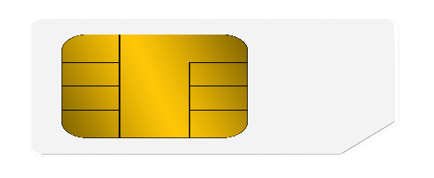

**DEBIT CARD BANK NAME**

**1234 5678 4321 2006**

**Adarsh Maurya Valid 16/25**

**

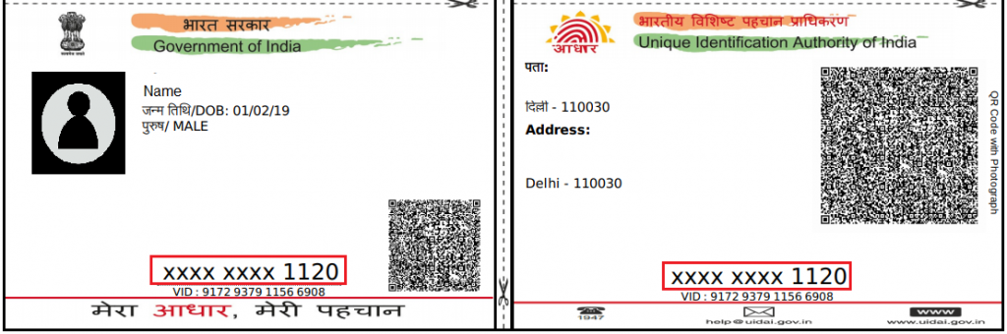

**NAME=Adarsh Maurya**

**D.O.B=12/09/2006**

**FATHER NAME=Sant Saran**

**1234 6700 2006**

