**ADARSH KUMAR MAURYA**

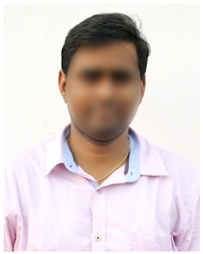**Email Id:** Akm2006@gmail.com

**Mobile:** 7291XXXX06.

**Address:** H No 153/4, Bijwasan,

New Delhi 110061.

**CAREER OBJECTIVE**

* To obtain a challenging career in the IT industry and put all my efforts into the growth of the organization and have a great working environment.

**SUMMARY**

* An enthusiastic, punctual & carer minded individual with excellent communication and interpersonal skills.

**EDUCATIONAL QUALIFICATION**

* 10th Pass From Govt. BSSS

**EXPERIENCE**

Fresher

**PERSONAL PROFILE**

Father’s Name : Sant Saran

Date of birth : 12 Sep 2006

Gender : Male

Nationality : Indian

Languages Known : English & Hindi

Religion : Hindu

Hobbies : Listening Songs

**DECLARATION**

I hereby declare that all the above mentioned information is true to the best of my knowledge and belief.

Place:

Date: **ADARSH KUMAR MAURYA**