Table of Contents

Business Case Study 2

Database Relational Model 3

Self-Evaluation 4

Black Box Testing 5

Bibliography 8

**Report**

This assignment is further development process of the previous semester’s coursework. In the prior task, we had to produce a beneficial database for chosen case study to make life easier. However, current implementing web interface in this task is regarded as one of the realistic model views of the project. Additionally, there are some functions and features introduced in earlier coursework were applied in practice as much as possible.

# Business Case Study

. “Gullar Olami” flowers shop that operates in Tashkent is selected as case study to this course work. “Gullar Olami” has four branches in Tashkent city that provides bouquets of flowers for its customers. The company is planning to extend in order to open new branches in other regions of the country. Therefore, it need enhanced database system to develop its work efficiency. Branches of this shops’ system has its cashiers and other employees who are managed by managers: every branch has its own general manager. Employees who are current citizen and resident of Tashkent city can be employed by the company. Flowers are delivered by licensed suppliers who provides different types of flowers from countryside and from abroad for branches of the company. The company provides several kinds of bouquets for its customers: bouquets can include from one to five types of flowers. If customers purchase more than 3 bouquets, they can get 15 percent discount from the shop. Loyal customers of the shops will be awarded with membership cards that they can always buys bouquets with 20 percent discount.

While developing prototype of the early DB system, minor changes have been made to enhance the system. Here is the Database Relational Model for RadissonBlu Hotel that was used in the previous coursework task:

# Database Relational Model

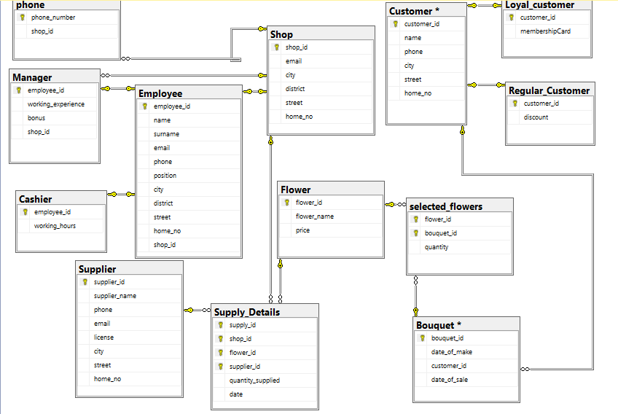

# Self-Evaluation

When I was developing the application for “Gullar Olami” flower shop, I faced to the problem that I needed to make flowers selectable and to send data of selected flowers to WishList. I did not have any idea how to do it. First of all, I tried to send the data of selected flower with ViewBags, however I could not send data from one controller to another one. At the end, I used cookies to send data. I made several cookies that saves the properties of flowers data.

Another problem that I had during the development was populating dropdown the countries for a form of registration. To solve this problem, I tried making Countries table in the database and populating this database with the list of countries. Then, I wanted to send list of countries to the View through ViewBag. But, the application did not show list of countries in the dropdownlist; I tried to solve this problem, however, I could not find the error. Therefore, I used to make enumeration of countries in the Model and filled the enumeration with the list of countries that was copied from the internet. Then, I populated the dropdownlist with the data in the enumeration.

# Black Box Testing

|  |  |  |  |
| --- | --- | --- | --- |
| Test description | Expected results | Actual results | Comments |
| Login | Clients should provide their username and password, which they registered. If either username or password is entered wrongly, authentication message will appear. |  | This function appears first entry view in the project when it runs. If user wants to navigate home page of the web application, he will be allowed to see even before logged in. |
| Flower Search/Filter | Sometimes users want to see flowers` info. Guests can find flowers by their delivered dates or their name or color. |  | This functionality works well only when user fills out search inputs correctly and completely. |
| Ordering | Flowers can be selected and reserved by registered clients and there is a list of Flowers existed in a shop. All fields should be provided with valid data. No way to enter invalid data.  After clicking “add to wishlist”, flowers data will be sent to wish list form. Client should provide number of flowers the he or she want to order and comments for wishlist. |  | These two functions are within the separate pages. All functions worked as expected. All data stored in the database. Clients can select flower and specify quantity that they want to buy and can enter comment.  Data will be stored to the wishlist of the customer. And customer can see all his or her orders. |