Files with submission: drive.py, model.json, model.h5, model.py
Solution Video: https://www.youtube.com/watch?v=62_ZWtj-UOo
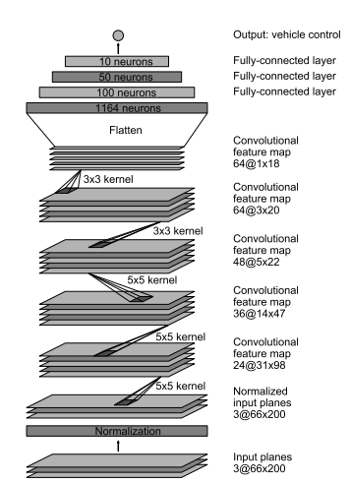
Before starting the actual architecture, I cleaned up the data to provide better results. In this preprocessing, I did several things. The steps to it are as follows:
1. Read the CSV file provided into a pandas dataframe, while labeling all the columns.
2. Find and extract the center image from its residing folder.
3. Crop the image to get rid of unnecessary data (e.g. trees, landscape, etc) and focus primarily on the road. The helps the architecture better understand the road without have the need to understand the landscape around it.
4. Resize the image to a smaller size (i.e. 200x66). This allows for faster computation of the model when it's executed, because of its smaller size.
5. Carry out steps 2 to 4 for all the images and put them into an array.
6. For the array which contains all the images, normalize the images along with converting it to float. This makes sure that the range of the pixels for the data being compared in all images is comparable and that we’re not comparing data point which aren’t on a common scale range.
7. Extract and input all the steering data into its own array. Their position in the array corresponds to their appropriate picture.
8. Split the images and steering angles arrays into training and testing data. I used the recommended 2/3 training and 1/3 testing approach.
9. Reshape the training and test data so that it can be accepted by the format needed when using Keras.
As you may have noticed, I left the images to have their RGB channels and didn't convert them to grayscale. I felt that the colors were important to get better results. I didn't have the chance to train a grayscale model, but that would be an interesting comparison to see, if I were to do this again in the future.
Note: Steps 3 and 4 of the preprocessing steps were also performed in the drive.py file.
The architecture that I used for this assignment was that I mimicked the NVIDIA architecture provided in their paper. I've added a diagram of the architecture (Figure 1).
Figure 1
I had used dropout techniques in the architecture, but saw that the results didn't really stand to make a difference as I assumed it would (see commented dropout sections to see where I had added them).
The way I obtained the images for my model is that I drove the track several times the way it was intended and then I drove it going in the opposite direction. I used these images to run my model on and see how my car performed. I paid attention to the areas where it would go completely off the road and then went back to those areas to take more images only in those sections where my model didn't perform. I did this several times until receiving the results I submitted. The places I found to be most difficult were the turn before getting on the bridge, the turn where the dirt path begins and the final turn with the red striped. Those are the areas where you will find many images of. Please see images below of some of showing the preprocessing of an area I found to be difficult and had to go back to and how I would transform it.
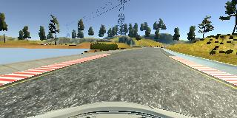
Step 3

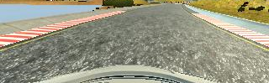
Step 4

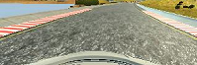
Step 6

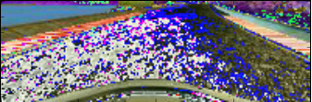
Step 6.5

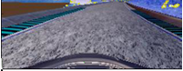

Here are a couple of examples of images taken when I went back to the areas which gave me some issues. The first is of the area where the dirt road begins. I drove by it several times, in attempt to show the car how to act when it sees the road split off into 2 (concrete and dirt road). You can see that in my images where I try and tell the car what to do, I drove close to the edge. The second image is of the last bend. I found that my car kept falling off at that location. With this location, I also drove really close to the edge, showing the car that when it gets there (which it always did, before falling off) how it should steer back on to the road.
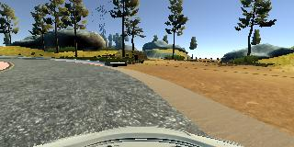
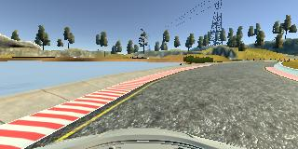

In terms of the epochs and batch size used in this assignment, I used a small number of epochs (i.e. 3) and a small number for the batch size (i.e. 10). I had tried several sizes of epoch, ranging from 2 to 20. I found that when I had trained my same dataset on numbers larger than 5, the model started overfitting and when actually tested in autonomous mode, it wouldn’t be able to complete the track. As for the batch size, I found that with larger numbers (such as 100 or 1000), the model would be trained faster, but then the model wouldn’t end up being nearly as good as it was when using the smaller batch size of 10.

