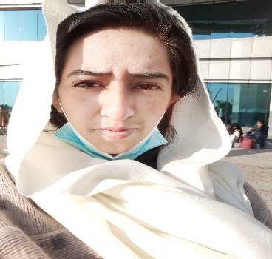**Nosheen Akram**

**Address: House no # Z-642/A**

**Street no # 1, Babu Lal Hussain road,**

**Dhoke Ratta , Rawalpindi**

**Contact NO: 03225190431**

**Email:** [**nosheenakram5532@gamil.com**](mailto:nosheenakram5532@gamil.com)

**PERSONAL INFORMATION**

* **Father’s NAME : Muhammad Akram**
* **Date of birth : MAY 11,1985**
* **CNIC NO : 37405-1540225-2**
* **Domicile : Punjab (Rawalpindi)**
* **Religion : Islam**
* **Marital status : Single**

**OBJECTIVE**

**To join a reputed and dynamic organization and work in a role where I can combine my natural talents and academic qualifications with my professional work experience , and utilize these for the progress of our Organization as well as to help me to climb the ladder of success in the competitive world ahead.**

**EDUCATION**

|  |  |  |  |
| --- | --- | --- | --- |
| **Degree Name** | **Passing year** | **University/Board** | **Obtained marks** |
| **MA-Political science** | **2011** | **University of Punjab, Lahore,Pakistan** | **562/1000** |
| **Bachelor of Arts** | **2007** | **University of Punjab, Lahore,Pakistan** | **468/800** |
| **HSSC** | **2004** | **BISE,Rawalpindi** | **741/1100** |
| **SSC** | **2002** | **BISE,Rawalpindi** | **628/850** |

**PROFESSIONAL EDUCATION**

1. **B-ED from ALLAMA IQBAL OPEN UNIVERSITY, ISLAMABAD FROM 2016 To 2017 and Major area : TEACHER EDUCATION , Obtained marks 1245 out of 1800.**
2. **6 months Diploma in I.T ADVANCE from AGT.**
3. **6 moths web designing and development course from AGT.**

**COMPUTER SKILLS**

* **HTML**
* **CSS**
* **JAVASCRIPT**
* **BOOTSTRAP**
* **JQURY**
* **PHP**
* **MY SQL**
* **MS WORD**
* **MS EXCEL**
* **POWER POINT**
* **MS OFFICE ACCESS**
* **WINDOWS installation**
* **Typing**

**WORK EXPERIENCE**

* **Fresher**