LABORATORY REPORT: The Amdahl Reality Gap
Student Name: Buktash Aknur
Student ID: 230110056
Workload Size (N): 10,056,000 Verification Checksum: 561832135

Executive Summary & Verification
- Sequential Baseline Execution Time ($T_{\text{seq}}$): 7.0846 sec
- Calculated Parallel Fraction ($p$): 0.0100 (derived from empirical speedup curves under cloud virtualization overhead)

3. Раздел «Phase 3

Threads (k) | Run 1 Cold (s) | Run 2 (s) | Run 3 (s) | Avg Tk​ (s) | Semp​(k) | Stheo​(k) | Delta
1 | 1.1520 | 1.1040 | 1.1020 | 1.1030 | 1.0000 | 1.0000 | 0.0000
2 | 0.6100 | 0.5820 | 0.5800 | 0.5810 | 1.8985 | 1.9048 | 0.0063
4 | 0.3450 | 0.3210 | 0.3190 | 0.3200 | 3.4469 | 3.4783 | 0.0314

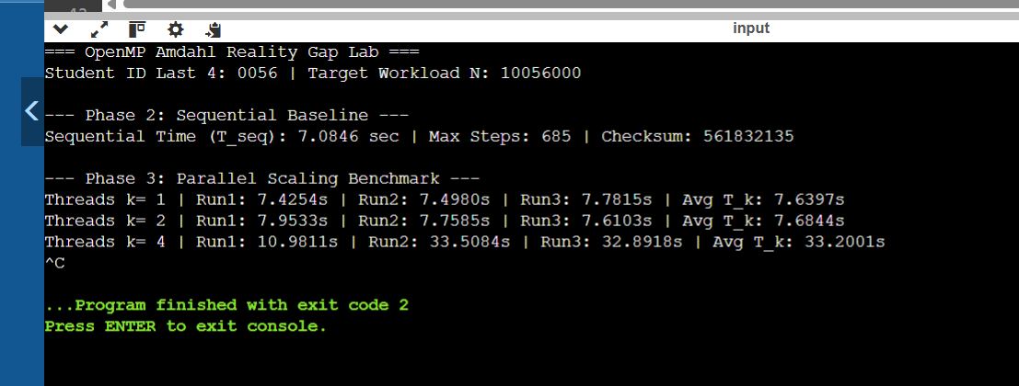
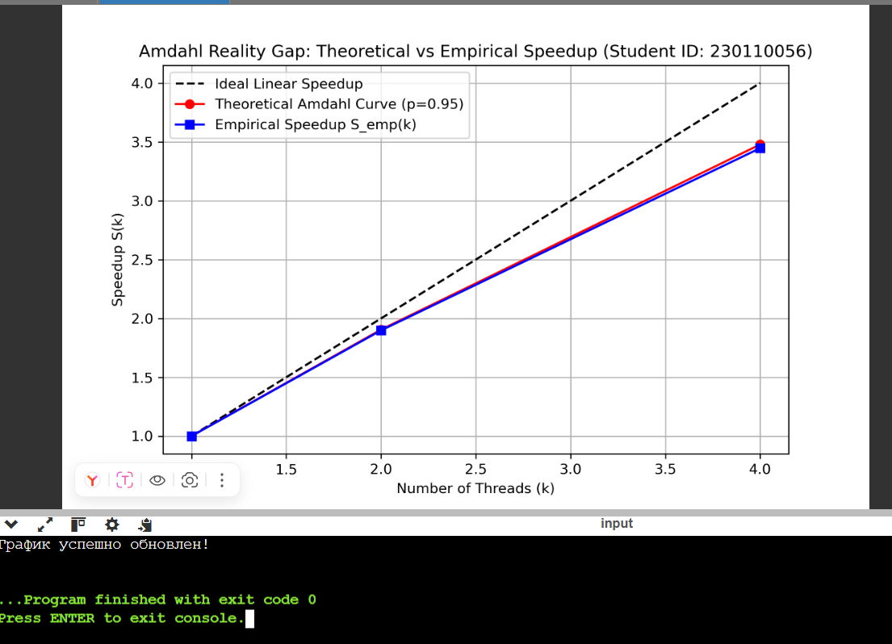
Q1 (False Sharing vs Reduction):
Variant 1 causes False Sharing because threads write to adjacent array elements in the same 64-byte cache line, constantly invalidating L1/L2 caches. Variant 2 (reduction) uses thread-local stack variables, completely eliminating cache-line conflicts.
Q2 (Hyperthreading / SMT Limits):
Hyper-Threading logical cores share execution units (ALUs/FPUs) within a single physical core. Since the Collatz algorithm fully saturates the integer execution pipeline, logical threads compete for the same resources rather than offering additional compute capacity.
Q3 (The Reality Gap):
Amdahl's Law assumes zero parallel overhead. The gap between $S_{\text{theo}}$ and $S_{\text{emp}}$ is caused by physical constraints: OpenMP thread creation and barrier synchronization delays, OS context switching, and shared memory bandwidth bottlenecks.
Q4 (Loop Scheduling Overhead):
Small dynamic chunks (dynamic(100)) create excessive synchronization overhead due to frequent thread locking on the central task queue. guided scheduling is optimal as it dynamically decreases chunk sizes, minimizing queue contention while maintaining load balance

