UNIVERSITY OF PÉCS
FACULTY OF SCIENCES
INSTITUTE OF MATHEMATICS AND INFORMATICS
PHIOFIT
A GAMIFIED FITNESS APPLICATION FOR STUDENTS



Supervisor: Dr. Horváth Zoltán | Author: Daniil Khersonets (HKR6YU)
External supervisor: - | BSc in Computer Science
`

ABSTRACT
PhioFit is a mobile fitness application that involves users to build more consistent workout habits. Many people and especially students struggle with regular training because of lack of time or overwhelming schedules. Low motivation ruins consistency and people started skipping or fully dropping their workouts, which makes it very difficult to return to the old routine. This thesis is used to show how gamification systems perform in helping those people to not just follow the instructions and do something that is healthy, but to enjoy the process and have fun.
Gamification system is already used in many different platforms, for example – Duolingo. It showed that systems such as streaks, points, rewards, levels can keep users active and engage them for a long period of time. This is what inspired the development of PhioFit.
The results show that combining a simple workout tracker with gamified elements can create a more enjoyable and motivating experience.

TABLE OF CONTENTS
Page
ABSTRACT 2
LIST OF ILLUSTRATIONS 4
LIST OF TABLES 5
1. INTRODUCTION AND RESEARCH GOALS 6
1.1 MOTIVATION 6
1.2 GOALS 7
2. INTRODUCTION OF TOOLS/MATERIALS AND METHODOLOGY 8
2.1 TOOLS AND TECHNOLOGIES USED 8
2.2 DEVELOPMENT METHODOLOGY 10
2.3 FUTURE EXTENTIONS AND CLOUD INTEGRATION 11
3. INTRODUCTION, ANALYSIS AND DISCUSSION OF RESULTS 12
4. CONCLUSION 13
5. ACKNOWLEDGMENT 14
6. REFERENCE LIST 15
7. APPENDIXES Error! Bookmark not defined.
8. DECLARATION OF ORIGINALITY OF THE WRITING 16

LIST OF ILLUSTRATIONS
Page
Figure 2.1. Tooks and Methodologies 8
Figure 2.2 - Iterative methodology (source: Wikipedia.org) 10
Figure 2.3 - Gamification Methodology (source: educationaltechnology.net) 11

LIST OF TABLES

INTRODUCTION AND RESEARCH GOALS

MOTIVATION
Regular physical activity is essential for keeping in good conditions both health and mental wellness. Many university students struggle to sustain their workout routines. Their weekly plans often change because of classes, homework, part-time jobs or simply exhaustion. When life is very busy, it becomes hard to maintain stable and consistent routine. After skipping some days, the habit slowly disappears. Even students who intend to exercise often lack understanding on how to plan their workouts or track their progress.
At the same time many young people spend time on apps that use gamification to keep users engaged. Duolingo is one example, where simple elements such as streaks, levels, points and small rewards encourage users to come every day. These models show that basic rewards can help users develop habits and stay motivated for durations.
PhioFit was developed based on this idea. The aim of the project is to imply gamification methods and show their effectiveness in fitness context. The goal is not to replace coaching but to help users track their progress conveniently and boost their motivation. PhioFit integrates simple gaming elements, that create a mood and feeling of being inside of a game. Those elements are experience, levels, tracking progress, tasks and rewards.
Besides the fitness aspect, this thesis is also important from a software development point of view. It provides an opportunity to design a real mobile application with a backend.

GOALS
While most of the fitness applications relies on using the training programs that are popular and seems to be “well-known” without any involvement. Because of that, people either prefer to copy someone else’s fitness program blindly and rely on basics, without understanding what they’re doing, which causes small progress overtime and worthless feelings. Without a structured plan it’s very easy to get lost and feel frustrated. Here is where gamification systems can shine, showing how easy it can be to obtain useful habits and stay consistent with them.
PhioFit is an application that concludes classic systems from games, that helps to engage users and gives them excitement to move forward to a new level. Those systems will be explained in chapter 2 of this thesis.

INTRODUCTION OF TOOLS/MATERIALS AND METHODOLOGY
The development required some popular tools and frameworks that help to support cross-platform mobile applications and server-side data management. In this chapter the tools used in the project were explained and why they were chosen. The chapter also describes main ideas behind the system design and methodologies that were followed during the thesis.
Illustration of all Tools and Methodologies described on image 1:
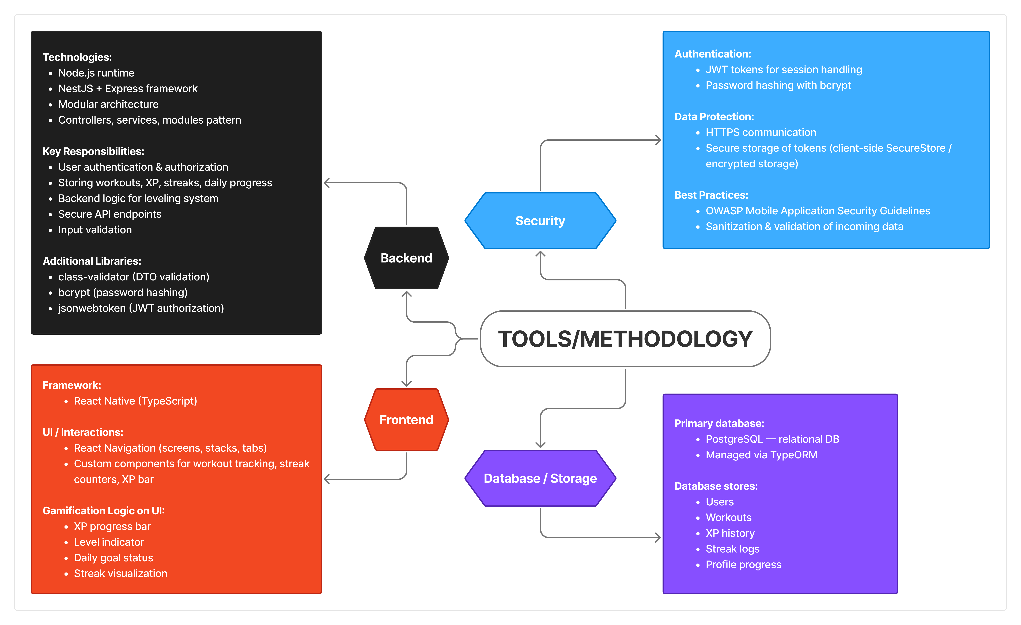
Figure 2.1. Tooks and Methodologies

TOOLS AND TECHNOLOGIES USED
Frontend
React Native, a very popular and powerful framework for building apps that work with cross-platforms, that’s why it was used for developing this project. Main idea of using React Native is that a codebase functions on both Android and iOS speeding up the development and simplifying the maintenance. The frontend is written mostly in TypeScript, it is a typed variant of JavaScript. It helps to minimize a lot of errors during the development and flag types or absent properties before executing the actual code.
React Native already has many basic components, which makes it easier to build the screens. Extra libraries, such as React Navigation were used to handle transitions between screens, for example home screens, workout page and profile page.

Backend
PhioFit backend was created with NestJS, a framework that is based on Node.js and Express. NestJS was chosen because it has a modular structure. It enables separation into 3 separate parts of coding blocks: controllers, services and modules. By using this, the code was organized and makes future expansion much easier.
The backend is responsible for user registration, login, authentication, storing data related to workouts, XP points, and streaks. It handles personal data and uses bcrypt for hashing passwords, with JSON Web Tokens (JWT) for authorizing users. This means that user’s credentials are kept safe, and only authenticated users can access protected parts of the application.

Database
For storing such information as: workouts, gamification data, user profiles - the project uses PostgeSQL. PostgreSQL is a relational database suited for managing structured data.
To work with the database in NestJS, I used TypeORM. It lets me write database tables as TypeScript classes, so the code is clearer. TypeORM allows us to work with the databases and its tables using TypeScript classes. It makes the code more readable and reduces the chance of mistakes when writing SQL queries manually.
Security Tools and Practices
The application manages workout records and user profiles within the number of fundamental security protocols that were implemented. Passwords are consistently saved in a form of tool that is called bcrypt and verification relies on JWT tokens that follow every request.
Sensitive data, such as authentication tokens on the client side is stored using secure storage library. HTTPS is required for communicating with the backend, because this way it helps to avoid several types of attacks from outside.

DEVELOPMENT METHODOLOGY
The development implies an iterative methodology. Each iteration produced a working version (it’s adapted to the working GitHub project, so that it’s possible to check every single part of the project on every stage and test it). Instead of attempting to construct the whole system simultaneously, the project was split into small components that were developed separately. Split parts include user registration, login, workout tracking. After these key features were finished, gamification aspects were introduced right after. Last step was to implement experience points (XP) with the leveling system, daily objectives and streak monitoring. Working in small steps helped a lot, because it was easier to test each feature separately.
Illustration of Iterative methodology process:
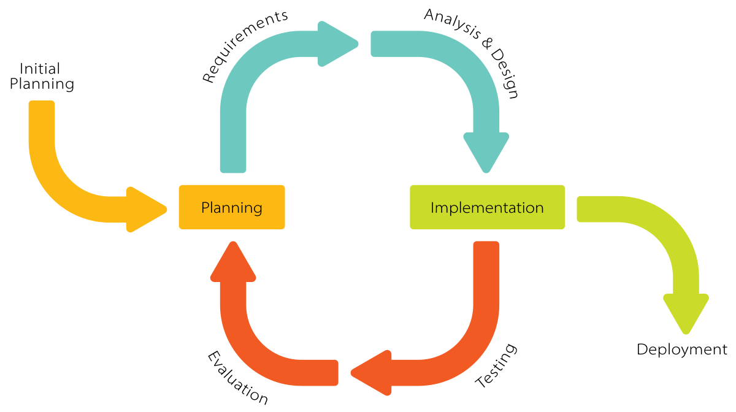
Figure 2.2 - Iterative methodology (source: Wikipedia.org)

Gamification Methodology
The idea of gamification system of PhioFit came from some popular known apps, that use simple reward systems and help to stay consistent. The aim wasn’t to develop a game, but rather to create a path that users will want to go through and reach certain points. For example, max level, or first place in the leaderboard (probably this feature will be implemented in the future).
The main gamification components that were implemented in this project include:
- Experience Points (XP): Points that user gets after doing tasks. Certain number of points let user get to a new level.
- Leveling System: Every user starts from level 0. Certain amounts of XP allow users to raise that level and get rewards.
- Daily Goals: It’s a task or goal that needs to be completed each day / each week / each month.
- Streak Monitoring: When users stay consistent and maintain tasks at certain times, their streak grows showing their consistency.
They were picked because they are simple and useful for showing progress. Using them helps users to have a clear picture of their progress and understand what they are doing right now, at what stage they’re staying.
Illustration of a Gamification methodology:
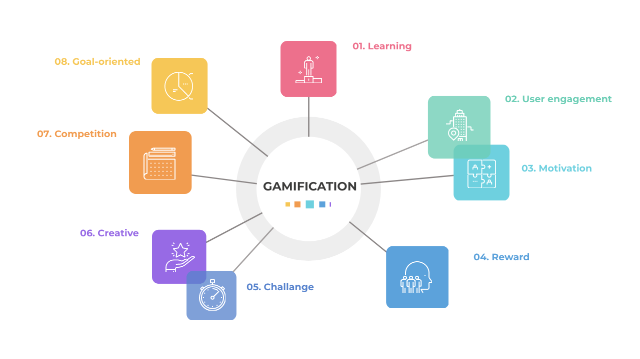
Figure 2.3 - Gamification Methodology (source: educationaltechnology.net)

FUTURE EXTENTIONS AND CLOUD INTEGRATION
Currently, the existing PhioFit version saves data on backend. The architecture was created to potentially implement cloud capabilities later. Platforms like Supabase, Firebase or cloud hosting services can be used for automated backups, push notifications and automatic updates.

INTRODUCTION, ANALYSIS AND DISCUSSION OF RESULTS

CONCLUSION

ACKNOWLEDGMENT

REFERENCE LIST
[1] Meta, “React Native Documentation,” 2024. [Online]. Available: https://reactnative.dev/docs
[2] N. J. S. Team, “NestJS Documentation,” 2024. [Online]. Available: https://docs.nestjs.com
[3] PostgreSQL Global Development Group, “PostgreSQL 16 Documentation,” 2024. [Online]. Available: https://www.postgresql.org/docs/
[4] TypeORM Project, “TypeORM Documentation,” 2024. [Online]. Available: https://typeorm.io
[5] Wikipedia, “Iterative and incremental development,” 2024. [Online]. Available: https://en.wikipedia.org/wiki/Iterative_and_incremental_development
[6] Educational Technology, “What Is Gamification?” 2024. [Online]. Available: https://educationaltechnology.net
[7] Duolingo, “How Duolingo Keeps Learners Motivated,” 2024. [Online]. Available: https://www.duolingo.com

DECLARATION OF ORIGINALITY OF THE WRITING
(According to Code of Studies and Examinations of the University of Pécs, Annex nr. 14/1.)

I, the undersigned, ……………………………………………………………………….............
(name) …………………………………………...(NEPTUN system identifier), declare under
penalty of perjury

that every part of my writing,

…………………………………………………………………………………………………...

…………………………………………………………………………………………………...

is the result of my own, autonomous work, I only used referred sources (special literature,
tools, etc.) and I observed the pertaining rules of the University of Pécs while preparing my
writing.

I am aware that the University of Pécs has the right to check the observation of copyright
rules through a plagiarism tracing system.

Pécs, ________________________ month _________ day, 20____ year

…………………………………………….
signature of the student

