Home Assignment: Developing a responsive website

ASSESSMENT AND INTERNAL VERIFICATION FRONT SHEET (Individual Criteria)

|  |  |  |  |  |  |  |
| --- | --- | --- | --- | --- | --- | --- |
| Course Title | MCAST Advanced Diploma in IT | | | Lecturer Name & Surname | Andrew Caruana | |
| Unit Number & Title | | ITWEB-406-1501: Website Design | | | | |
| Assignment Number,  Title / Type | | 3, Synoptic developing a responsive website (Home) | | | | |
| Date Set | | 29-01-2024 | Deadline Date | 06-02-2024 | | |
| Student  Name | Aleksa Grujicic | | ID Number | 0249154A | Class /  Group | 4.1A DiG |

|  |  |  |  |  |
| --- | --- | --- | --- | --- |
|  | Student’s declaration prior to handing-in of assignment:   I certify that the work submitted for this assignment is my own and that I have read and understood the  respective Plagiarism Policy | | | |
|  | Student’s declaration on assessment special arrangements (Tick only if applicable)   I certify that adequate support was given to me during the assignment through the Institute and/or the Inclusive  Education Unit.   I declare that I refused the special support offered by the Institute. | | | |
| Student Signature: | |  | Date : |  |
|  | |  |  |  |
|  | |  |  |  |

|  |  |  |
| --- | --- | --- |
| Assessment Criteria | Maximum  Mark | Mark  Achieved |
| LO 1 - Preparing a website using the latest mark-up language |  |  |
| KU1.2: Show correct understanding of the W3C standards | 5 |  |
| AA1.3: Choose the right approach for the provided scenario | 12 |  |
| LO 2 - Design a website using the latest styling technology |  |  |
| KU2.3: Show advanced understanding of the latest styling properties | 15 |  |
| KU2.5: Collect and prepare site content | 12 |  |
| LO 3 - Create interactivity in the website using JavaScript and JavaScript Framework |  |  |
| KU3.2: Define the basic selectors of a JavaScript framework | 12 |  |
| LO 4 - Upload, test and review created website |  |  |
| AA4.1: Explain how a website is properly tested | 10 |  |
| AA4.2: Deploy a website to demonstrate its functionality | 14 |  |
| SE4.3: Propose and implement further changes to improve cross-browser compatibility | 20 |  |
|  |  |  |
| Total Mark | 100 |  |
|  |  |  |
|  |  |  |

ITWEB-406-1501 - Website Design pg.1



Home Assignment: Developing a responsive website

Advanced Diploma in IT (MQF Level 4 - Year 1)

ITWEB-406-1501 - Website Design

Home Assignment: Developing a responsive website

Assignment Guidelines

➢ This assignment is a Home Assignment and should be strictly completed by the 6th February 2024.

➢ Fill in the assignment cover sheet completely. The student’s assignment cover sheet should be attached   
 to the project being submitted. Note that assignments handed in without the cover sheet will be   
 considered as Not Submitted.

➢ Answer all the questions in a separate document or relevant programs/files.

➢ Clearly highlight the Criteria Number/Question Number and your answer in your work.

➢ Submission method: Soft copy only and on Moodle (more instructions will be given by your lecturer). ➢ Plagiarism is strictly prohibited. Proper references must be used. Copying will be penalized in line with   
 the College’s disciplinary procedures.

➢ Individual interviews may be held and hence the achievement of marks will depend on the outcome of   
 the interview accordingly.

ITWEB-406-1501 - Website Design pg.2

Home Assignment: Developing a responsive website

Assignment Overview

In this assignment you are required to create a website using the latest markup, styling, and scripting language (HTML, CSS and JavaScript) for a fictitious iGaming company offering 12 games of your choice. This assignment is divided into separate tasks where each task is associated with one or more criteria.

Please read each task carefully before you attempt it.

Your website must include at least the following 3 pages:

1. ‘Home’ page with a carousel in the header section.

2. A ‘Games’ section or page

3. A ‘Contact Us’ section or page

Question 1 - Proposal (KU2.5 - 12 marks)

In a word document create:

• A paragraph describing the fictitious gaming company on which you will be creating your website. • A colour palette with at least three colors that will be used throughout the website design stage. • 3 High-Fidelity desktop wireframe designs, one for each page in your website.

Question 2 - Overall Website Creation (KU2.3 - 15 marks)

The website pages must match with the wireframe designs.

You are to include 3 different CSS3 properties of your choice in any part of the website. Screen shot the CSS code and explained what each property does in your word document.

The styling must be done using an external stylesheet. Proper content and styling must be used throughout the   
website.

Question 3 - Improving website usability and compatibility (SE4.3 - 20 marks)   
You are to improve your website by including the following in the ‘Games’ section or page:

a) At least 12 games. Each game must have an image.

b) Underneath each game you must place its name. When the image is clicked displays a JavaScript alert   
 message saying “Thank you for playing with us”.

c) You must use Media Queries for the games page such that:

i. on a mobile viewport (min-width: 600px) the games are displayed one under the other (one

game per row).

ii. and on tablet viewports (min-width 801px) three games are to be displayed near each other

(three games per row).

ITWEB-406-1501 - Website Design pg.3

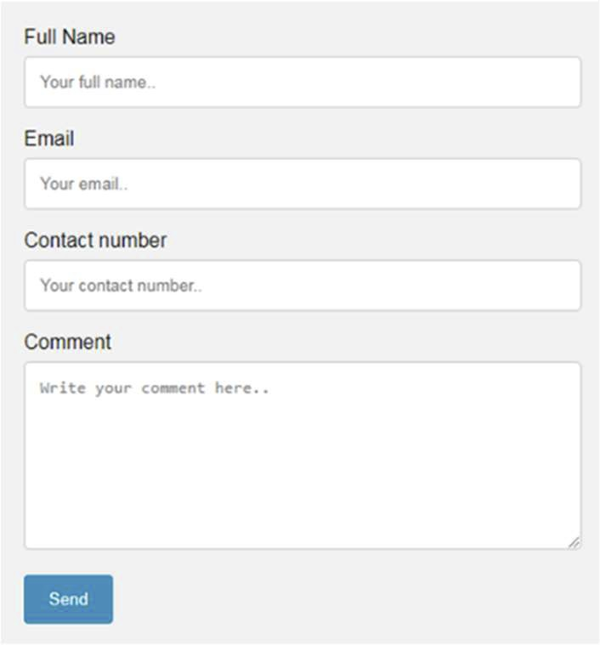

Home Assignment: Developing a responsive website

A sample of one game layout is as follows:

Question 4: Adding jQuery (KU3.2 - 12marks, AA1.1 - 12marks)

a) Within the Contact page you are required to include a contact form with at least 4 inputs; full name, e-  
mail address, phone number, and comments. Use jQuery to validate the inputs. Check that:

a. the Full Name input is not left empty or includes numbers

b. the Email address is not empty and is in proper email format

c. the Phone Number input is not empty or includes letters.

d. the comment section is not empty.

If any of the inputs are invalid, an error message must be shown. A sample layout of the contact form is shown as follows:

b) Within the Home page you are to make use of a free jQuery (or bootstrap) carousel plugin of your choice to create a carousel section having at least 6 images.

The carousel section must be styled to take 80% of the screen’s width and positioned in the center of the   
screen.

In your assignment document you must also include a reference to the website of the jQuery (or bootstrap) plugin you chose.

ITWEB-406-1501 - Website Design pg.4

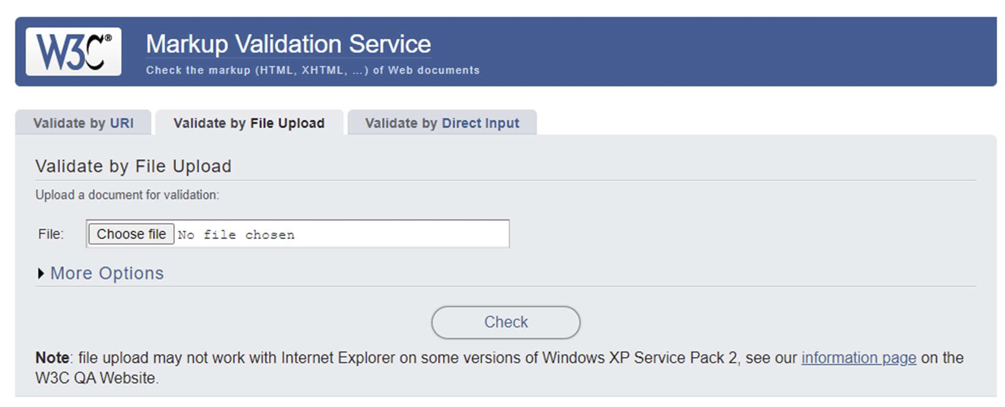

Home Assignment: Developing a responsive website

Question 5: W3C Markup Validation (KU1.2 - 5marks)

Use the HTML Validator found at <https://validator.w3.org/> and validate all the HTML files you created for   
your website.

From the results given by the HTML Validator, you are then to include a screenshot of any 2 errors found within your HTML files and explain exactly in which HTML page(s) they were identified.

Once you fix those 2 errors, you must re-validate those HTML files again and include a screenshot that those errors were not identified again by the Validator.

Question 6: Testing (AA4.1 - 10marks)

Using the below test case template, you are required to test 2 different features/functionalities of your choice in your website.

You need to recreate and fill in this test case template for each test case that you perform.

|  |  |  |  |  |  |
| --- | --- | --- | --- | --- | --- |
| Project: | |  | | | |
| Author: | |  | | | |
| Test Case number: | |  | | | |
| Test Case Title: | |  | | | |
| Test Case Description: | |  | | | |
| Steps  Performed | Expected  outcome | | Actual  outcome | Result (Pass/Fail) | Further  comments |
|  |  | |  |  |  |

(AA4.1 - 5 marks per complete/correct test case)

ITWEB-406-1501 - Website Design pg.5

Home Assignment: Developing a responsive website

Question 7 - Hosting (AA4.2 - 14marks)

Upload your completed website to a web hosting space such as:   
 • Heroku - [https://www.heroku.com](https://www.heroku.com/)

• Github - [https://github.com](https://github.com/)

• FreehostingEU - <https://www.freehostingeu.com/>

You are also to include:

• Screenshots of all the main steps required to upload the files to your chosen web host;

• A screenshot while browsing your homepage once uploaded;

• The full URL of your home page.

ITWEB-406-1501 - Website Design pg.6

Home Assignment: Developing a responsive website

Marking scheme

|  |  |  |  |
| --- | --- | --- | --- |
| Criteria | Marking structure | Maximum  mark | Mark  Awarded |
| KU2.5 (Q1) | Q1a: 3 marks for a proper proposal description  Q1b: 3 marks for proper colour choice  Q1c: 2 marks for each proper High-Fidelity wireframe design (2  marks each - 6 marks) | 12 |  |
| KU2.3 (Q2) | Q2a: all pages must match with the wireframe designs (3 marks each  - 9 marks)  Q2b: 3 different CSS3 properties should be used in creation of the  website and discuss them in the documentation (3 marks)  Q2c: Proper contents and styling using external stylesheet. (3 marks) | 15 |  |
| SE4.3 (Q3) | The Games page:  Q3a: At least 12 games included with an image each. (3 marks)  Q3b(i): Media Query for mobile viewport correctly implemented  (6marks)  Q3b(ii): Media Query for tablet viewports correctly implemented  (6marks)  Q3c: Play Now button added underneath each game, which when  clicked it should display a JavaScript alert “Thank you for playing  with us”. (5marks) | 20 |  |
| KU3.2 (Q4) | Q4a: The Contact page having a form with at least 4 validated inputs  using jQuery.  • 4 marks inputs created  • 4 marks validation of inputs  • 4 marks proper error messages displayed | 12 |  |
| AA1.1 (Q4) | Q4b: jQuery (bootstrap) carousel plugin correctly implemented  within the Home page and having at least 6 images. (8 marks)  The carousel section styled to take only 80% of the screen width and  positioned in the centre of the screen. (2marks)  Reference to the chosen jQuery (or bootstrap) plugin website also  included in documentation. (2marks) | 12 |  |
| KU1.2 (Q5) | Q5: 2 errors found and documented using the HTML Validator, and  fixed and re-validated again. (2.5marks for each error identified,  documented, fixed and re-validated). | 5 |  |
| AA4.1 (Q6) | Q6: 2 correct test cases performed and documented (5 marks each) | 10 |  |
| AA4.2 (Q7) | Q7: Website uploaded and screenshots of all the main steps  required to upload the files to a chosen web host are given  (10marks)  Screenshot of homepage once uploaded (2marks)  Full URL of home page given (2marks) | 14 |  |

Total Marks (out of 100): ______

ITWEB-406-1501 - Website Design pg.7