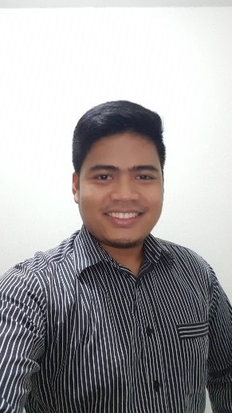Alexander V. Pangilinan

#7087 Unit 3 Quirino Street Brgy. South Cembo, Makati City, Philippines 1214

Contact number : (+63) 9274045717

Email Address: alexander.v.pangilinan@gmail.com

Objective: To secure a position with a stable and profitable organization, where I can be a member of a team and utilize my business experience to the fullest.

Personal Profile:

Birthday: August 30, 1989

Age: 28yo

Religion: Jehovah's Witnesses

Marital Status: Single

Mothers Maiden Name: Francisca B. Villaseñor

Fathers Name: Eustacio D. Pangilinan

Educational Background:

Tertiary:

University of the East (2009 - 2012)

Bachelor of Science in Computer Engineering(B.S COE)

Wesleyan University Philippines (2006 - 2008)

Bachelor of Science in Electronics and Communication Engineering(B.S E.C.E)

Achievements:

* ECE Licensure Examination passer
* ECT Licensure Examination passer

Skills Summary:

* Expert in Microsoft applications such as MS Word, MS Powerpoint, MS Excel
* Expert in Software Testing ( Manual and Automated )
* Intermediate in Programming Language ( c# )
* Proficient in English Language ( Written and Verbal )
* Expert in Functional Testing
* Intermediate in Oracle Testing
* Trained with Performance Testing
* Proficient in Agile Testing
* Expert in Automation Scripting using Selenium WebDriver
* Expert in Automation Scripting using Sikuli
* Experienced in Automation Scripting on Parasoft – SOA Test
* Experienced in Unified Functional Testing (UFT)
* Trained in Java Programming Language
* Trained in VBA Programming Language

Work Experience:

INFOR PSSC INC – Software Quality Assurance(Analyst level) (October 2017 – Present)

Business Address: 29th flr. Net Park bldg, 5th Ave, BGC Taguig, 1634 Metro Manila

Previous Projects and Roles

|  |  |  |
| --- | --- | --- |
| **Project** | **Role** | **Responsibilities** |
| Data Warehouse | * Functional Tester * Automation Tester | * Test design * Peer review * Execute test script on different Browser and Platforms * Logging defects * Report Team progress on weekly team meetings * Create Automation Framework using SikuliX in Eclipse * Create Automation Framework using Appium in Eclipse * Create Automation Framework using Selenium WebDriver in Eclipse * Create macro tools for QA used |

Accenture Phils., Inc – Software Automation Engineer (August 2013 – October 2017)

Business Address: 7th flr. Robinsons Cybergate 1 Pioneer Street, Mandaluyong City, Metro Manila 1554

Contact no: (02) 580 5888

Projects and Roles

|  |  |  |
| --- | --- | --- |
| **Project** | **Role** | **Responsibilities** |
| BPO Tool | * Manual Tester * Mobile Tester | * Test design * Peer review * Execute test script on different Browser and Platforms * Logging defects * Sending daily Team Status Report * Report Team progress on weekly team meetings |
| Telco services | * Agile Tester * Functional Tester * Automation(selenium) | * Test design * Peer review * Execution * Logging defects * Sending daily Team Status Report * Attend daily stand up meetings * Report team progress on weekly team meetings with the managers |
| Telco Products | * Agile Tester * Functional Tester * Mobile Tester * Automation(selenium) | * Test design * Peer review, Execution * Logging defects * Sending daily Team Status Report * Attend daily stand up meetings * Report team progress on weekly team meetings with the managers |
| Telco Middleware Test | * Automation Tester (ParaSoft SOA Test) | * Scripting * Peer review * Sending daily Team Status Report * Report Team progress on weekly team meetings |
| Data migration | * Automation Tester (HP UFT/QTP) | * Scripting * Peer review * Sending daily Team Status Report * Report Team progress on weekly team meetings * Create macro tools for QA used. |

Character References:

Dimple R. Masicap (+639179639702), Accenture

Jayzon De Leon (+639151430951), Accenture

ALEXANDER V. PANGILINAN