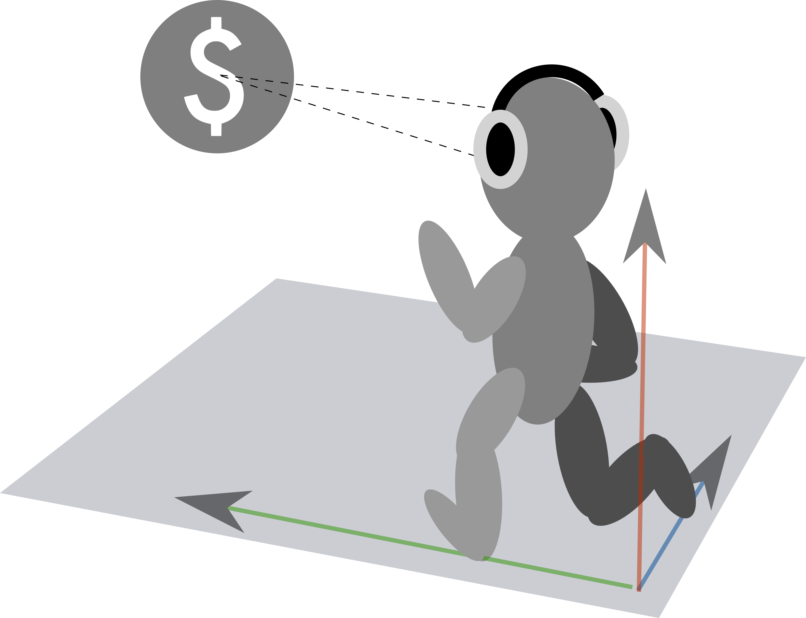

**Sound-guided running**

Using GPS and binaural audio in an exercise application

Bachelor of Science Thesis in Computer Science and Engineering

MARCUS BERNHARD

DANIEL JOHANSSON

JOAKIM JOHANSSON

LINUS KARLSSON

ANTON PALMQVIST