****

**Technical Report**

**On**

**Student’s Work Experience program 1 (SWEP 1)**

**Undertaken at Afe Babalola University, Ado-Ekiti,**

**Ekiti, Nigeria.**

**Written By**

**Akoh Jesse Godwin**

**18/ENG03/013**

**Submitted to, The Department of Civil and Water Engineering,**

**College of Engineering, Afe Babalola University, Ado-Ekiti, Ekiti State, Nigeria.**

**In Partial Fulfillment of Requirements for the Award of Bachelor of Engineering (B.Eng) Degree in Civil Engineering.**

**December, 2020.**

**CERTIFICATION**

This is to certify that this work was undertaken by Akoh Jesse Godwin (18/ENG03/013) of the department of Civil Engineering, at Afe Babalola University; under the supervision of Engr. Dr Emeka Nnochiri, with the report prepared and presented to the department of Civil Engineering, Afe Babalola University, Ado-Ekiti (ABUAD), Ekiti State, Nigeria, during the 2019/2020 Student Work Experience Programme 1 (SWEP 1).

**SUPERVISOR SIGNATURE & DATE**

**SIGNATURE AND DATE**

**HEAD OF DEPARTMENT**

**CIVIL ENGINEERING**

**DEDICATION**

This report is dedicated to my family; my Mother and Father for their unwavering support. My friends,Course Mates, Lecturers and the Department of Civil Engineering. Also my amiable Supervisor,Engr Dr Emeka Nnochiri and to all my colleagues who partook of the Internship program at the Campus Environs.

Akoh Jesse Godwin

300L

Civil Engineering.

**ACKNOWLEDGEMENT**

First above all, I give thanks to the almighty Allah who has given me life and provided me with the vast opportunities i befit from, to him alone I give praise and Honour.

My profound gratitude goes to Provost of the College of Engineering, Prof J.O Dada and the H.O.D of the Civil Engineering programme; Engr. Prof. S.A OLA.

Very special appreciation goes to the members of the academic staff of Afe Babalola University, Ado Ekiti, Ekiti State, Nigeria. My appreciation also extends to the never relenting lecturers of the Civil Engineering department for their aid in helping me execute this report successfully.

I express my special gratitude to my industrial supervisor Engr. Emeka, for the support, knowledge and guidance given to me all through my industrial training. And also,all my industrial colleagues and Instructors Mr Asanta S.P, Mr Benjamin H.A, Mr Omitokun E.O, Mr Audu J.O, Mr Paul Edoh and Mr Itamakinde H.A who put me through, during the period of this training.

Lastly I give thanks to my Parents Mr and Mrs Akoh for their Love and Support.

**ABSTRACT**

The Student Work Experience Program (SWEP) is an educational scheme set up by the Federal Government to expose second and third engineering students of tertiary institutions to practical skill acquisition relevant to their course of study as well as industrial experience. It avails students of universities and polytechnics the opportunity of being familiarized and exposed to the needed experience in handling machinery and equipment.

My 2019/2020 SWEP was undertaken at the premises of the Afe Babalola University premises, Ekiti State, Nigeria. Site studies on all round construction and design processes, site management, and the heavy maintenance Engineering, Water supply, electricity supply which runs on the Afe Babalola University Main campus were carried out during the process of this training.

The SWEP programme taught me about building processes, the workforce involved, materials used and the heavy engineering which the ABUAD campus runs on. It also exposed me to different machinery and equipment related to my field of engineering. Furthermore, it exposed me to various hazard to avoid while working on am Engineering Project, so as to prevent injury to myself, and avoid damage of the tools in use or the vehicle being repaired. It also gave me the opportunity to experience the hard work an engineer must put into his business, in order to achieve his required aim also learning about the importance of team work.

**TABLE OF CONTENTS**

**TITLE PAGE**

CERTIFICATION …………………………………………………………….…. i

DEDICATION …………………...……………………………………….... ii

ACKNOWLEDGEMENT.…………………………………………………... iii

ABSTRACT ………………….………………………………………………... iv

LIST OF FIGURES ………………………………………………………… vi

**CHAPTER ONE:**

**INTRODUCTION** ………………………………………………. 1

* 1. Background to SWEP ………………….……………………………… 1
  2. Objectives to SWEP ……………………………………………………. 1
  3. Log Book ………………………………………………………………. 2
  4. My SWEP program…………………………………………………….2

1.41 Safety equipment's and precautions……………………………………..2

1.42 Personal Protective Equipment………………………………….……… 3

* 1. Location………………………………………………………………… 3
     1. The Alfa-Belgore Hall…………………………………………………..3
     2. The Abuad Works department…………………………………………3
     3. The Abuad new Pharmacy Construction site…………………………. 3

**CHAPTER TWO:**

**LITERATURE REVIEW**……………………………….. **5**

2.1 Geotechnical Survey…………………………………………5

2.1.2 Parameters of a Geotechnical Survey……………………..6

2.1.3 Modern Tools of a Geotechnical Survey………………….7

2.1.4 Importance of a Geotechnical Survey………………………8

2.2+/:.2 Foundation Depth …………………………………………………..9

**2.2 LOAD CAPACITY**………………………………………………….8

2.2.1 Foundation Design………………………………………………….9

2.2.3 Foundation Materials…………………………………………………….10

2.2.4 Foundation Load Transfer…………………………………….12

2.3 Earthing………………………………………………………….13

2.4 Inspection Chamber………………………………………………..16

2.4.1 Septic Tank…………………………………………………………..17

2.4.2 Soakaway………………………………………………………………….18

**2.5 HVAC**………………………………………………………………………..18

2.5.1 HVAC system selection…………………………………………………21

2.5.2 BASIC COMPONENTS OF AN HVAC SYSTEM……………………22

2.5.3  CLASSIFICATION OF HVAC SYSTEMS…………………………23

2.5.4 HVAC SYSTEM REQUIREMENTS…………………………………..23

**2.6 CONSTRUCTION MATERIALS………………………………24**

**2.6.1** Materials for construction……………………………………….24

**2.6.2** Civil engineering machinery……………………………………….25

**2.7** Compressive test…………………………………………………………26

**2.8** Super structure and sub structure……………………………………29

**2.9.** POWER TRANSMISSION AND TRANSFORMERS…………..29

**CHAPTER THREE: ACTUAL WORKDONE**……………………………….31

**3.1** First Week of training…………………………………………………31.

**3.2** Second week of training………………………………………………33

**3.1.3** Third week of training……………………………………………….35

**CHAPTER FOUR: EXPERIENCE GAINED AND CHALLENGE ENCOUNTERED**………………………………………………………………..3**9**

**4.**1 Experience gained……………………………..39

**4.**2 Challenges encountered……………………….39

**CHAPTER FIVE: CONCLUSION AND RECOMMENDATION**……………41

**5.1** Conclusion…………………………………………………………………..41

**5.2** Recommendation……………………………………………………………..41

5.3 References……………………………………………………………………….43

**CHAPTER ONE**

**INTRODUCTION**

This report entails the activities and nature of the work done during the 2019/2020 Students Work Experience Program (SWEP) undertaken at Afe Babalola University, Ado-Ekiti, Nigeria.

* 1. **Background to SWEP**

SWEP similar to SIWES is a program established by the Federal Government to solve the problem of poor practical skills preparatory for employment in industries by Nigerian graduates of tertiary institutions.

The program was introduced for second- and third-year students of universities and polytechnics to enable them the opportunity to be conversant with opportunities of being familiarized to the required experiences in handling and operating industrial devices and machines which may not be readily available in tertiary institutions.

The program exposes students to industry-based skills necessary for a smooth transition from the classroom to the world of work.

* 1. **Objectives of SWEP**

The following are the objective of SWEP:

1. Provide an avenue for students in institutions in higher learning to acquire industrial skills and experience in their approved course of study
2. Bridge the gap between theoretical and practical knowledge in uplifting of the overall base knowledge of the students to be applied in real work situations.
3. Aid students in making career choices.
4. Prepare students for the industrial work situation, which they are likely to meet after graduation.
5. Diversify the practical experience and helps students in developing attributes of teamwork and correlation with members of other profession and disciplines.
6. Exposes students to work methods and techniques in handling equipment and machinery in their institutions and industries.
   1. **Log book**

This is a daily report writing which entails the routine work done and projects handled or executed, summary of the lessons learned. The log book was inspected, examined and signed by both the industrial based supervisor and the college-based supervisor.

* 1. **My SWEP Program**

I started my SWEP on the 13th of November. During this Period, I was posted to different locations around the campus, there I learned many things which mostly revolve about;

* Construction works
* Building design,
* Interdisciplinary approach between various disciplines and professionals site,
* Description and use of materials and equipment on site

**1.4.1 Safety Equipment and Precautions**

Safety can be described as the condition of being protected from or unlikely to cause danger risk or injury. It can be defined as the elimination or control of recognized hazard. Safety is accident prevention.

Maintenance is an activity for the upkeep of any equipment, for its safe and reliable operation through-out its useful life.

**1.4.2 Personal Protective Equipment**

The following includes the equipment worn to reduce rate or impact of accident at the site

1. Goggles for shielding the eye
2. Safety boot for foot protection
3. Overalls for body protection

.

* 1. **Location**

The SWEP internship program was undertaken at various sites and Engineering works stations around the Afe Babalola University Campus. The various places visited were;

* The Alfa-Belgore Hall Construction Site
* The ABUAD Works Department
* The ABUAD New Pharmacy Construction Site

**1.51 The Alfa-Belgore Hall Construction Site**

On this Location, there was an ongoing Construction/Refurbishment of the Universities multipurpose Hall. In this Location, various parts and site works were visited e.g the electrical and wiring, the drainage system, air-conditioning e.t.c

We visited the Ground and First Floors on which most of the training was done.

It is located in the heart of the campus premises of the Afe Babalola University,

**1.52 The ABUAD Works Department**

The ABUAD works department is where most of the maintenance engineering works, Water and Electricity supply and overall planning and supervision is carried out. On this location there was an inspection and survey of the power transmission lines, the earthing and water works.

**1.53 The ABUAD New Pharmacy Construction Site**

On this Location, there was an ongoing Construction of a new campus Pharmacy. The instructors, and supervisors took us through the construction processes involved, the machinery and the materials used.

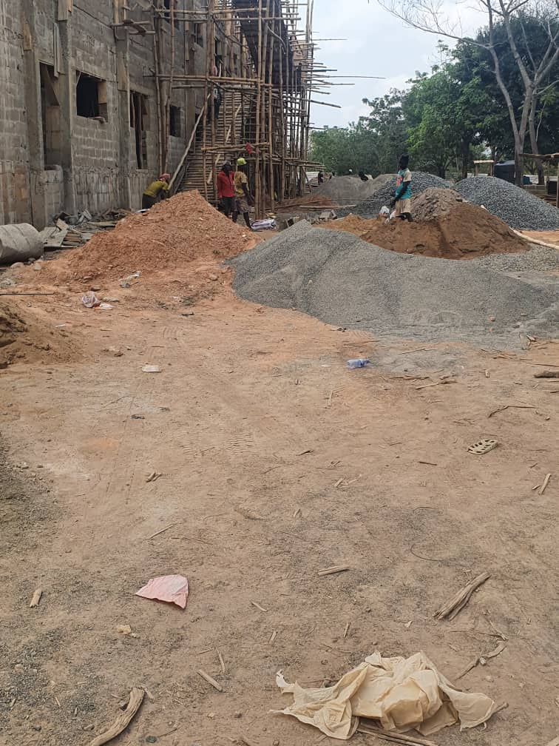

*Fig 1.1 The pharmacy Construction site*

**CHAPTER TWO**

**LITERATURE REVIEW**

2.1 GEOTECHNICAL SURVEY

A **Geotechnical survey** is the first step in the construction or consolidation of a site. It includes information about soil consistency and structure, groundwater level and recommendations for the technical project. Following the drilling, the samples collected from the ground are taken to the lab for analysis.

Based on these results and field observations, the geotechnical report is devised, which together with the drilling records represents the documentation that is delivered to the customer.

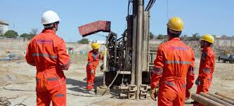

*Fig 2.1 Geotechnical survey being carried out*

Geotechnical investigations are executed by geotechnical engineers and geologists to acquire information regarding the physical characteristics of soil and rocks. The purpose of geotechnical investigations is to design earthworks and foundations for structures, and to execute earthwork repairs necessitated due to changes in the subsurface environment.

A geotechnical examination includes surface and subsurface exploration, soil sampling, and laboratory analysis. Geotechnical investigations are also known as foundation analysis, soil analysis, soil testing, soil mechanics, and subsurface investigation.

The samples are examined prior to the development of the location. Geotechnical investigations have acquired substantial importance in preventing human and material damage due to the earthquakes, foundation cracks, and other catastrophes. Geotechnical investigations can be as simple as conducting only a visual assessment of the site or as detailed as a computer-aided study of the soil using laboratory tests.

## **2.1.2** Parameters of Geotechnical Investigations

Geotechnical investigations are a vast discipline that can include geophysical methods, geologic mapping, and photogrammetry. A geologist is concerned with the soil conditions and determines the structure size that may be safe for the soil under examination.

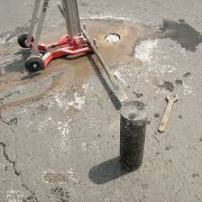

*Fig 2.2 Ground testing*

Geotechnical investigation may also disclose issues that may be difficult in an earthquake, like soil liquefaction. The investigations can also be utilized to find a formation like bedrock that can be able to support a structure in an earthquake. Soil examination is of great significance in the construction industry. It is conducted before the construction to prevent collapse of structure foundations. The nature of the soil and its bearing capacity is determined to establish the foundation stability. This is necessary since the structure foundation failures are almost permanent

## **2.1.3** Modern Tools of Geotechnical Survey

Geotechnical examination has progressed rapidly with the development of several other engineering disciplines. Thus, the investigations now are much more accurate and fast. Ground penetrating radar is being used that utilizes radar pulses for subsurface imaging. This is a non-destructive technique that uses the reflected electromagnetic radiations from the subsurface structures to acquire data for further analysis. Antennas are used for transmission and receiving of signals. The transmission antenna emits high

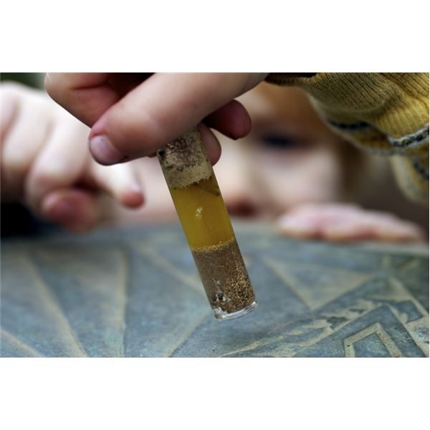

frequency pulses into the soil. The waves strike objects with unlike dielectric constants, and the data received is analyzed for variations detected in the return signal. The principles of reflection seismology are applied by using electromagnetic energy.

This process can be utilized in rocks, structures, pavements, fresh water, ice, and soil, to sense matter, material changes, cracks, and voids.

Engineering applications include discovering buried structures, identify landfills and contaminated areas. A Geographic Information System (GIS) is used that is mapping software for remote sensing, land survey, and photogrammetry.

**2.1.4** IMPORTANCE OF A GEOTECHNICAL SURVEY

Geotechnical investigations have acquired substantial importance in preventing human and material damage due to the earthquakes, foundation cracks, and other catastrophes. Geotechnical investigations can be as simple as conducting only a visual assessment of the site or as detailed as a computer-aided study of the soil using laboratory tests.

The purposes of a Geotechnical Investigation are to investigate the soil and geologic conditions of a property and to provide recommendations and design criteria for construction. The scope of a Geotechnical Investigation includes review of available literature; conducting on-site exploration, mapping/logging and sampling; and laboratory testing of samples obtained in the field. The collected data is analyzed and geotechnical criteria for foundations, retaining walls, site grading and site drainage are developed.

**2.2 LOAD CAPACITY**

The assessment of the soil bearing capacity under existing buildings depends on several factors, including the type of building, type of soil, etc. For example, the soil bearing capacity of light buildings constructed on granular soils can be assessed by

drilling a 100mm borehole near the building. Then the standard penetration test can be done within the borehole and the test results can be used to reassess the required bearing capacity. This helps the engineer know the maximum amount of load the can carry and helps construction engineers plan towards safe and stable economic design.

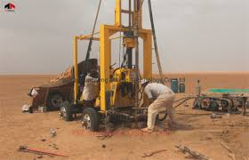

**2.2.1 FOUNDATION DESIGN**

Foundation design is the creation of a construction plan for a building foundation. It is a highly specialized function and usually performed by a structural engineer. The foundation is the structural base that stands on the ground and supports the rest of the building. Therefore, foundation design must involve extensive study of the ground below the foundation as well as the design and materials used on the foundation itself.

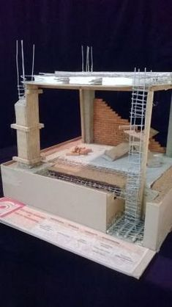

## 2.2.2 Foundation Depth

There are many types of building foundations. With the exception of slab-on-grade foundations, which are laid at ground level, most foundations may be installed at a variety of depths. The required depth of any foundation can depend on several factors:

* **Soil bearing capacity.** This determines how much load (weight or force) the existing soil can withstand.
* **Soil type.** Different types of soil have different properties that can affect their suitability for supporting a foundation.
* **Frost depth.** The depth to which the soil freezes in the coldest time of the year, known as the frost depth or frost line, often is used to determine the minimum depth for many types of foundations.
* **Groundwater table.** A high groundwater table can limit the foundation depth as well as the type of foundation that can be used. Groundwater height is usually included in a soil study.
* **Minimum depth.** Disregarding other factors, the minimum depth of a foundation typically is not less than 18 inches to allow for the removal of topsoil and variations in ground level.

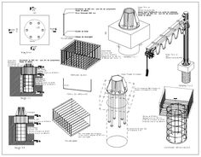

## 2.2.3 Foundation Materials

Foundations typically are built with masonry, such as concrete block or [brick](https://www.thebalancesmb.com/guide-to-brick-masonry-construction-844829), or with poured concrete. Masonry materials offer high compressive strength and are much more resistant to damage from moisture and soil than wood and metal materials. A masonry foundation typically extends above the ground to protect other building materials from moisture and other damaging effects of ground contact. Masonry foundations usually are reinforced internally with metal rebar or other materials. Contractors will often use [hydraulic cement](https://www.thebalancesmb.com/what-is-hydraulic-cement-uses-and-how-to-apply-845076) to seal around pipes or raceways that penetrate the masonry or concrete foundation.

Some building foundations are built with treated wood posts or piers. In this case, the foundation supports are driven deep into the earth and/or rest on rock or concrete pads. Posts and piers often are used when building on or near water or where the land is prone to flooding.

One of the most important foundation materials is the base, or subbase, of inorganic material laid directly under the foundation. In general, submerged soil and clay have limited bearing capacity and cannot handle the loads imposed by a building. Therefore, soils are dug away and replaced with a dry and uniform dense material, such as gravel or crushed stone that offers maximum shear resistance and bearing capacity. Base materials also promote drainage of subsurface water and do not expand with high levels of moisture, as soil does.

These materials are;

* Wood

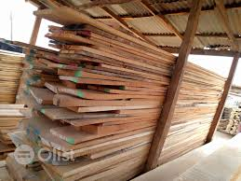

* Concrete Blocks

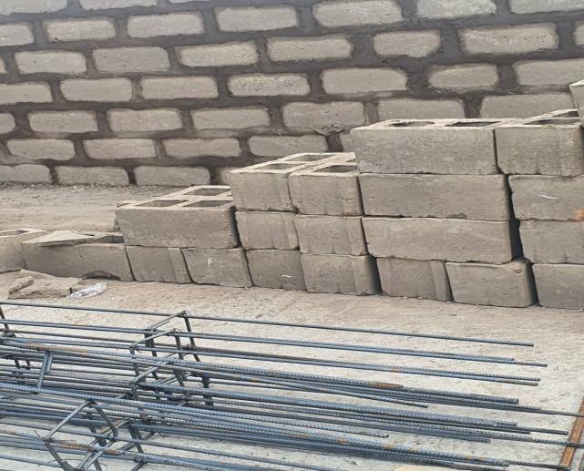

* Reinforced concrete

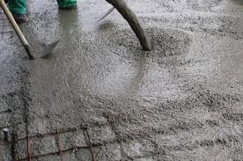

* Cement

## 2.2.4 Foundation Load Transfer

Foundations must be designed so that loads imposed by the building are transferred uniformly to the contact surface to transmit the sum of the dead load, live load, and wind load to the ground. The net loading capacity coming into the soil should not exceed the bearing capacity of the soil.

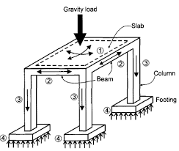

Foundation design also must take into account expected settling from the building to ensure that all movement is controlled and uniform to prevent damage to the structure. In addition, the [overall design of the foundation](https://www.thebalancecareers.com/top-best-paid-construction-jobs-4054066" \t "https://www.thebalancesmb.com/_blank), superstructure, and characteristics of the ground should be studied to identify potentially beneficial construction strategies.

**2.3 EARTHING**

Earthing or grounding is the process of transferring the immediate discharge of electricity directly to the earth plate, by means of low resistance electrical cables or wires. Earthing really is one of the most important aspects of electric networks, since it makes the most readily available and dangerous source of power much safer to use.

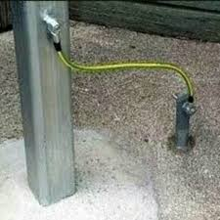

In case of a short circuit due to leakages arising from weak insulation or damage, the grounding wire safely removes excess electricity and passes it on to the ground where it lies dormant. All this happens without excessive complications, simply through ingenious and cheap construction, design and set-up!

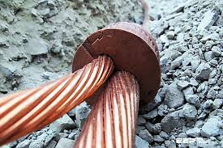

Some people have second thoughts about the need for grounding installation and extra construction electrical material, especially in large-scale residential or commercial projects. If you already use top quality equipment and perform constant maintenance, why would you need earthing?

The answer lies in the fact that life is unpredictable, and you should always prepare for the unexpected. The safety an earthing or grounding system provides comes simply, making your building and [electric boxes](https://www.dfliq.net/electrical-materials-products/electrical-boxes/) shock-free at a very low cost.

## **Benefits of earthing or grounding in an electrical system**

1. **Overload Protection**– In scenarios where excessive power surge occurs, a grounded system helps immensely. This simple form of surge protection can instantly save your electrical appliances and devices from getting fried by excessive electrical power, saving your data as well as equipment.
2. **Voltage Stabilization** – When it comes to calculating the right amount of power to be distributed between voltage sources, the earth provides that universal standard point of reference. Earthing takes the guesswork out of voltage stabilization, helping to ensure that no circuits overload or blow up

.

1. **Damage, Injury & Death Prevention** – Blown fuses or a tripped circuit breakers are far more welcome than electrical fires or shocks, which can pose serious safety hazards to people and property. Essentially, grounding protects against equipment, property and data loss, as well as injuries and fatalities!

## **Common Types of Earthing Used in Electric Construction Projects**

1. **Plate Type** – In a plate earthing system, components such as electrical wires, rods, pipes, plates and conductors are made of copper, cast iron or galvanized

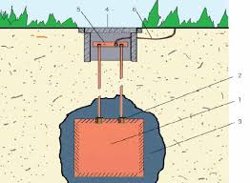

iron.A copper or iron plate that’s 2 feet square and .25 inch thick is buried in an earth pit, with bolts placed vertically and layers of salt and charcoal up to a certain level from the bottom of the pit. The depth at which the plate needs to be buried is usually around 8-10 feet from ground level.

1. **Pipe** **Type** – Because of its reliability, durability and easy of handling, pipe type earthing is often used in home and office electrical installations, transmission lines, etc. Also known as earthing electrode pipes, this is the most common and preferred earthing system type used in typical earth and   
   moisture conditions.

This kind of earthing also uses copper pipes, the length of which depends on the soil type and moisture content as well as current to be carried. The diameter of the pipe is usually 1.5 inches while the length can vary from 2.75 feet for rocky and dry soil to 15.5 feet. in moisture-rich soil.

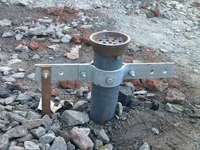

**2.4 INSPECTION CHAMBER**

An Inspection Chamber is a clean-out generally installed at the property line of a building. It allows the municipality or city to access the sanitary or storm sewers without disturbing the building owner.

The municipality or city can service the laterals to the building with cleaning equipment for blockages or they can camera the lateral for inspection purposes. An Inspection Chamber installed at the property line can indicate whether the blockage is on the building owner’s side or the city/municipality’s side and whose responsibility it is for cleaning.

Inspection Chambers can also be used for ‘sampling’ what is going through the lateral should the need arise to take samples.

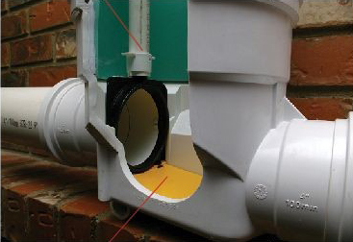

The Mainline Adapt-a-Valve Inspection Chamber is versatile in that it can be adapted to become an extendible backwater valve or can be used to pressure test the lateral or isolate the lateral if need be. The body of the Mainline Adapt-a-Valve Inspection Chamber has a special slot molded right into it that is designed to accept the backwater valve gate or the test/isolation gate.

**2.4.1 SEPTIC TANK**

A **septic tank** is an underground chamber made of concrete, fiberglass, or plastic through which domestic waste water ([sewage](https://en.wikipedia.org/wiki/Sewage)) flows for [basic treatment](https://en.wikipedia.org/wiki/Sewage_treatment) Settling and [anaerobic](https://en.wikipedia.org/wiki/Anaerobic_digestion) processes reduce solids and organics, but the treatment efficiency is only moderate (referred to as "primary treatment").

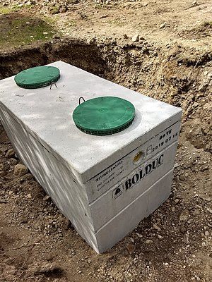

Septic tank systems are a type of simple [onsite sewage facility](https://en.wikipedia.org/wiki/Onsite_sewage_facility) (OSSF). They can be used in areas that are not connected to a [sewerage](https://en.wikipedia.org/wiki/Sewerage) system, such as rural areas.

The treated liquid effluent is commonly disposed in a [septic drain field](https://en.wikipedia.org/wiki/Septic_drain_field), which provides further treatment. Nonetheless, [groundwater pollution](https://en.wikipedia.org/wiki/Groundwater_pollution) may occur and can be a problem.

**2.4.2 SOAK AWAY**

A soakaway is simply a hole dug into the ground, filled with rubble and coarse stone which allows surface water to percolate back into the earth close to where it falls. As part of a full drainage system it is an efficient and low environmental-impact way of dealing with surface water (also called runoff, rain water or storm water). There will be a pipe leading into the soakaway, from the area where there is excess water, like a gutter from a roof, a driveway drain or a French drain.

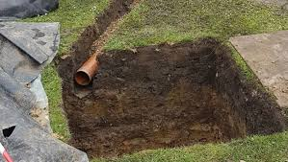

**2.5 HEATING, VENTILATION AND AIR CONDITIONING SYSTEM (HVAC)**

HVAC systems are milestones of building mechanical systems that provide thermal comfort for occupants accompanied with indoor air quality. HVAC systems can be classified into central and local systems according to multiple zones, location, and distribution.

Primary HVAC equipment includes heating equipment, ventilation equipment, and cooling or air-conditioning equipment. Central HVAC systems locate away from buildings in a central equipment room and deliver the conditioned air by a delivery duct work system.

Central HVAC systems contain all-air, air-water, all-water systems. Two systems should be considered as central such as heating and cooling panels and water-source heat pumps. Local HVAC systems can be located inside a conditioned zone or adjacent to it and no requirement for duct work. Local systems include local heating, local air-conditioning, local ventilation, and split systems.

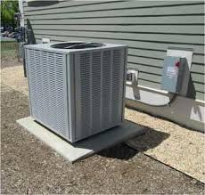

Heating, ventilation, and air conditioning (HVAC) system is designed to achieve the environmental requirements of the comfort of occupants and a process.

HVAC systems are more used in different types of buildings such as industrial, commercial, residential and institutional buildings.

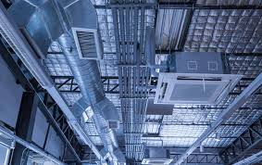

The main mission of HVAC system is to satisfy the thermal comfort of occupants by adjusting and changing the outdoor air conditions to the desired conditions of occupied buildings [[1](https://www.intechopen.com/" \l "B1)]. Depending on outdoor conditions, the outdoor air is drawn into the buildings and heated or cooled before it is distributed into the occupied spaces, then it is exhausted to the ambient air or reused in the system.

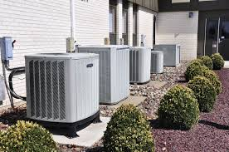

The selection of HVAC systems in a given building will depend on the climate, the age of the building, the individual preferences of the owner of the building and a designer of a project, the project budget, the architectural design of the buildings [[1](https://www.intechopen.com/" \l "B1)].

HVAC systems can be classified according to necessary processes and distribution process [[2](https://www.intechopen.com/" \l "B2)]. The required processes include the heating process, the cooling process, and ventilation process. Other processes can be added such as humidification and dehumidification process. These process can be achieved by using suitable HVAC equipment such as heating systems, air-conditioning systems, ventilation fans, and dehumidifiers.

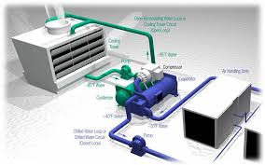

The HVAC systems need the distribution system to deliver the required amount of air with the desired environmental condition. The distribution system mainly varies according to the refrigerant type and the delivering method such as air handling equipment, fan coils, air ducts, and water pipes.

**2.5.1 HVAC system selection**

System selection depends on three main factors, namely;

* Building configuration,
* The climate conditions,
* The owner’s desire

The design engineer is responsible for considering various systems and recommending more than one system to meet the goal and satisfy the owner of a building. Some criteria can be considered such as;

* Climate change (e.g., temperature, humidity, and space pressure),
* Building capacity,
* Spatial requirements,
* Capital cost,
* Operating cost,
* Maintenance cost,
* Life cycle analysis,
* Reliability and flexibility.

**2.5.2 BASIC COMPONENTS OF AN HVAC SYSTEM**

The basic components or equipment of an HVAC system that delivers conditioned air to satisfy thermal comfort of space and occupants and the achieve the indoor air quality are listed below;

* Mixed-air plenum and outdoor air control
* Air filter
* Supply fan
* Exhaust or relief fans and an air outlet
* Outdoor air intake
* Ducts
* Terminal devices
* Return air system
* Heating and cooling coils
* Self-contained heating or cooling unit
* Cooling tower
* Boiler
* Control
* Water chiller
* Humidification and dehumidification equipment

**2.5.3**  **CLASSIFICATION OF HVAC SYSTEMS**

The major classification of HVAC systems is central system and decentralized or local system. Types of a system depend on addressing the primary equipment location to be centralized as conditioning entire building as a whole unit or decentralized as separately conditioning a specific zone as part of a building. Therefore, the air and water distribution system should be designed based on system classification and the location of primary equipment.

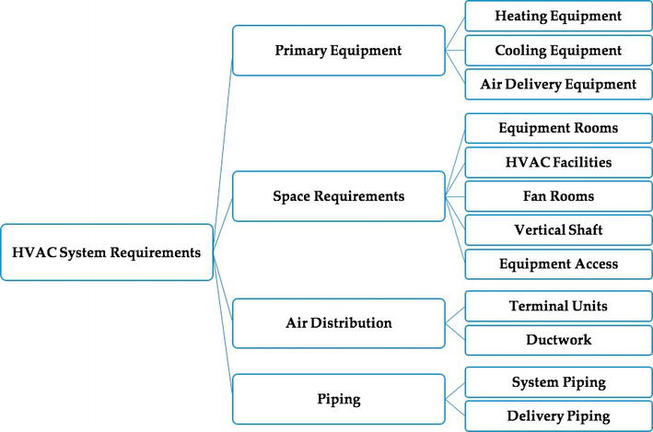

**2.5.4 HVAC SYSTEM REQUIREMENTS**

Primary equipment includes heating equipment such as steam boilers and hot water boilers to heat buildings or spaces, air delivery equipment as packaged equipment to deliver conditioned ventilation air by using centrifugal fans, axial fans, and plug or plenum fans, and refrigeration equipment that delivers cooled or conditioned air into space. It includes cooling coils based on water from water chillers or refrigerants from a refrigeration process.

Space requirement is essential in shaping an HVAC system to be central or local. It requires five facilities as the following:

Equipment rooms: since the total mechanical and electrical space requirements range between 4 and 9% of the gross building area. It is preferable to be centrally located in the building to reduce the long duct, pipe, and conduit runs and sizes, to simplify shaft layouts, and centralized maintenance and operation.

Fan rooms contain the HVAC fan equipment and other miscellaneous equipment. The rooms should consider the size of the installation and removal of fan shafts and coils, the replacement, and maintenance. The size of fans depends on the required air flow rate to condition the building, and it can be centralized or localized based on the availability, location, and cost. It is preferable to have easy access to outdoor air.

The piping system is used to deliver refrigerant, hot water, cooled water, steam, gas, and condensate to and from HVAC equipment in a direct, quiet and affordable way.

**2.6 CONSTRUCTION MATERIALS**

There are many types of building materials used in construction such as Concrete, Steel, Wood and Masonry. Each material has different properties such as weight, strength, durability and cost which makes it suitable for certain types of applications. The choice of materials for construction is based on cost and effectiveness to resisting the loads and stresses acting on the structure. As a structural engineer, I work with my clients to decide on the type of materials used in each [project](https://structuralengineeringbasics.com/what-kind-of-projects-do-structural-engineers-work-on/) depending on the size and use of the building.

**2.6.1 MATERIALS FOR CONSTRUCTION**

Stones, Bricks, Cement, Sand, Steel, Plaster of Paris, Lime, Paint and Varnishes and Timber are a few of the traditional materials that have been used in construction for several centuries

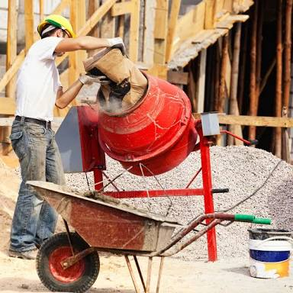

These materials include:

Concrete, Steel, Wood, Cement, Sand, Aggregates, Iron Reinforcements, Polymers, Rubber, Water etc

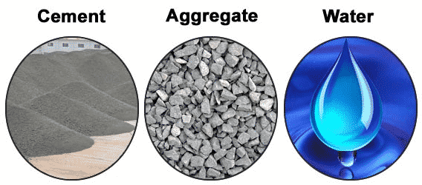

**2.6.2 CIVIL ENGINNERING MACHINERY**

There are several equipment that is been used in the Construction Industry. These are used for both large and small scale purposes. Various types of Equipment are been used for Building & structural Construction, Road construction, underwater and other marine construction work Power projects etc.There are various operations that are involved in construction projects , whether it’s a large scale or a small scale; Excavation and digging of large quantities of earth, Placement of construction materials (eg:-Bricks, concrete) Compacting and leveling, Dozing, Grading, Hauling etc…

Construction equipment can be categorized in to 4 main sections based on purpose and use, They are:

1. Earth Moving equipment
2. Construction vehicle
3. Material Handling Equipment
4. Construction Equipment

### 1. EARTH MOVING EQUIPMENT

1.1 [Excavators](https://basiccivilengineering.com/2015/04/use-of-excavator-in-construction.html" \t "https://basiccivilengineering.com/2015/04/_blank)  
1.2 [Graders](https://basiccivilengineering.com/2015/05/use-of-grader-in-construction-advantage.html" \t "https://basiccivilengineering.com/2015/04/_blank)  
1.3 [Loaders](https://basiccivilengineering.com/2015/04/use-of-loaders-in-construction.html" \t "https://basiccivilengineering.com/2015/04/_blank)  
1.4 [Skid loader](https://www.basiccivilengineering.com/2015/05/use-of-skid-steer-loaders-in.html" \t "https://basiccivilengineering.com/2015/04/_blank)  
1.5 [Crawler loaders](https://www.basiccivilengineering.com/2015/05/use-of-crawler-loader-in-construction.html" \t "https://basiccivilengineering.com/2015/04/_blank)  
1.6 [Backhoe](https://basiccivilengineering.com/2015/05/a-backhoe-also-known-rear-actor-or-back.html" \t "https://basiccivilengineering.com/2015/04/_blank)  
1.7 [Bulldozers](https://basiccivilengineering.com/2015/05/use-of-bulldozer-in-construction.html" \t "https://basiccivilengineering.com/2015/04/_blank)  
1.8 [Trenchers](https://basiccivilengineering.com/2015/05/use-of-trenchers-in-construction.html" \t "https://basiccivilengineering.com/2015/04/_blank)  
1.9 [Scrapers](https://basiccivilengineering.com/2015/05/use-of-scrapers-in-construction.html" \t "https://basiccivilengineering.com/2015/04/_blank)  
1.10 [Wheeled loading shovels](https://basiccivilengineering.com/2015/05/use-of-wheeled-loading-shovels-in.html" \t "https://basiccivilengineering.com/2015/04/_blank)

### 2. CONSTRUCTION VEHICLE

2.1 [Tippers](http://www.basiccivilengineering.com/2015/05/use-of-tippers-in-construction.html" \t "https://basiccivilengineering.com/2015/04/_blank)

2.2 [Dumbers](http://www.basiccivilengineering.com/2015/05/use-of-dumpers-in-construction.html" \t "https://basiccivilengineering.com/2015/04/_blank)

2.3 [Trailers](http://www.basiccivilengineering.com/2015/05/use-of-trailer-construction-vehicle.html" \t "https://basiccivilengineering.com/2015/04/_blank)

2.4 [Tankers](http://www.basiccivilengineering.com/2015/05/use-of-tanker-tank-truck-used-in.html" \t "https://basiccivilengineering.com/2015/04/_blank)

### 3. MATERIAL HANDLING EQUIPMENT

3.1 [Crane](https://basiccivilengineering.com/2015/05/use-of-crane-in-construction-advantage.html" \t "https://basiccivilengineering.com/2015/04/_blank)  
3.2 [Conveyors](http://www.basiccivilengineering.com/2015/05/use-of-conveyors-material.html" \t "https://basiccivilengineering.com/2015/04/_blank)  
3.3 [Hoists](https://basiccivilengineering.com/2015/05/use-of-hoist-in-construction.html" \t "https://basiccivilengineering.com/2015/04/_blank)  
3.4 [ForkLifts](https://basiccivilengineering.com/2015/05/use-of-forklift-in-construction.html" \t "https://basiccivilengineering.com/2015/04/_blank)

### 4.CONSTRUCTION EQUIPMENT

4.1 [Concrete Mixture](https://basiccivilengineering.com/2015/05/use-of-concrete-mixture-cement-mixture.html" \t "https://basiccivilengineering.com/2015/04/_blank)

4.2 [Compactors](https://basiccivilengineering.com/2015/05/use-of-compactor-in-construction.html" \t "https://basiccivilengineering.com/2015/04/_blank)

4.3 [Pavers](https://basiccivilengineering.com/2015/05/use-of-paver-in-construction.html" \t "https://basiccivilengineering.com/2015/04/_blank)

4.4 [Road Rollers](https://basiccivilengineering.com/2015/05/use-of-road-rollers-in-construction.html" \t "https://basiccivilengineering.com/2015/04/_blank)

**2.7 COMPRESSIVE TEST**

Compressive strength is the capacity of material or structure to resist or withstand under compression. The Compressive strength of a material is determined by the ability of the material to resist failure in the form cracks and fissure.

In this test, the push force applied on the both faces of concrete specimen and the maximum compression that concrete bears without failure is noted.

This is carried out with the aid of the universal testing machine

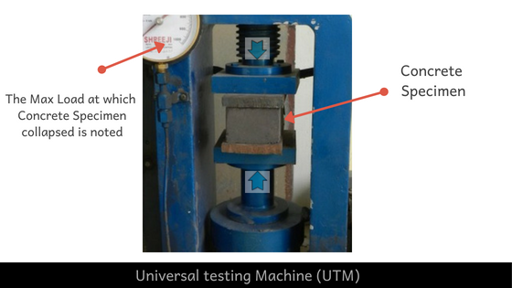

**2.8 SUPER STRUCTURE AND SUB STRUCTURE**

The two major components of buildings are the **substructure** and **superstructure**. The **substructure** is the part of the building that is underneath the ground, while the **superstructure** is everything that is above ground.

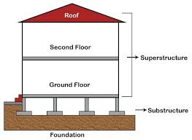

The **substructure** of a building transfers the [load](https://en.wikipedia.org/wiki/Structural_load) of the building to the ground and isolates it horizontally from the ground. This includes [foundations](https://en.wikipedia.org/wiki/Foundation_(engineering)) and basement [retaining walls](https://en.wikipedia.org/wiki/Retaining_wall).[[1]](https://en.wikipedia.org/wiki/Substructure_(engineering)" \l "cite_note-1) It is differentiated from the [superstructure](https://en.wikipedia.org/wiki/Superstructure).

A **superstructure** is an upward extension of an existing structure above a baseline

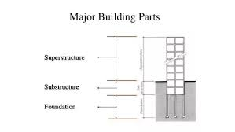.

**2.9. POWER TRANSMISSION AND TRANSFORMERS**

****Transformers**** are used to change one current into another current. Step up transformers increase the voltage of the current while step down transformers decrease the voltage. In ****power transmission****, which is power transmitted through wires over large distances, there is a power loss due to the resistance caused by ( I^2)R heating. In this process, step up transformers are needed to pump up the voltage using AC.

A **transformer** is a passive electrical device that transfers electrical energy from one electrical circuit to another, or multiple [circuits](https://en.wikipedia.org/wiki/Electrical_network). A varying current in any one coil of the transformer produces a varying [magnetic flux](https://en.wikipedia.org/wiki/Magnetic_flux) in the transformer's core, which induces a varying [electromotive force](https://en.wikipedia.org/wiki/Electromotive_force) across any other coils wound around the same core. Electrical energy can be transferred between separate coils without a metallic (conductive) connection between the two circuits. [Faraday's law of induction](https://en.wikipedia.org/wiki/Faraday's_law_of_induction), discovered in 1831, describes the induced voltage effect in any coil due to a changing magnetic flux encircled by the coil.

Transformers are most commonly used for increasing low [AC](https://en.wikipedia.org/wiki/Alternating_current) voltages at high current (a step-up transformer) or decreasing high AC voltages at low current (a step-down transformer) in electric power applications, and for coupling the stages of signal-processing circuits. Transformers can also be used for isolation, where the voltage in equals the voltage out, with separate coils not electrically bonded to one another.

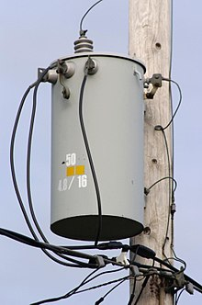

Since the invention of the first [constant-potential transformer](https://en.wikipedia.org/wiki/Constant-potential_transformer) in 1885, transformers have become essential for the [transmission](https://en.wikipedia.org/wiki/Electric_power_transmission), [distribution](https://en.wikipedia.org/wiki/Electric_power_distribution), and utilization of alternating current electric power.[[2]](https://en.wikipedia.org/wiki/Transformer" \l "cite_note-Bedell_(1942)-2) A wide range of transformer designs is encountered in electronic and electric power applications. Transformers range in size from [RF](https://en.wikipedia.org/wiki/Radio_Frequency) transformers less than a cubic centimeter in volume, to units weighing hundreds of tons used to interconnect the [power grid](https://en.wikipedia.org/wiki/Power_grid).

**CHAPTER THREE**

**ACTUAL WORK DONE**

**3.1 WORK DONE**

**3.1.1**

* + 1. **First Week Training**

I began my SWEP 1 internship program at the premises of the Afe Babalola university campus , and it lasted for a period of 3 weeks that is from 13th November, 2020 to 28th November, 2020. It was a really wonderful experience, as there was a lot of skill acquired and a lot of knowledge gained during this period.

I began my training, with an orientation on the do’s and don’ts which must be adhered to ensure safety of lives on site. Some of these works on site safety measures include;

1. Refraining from operating machinery without assistance from an authorized or skill personnel or worker
2. Wearing of Safety gear
3. Emergency management techniques in case of any site emergency.

I moved to the first floor of the Alfa-Belgore construction re-innovation project where I learnt about the geotechnical survey, which is the first and most important thing to embark on before a construction work.

And also how foundations are built and designed after the initial survey and leveling have been carried out and the personnel who carried it out, which are the geotechnicians and soil mechanics.

After there, I moved to the ground floor section where we tiled the walls of the ICT section in the Hall, I learned about the various materials used in the Tiling process which involved;

* Cement
* White Cement
* Water
* Sand, sharp sand
* Tiles
* Spacers

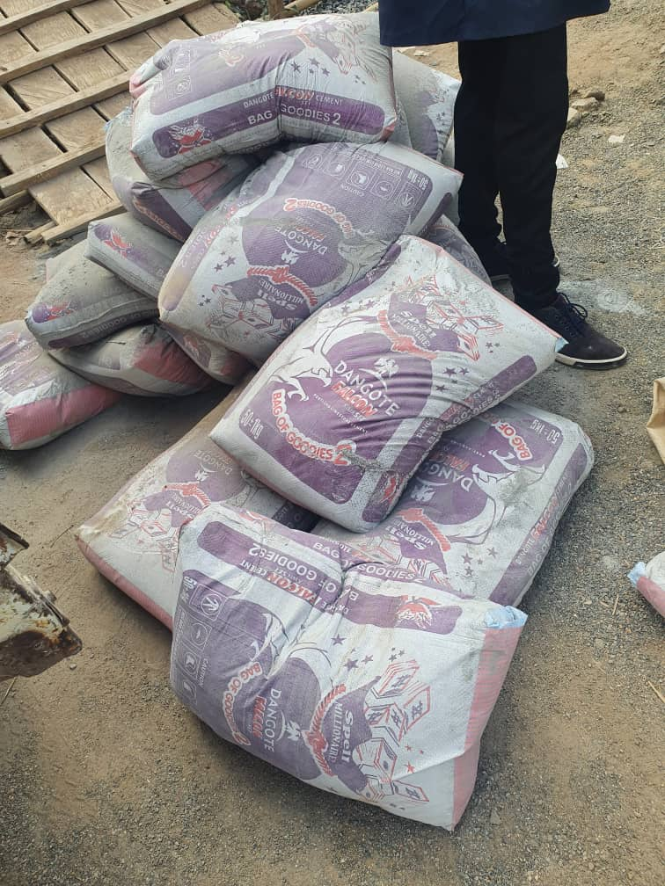

Then we went on to mix concrete paste for the rest of the tiling Job.

After that We went on to learning about the Earthing of a building and how armoured cables are used underneath the soil to act as neutral wire, I also learnt about the plumbing and drainage system of a building with regards to the inspection chambers, the septic tanks and the soak away pits. Plus their different functions in a building which are:

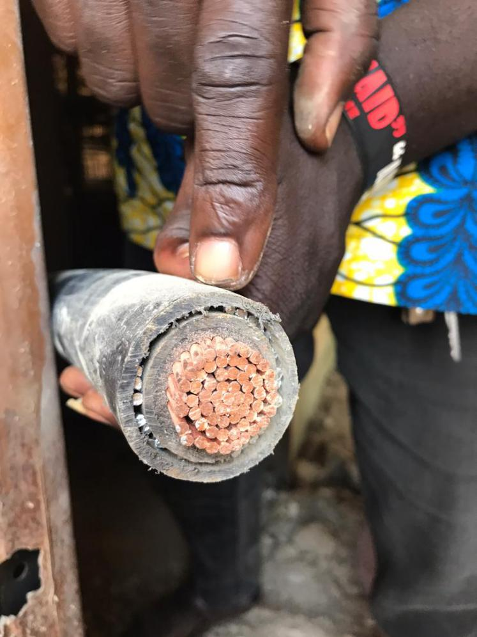

***Fig 3a, Armoured cables used for earthing***

Inspection chambers are access points to underground pipework which allow maintenance and the removal of blockages. While septic tanks are simply self-contained systems of tanks that are used to collect effluent and store solid waste and waste water. It's then stored within the tank until it overflows into either a drainage field, or a soakaway.

**3.1.2**

* + 1. **Second Week Training**

In the second week of the SWEP internship program, I was posted to the ground floor of the Alfa-Belgore re-innovation project. Under the supervision of Mr Obende and Dr Emeka Nnochiri. I learnt about the air conditioning and Ceiling of the Alfa-Belgore Hall.

Types of ceiling are:

* Asbestos
* Plaster of Paris (POP)
* Gypsum Board
* PVC

The type of ceiling used in the Alfa-Belgore project is the Plaster of Paris, the plaster of Paris is suspended with fillers and they are coated with white cement to make them firm. The air conditioning is screwed to the ceiling.

I also learnt about the reinforcements used in the project and of what sizes and materials they were and when they are appropriate for use.

In this Location we learnt how the horizontal metal supports that house the piping of the air ducts and water condenser of the Air conditioners and how they are fixed into their supports

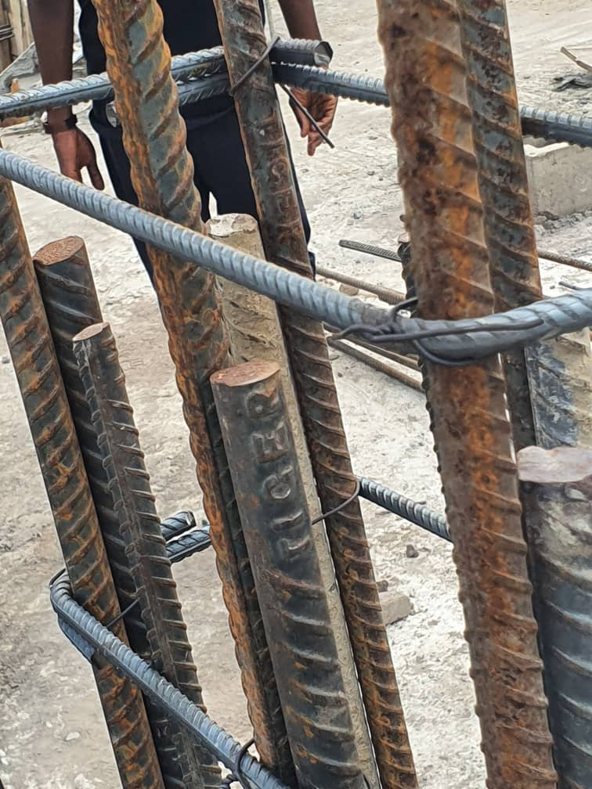

***Fig 3b, Iron Reinforcements***

**3.1.3**

* + 1. **Third Week of Training**

I continued my SWEP on the third week at the ABUAD NEW PHARMACY construction project, and the Abuad Works department.

At the Works department I learnt about the School’s water and power supply systems and the schools power transmission lines through cables and transformers.

The transformers step up and step down voltages coming from various distribution and generation plants across the region, the three cable lines each carrying voltage of 33KVA.

Then are supplied across the campus as connected by power towers (poles)

I also in the Works department learnt about the Water distribution and purification Processes and systems across the campus

Then at the ABUAD pharmacy construction site, as lead by our Coordinator Dr Engr Emeka Nnochiri we were taught about the members of the edifice and how they are erected, we also learnt how the materials are used in their proportions to construct.

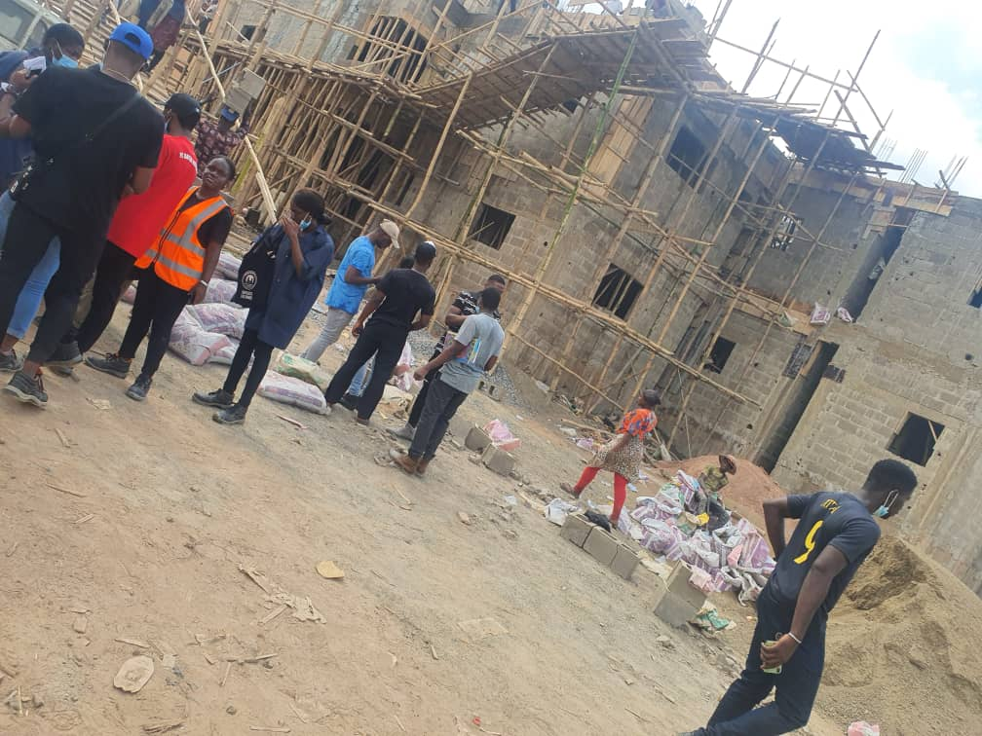

**CEMENT MIXING FOR SLAB GROUND**

In this Location, I learnt how the materials are proportionally mixed in erecting or constructing slabs in a structure. The materials include:

* Stone Dust (3 head pans about 75kg)
* A bag of cement (50kg)
* Coarse aggregates and water

It is made by mixing first Cement and the Stone dust, then leaving it open to add the coarse aggregates and water which is stirred quickly with the spade to avoid quick setting of the concrete.

Curing of concrete is defined as providing adequate moisture, temperature, and time to allow the concrete to achieve the desired properties for its intended use.

Workability of Concrete is a broad and subjective term describing how easily freshly mixed concrete can be mixed, placed, consolidated, and finished with minimal loss of homogeneity.

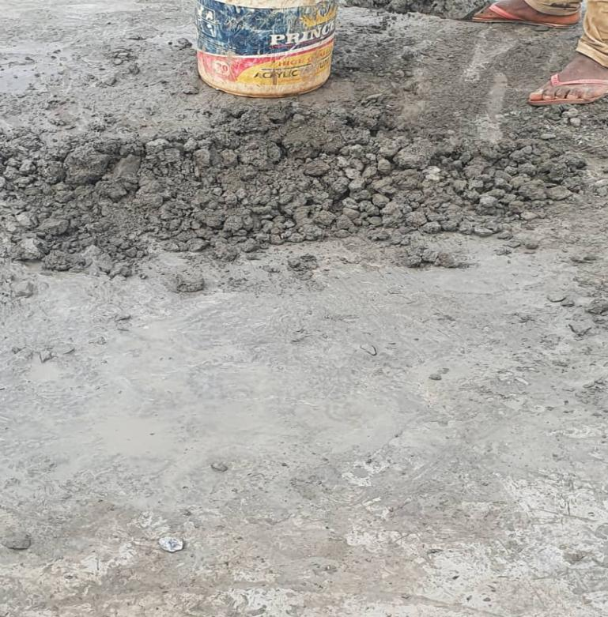

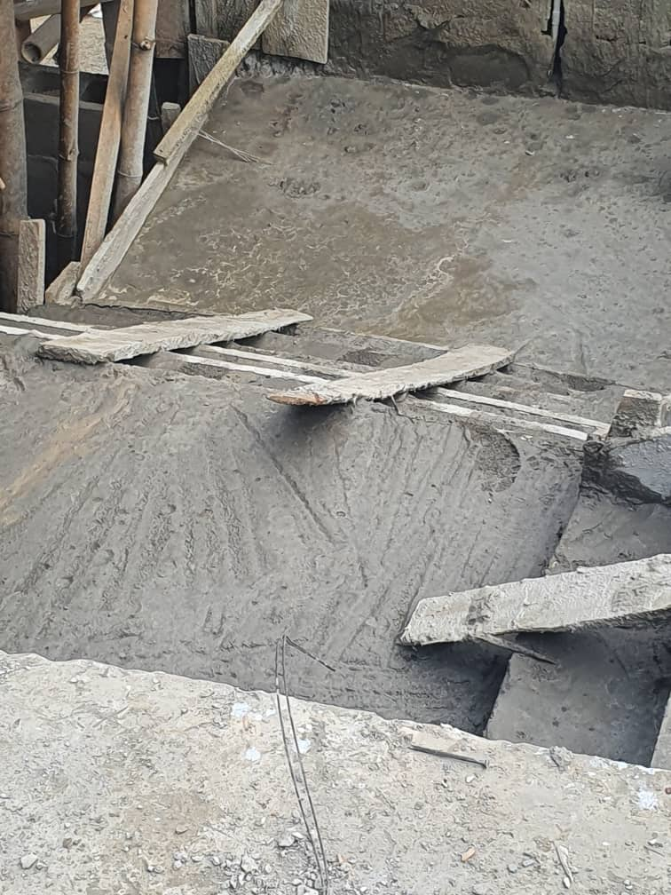

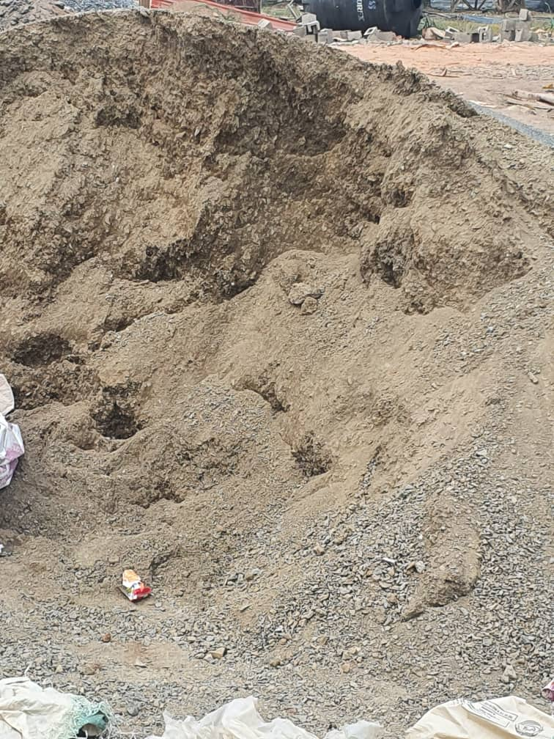

**Block Setting**

**Block setting** is act of **setting** a blocks,by using professional blub,lines with standard mortal ratio 1:5:6. The mortar bed is made of Cement without and sand (without stones). A spirit level is used to set the alignment of the blocks as they are being laid. Also a shocking cub and mortar on which the block is laid on the mortar bed.

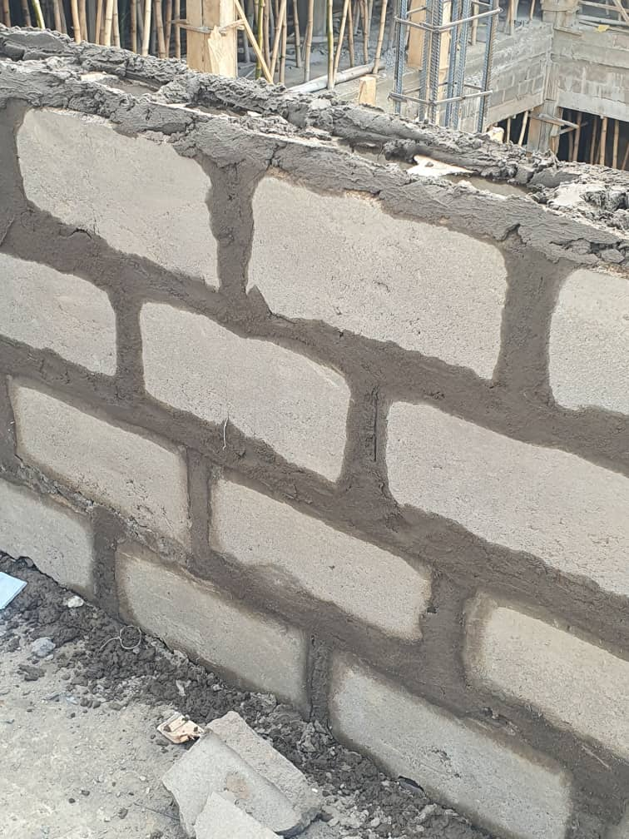

Then lastly I learned about the super structure and sub structure of the building, the sizes of the blocks and various sub materials used. The lintel, the windows, supports and types of foundations used in the construction of the Pharmacy

.**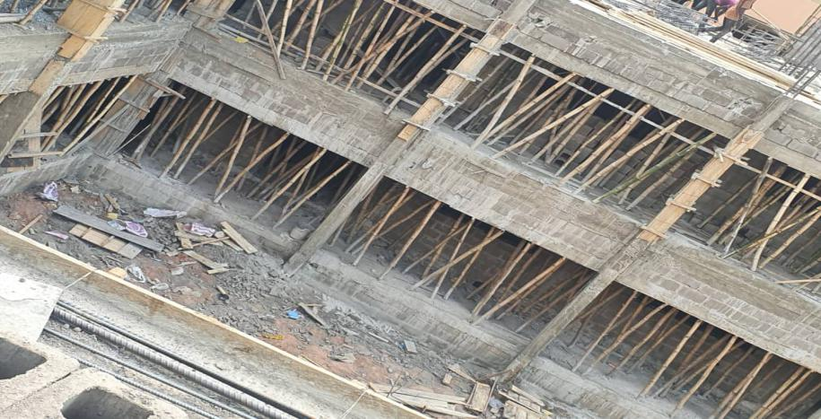**

**CHAPTER FOUR**

**EXPERIENCE GAINED AND CHALLENGE ENCOUNTERED**

**4.1 Experience gained**

There were a lot of experiences gained, during my 3 week IT at Afe Babalola University. Some of these experiences include;

1. Proper knowledge of the Site rules and regulations.
2. Proper knowledge on the operation of site materials.
3. Proper maintenance techniques of site power lines and transformers.
4. I learnt how to diagnose electrical faults
5. I learnt how to identify cables based on color and length
6. I learnt how to use distribution boards
7. I learnt how to mix construction materials in appropriate proportions
8. I learnt how loads affect edifices and how they are controlled using structural members which include beams, columns, slabs and foundations e.t.c
9. I learnt about Geotechnical survey and how they are carried out
10. I learnt how to tile walls and the materials used
11. Better exposure in terms of team work on projects.
12. Proper diagnosing procedures to identify foundation faults.

**4.2 Challenges encountered**

During the course of the course of the industrial training attachment program, a few challenges were encountered and noted:

Some of these problems are general and personal. Some of which include;

1. .Timing of the Programme as it clashed with some school work
2. In-ordinate communication of rescheduled meetings
3. I was sick during the third week of the programme

Asides the a fore-mentioned, there were no challenges faced as regards the SWEP programme was enriching and the experience I needed to pursue the career in the Civil Engineering profession.

**CHAPTER FIVE**

**CONCLUSION AND RECOMMENDATION**

**5.1 Conclusion**

In conclusion, the students work experience programme undertaken at the Campus premises of Afe Babalola University, Ado-Ekiti, Ekiti, was enlightening and helpful in the development of certain skills and understanding of certain aspects related to my course of study. It provided the necessary exposure to real work situation as well as the acquisition of industrial skills that are relevant to Civil engineering. It also enhanced self-development by improving problem solving and creative abilities by tasking both the mental and physical faculties which provided for the acquisition of new knowledge, skills, and experience.

With respect to the above mention, I believe that I have gained experience during my period of this industrial training. During the few weeks period of the work experience programme, there were practical exposure to the process of automobile servicing, repairs and maintenance.

**5.2 Recommendation**.

The following are my opinions and recommendations to the School as regards the SWEP program

1. The school should provide training workshops and programs which would help students gained more experience which would help the students gain more experience which would be relative to the their respective choice of professions.
2. The university should establish formidable industry partnerships to foster quick absorption of students into the workforce during internships and after graduation.

**5.3 References**

1. .https://en.wikipedia.org/wiki/Transformer
2. <https://www.ukseptictanks.co.uk/Septic-tank-Soakaway>
3. <http://spiff.rit.edu/classes/phys213/lectures/transform/transform.html>
4. <https://www.brightstorm.com/science/physics/magnetism/transformers-power-transmission/>
5. <https://en.wikipedia.org/wiki/Superstructure>
6. <https://en.wikipedia.org/wiki/Substructure_(engineering)>
7. <https://www.letsbuild.com/blog/substructure-superstructure>
8. <https://basiccivilengineering.com/2015/04/type-of-equipment-use-in-construction.html>
9. <https://civilread.com/compressive-strength-of-concrete-test/>
10. <https://www.civilengineeringforum.me/compressive-strength-test-of-concrete/#:~:text=Compressive%20Strength%20Test%20Idea%3A,placed%20in%20water%20for%20curing.&text=5%2D%20Divide%20failure%20load%20by,the%20compressive%20strength%20of%20concrete.>
11. <https://basiccivilengineering.com/2015/05/use-of-wheeled-loading-shovels-in.html>
12. <https://structuralengineeringbasics.com/what-types-of-construction-building-materials/>
13. <https://www.intechopen.com/>
14. <https://www.diydoctor.org.uk/projects/soakaway-water-drainage-system.htm>
15. <http://backwatervalve.com/products/inspection-chamber.html#:~:text=An%20Inspection%20Chamber%20is%20a,without%20disturbing%20the%20building%20owner.>
16. <https://www.dfliq.net/blog/earthing-important-electrical-construction-projects/>
17. <https://www.quora.com/What-are-the-benefits-of-geotechnical-survey>
18. <https://www.thebalancesmb.com/foundation-design-844472#:~:text=Foundation%20design%20is%20the%20creation,the%20rest%20of%20the%20building.>
19. <https://www.researchgate.net/post/How_to_evaluate_the_bearing_capacity_of_existing_buildings>
20. <http://www.qualitests.com/geotechnical-investigations/#:~:text=The%20purpose%20of%20geotechnical%20investigations,soil%20sampling%2C%20and%20laboratory%20analysis>
21. <https://link.springer.com/article/10.1007/BF03036539>
22. https://www.brighthubengineering.com/geotechnical-engineering/59657-geotechnical-surveys/.