Genie Installation Guide​‍‍​‌‍‌‌‍‍‌‌‍‌‌‌‍‍‍‍‍‌‍‍‍‌‍‌‌‌‌‍‌‌‍‌​
Every step explained, for Windows and Mac
This guide assumes nothing. Follow it top to bottom and you will go from a fresh computer to a working Genie studio. Where Windows and Mac differ, both paths are given. If anything goes wrong, the Troubleshooting section near the end almost certainly covers it, and the support group covers the rest.
What you need before you start
1. Your Genie Community Edition zip (it looks like
Genie_Community_*.zip). There is no license key: this edition is free.
2. A Claude account with Claude Code access (an Anthropic subscription that includes Claude Code). Genie's primary engine runs on it. If you also have a ChatGPT account, Genie can use its backup engine too, but you can start without one.
3. About 20 minutes. Most of it is waiting for automatic installs.
Step 1: Install Python (the only thing you install by hand)
Python is the small program that runs Genie's installer. Everything else installs itself later.
Windows:
1. Open your web browser and go to python.org/downloads.
2. Click the big yellow button that says Download Python 3.x.x.
3. Open the file it downloads (it is in your Downloads folder).
4. VERY IMPORTANT: on the first screen of the installer, tick the little checkbox at the bottom that says "Add python.exe to PATH". This one checkbox prevents almost every installation problem people have.
5. Click Install Now and wait for "Setup was successful", then click Close.
Mac:
1. Go to python.org/downloads and click Download Python 3.x.x.
2. Open the downloaded .pkg file and click Continue through the installer, then Install. Enter your Mac password when asked.
Check it worked: open a terminal (next step shows you how) and type
python --version (Windows) or python3 --version (Mac), then press Enter. If you see a version number like Python 3.12.x, you are ready.
Step 2: Extract your Genie delivery
1. Find the Genie_Community_*.zip file in your Downloads folder.
2. Windows: right-click it and choose Extract All..., then click Extract. Mac: double-click the zip and it extracts itself.
3. You now have a normal folder with the same name. Open it. You should see Start Genie.bat and a file called CLAUDE.md. If you see them, you are in the right place.
4. OPTIONAL BUT TIDY: move this folder somewhere permanent, like your Documents folder. Genie will live where you install it.
Step 3: Open a terminal IN that folder
The terminal is just a window where you type commands. You only need two or three commands, and this guide gives you every one exactly.
Windows (easiest way):
1. Open the extracted Genie folder in File Explorer.
2. Click once on the empty space of the address bar at the top (where the folder path is shown).
3. Type cmd and press Enter. A black window opens, already pointed at the right folder. That is your terminal.
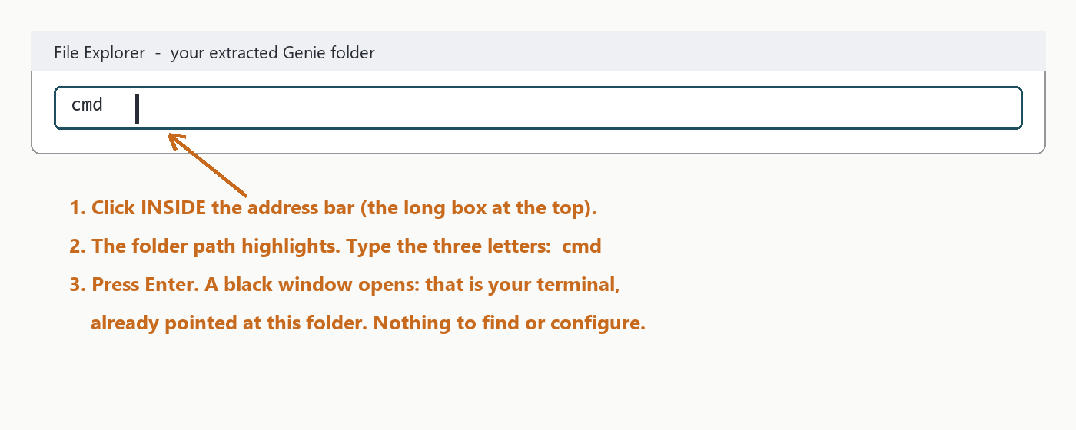
Opening a terminal from the File Explorer address bar
Mac:
1. Open the extracted Genie folder in Finder.
2. Right-click (or Control-click) the folder name in the path bar at the bottom and choose "Open in Terminal". (If you do not see a path bar: Finder menu, View, Show Path Bar.)
How the terminal works (60 seconds, worth reading once)
The black window always shows a line ending in > (Mac: % or $). That line is the prompt, and it tells you two things: which folder you are standing in, and that the terminal is ready. You type a command after the > and press Enter; the terminal does the work and answers on the lines below, then shows a fresh prompt.
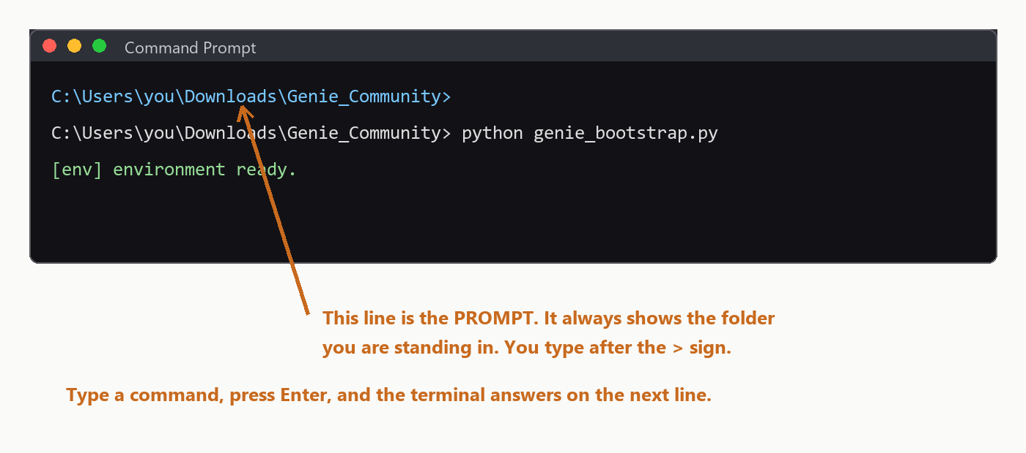
The prompt shows which folder you are in
Moving between folders: the `cd` command. cd means "change directory", and directory is just the old word for folder. It is the only movement command you will ever need:
• cd Genie moves you into a folder named Genie that is inside
your current folder. Watch the prompt: it now ends in \Genie, which is how you know it worked.
• cd .. (that is: cd, a space, two dots) steps you back out to
the folder above.
• cd followed by a full path jumps straight there from anywhere, for
example: cd C:\Users\you\Documents\Genie
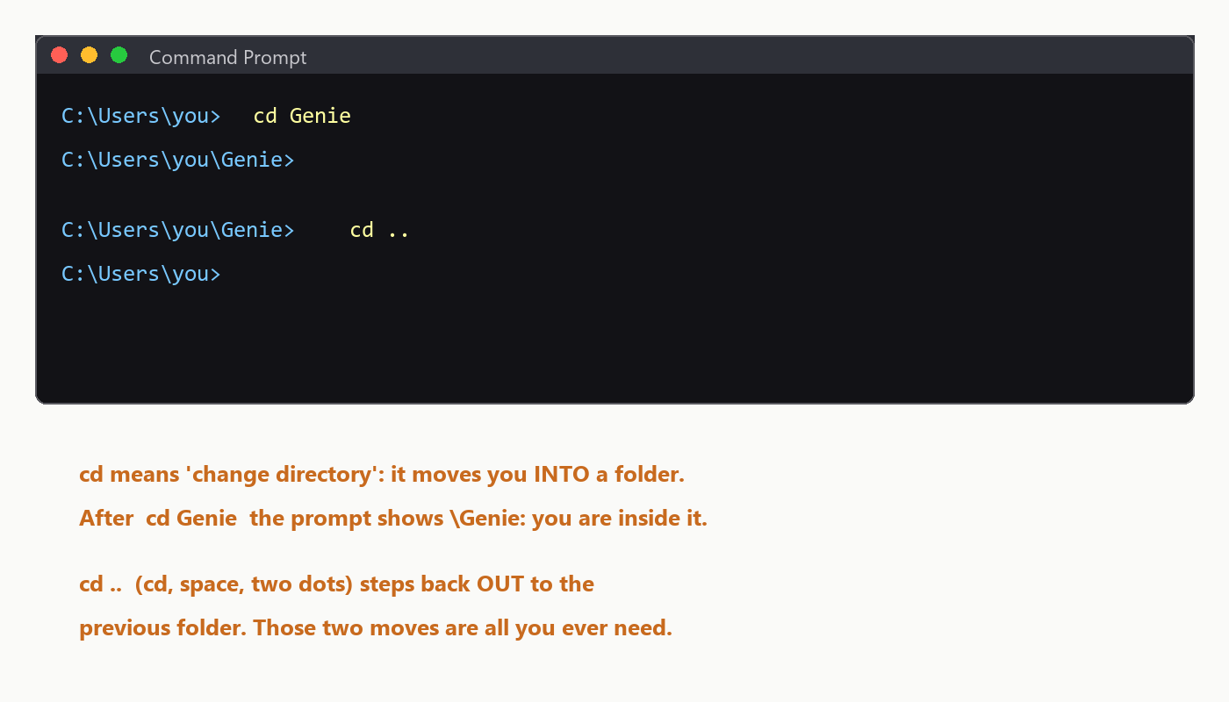
Moving in and out of folders with cd
The drag trick (easiest of all). You never have to type a path by hand: type cd, then ONE SPACE, then drag the folder from File Explorer (Mac: Finder) into the black window. The full path types itself; press Enter and you are inside. When this guide says "open a terminal in your Genie folder", this trick is the fastest way: open any terminal, type cd , drag the Genie folder in, press Enter.
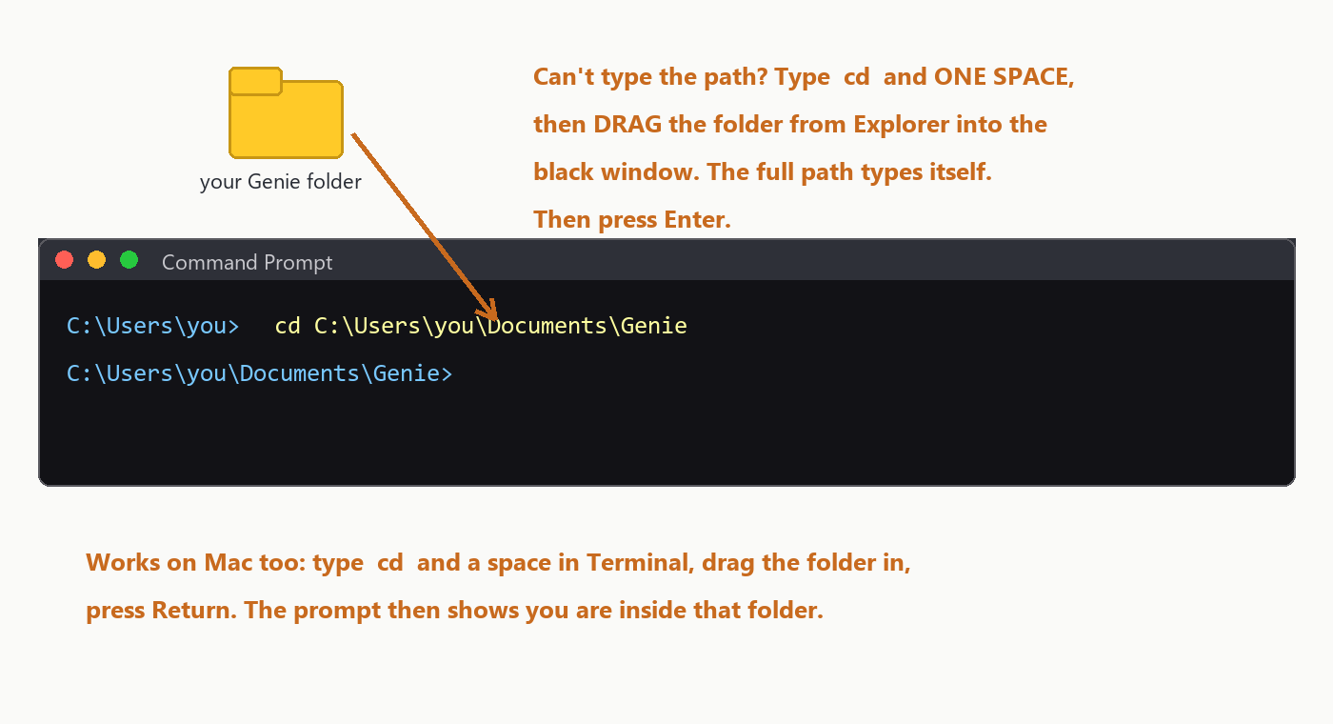
Type cd, a space, then drag the folder into the terminal
Two small comforts: the terminal never does anything until you press Enter, so you can look at what you typed first; and if a command ever prints something you do not understand, copy it into the support group and carry on. Nothing you type from this guide can break your computer.
Step 4: Nothing to activate
The Community Edition has no installer and no license key. The folder you extracted IS Genie. Keep the terminal open in that folder and go to Step 5.
Step 5: First start, where everything installs itself
1. In the terminal, move into the installed Genie folder with cd: type cd, one space, then either type the folder's location, or simply drag the Genie folder into the terminal window (the drag trick from Step 3), and press Enter. The prompt should now end in \Genie.
2. Type claude and press Enter.
• The very first time, your browser opens and asks you to log in to your Claude account. Log in once; it stays remembered.
• If the terminal says claude is not recognized, that is fine: it is not installed yet. Type Windows: python genie_bootstrap.py Mac: python3 genie_bootstrap.py and press Enter; the bootstrap installs it for you (next point), then type claude again.
3. The FIRST conversation: type "Genie, run the first-run setup" and press Enter. Genie now sets up everything by itself:
• installs the apps it needs (Node.js, the engine programs, Google Chrome if missing, and a free document converter if you do not have Microsoft Word). Windows may show a couple of permission pop-ups; click Yes;
• installs all its Python components;
• starts filling its design reference libraries in the background. You do not need to watch it. It reports when it is done, and it never needs doing again.
Step 6: Confirm everything works
Type: "Genie, standup"
Genie should introduce itself and give you a status report. That is your daily command from now on. If you got a standup, the core installation works. Three short linking steps remain (Codex, VS Code, and your browser); do them now while you are set up, then your first book is one message away: see the "Your First Book in 48 Hours" guide included in your Genie folder.
Step 7: Link Codex with Claude Code (Genie's second engine)
Claude Code is Genie's main engine. Codex (which runs on your ChatGPT account) is its second engine: Genie drives it automatically for cover art, A+ Content images, and as a backup writer. Linking the two takes two short commands, once.
1. Sign Codex in. In your terminal (any folder), type:
codex login --device-auth
and press Enter. It prints a web link and a short code. Open the link in your browser, type the code, and sign in with your ChatGPT account. When the terminal says you are logged in, Codex is ready. (If it says codex is not recognized, run the bootstrap from Step 5 first; it installs the Codex program.)
2. Let Claude Code use it. Open your terminal in the Genie folder, type claude and press Enter, and when Claude Code asks whether to allow the codex helper, approve it. Type /exit to leave. That approval is remembered.
3. That is the whole link. From now on, when Genie needs Codex (for example to generate a cover), it calls it in the background; you never open Codex yourself.
Step 8: Install VS Code with Codex and Claude Code (recommended)
VS Code is a free visual workspace. With both extensions installed you can talk to Genie in a side panel instead of a black terminal window, and Codex is available in the same place.
1. Install VS Code. Go to code.visualstudio.com, click Download, open the downloaded file, and click through the installer (next, next, finish). Mac: drag the app into Applications.
2. Install the two extensions automatically. Re-run the bootstrap once (in your Genie folder terminal: python genie_bootstrap.py, Mac python3). When VS Code is present it installs the Claude Code extension and the Codex extension for you.
• Manual fallback: open VS Code, click the Extensions icon in the left bar (four squares), search "Claude Code" (publisher: Anthropic) and click Install; then search "Codex" (publisher: OpenAI) and click Install.
3. Open your studio. In VS Code choose File, Open Folder, and pick your Genie folder.
4. Sign both in. Click the Claude icon in the left sidebar and log in with your Claude account; click the Codex icon and log in with your ChatGPT account (it may already be signed in from Step 7).
5. Talk to Genie in the Claude panel exactly as in the terminal: start with "Genie, standup".
Step 9: Connect your browser (two Chrome extensions)
Genie uses Google Chrome for live work: studying Amazon best sellers, pulling cover reference images, and generating art. Two extensions link your apps to the browser. Both are free and take a minute each.
A. The Claude extension (links Claude Code to Chrome):
1. Open Chrome and go to the Chrome Web Store (chromewebstore.google.com).
2. Search for "Claude" and pick the extension published by Anthropic (it is called Claude, sometimes shown as "Claude in Chrome").
3. Click Add to Chrome, then Add extension.
4. Click the puzzle-piece icon at the top right of Chrome, click the pin next to Claude so it stays visible, then click the Claude icon and sign in with the same Claude account you use for Claude Code.
5. Done: Genie can now browse with you, research niches live, and pull cover references from Amazon.
B. The ChatGPT extension (links your ChatGPT account to Chrome):
1. In the same Chrome Web Store, search for "ChatGPT" and pick the extension published by OpenAI.
2. Click Add to Chrome, then Add extension.
3. Click its icon and sign in with your ChatGPT account (the same one you used for Codex in Step 7).
4. Also open chatgpt.com once in Chrome and make sure you are signed in there and stay signed in. That signed-in tab is what lets Genie use ChatGPT's image engine in your browser when it designs covers.
C. While you are here, sign in once to the sites Genie works with:
• labs.google (Google Flow, a free image engine) with your Google
account;
• kdp.amazon.com (Amazon KDP) with your publishing account, and any
other store you publish to (IngramSpark, Draft2Digital, Kobo, Google Play Books, Barnes & Noble Press, Lulu). Genie never asks for or types your passwords; you sign in yourself, once, and the browser remembers.
Updating Genie later
When a new Community Edition zip is released, your books and settings all survive:
1. Save the new zip in your Downloads folder (no need to extract it).
2. Open a terminal in your Genie folder (Step 3).
3. Run python genie_update.py <path-to-the-new-zip> (Mac: python3), and it updates your existing install in place.
You never reinstall from scratch and never lose your work.
Troubleshooting
• "python is not recognized" (Windows): Python was installed
without the PATH checkbox. Re-run the Python installer from Step 1, choose Modify, and enable "Add python to environment variables". Then close and reopen your terminal.
• "command not found: python" (Mac): use python3 instead of
python in every command.
• The terminal opened in the wrong folder: type cd followed by a
space, then drag the Genie folder from Explorer/Finder into the terminal window and press Enter. That moves you into it.
• Permission pop-ups during first run: those are Windows asking to
install Node.js or Chrome. Click Yes. If you clicked No by mistake, run python genie_bootstrap.py again.
• Claude asks me to log in again: normal after a long time or a
password change. Log in and continue.
• `codex login` says command not found: run the bootstrap once
(python genie_bootstrap.py in the Genie folder), then try again.
• The Codex sign-in link expired: just run
codex login --device-auth again; a fresh code is issued each time.
• Cannot find an extension in the Chrome Web Store: check the
publisher name (Anthropic for Claude, OpenAI for ChatGPT). Names and icons change now and then; the publisher is the reliable marker.
• Genie says the browser is not connected: open Chrome, click the
Claude extension icon, and make sure it is signed in; then try again in the same session.
• A step failed and Genie mentioned a "blocker": Genie keeps
working around it and will retry. If it persists, copy the exact message into the support group.
Support
Post in the Genie WhatsApp support group. Join here (also linked in your welcome email):
https://chat.whatsapp.com/B7VyRrEM9fp7jkzzvSRJIj
Say which pack you have (Starter / Pro / Max), which step you are on, and paste the exact message you see. Screenshots help.
Welcome to Genie. Your studio is ready. ​‍‍​‌‍‌‌‍‍‌‌‍‌‌‌‍‍‍‍‍‌‍‍‍‌‍‌‌‌‌‍‌‌‍‌​

