Engs 31 / CoSc 56
Lab 3: Stopwatch
To be completed in lab during the week of April 26.
Learning objectives
1. How to combine a controller (state machine) with a datapath (in this case, a counter)
2. Continue to develop skill with modular design, construction, and testing.
3. Continue to develop skill with the oscilloscope.
4. Continue to develop your communication skills in digital electronics.
This lab is your first “big” system, with both a datapath (counters and display) and a controller (buttons and a state machine). It will be manageable because you already know a lot about counters and have already thought about the state machine, in class. We will walk you through the design process in the prelab and in-lab steps. In Labs 4 and 5, we will leave it up to you to follow the design process without detailed guidance. As you go along, make sure that you understand each design step and could explain it to someone who has not read this laboratory sheet.
For figures:
- Figures in this class will be primarily used as a communication tool. When you are asked to annotate a diagram or a waveform, do so in a way that an engineer unfamiliar with the design could look at your figure and quickly identify the important parts of the schematic or waveform.

In the LAB:
Part I: Component Design and Validation
There are four steps in this first section of the lab. Read all the way to the end before starting. This week’s deliverables will be handled a little differently. There will be a deliverable for each section. In each section you will design a new component of the lab. Rather than submitting each deliverable in a template form, you will be asked to write a short report that provides context for the screenshots you acquire.

Each new component you want to simulate should be its own project, which you should create a directory for in your O: drive under your lab 3 folder. Do not try to import and simulate all the components in a single project.

0. Debugging Log
Last week you should have begun a debugging log. Each entry into your log should include a description of the problem encountered (the error message, warning, description of incorrect hardware behavior, etc.) and what you did to remedy the problem. You can format this however it will be the most helpful for you, but you must keep this live documented updated and include it in the submission of each laboratory exercise. Vivado error messages are often cryptic and having a list of what you have done in the past is often invaluable and saves you time.

Deliverable 0: Debugging Log
- Include in your report your most current draft of your debugging log as an appendix at the end.

Error:
1.[HDL 9-806] Syntax error near “process” [bcd_digit.vhd:48]
2.[HDL 9-806] Syntax error near “reset” [bcd_digit_tb.vhd:59]
3. counting down was not wrapping up to 9 after reaching zero
4.[HDL 9-806] Syntax error near “end” [lab4_core_tb.vhd:91]
5. “No actual specified local port “reset” [top_level.vhd 25] (this was in EDA playground)
Solution:
1.Looked at the line(s) near /on line 48. This was an issue of a semi-colon. This was fixed by putting the semi-colon.
2.This was an error in the port map of the testbench. There was a missing comma after clk=>clk before reset => reset.
3.Made a condition that handles this. When count is zero and we are counting down, we wrap around to 9.
4. Was missing an extra “end if;”.
5. The simulation for the test bench lacked these signals.

1. BCD counter
In Lab 2 you designed, simulated, and implemented a four-bit decade counter (bcd_digit) with control inputs reset, CE (count-enable), and up/down, and an output called TC (terminal count).

For this lab, you won’t need the up/down functionality; we will see later how to “wire” the counter to only count up. Leave the up/down functionality in the design.

Modify the TC logic so that TC is true when uy=9 and CE=1, and false otherwise. That is, even if the count is 9, TC is not asserted unless the counter is also enabled. If the counter is halted while it is at 9, TC will go low until the counter is restarted.
After making this change, modify your Lab 2 bcd_digit testbench accordingly and resimulate the design to verify it is working correctly.

Deliverable 1:
- Turn in a copy of your simulation waveform, showing important features.
When making figures, imagine that you will be using the figure to explain an important concept to someone. This figure should make it easy to see that your design is working well.

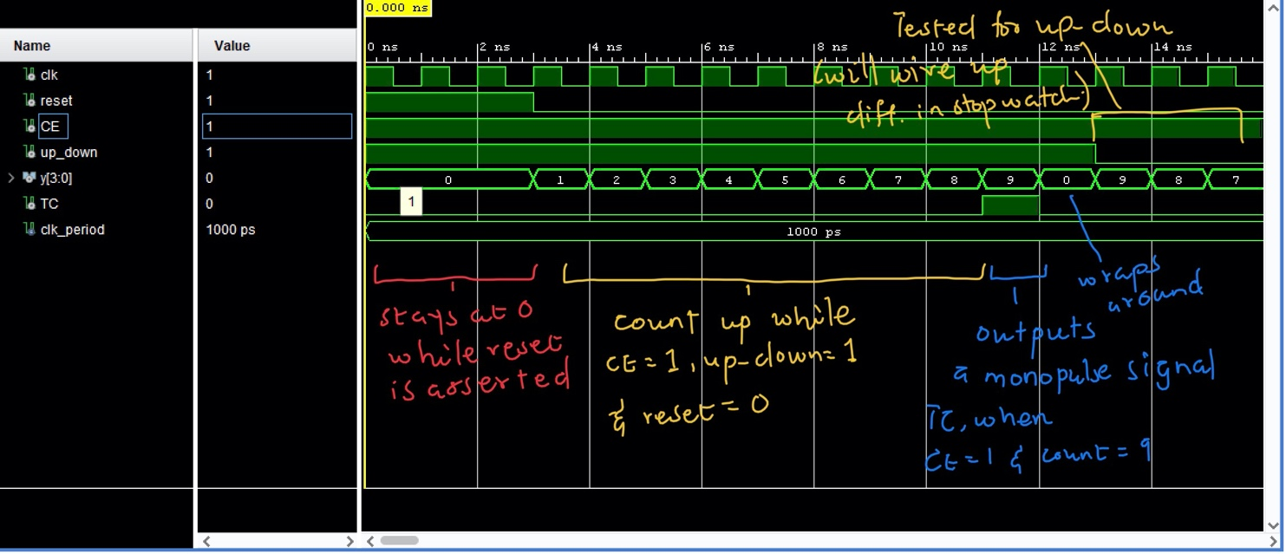

2. Multi-digit counter
Counters may be combined to make a multi-digit BCD counter. As shown in the block diagram above, the CE of the least significant digit is connected to the run/stop signal. The TC of that digit is connected the CE of the next higher digit, and so forth.

The tens digit is enabled by the TC output of the ones digit. As designed in the previous step, the TC output of the ones digit is asserted when the ones counter is enabled and its count 9. In turn, the ones counter is enabled when the tenths counter is enabled (by run/stop) and its count is 9. Taken together, the tens digit will increment when run/stop is asserted and the count of all three digits is 09.9, 19.9, 29.9, etc. Think about this until you are convinced.

Deliverable 2:
- Turn in a copy of your simulation waveform, showing important features.

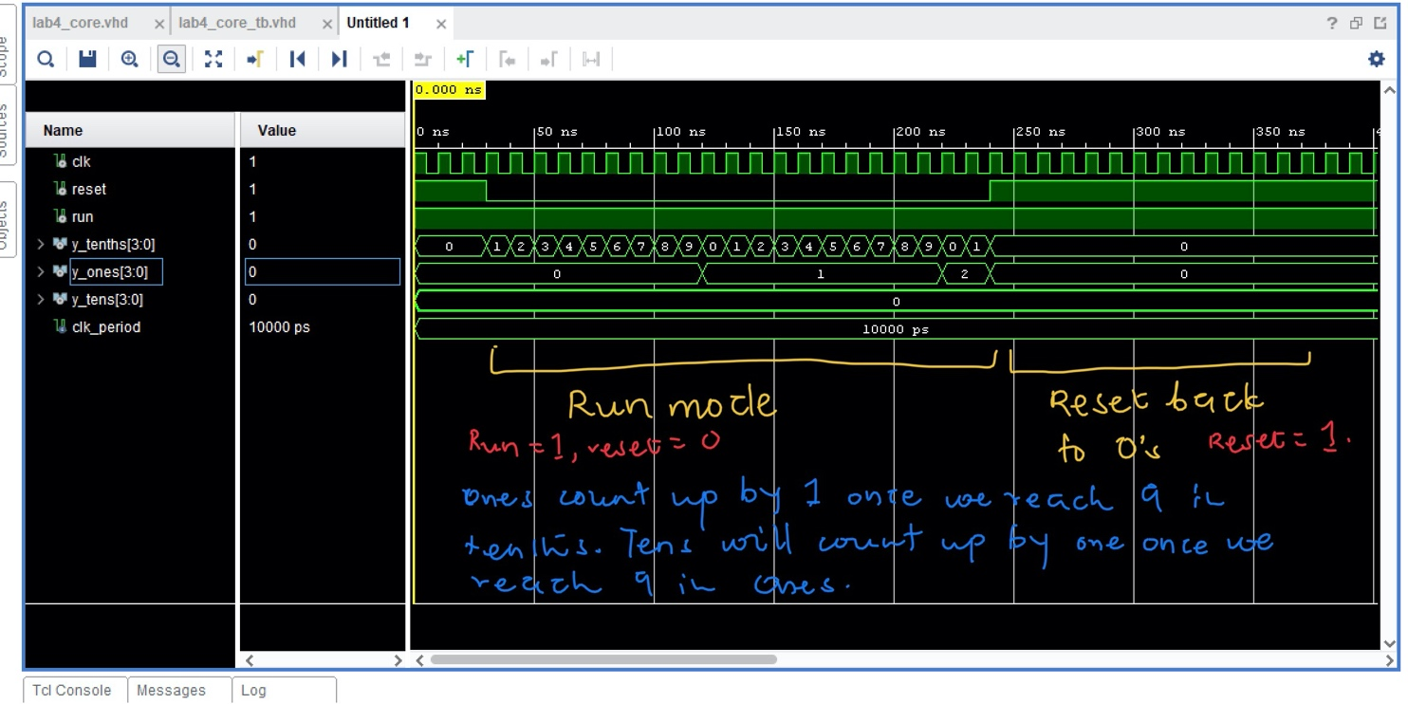

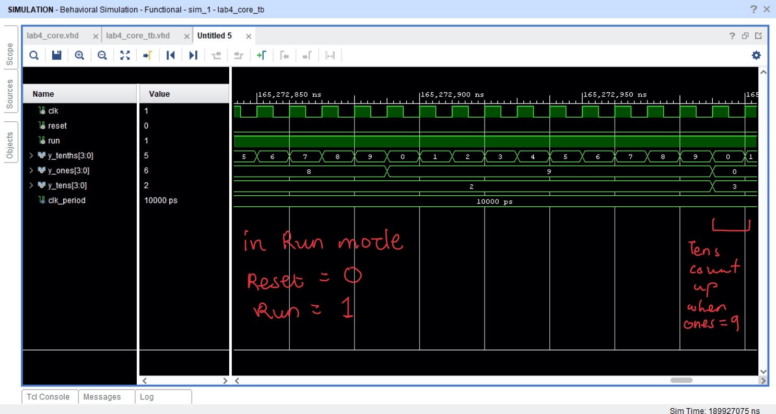

- Display

One of the in-class exercises is to design a multiplexed seven-segment display. We will provide a display decoder in lab3_shell so that you don’t have to validate your own design.
We do not, however, provide you with the hardware to acquire and display a split time. The solution is not difficult, but you must figure it out yourself. Before you begin coding, make a high level (read: simple) block diagram for this component.

Modify lab3_core.vhd to include the split time logic; a port called split is already in the entity, commented out. Modify your testbench to confirm that the split time logic works correctly.
Deliverable 3:
1. Turn in a copy of your block diagram.
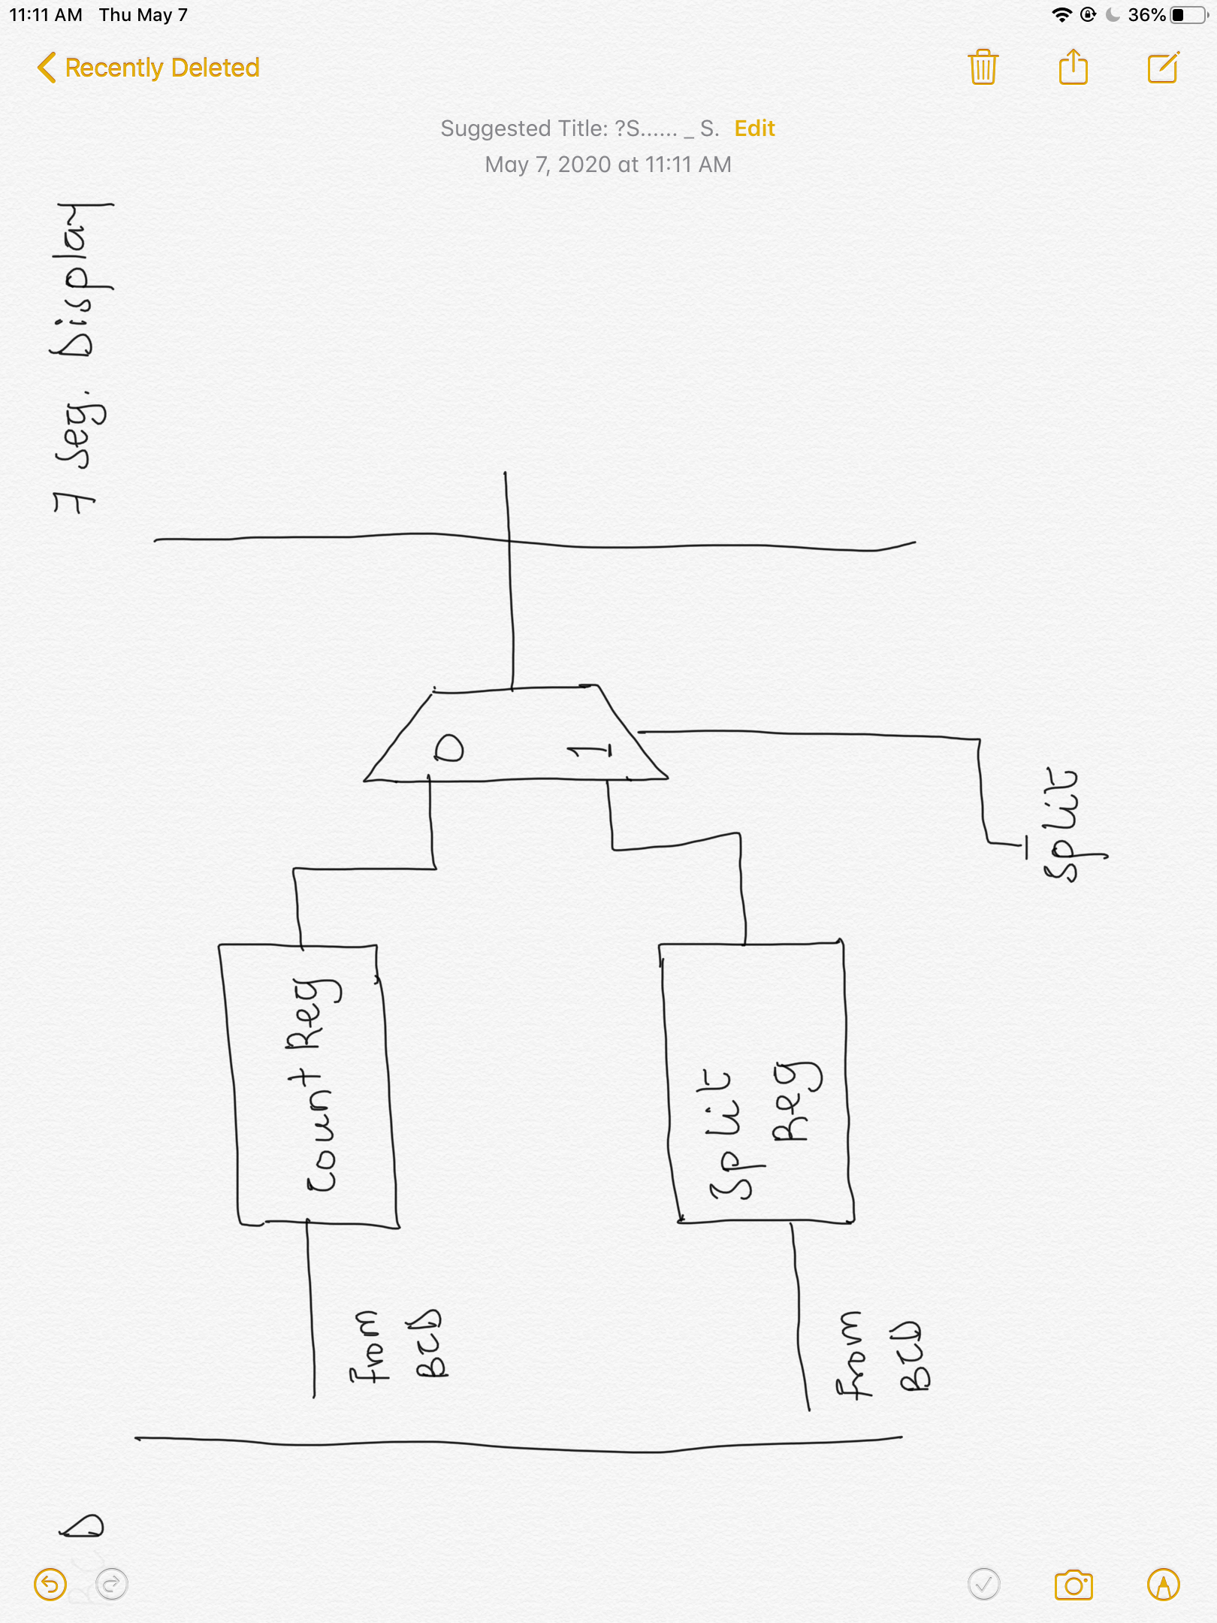

- Turn in a copy of your simulation waveform, showing important features.
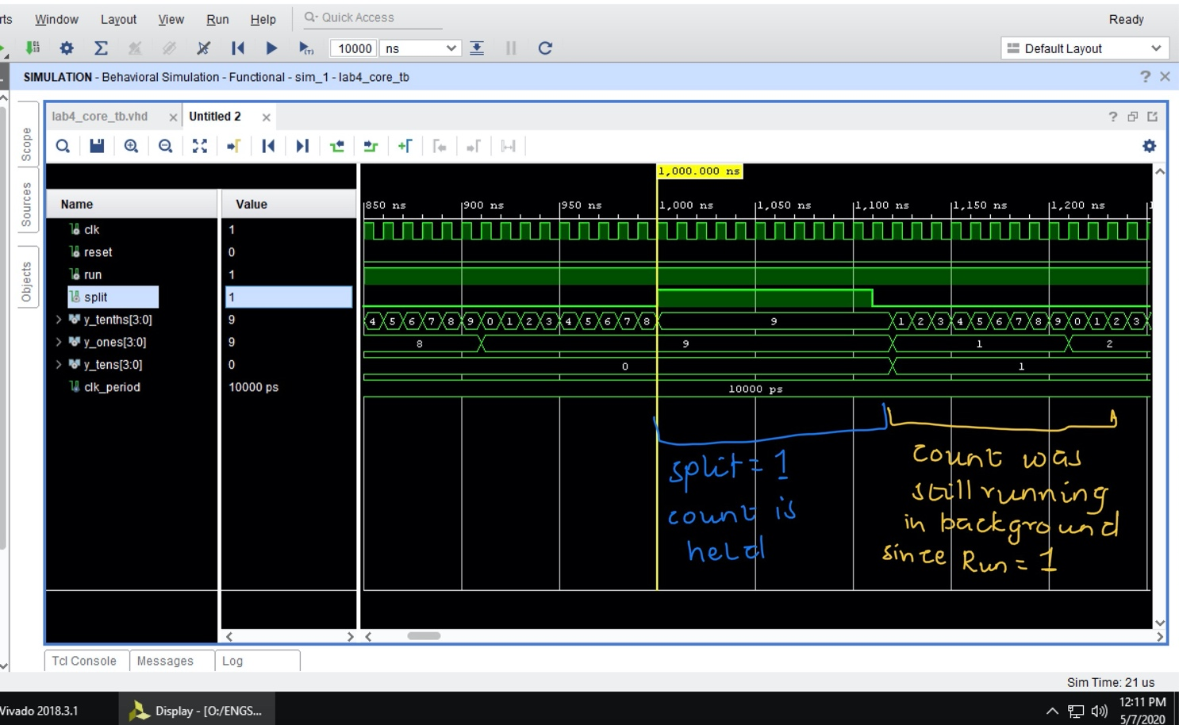

4. Controller

The inputs are assumed to come from monopulsers (provided in lab3_shell), so they are asserted for only one clock cycle with each press of a button. When connected to the counters and the display, the controller will produce the actions described in the Introduction.
First, work out the logic of the controller as a state diagram. Then write a VHDL model, in Vivado, as a two-process state machine in a file with entity and architecture blocks. Use this entity block:

entity lab3_controller is
port( clk: in std_logic;
run_stop_reset_mp: in std_logic; -- monopulsed buttons
split_mp: in std_logic;
reset: out std_logic; -- to lab3_core
run: out std_logic;
split: out std_logic );
end entity;
Write a testbench and use Vivado to verify the correct state sequence and outputs.

Deliverable 4:
- Turn in a copy of your block diagram.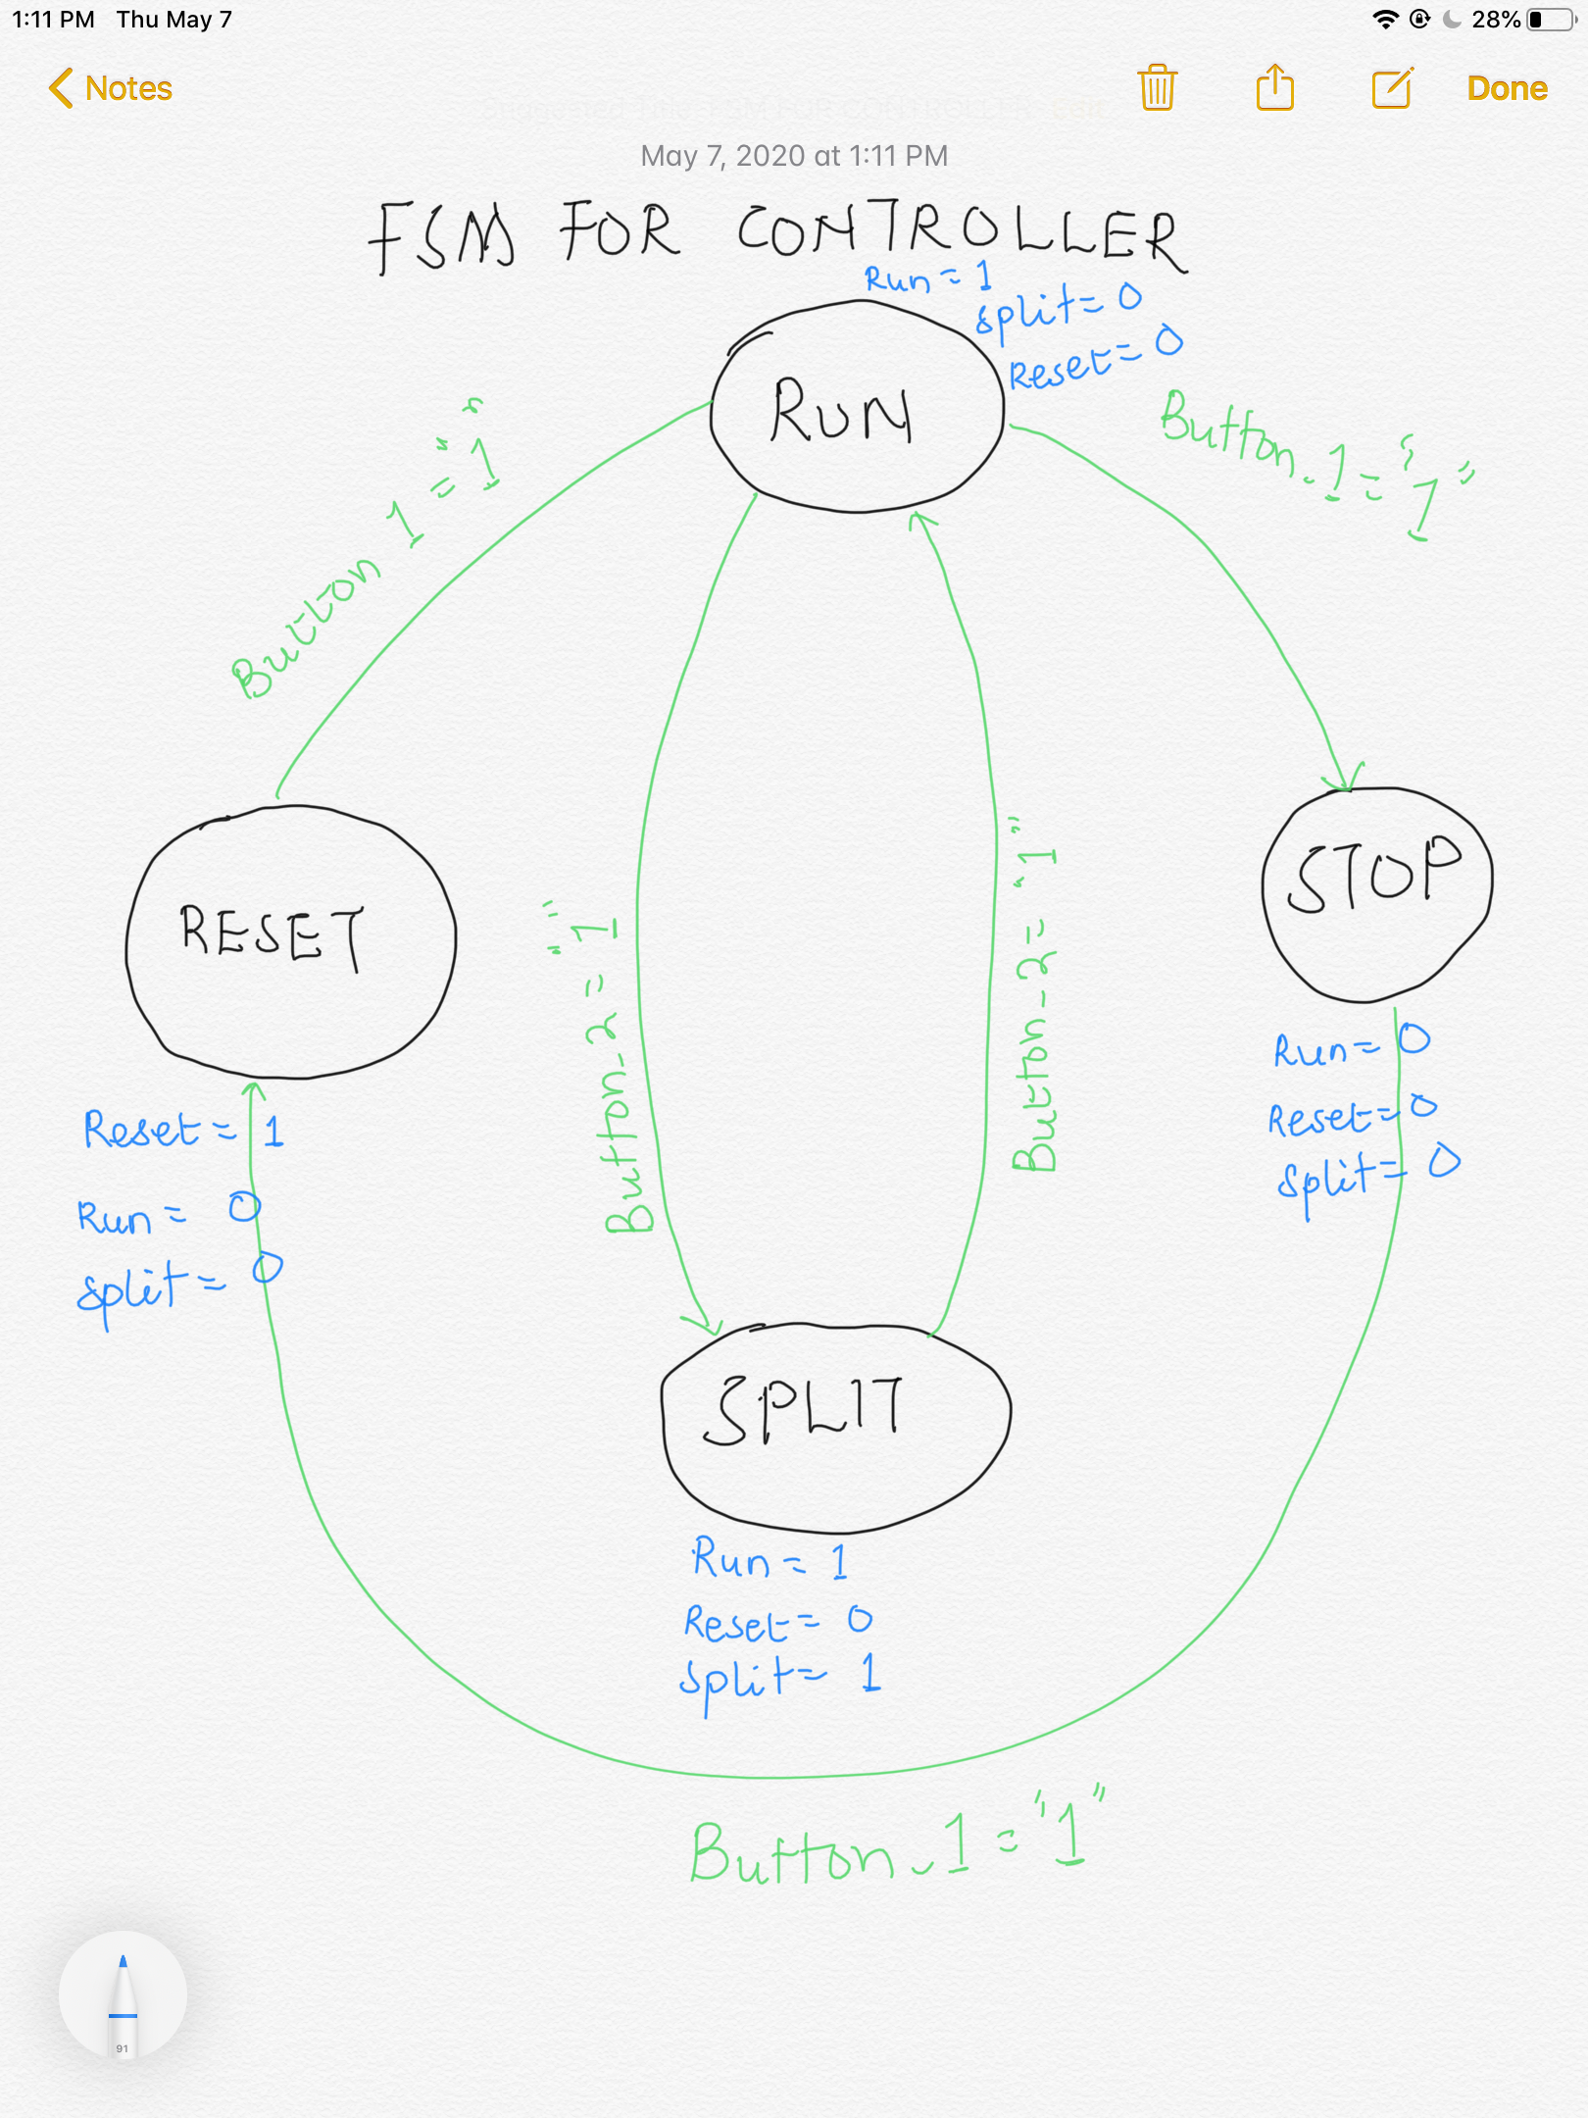

- Turn in a copy of your simulation waveform, showing important features.

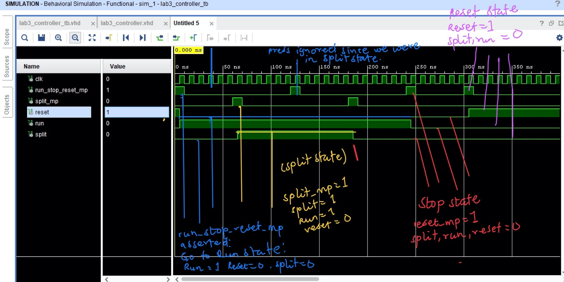

Part II: Build and test
The final build and test should go smoothly if your Part I is sound.
1. Create a new project, add the supplied files (lab3_shell.vhd, mux7seg.vhd, and lab3.xdc) with your design (lab3_core, bcd_digit, lab3_controller). Your project hierarchy should look like this:
Lab3_shell.vhd
Lab3_controller.vhd
Lab3_core.vhd
bcd_digit.vhd (3 instances)
mux7seg.vhd

2. Elaborate the RTL schematic. Inspect the RTL schematic to make sure that it agrees with the block diagram at the beginning of this handout (three instances of bcd_digit, the controller, and additional logic for the split time).

3. Create a testbench that allows you to simulate the full design with all the components added.
Deliverable 5:
- Turn in a copy of your simulation waveform, showing important features.
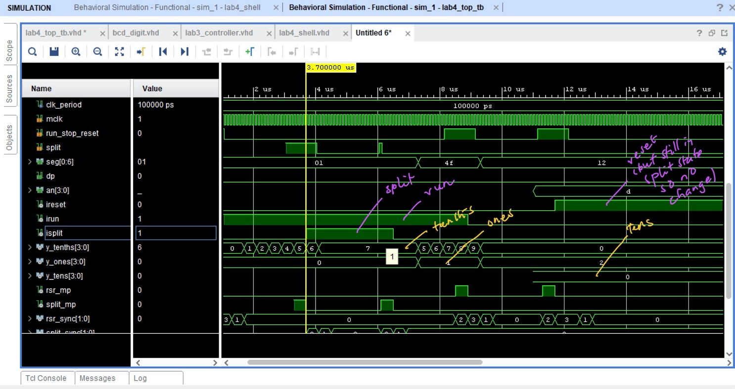
4. Take the complete system through synthesis (check and correct any warnings) and implementation, download the bitstream file onto your Basys3 board, and test. If all goes well, the system should behave like a stopwatch!

Part III: Analysis
4. Last week you saw how the synthesis and utilization reports provide information about resource usage on the FPGA. This week you’ll learn a little more about synthesis.
Click the “Reports” tab at the bottom of the Vivado window, and under Synth Design open the Vivado Synthesis Report.
Scroll down to the table called “Detailed RTL Component Info”, at about line 100. What are the higher level units (registers, adders, etc) that the synthesis tool inferred from your VHDL model? Scroll down a little farther and you’ll see these units listed by the modules in the design (shell, controller, etc). These higher level units are eventually implemented with basic FPGA elements like LUTs, flip flops, etc.
Keep scrolling down to about line 310 to obtain the statistics for the basic FPGA elements. How many of each of these are used in your design? Key:
• BUFG: internal buffer that routes the output of a clock divider onto the special clock distribution wiring in the FPGA.
• CARRY4: fast carry logic used for large adders.
• LUT1-LUT6: lookup tables using from 1 to 6 inputs.
• FDRE: D flip-flop with reset and enable.
• IBUF: Input buffers (connecting FPGA input pins to the input ports of your logic)
• OBUF: Output buffers (connecting output ports of your logic to FPGA output pins)
Deliverable 6:
- Record your answers to the above questions.
HIGHER LEVEL UNITS
1.Adders
2. Registers
3. Muxes

STATISTICS OF BASIC FPGA ELEMENTS
- BUFG: 2
- CARRY4: 6
- LUT1- LUT6: 6+12+7+21+8+6 = 60
- FDRE: 80
- IBUF: 3
- OBUF: 12

After the LAB:
- Write a short report that includes and provides context for the deliverables that you collected throughout the lab. Strive to keep it as brief, concise, and neat as possible. Write it for an audience that is familiar with engineering concepts and digital electronics and does not know the finer points of the design/project.

BCD counter:
The BCD counter is just like the one we implemented in Lab 2. The only modification is that we assert a monopulse TC out only when count is 9 and CE is asserted. Deliverable 1 show preserving the normal operation of the counter thus counting up and down. Waveform also shows TC being asserted at 9 when CE is enabled and up_down is enabled.

Multi-digit counter:
In designing the multi-digit counter, we just had to wire up three different BCD counters. The TC for one counter was used as the enable for the next counter. Eg. The TC of the tenth counter is used as an enable for the ones counter. The deliverable 2 shows the counting of tenths that activate the ones when it reaches nine and likewise for the tens.

Display:
In this stage we determined how to inculcate how to make the stopwatch’s display to switch between the split time and the run time. The deliverable shows the block diagram with the Split signal used as a select bit to choose between displaying run time and split time.
The waveform shows normal run as well as the split time being held when split signal is asserted. When the split is displaying, the stopwatch continues to run in the background.

Controller:
The controller we designed had 4 states: run, split, stop and reset. Two buttons run_stop_reset_mp and split_mp, informs switching between these states. The controller’s outputs are used as the inputs to the counters.
The block diagram shows the transition between the states of the controller and the output at each state.
The waveform shows the button presses and the outputs with those presses gives information about the states we are in.

Top Level:
We aggregate all our designs in this project and run the overall design through a testbench for simulation. After the simulation was the synthesis, implementation and device programming.

The deliverable shows the final behavior of the stopwatch with all cases tested(mostly).

Resource Analysis:
This shows the number of resources used as inferred from the VHDL code.

- Either show a TA or Ben Dobbins your working design or record a short video demonstrating the operation of your stopwatch to submit to Canvas (submission details forthcoming).

