Formula for Population Variance
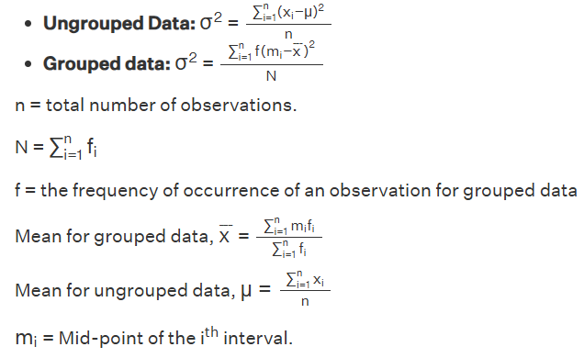
Formula for Population Standard Deviation
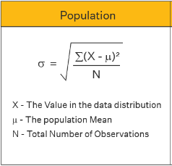
Formula for Sample Variance
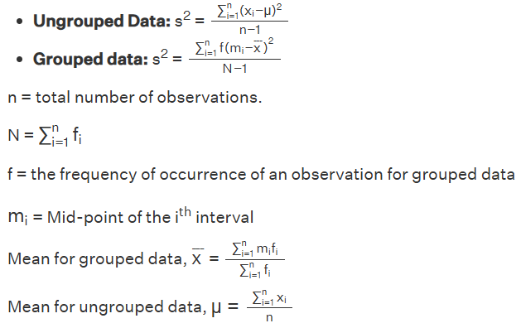
Formula for Sample Standard Deviation
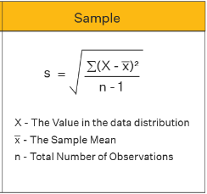
Formula for Chebyshev’s Theorem
- Minimum proportion within k standard deviations: $1- \frac{1}{k^{2}}$
- Maximum proportion outside k standard deviations: $\frac{1}{k^{2}}$
Formula for Moments
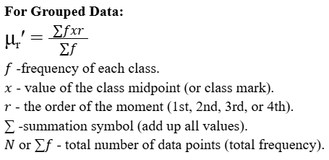
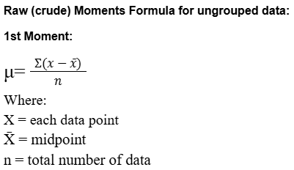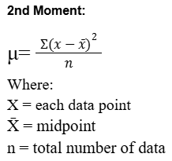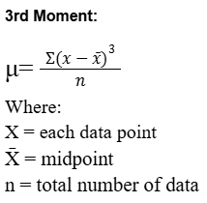
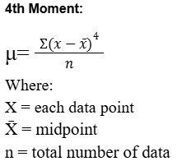
Formula for Skewness
Sk = $\frac{3(mean - median)}{standard deviation}$
positive skewness = Mean > Median >Mode
negative skewness = Mode > Median > Mean
zero skewness = Mean = Mode = Median

Pearson’s First Coefficient
Using mode:
Sk = $\frac{x - mode}{standard deviation}$
Using median:
Sk = $\frac{3(x - median)}{standard deviation}$
Formula for Kurtosis
For Ungrouped Data:
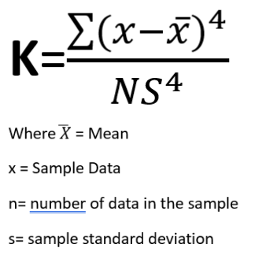
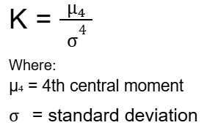

For Grouped Data:
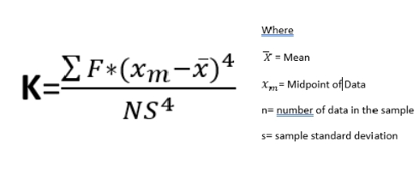

Formula for Pearson’s Correlation
For Ungrouped Data:
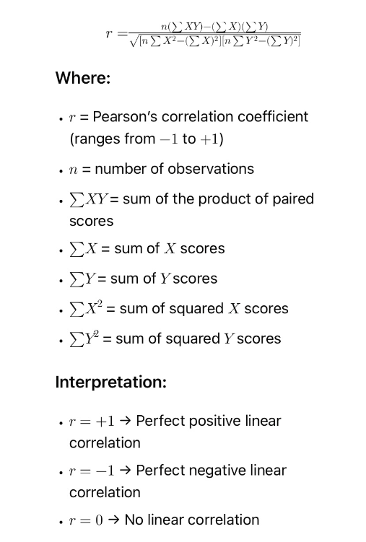
For Grouped Data:

Where:
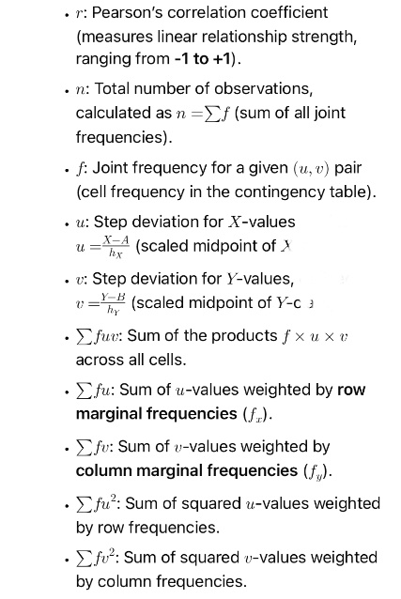
Formula for u:
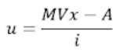
Where:
MVx = midpoint of x class interval
A = assumed mean
i = class interval
formula for v:
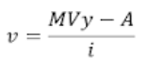
MVy = midpoint of y class interval
A = assumed mean
i = class interval
Formula for Spearman’s Rank Correlation
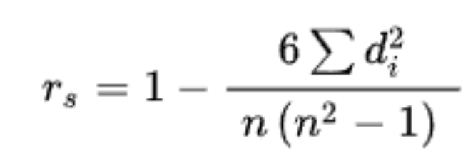
Where:
r = Spearman’s rank correlation coefficient
di = difference in ranks for the i-th pair
di2 = squared value of the difference of the ranks of the two variables
n = number of observations

Formula for Goodman and Kruskal Gamma
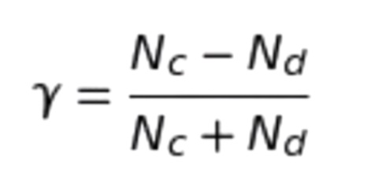
where:
γ = Goodman and Kruskal’s Gamma
Nc = num of Concordant pairs
Nd = num of Discordant pairs

Formula for Regression
Linear Equation – Y = mX + b
Where
Y = predicted value
X = input value
m = slope of the line
b = y-intercept
Formula for the slope(m)
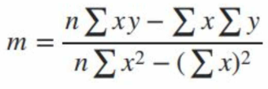
Formula for y-intercept(b)
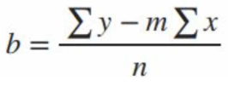
Basic Concept of Probability
Mutually Exclusive Events: Two events are mutually exclusive if they cannot happen at the same time. = P(A∩B)=0
Independent Events: Two events are independent if the outcome of one event does not affect the outcome of the other. = P(A∩B)=P(A)×P(B)
Formula for Probability
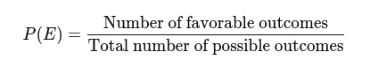
Types of probability
Theoretical probability is based on reasoning or calculations, assuming all outcomes are equally likely.
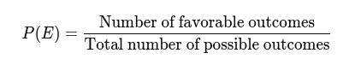
Experimental probability is based on actual experiments or observations. It shows what actually happens when you try something many times.
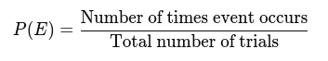
Axiomatic probability is based on a set of rules (axioms) established by mathematicians. It's a formal, logical approach used in advanced probability theory.
Axiom 1 Non-negativity = P(E) </= 0
Axiom 2 Normalization = P(E) = 1
Axiom 3 for Mutually Exclusive events
= P(A or B) = P(A) + P(B)

Tree Diagram and Probability
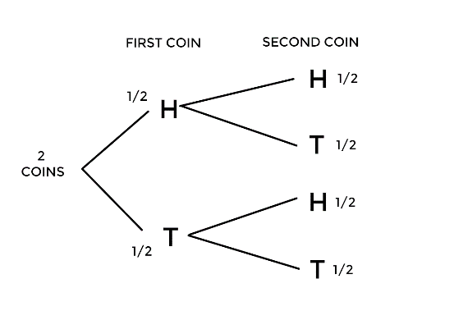
S = {HH,HT,TH,TT}
HH = ½ x ½ = ¼
HT = ½ x ½ = ¼
TH = ½ x ½ = ¼
TT = ½ x ½ = ¼

Venn Diagram and Probability
For Non Mutually Exclusive Events:
P(A ∩ B) = P(A) x P(B)
P(A ∪ B) = P(A) + P(B) - P(A ∩ B)
P(A/B) = P(A ∩ B)/P(B)

For Mutually Exclusive Events:
P(A ∩ B) = 0
P(A ∪ B) = P(A) + P(B)
Example: S={1,2,3,4,5,6} A={1,2,3} B={5,6}
Mutually Exclusive Events
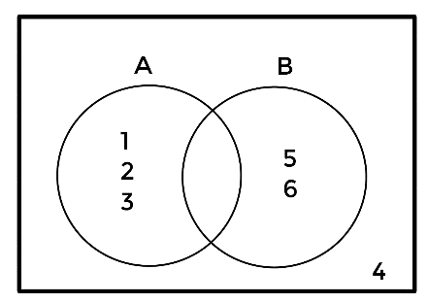
Example: S={1,2,3,4,5,6} A={1,2,3,4} B={3,4,5}
Non Mutually Exclusive Events
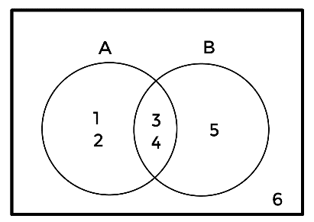
Additive Rule
Formula: 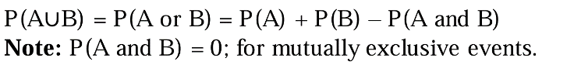
Mutually Exclusive Event
Formula: P(A∪B)=P(A)+P(B)
Complement Rule
Formula:

Multiplication Rule
Formula: 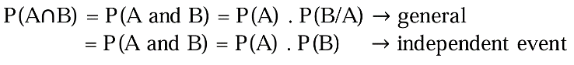
Conditional Probability Rule
Formula: 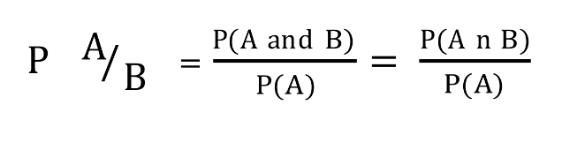
Rules of Total Probability
Formula: 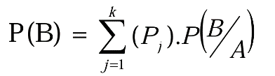
Sum of Probabilty
Formula: 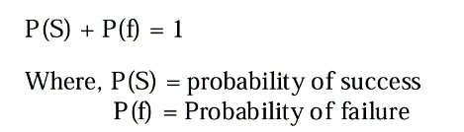
Experimental Probability
Formula:
Mean
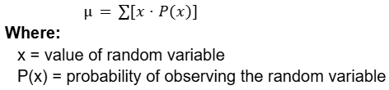
Standard Deviation
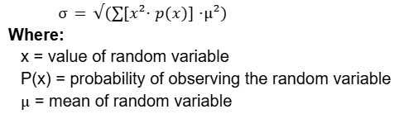
Variance
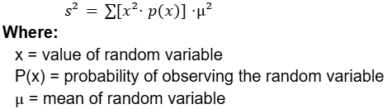
Price Index
Price Relative
$$P_{x}=\left(\frac{P_{n}}{P_{0}}\right)x 100$$
Where:
Pn = Price in the current/given year
P0 = Price in the base year
Quantity Relative or Volume Relative or Simple Quantity Relative
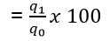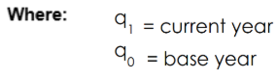
Simple Aggregate Volume or Aggregate Quantity Relative
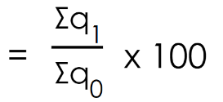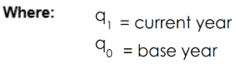
Laspeyres’ Weighted Quantity/volume
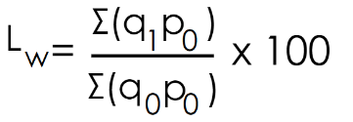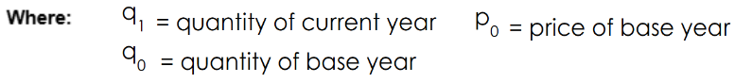
Paasche’s Weighted Quantity/volume
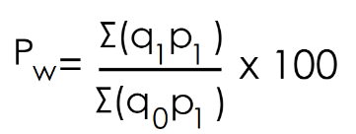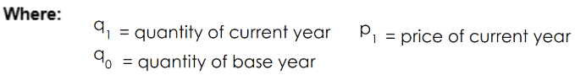

Fisher’s ideal quantity/volume
There are 2 formulas(Fw):
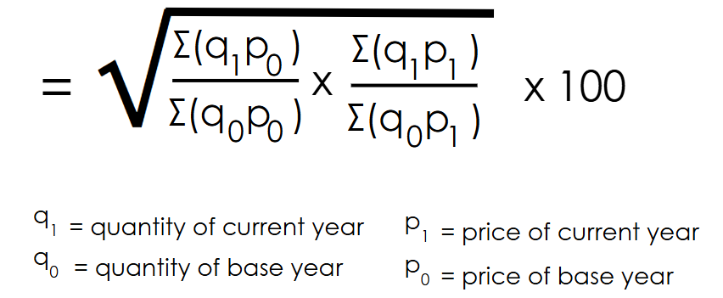
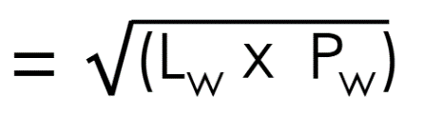
Weighted Price Index Number
Laspeyres’ Price Index
Formula: 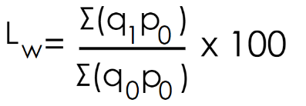
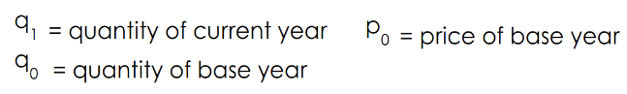
Paasche’s Price Index
Formula: 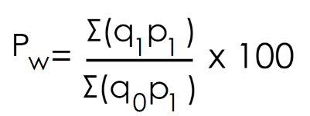 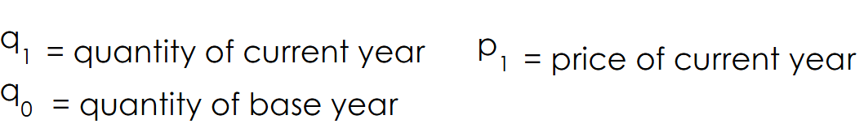
Fisher’s Price Index
Formula: 
Value Index
Formula: 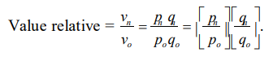
Consumer Price Index
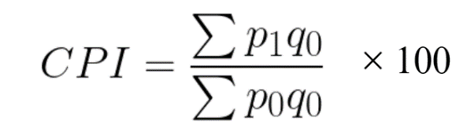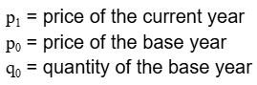
Inflation Rate
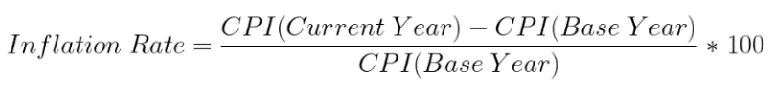
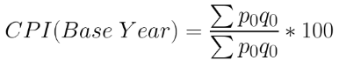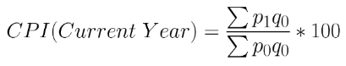
Real Income
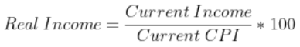
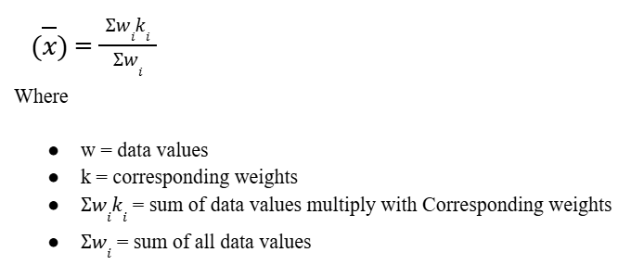
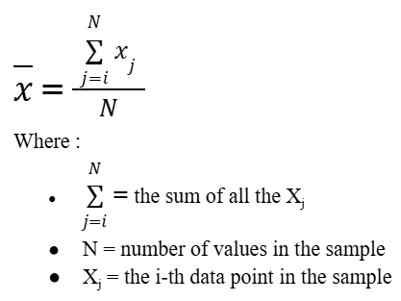
Formula for Arithmetic Mean

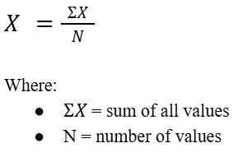
Mean Formula for Ungrouped Data

Formula For Weighted Arithmetic mean

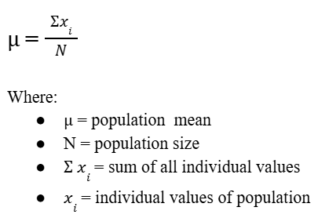
Formula for Population Mean

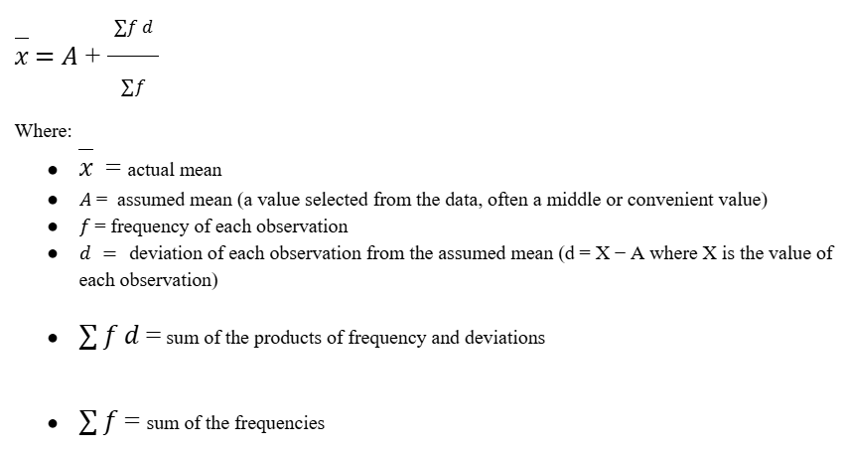
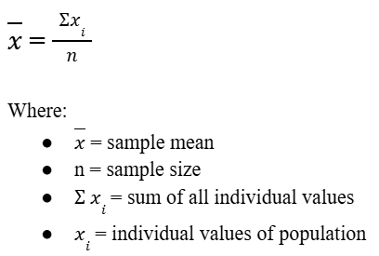
Formula for Sample Mean

Mean Formula for Grouped Data
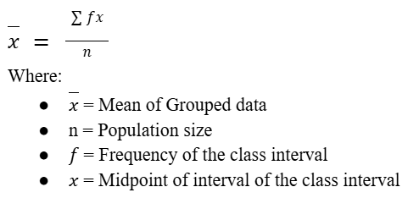

Formula for Assumed Mean

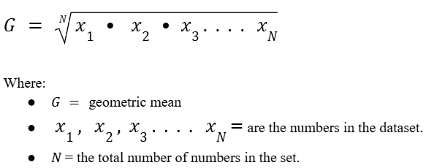
Formula for Geometric Mean
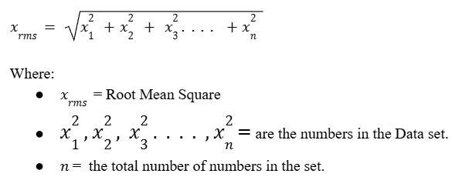

Formula for harmonic mean

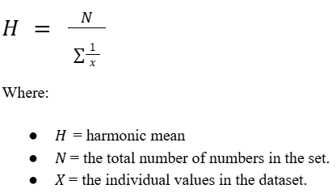

Formula for Quadratic mean (Root Mean Square)

Median Formula for Ungrouped Data:
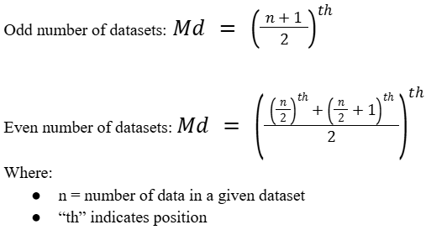

Median Formula for Grouped Data:
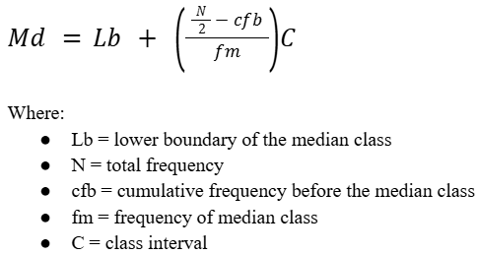

Mode Formula for Ungrouped Data: Most Freq.
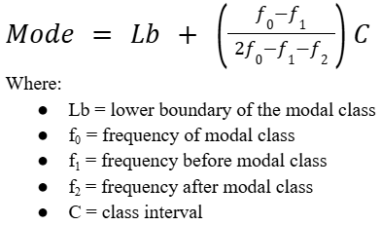
Mode Formula:

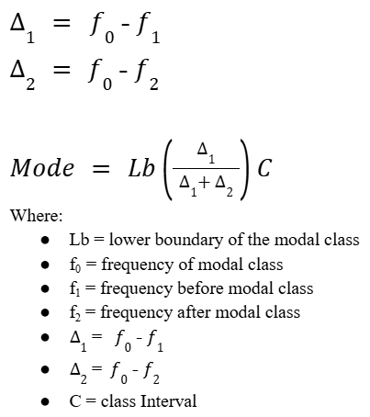
Delta Formula:

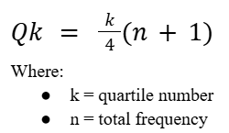
Quartile Formula for Ungrouped Data:

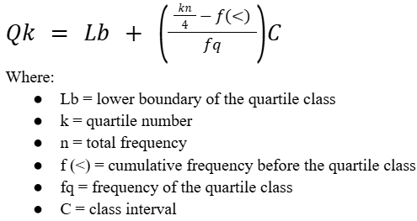
Quartile Formula for Grouped Data:

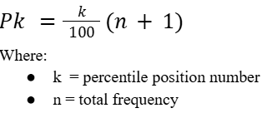
Percentile Formula for Ungrouped Data:

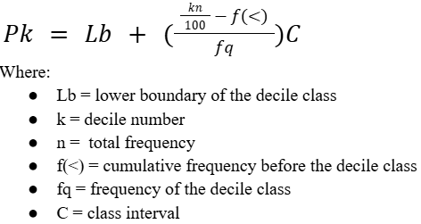
Percentile Formula for Grouped Data:

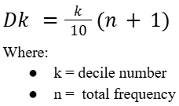
Decile Formula for Ungrouped Data:

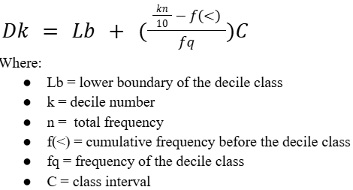
Decile Formula for Grouped Data:

