LAB 3: Goals, Events, and Reactive Behavior
DCIT 403
11125009
Date: February 19, 2026

FSM Diagram
The agent operates through 6 states with severity-based transitions:
┌──────────────┐
│ │
┌─────────►│ IDLE │
│ │ │
│ └──────┬───────┘
│ │ activation
│ ▼
│ ┌──────────────┐
│ ┌─────►│ MONITORING │◄─────┐
│ │ │ │ │
│ │ └──────┬───────┘ │
│ │ │ │
│ │ severity<3 │ severity≥3 │
│ │ ▼ │
│ │ ┌──────────────┐ │
│ │ │ ALERT │ │
│ │ │ │ │
│ │ └──────┬───────┘ │
│ │ │ │
│ │ ▼ │
│ │ ┌──────────────┐ │
│ │ │ RESPONDING │ │
│ │ │ │ │
│ │ └──────┬───────┘ │
│ │ │ │
│ │ ▼ │
│ │ ┌──────────────┐ │
│ │ │ RESCUE │ │
│ │ │ │ │
│ │ └──────┬───────┘ │
│ │ │ │
│ │ ▼ │
│ │ ┌──────────────┐ │
│ │ │ COMPLETED │──────┘
│ │ │ │
│ │ └──────┬───────┘
│ │ │
│ │ │ max missions
│ │ ▼
└───┴──────────[END]
From State | To State | Trigger
IDLE | MONITORING | Agent activation
MONITORING | MONITORING | Severity < 3
MONITORING | ALERT | Severity >= 3
ALERT | RESPONDING | Goal: Initiate rescue
RESPONDING | RESCUE | Arrival at location
RESCUE | COMPLETED | Operations finished
COMPLETED | MONITORING | Next mission
COMPLETED | END | Max missions reached

Source Code Implementation
The rescue agent FSM is implemented in rescue_agent_fsm.py. The following screenshots show the complete source code:
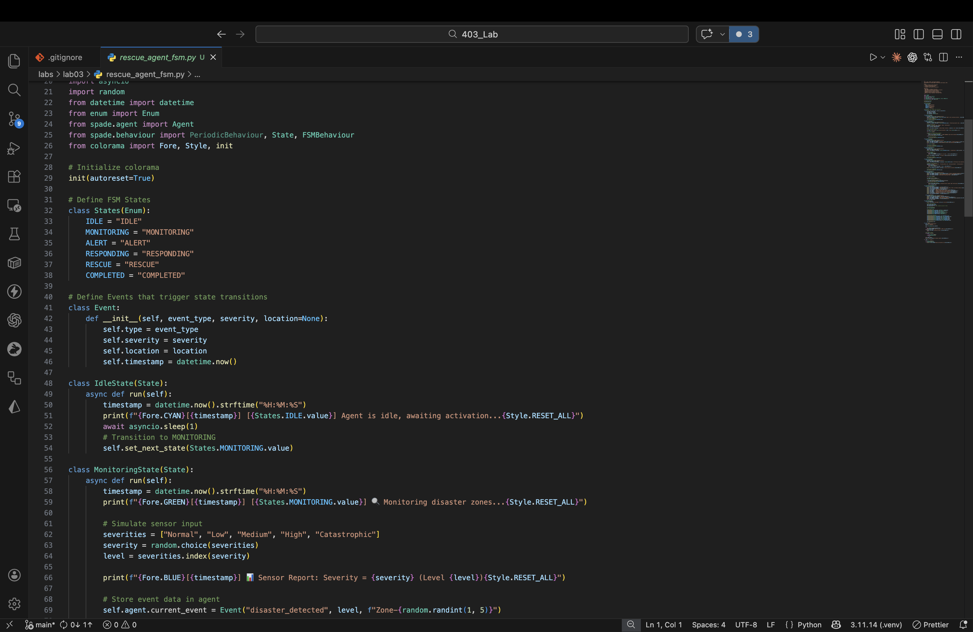
Figure 1: rescue_agent_fsm.py — Imports, FSM States, Event class, IdleState & MonitoringState (lines 1-68)

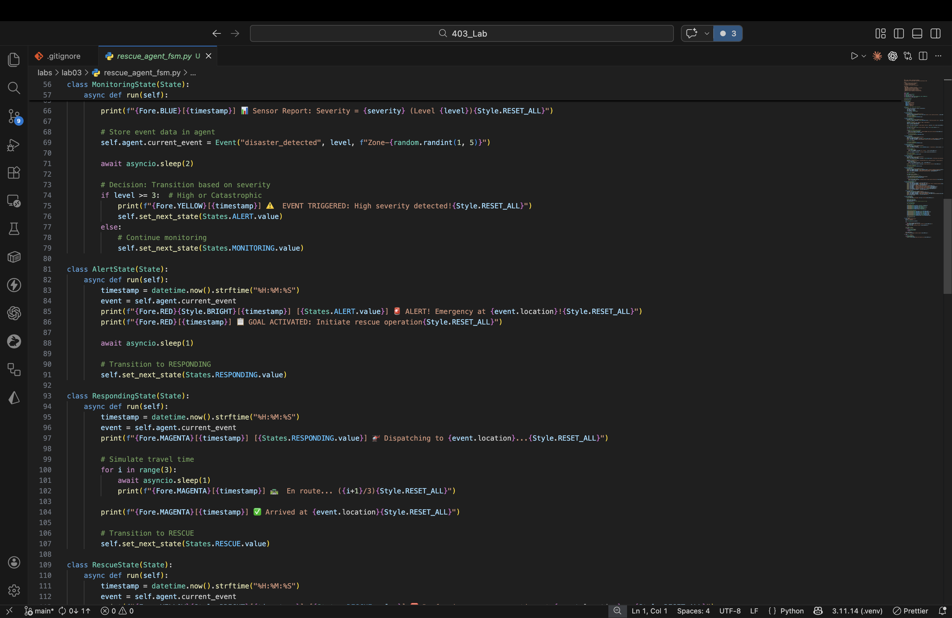
Figure 2: rescue_agent_fsm.py — MonitoringState, AlertState & RespondingState (lines 56-113)

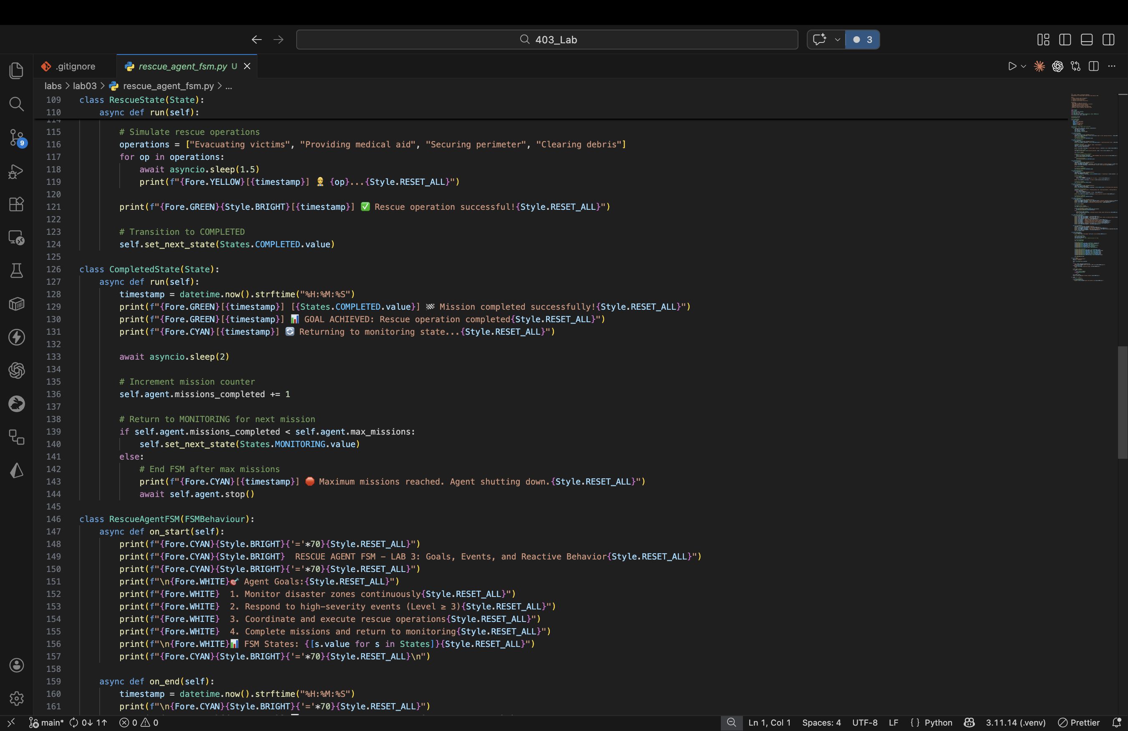
Figure 3: rescue_agent_fsm.py — RescueState, CompletedState & FSM Behaviour (lines 109-164)

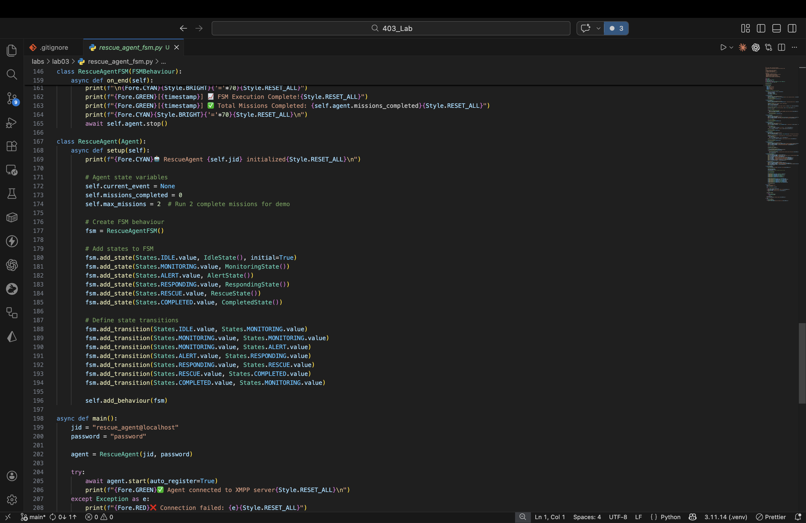
Figure 4: rescue_agent_fsm.py — RescueAgent class, setup & main function (lines 157-210)

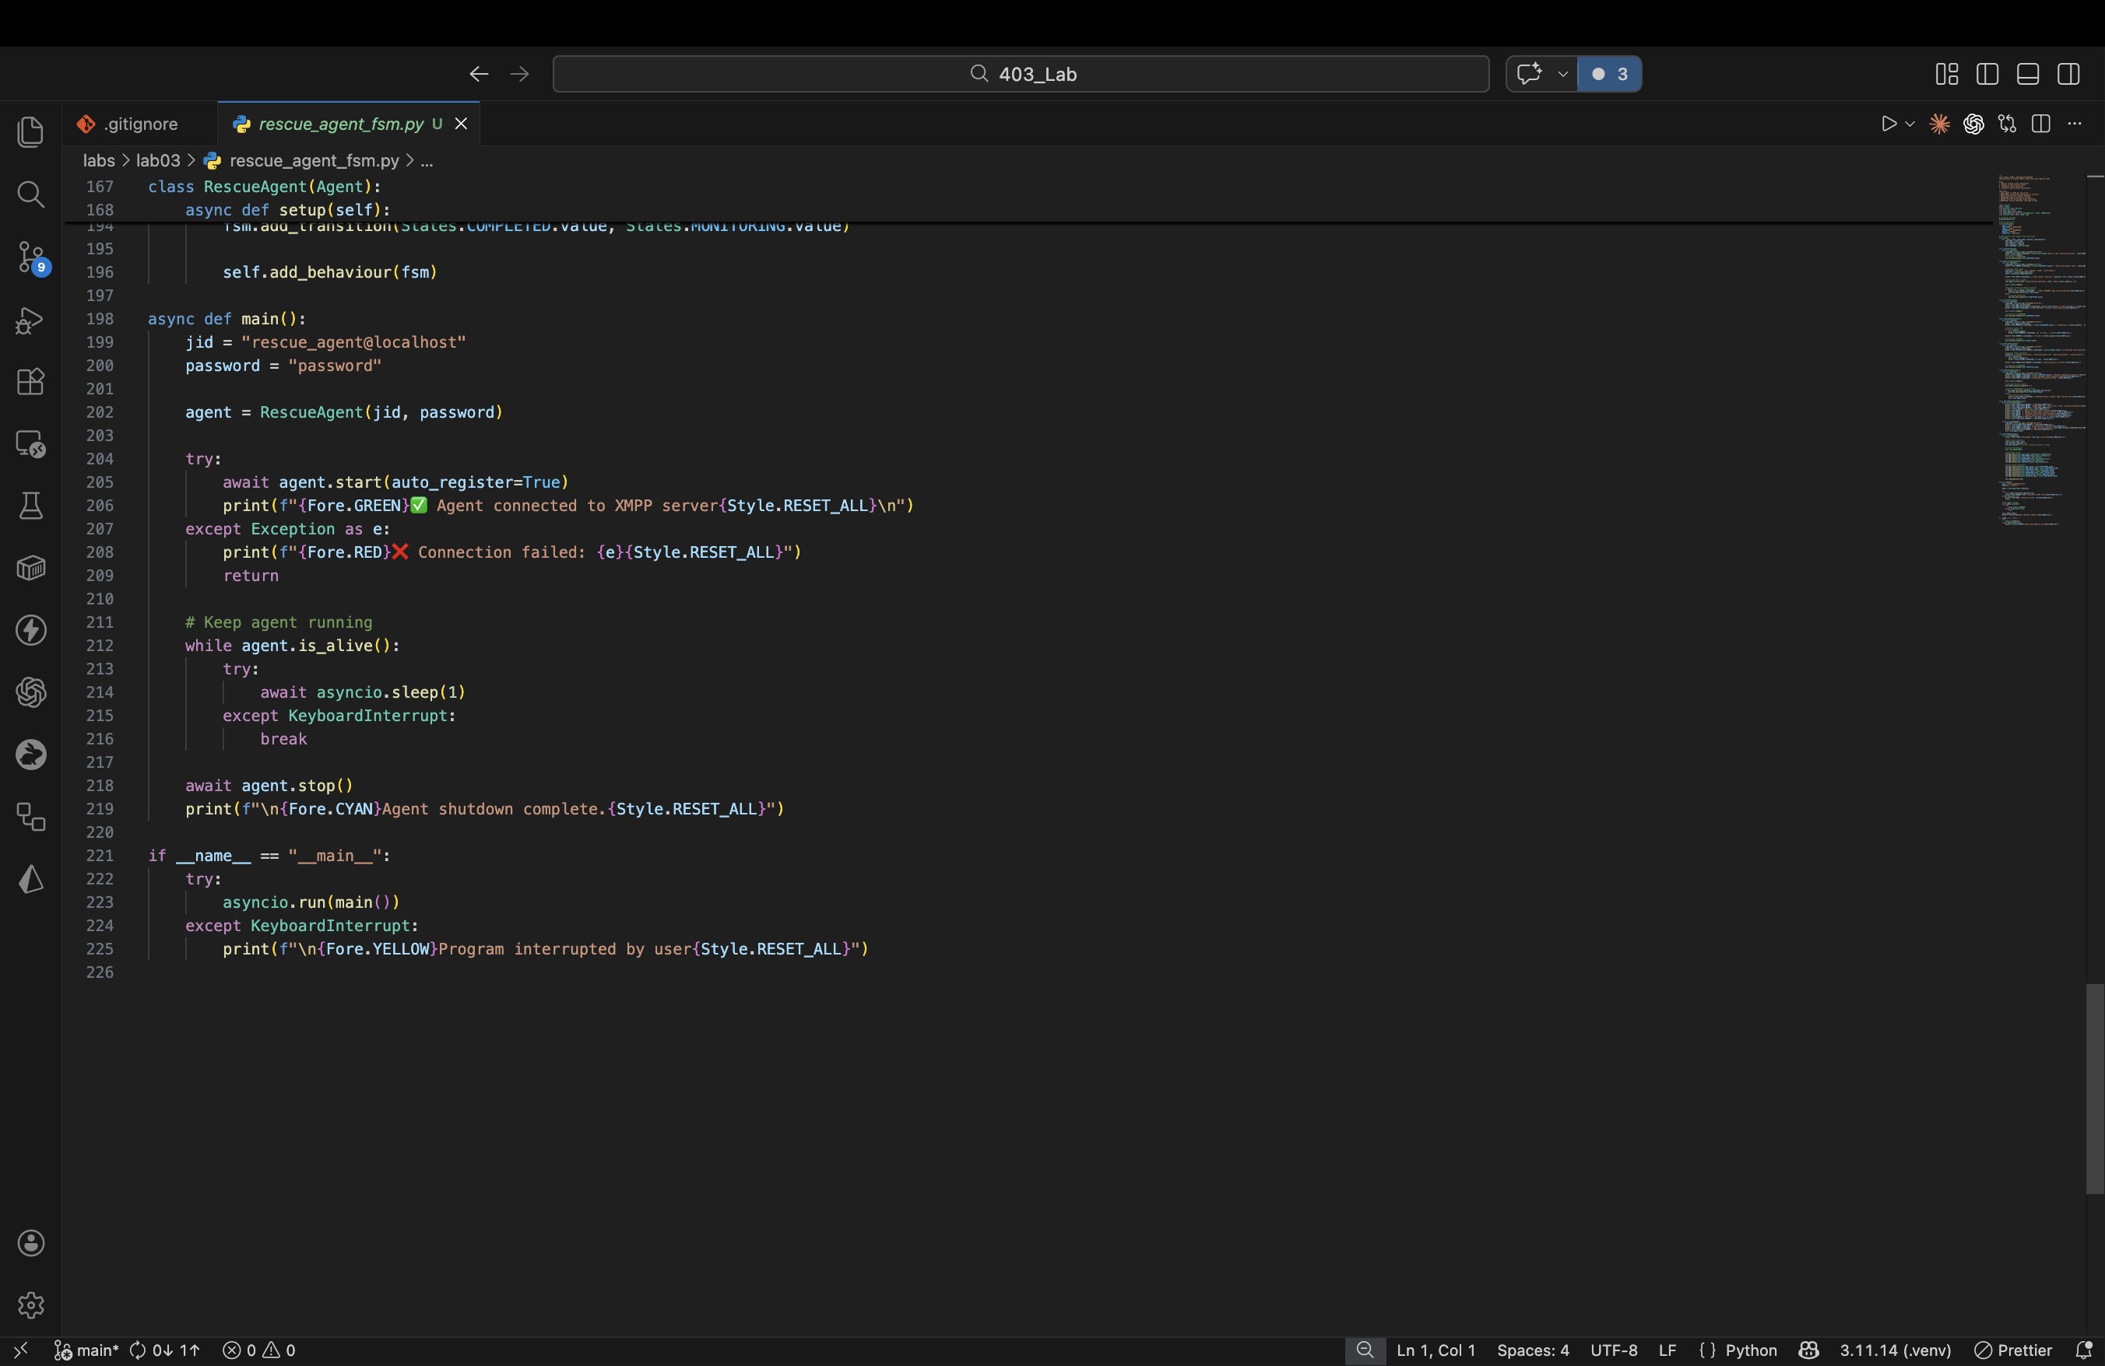
Figure 5: rescue_agent_fsm.py — main() continued & entry point (lines 167-226)

Execution Trace
[20:54:00] [IDLE] Agent is idle, awaiting activation...
[20:54:01] [MONITORING] Monitoring disaster zones...
[20:54:01] Sensor Report: Severity = Low (Level 1)
[20:54:03] [MONITORING] Monitoring disaster zones...
[20:54:03] Sensor Report: Severity = High (Level 3)
[20:54:03] EVENT TRIGGERED: High severity detected!
[20:54:05] [ALERT] Emergency at Zone-4!
[20:54:05] GOAL ACTIVATED: Initiate rescue operation
[20:54:06] [RESPONDING] Dispatching to Zone-4...
[20:54:09] Arrived at Zone-4
[20:54:09] [RESCUE] Performing rescue at Zone-4...
[20:54:09] Evacuating victims...
[20:54:11] Providing medical aid...
[20:54:12] Securing perimeter...
[20:54:14] Clearing debris...
[20:54:15] Rescue operation successful!
[20:54:15] [COMPLETED] Mission completed successfully!
[20:54:15] GOAL ACHIEVED: Rescue operation completed
[20:54:17] [MONITORING] Monitoring disaster zones...
[20:54:17] Sensor Report: Severity = Catastrophic (Level 4)
[20:54:17] EVENT TRIGGERED: High severity detected!
[20:54:19] [ALERT] Emergency at Zone-2!
[20:54:20] [RESPONDING] Dispatching to Zone-2...
[20:54:23] Arrived at Zone-2
[20:54:23] [RESCUE] Performing rescue at Zone-2...
[20:54:29] Rescue operation successful!
[20:54:29] [COMPLETED] GOAL ACHIEVED: Rescue operation completed
[20:54:31] Maximum missions reached. Shutting down.
FSM Execution Complete! Total Missions: 2

