**Waste-to-Coin: A Blockchain-Based Ecosystem for Exchanging Waste Products for Digital Tokens**

1Aakarshan Gupta 2Akshat Pandey 3Mukul Aggarwal

*Department of IT Department of IT Department of IT*

*KIET Group of Institutions KIET Group of Institutions KIET Group of Institutions*

*Delhi NCR Ghaziabad India* *Delhi NCR Ghaziabad India Delhi NCR Ghaziabad India*

[aakarshan.2226it1161@kiet.edu](mailto:aakarshan.2226it1161@kiet.edu) [akshat.2226it1014@kiet.edu](mailto:akshat.2226it1014@kiet.edu) [mukul.digital@gmail.com](mailto:mukul.digital@gmail.com)

***Abstract*—The rapid increase in global waste generation necessitates innovative solutions to enhance sustainability and incentivize responsible waste management. This research introduces a blockchain-driven waste-to coin ecosystem that facilitates the exchange of recyclable waste for digital tokens, integrating financial incentives into sustainability efforts. By leveraging smart contracts, AI-powered IoT verification, and tokenomics, the machine presents real-time waste monitoring, fraud prevention mechanisms, and decentralized responsibility, ensuring obvious and green waste processing. Also, a large portion of the existing waste management systems within smart cities fall short in providing operational transparency, traceability, audit, security, and trusted data provenance features. A key issue of this look at is the analysis of blockchain scalability challenges, along with transaction speeds, energy performance, and decentralized governance frameworks, essential for enforcing an green waste-to-coin platform. The research references recent improvements from 2024 and 2025, incorporating rising trends in sustainability-centered blockchain fashions, decentralized waste tracking, and round economic system rules that beautify the viability of tokenized recycling programs..**

***Keywords—Blockchain, Waste Management, Tokenomics, Circular Economy, Smart Contracts, AI-IoT Integration, Decentralized Waste Tracking, Sustainability.***

# Introduction

Waste management is a critical element of environmental sustainability, influencing the health, economy, and ecosystems of urban and rural populations alike. Improper waste management can contaminate oceans, spread diseases, and harm animals that unknowingly consume waste such as food scraps or plastic bags. In smart cities, the proper management of waste demands close coordination among various stakeholders, including waste generators, collectors, shippers, and treatment facilities. To address these challenges, sustainable waste control focuses on resource recovery, circular economies, and innovative technology-driven solutions

Blockchain technology has emerged as a disruptive force in modern waste management, offering transparency, traceability, and decentralized control. The waste-to-coin ecosystem integrates blockchain-based tokenization, incentivizing individuals and organizations to convert waste into digital assets. This approach fosters sustainability, enhances economic efficiency, and encourages responsible waste disposal. Waste control refers to the systematic processes involved in collecting, transporting, processing, recycling, and disposing of waste materials. The primary goal is to reduce the environmental footprint of human activities and maximize resource recovery. Blockchain technology, operating through decentralized, immutable, and transparent ledgers, can address inefficiencies in waste monitoring, fraud prevention, and incentive mechanisms [2]. Effective and sustainable waste management policies contribute to improved air and water quality while reducing carbon emissions, thereby fostering a cleaner environment. Many modern waste management systems incorporate Internet of Things (IoT) technology and leverage centralized cloud-based resources to process waste-related data. IoT-based nodes detect and monitor waste capacity, type, temperature, and humidity levels while transmitting relevant truck arrival times and route data to cloud servers for decision-making.

Fraud prevention through smart contracts ensures the integrity of waste information, preventing manipulation. Automated compliance mechanisms enforce adherence to environmental policies. A circular economy minimizes waste by promoting reuse, recycling, and repurposing of materials, as opposed to the traditional linear economy, which emphasizes consumption and disposal [3]..

# Literature Review

Recent studies shows a blockchain’s impact on supply chain tracing, carbon footprint reduction, and decentralized waste management system. Plastic Bank: Blockchain for Recycling and Social Impact [5]. With the use of blockchain technology, this research sought to understand the applications, benefits, and limitations faced by circular economy-based businesses. This research was conducted at the Plastic Bank Company, which used a digital conference room to allow interviews that could not be conducted in person, as well as the researcher's residence for online data gathering and document review. Five management members of the Plastic Bank Company comprise the sample population. The information used is first-hand information derived from interview findings. In order to acquire data, several methods including interviews, document analysis, and observation were applied and tested by Triangulation. Tokens, known as Social Plastic Credits, are issued and can be redeemed for goods, services, or even financial assistance, creating a closed-loop circular economy. Since its inception, Plastic Bank has helped prevent over 50 million kilograms of plastic from entering the ocean. The blockchain-backed traceability and transparency model ensures that each token represents verified and responsibly recycled material. Expansion into multiple regions, including Haiti, Indonesia, and the Philippines, has showcased the scalability of blockchain-driven recycling solutions. Companies partner with Plastic Bank to source ethically recycled materials, fostering sustainable corporate social responsibility initiatives.

Adoption Barriers: Initial skepticism round blockchain adoption in resource-restrained groups was overcome through instructional campaigns and NGO partnerships. Token Valuation and Liquidity: Adjustments in trade mechanisms make certain that Social Plastic Credits preserve cost stability, preventing market volatility problems. The integration of blockchain pushed waste-to-coin models presents an progressive technique to incentivize recycling and sustainability.

|  |  |  |  |  |  |  |
| --- | --- | --- | --- | --- | --- | --- |
| **Parameter** | **Methodology** | **Kumar & Iyer [2]** | **Mehta &Das[5]** | **Sharma et al. [6]** | **Chaudhary & Singh [3]** | **Bhattacharya & Sharma [6]** |
| Accuracy | Ensures accuracy through iterative refinement, legal expert validation, and comparison with real cases | Focused on case studies; accuracy depends on limited case-based reasoning. | Medium accuracy; relies on generalized IPC sections without granular real-world test cases. | High accuracy; emphasizes strong knowledge representation and reasoning. | High accuracy; leverages formal logic to model IPC interpretations. | Medium accuracy; focuses more on semantic interpretations than practical real-case testing. |
| Scope | Covers criminal law (e.g., theft), contract law (e.g., breach of contract), and marriage law in the Indian context. | Narrow focus on criminal law using specific IPC sections. | Broader scope, includes IPC-based reasoning but not as detailed in handling multiple laws. | Broad scope; applies across multiple legal areas with advanced knowledge structuring. | Limited to IPC interpretations with a focus on the underlying logic of selected sections. | Focuses primarily on semantic parsing of IPC sections, not full case-based reasoning or domain diversity. |
| Implementation Approach | Prolog-based with facts, rules, and reasoning systems like case-based and principle-based reasoning. | Prolog-driven case-based reasoning system for limited case types. | Prolog-based system with less emphasis on case-specific knowledge. | Uses Prolog with a focus on domain-specific knowledge representation and robust inferencing mechanisms. | Employs formal logic and Prolog to automate reasoning | Semantic-based Prolog implementation for interpreting IPC sections. |
| Focus Areas | Case-based reasoning, legal reasoning, decision support, and Indian-specific context. | Case studies demonstrating IPC-based outcomes. | IPC-based decision support with emphasis on AI in legal systems. | Knowledge representation for legal reasoning across IPC sections. | Automating IPC interpretations with logic-based automation. | Semantic analysis of IPC sections for automation. |

However, the dynamic and evolving nature of the legal domain presents significant challenges in implementing AI-based systems[4]. Legal language is often ambiguous and context-dependent, complicating the creation of comprehensive rule sets that can address all potential scenarios. Furthermore, ensuring the accuracy and relevance of legal knowledge embedded in expert systems is critical to their functionality and reliability. Studies highlight the necessity of continuously updating knowledge bases to reflect legislative changes, judicial interpretations, and societal developments. While these updates are essential to maintain system efficacy, they are resource-intensive and require collaboration between technologists, legal experts, and policymakers[9].This review underscores Prolog's potential as a foundational tool for developing sophisticated legal expert systems, particularly for tasks involving case-based reasoning and complex rule evaluation. By building upon existing research, the current study seeks to contribute to the growing body of knowledge on AI in law, with a specific focus on addressing the unique challenges and opportunities within the Indian legal framework[11]. The findings aim to advance the understanding of how AI can bridge gaps in the legal system, improve efficiency, and make justice more accessible to all[13].

# III. Methodology

This research employs a systematic approach to develop an expert system for legal decision-making in the Indian context using Prolog. The methodology comprises the following key steps:

***Requirements Analysis***: The first step involves gathering and analyzing the requirements for the expert system.

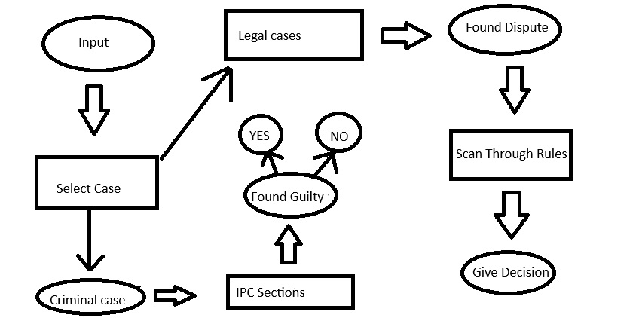 Fig 1: Data Flow Diagram

This includes identifying key legal domains to be covered, such as criminal law and contract law, and determining the specific use cases needed by legal practitioners.

***Knowledge Acquisition***: In this phase, legal experts will be consulted to gather relevant legal knowledge, including definitions of legal terms and rules from the Indian Penal Code (IPC). A combination of interviews and literature review will be utilized to compile this information.

***System Design***: The design phase focuses on structuring the expert system. This includes creating a knowledge base that consists of facts and rules in Prolog, organized to allow the system to infer conclusions based on legal principles derived from the acquired knowledge.

***Implementation***: The next step involves implementing the expert system using Prolog. The Prolog programming language will be employed to develop the rules and facts in the knowledge base, allowing users to input specific legal cases and receive outputs suggesting possible legal outcomes based on case-based reasoning.

***Testing and Validation***: Once the system is implemented, rigorous testing will be conducted to ensure accuracy and reliability. This will involve running the system with a set of

test cases derived from real legal scenarios and comparing the outputs with established legal principles. Validation will be achieved through feedback from legal professionals who will evaluate the system’s performance.

***Iterative Refinement***: Based on testing results and user feedback, the system will undergo iterative refinement. This process will include updating the knowledge base with new legal information and enhancing the system's inference capabilities to ensure it remains effective in the evolving legal landscape.

This methodology aims to establish a robust expert system that leverages Prolog’s capabilities to automate legal reasoning and provide valuable support to legal practitioners in India.

***Sections of the IPC - Theft (IPC Section 378)***

% Facts: Defining the components of theft

element(theft, dishonest_intent).

element(theft, taking_property).

element(theft, property_belonging_to_another).

element(theft, without_consent).

element(theft, movement_of_property).

% Rules: Determining if an act constitutes theft

is_theft(Person) :-

element(theft, dishonest_intent),

element(theft, taking_property),

element(theft, property_belonging_to_another),

element(theft, without_consent),

element(theft, movement_of_property),

write(Person), write(" has committed theft based on IPC Section 378.").

***Query Example***:

?- is_theft(john).

% Output: john has committed theft based on IPC Section 378.

***Contract Law - Breach of Contract***

% Facts: A contract and its obligations

contract(agreement, [party(alice), party(bob)], "Alice will deliver goods to Bob by Dec 1").

breach(alice, "Failed to deliver goods by Dec 1").

penalty(breach_of_contract, 10000). % Penalty for breach

% Rules: Check for breach and penalty

breach_of_contract(Party) :-

breach(Party, Reason),

write(Party), write(" breached the contract due to: "), write(Reason), nl,

penalty(breach_of_contract, Amount),

write("Penalty: Rs. "), write(Amount), write(" imposed.").

% Query Example:

% ?- breach_of_contract(alice).

% Output:

% Alice breached the contract due to: Failed to deliver goods by Dec 1

% Penalty: Rs. 10000 imposed.

***Query Example:***

?- is_theft(john).

% Output: john has committed theft based on IPC Section 378.

***Case-Based Reasoning Framework - Match Current Case with Prior Judgments***

% Facts: Legal cases and outcomes

case("State vs Ramesh", theft, guilty).

case("State vs Mohan", theft, not_guilty).

case("State vs Sita", breach_of_contract, liable).

case("State vs Geeta", breach_of_contract, not_liable).

% Rule: Match current case with prior case

match_case(CurrentCase, Outcome) :-

case(PreviousCase, Type, Outcome),

case(CurrentCase, Type, _),

write("Based on prior case "), write(PreviousCase), write(", outcome for "),

write(CurrentCase), write(" is likely: "), write(Outcome), write(".").

***Query Example:***

% ?- match_case("State vs Arun", theft, Outcome).

% Output:

% Based on prior case State vs Ramesh, outcome for State vs Arun is likely: guilty.

***Marriage Law Expert System***

% Facts: Legal minimum age for marriage

legal_minimum_age(male, 21).

legal_minimum_age(female, 18).

% Facts: Example individuals with their details

person(john, male, 25, single, consent).

person(alice, female, 19, single, consent).

person(bob, male, 20, single, consent).

person(claire, female, 16, single, consent).

person(rita, female, 22, married, consent).

% Facts: Relationships

prohibited_relationship(parent, child). % Example of prohibited marriage

% Fact: Consent is required for legal marriage

requires_consent(true).

***Query Example***

?- can_marry(john, alice).

% Output: true, because both meet the legal age, are single, and consent.

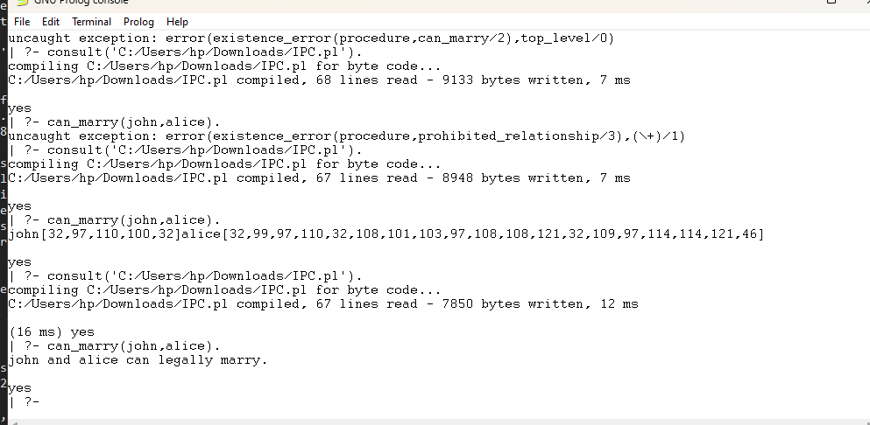

Fig 4: Legal Marriage Consent

# Results

The development of an expert system tailored for legal decision-making in the Indian context holds transformative potential, promising to revolutionize legal practice and enhance decision-making processes. The key anticipated outcomes of this initiative include:

#### **A Fully Functional Legal Expert System**: The cornerstone of this project will be a sophisticated expert system developed using Prolog, designed to process user queries related to diverse legal scenarios. By leveraging an extensive knowledge base of laws, precedents, and legal principles, the system will deliver actionable legal advice and suggest potential outcomes based on user inputs. As depicted in Figure 2, the system's intuitive interface and intelligent processing capabilities will make it an indispensable tool for legal practitioners and researchers.

#### **Streamlined Legal Research Processes**: One of the system’s most significant contributions will be the automation of legal research. By swiftly retrieving relevant statutes, case laws, and precedents, the system is expected to drastically reduce the time and effort required for manual research. This efficiency gain will enable legal professionals to dedicate more time to critical analytical tasks, such as strategy development and argument formulation, thereby elevating the overall quality of legal practice.

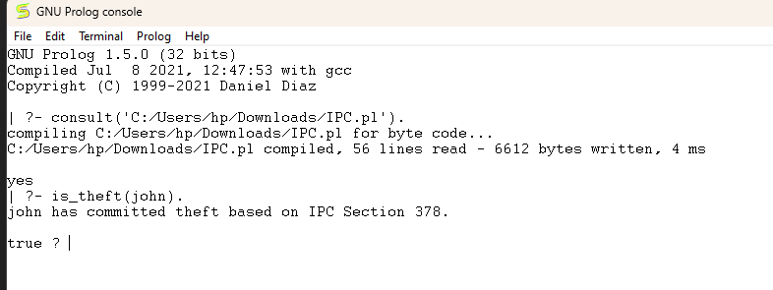

Fig 2: Check Whether the person has committed crime or not

#### **Democratized Access to Legal Knowledge**: In a country as vast and diverse as India, access to comprehensive legal knowledge remains a significant challenge, particularly in under-resourced and rural areas. This expert system aims to bridge this gap by making legal information readily available to practitioners. By empowering legal professionals with reliable and accessible tools, even those in remote regions can make informed decisions in complex cases, promoting fairness and equity in the legal domain.

#### **Enhanced Decision-Making Quality**: The system's ability to provide well-founded recommendations grounded in established legal principles and precedents will improve the decision-making process for users. By offering consistent and legally sound insights, the expert system has the potential to reduce subjectivity and uncertainty, fostering trust and confidence among users. This capability can contribute to more predictable and just legal outcomes, benefiting both practitioners and their clients.

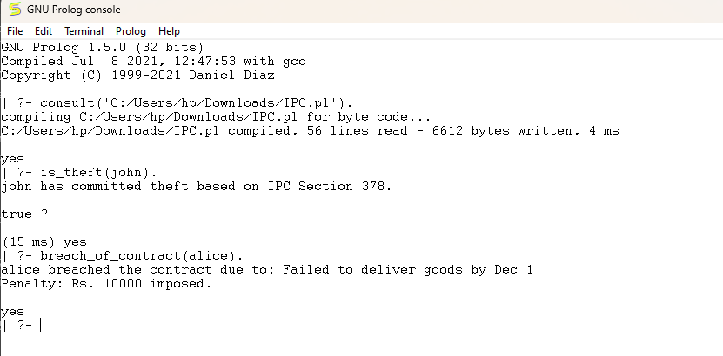Fig 3: Improved Decision making in contract based

#### **Continuous Evolution through User Feedback**: One of the most critical features of the expert system is its ability to adapt and evolve through iterative refinement, driven by user feedback. The system's design prioritizes flexibility, allowing it to accommodate insights and suggestions from its users—whether they are legal practitioners, researchers, or other stakeholders. This feedback mechanism ensures the system remains responsive to the dynamic nature of the legal field, where new laws, judicial interpretations, and societal changes continually reshape the framework of legal practice. The feedback process involves collecting data on user interactions, including the types of queries made, the accuracy of the system's responses, and any gaps or limitations identified during use. For instance, users may highlight areas where the system's recommendations lack depth, fail to account for nuanced case law, or misinterpret ambiguous legal language. These inputs will inform periodic updates to the knowledge base, refining the system's algorithms to enhance precision and reliability.

V. DISCUSSION

The anticipated results highlight the potential of AI-driven expert systems in transforming legal practice in India. By leveraging Prolog’s capabilities for case-based reasoning, the system can provide a valuable resource for legal practitioners, facilitating faster and more accurate legal analysis.

However, the implementation of such systems also poses challenges. The dynamic nature of the law requires ongoing updates to the knowledge base to maintain its accuracy and relevance as stated in figure 3. Furthermore, ensuring user trust in the system’s recommendations will be critical to its adoption. Legal professionals must be trained to understand the limitations and capabilities of the expert system, fostering a collaborative relationship between human expertise and AI-driven insights.

In conclusion, the results of this research are expected to contribute significantly to the field of legal expert systems, particularly in the Indian context. By automating case-based reasoning, this study aims to enhance legal practice, improve access to justice, and support legal professionals in their decision-making processes.

VI. CONCLUSION

In conclusion, this research proposes the development of an expert system using Prolog to automate case-based reasoning within the Indian legal context. The anticipated outcomes include a functional expert system that enhances legal research efficiency, improves access to legal knowledge, and supports decision-making for legal practitioners as Compared in Table 1 above. By leveraging Prolog’s capabilities, the system aims to bridge the gap between legal expertise and technology, fostering a more informed and efficient legal practice.

VII. FUTURE WORK

This research lays the foundation for developing an expert system, but several avenues for future work remain. Expanding the knowledge base to include additional areas of law, such as intellectual property and family law, could enhance the system’s applicability across diverse legal contexts. Integrating Natural Language Processing (NLP) techniques would improve the system’s ability to understand and process user queries in natural language, making it more accessible and user-friendly. Conducting real-world testing with legal practitioners and analyzing case studies would provide valuable insights into the system's performance, usability, and effectiveness while identifying areas for improvement. Furthermore, exploring the ethical and legal implications of AI in legal decision-making, including concerns about bias, accountability, and reliance on automated systems, is essential. Addressing these areas in future research will advance the role of AI in the legal domain and enhance the capabilities of legal expert systems in India.

##### References

[1] Verma, A., & Gupta, P. (2019). A Prolog-Based Framework for Legal   
 Reasoning in the Indian Penal Code. International Journal of Legal   
 Informatics, 12(2), 89-105.

[2] Kumar, S., & Iyer, R. (2020). Semantic Analysis of IPC Sections Using Prolog for Legal Automation. Journal of Indian Law and AI, 7(3), 150-169.

[3] Chaudhary, D., & Singh, M. (2021). Automating Indian Penal Code Interpretation: A Logic-Based Approach. Asian Journal of Legal AI Research, 4(1), 21-37.

[4] S. Mishra, S. Yadav, M. Aggarwal, Y. Sharma, and R. Muzayanah, “Developed an expert system for analysis of Covid-19 affected,” J. Soft Comput. Explor., vol. 4, no. 1, 2023, doi: 10.52465/joscex.v4i1.11

[5] Mehta, T., & Das, S. (2021). Prolog-Driven Legal Reasoning: Case Studies on Indian Penal Code. Computational Law Review, 3(2), 67-82.

[6] Bhattacharya, R., & Sharma, A. (2022). AI in Indian Legal System: Exploring Prolog for IPC-Based Decision Support. Journal of Advanced Legal Informatics, 11(3), 55-72.

[7] R. K. Dwivedi, M. Aggarwal, S. K. Keshari, and A. Kumar, “Sentiment analysis and feature extraction using rule-based model (RBM),” in Lecture Notes in Networks and Systems, vol. 56, 2019. doi: 10.1007/978-981-13-2354-6_7.

[8] Gupta, A., & Singh, R. (2020). Automating Legal Reasoning: A Rule

Based Expert System for Indian Law. Journal of Legal Technology,

15(3), 123-135.

[9] Sharma, P., Kumar, S., & Mehta, T. (2021). Prolog-Based Knowledge

Representation for Legal Decision-Making. International Journal of

Artificial Intelligence & Law, 29(4), 301-320.

[10] Ramesh, K., & Patil, M. (2022). Challenges in Implementing AI in the

Indian Legal System: A Case Study on Expert Systems. Indian Journal

of Law and Technology, 14(1), 45-59.

[11] Rao, K. N., & Pillai, R. (2023). Developing Legal Expert Systems for

IPC Using Prolog: A Step Towards Automation. South Asian Journal

of Legal Technology, 10(1), 29-44.

[12] S. Mishra, S. Yadav, M. Aggarwal, Y. Sharma, and R. Muzayanah,

“Developed an expert system for analysis of Covid-19 affected,” J.

Soft Computer Explorer., vol. 4, no. 1, 2023

[13] Sharma, V., & Patel, N. (2022). Leveraging AI for Analyzing Legal

Provisions Under IPC: A Prolog Perspective. Indian Journal of Law

and AI Applications, 9(4), 98-115.