Project report on online examination system

Prepared by : Guided by : Patel vipul B. (04) Prof. H.B.Patel
Patel pratik A. (07) Prof. K.L.Patel
Software Requirements Specification for Online Examination System
TABLE CONTENTS

1 INRODUCTION .................................................................................................................
1.1 PURPOSE ........................................................................................................................
1.2 SCOPE ............................................................................................................................
1.3 OVERVIEW .....................................................................................................................

2 GENERAL DESCRIPTION..............................................................................................
2.1 USER MANUAL................................................................................................................

3 FUNCTIONAL REQUIREMENTS .................................................................................
3.1 DESCRIPTION ..................................................................................................................
3.2 TECHNICAL ISSUES .........................................................................................................

4 INTERFACE REQUIREMENTS .....................................................................................
4.1 GUI ................................................................................................................................
4.2 HARDWARE INTERFACE ..................................................................................................
4.3 SOFTWARE INTERFACE ..................................................................................................

5 PERFORMANCE REQUIREMENTS .............................................................................

6 DESIGN CONSTRAINTS .................................................................................................

7 OTHER NON FUNCTIONAL ATTRIBUTES .............................................................
7.1 SECURITY .......................................................................................................................
7.2 RELIABILITY ...................................................................................................................
7.3 AVAILABILITY ................................................................................................................
7.4 MAINTAINABILITY ..........................................................................................................
7.5 REUSABILITY ..................................................................................................................

8 OPERATIONAL SCENARIOS .......................................................................................

9 PRELIMINARY SCHEDULE .........................................................................................

1. INRODUCTION

1.1 Purpose

- This Web Application provides facility to conduct online examination world wide.
- It saves time as it allows number of students to give the exam at a time and displays the results as the test gets over, so no need to wait for the result. wait for the result. It is automatically generated by the server.

- Administrator has a privilege to create, modify and delete the test papers and its particular questions.

- User can register, login and give the test with his specific id, and can see the results as well.

1.2 Scope

- this system allow to student to give their exam at any palce.it s save paper and give result very fast.

1.3 Overview

- this system provide an easy solution to the student to give exam online.

2. General Description

This Web Application provides facility to conduct online examination world wide. It saves time as it allows number of students to give the exam at a time and displays the results as the test gets over, so no need to wait for the result.It is automatically generated by
the server.
Administrator has a privilege to create, modify and delete the test papers and its particular questions. User can register, login and give the test with his specific id, and can see the results as well.

Data flow diagrams :
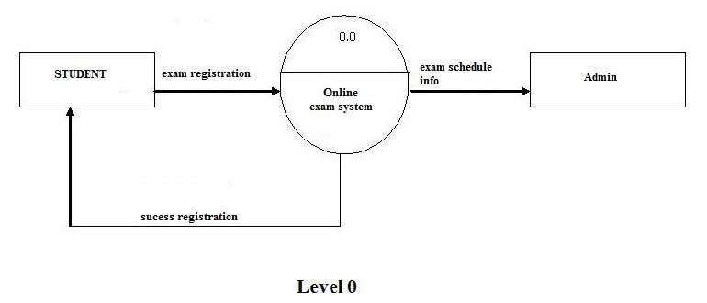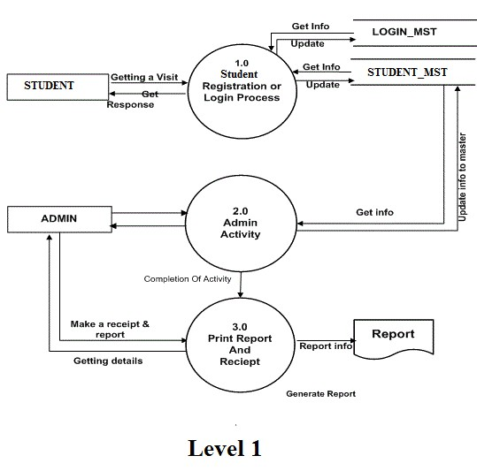
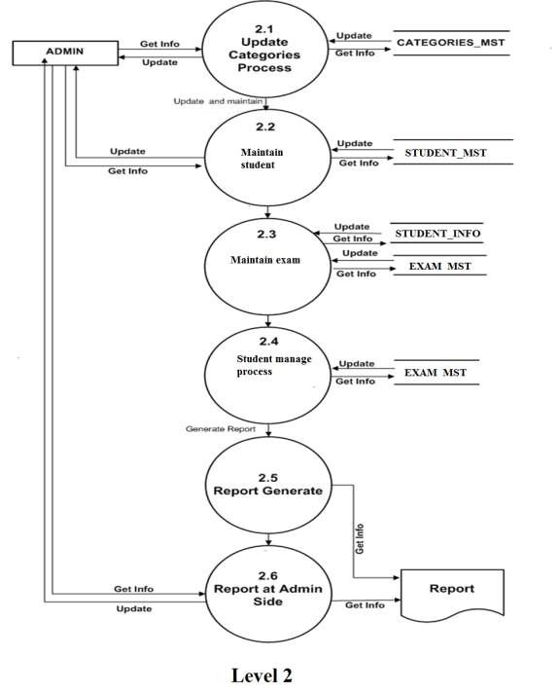

.
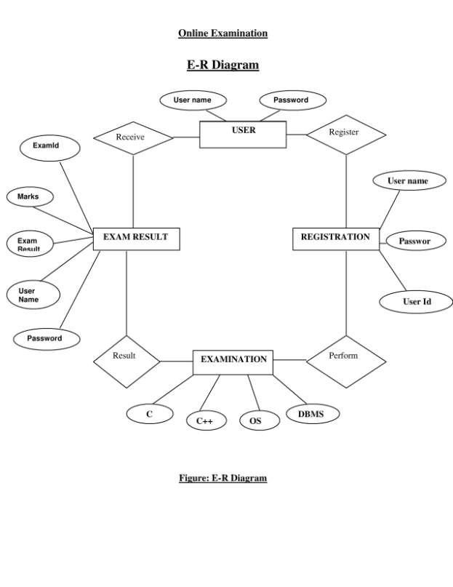

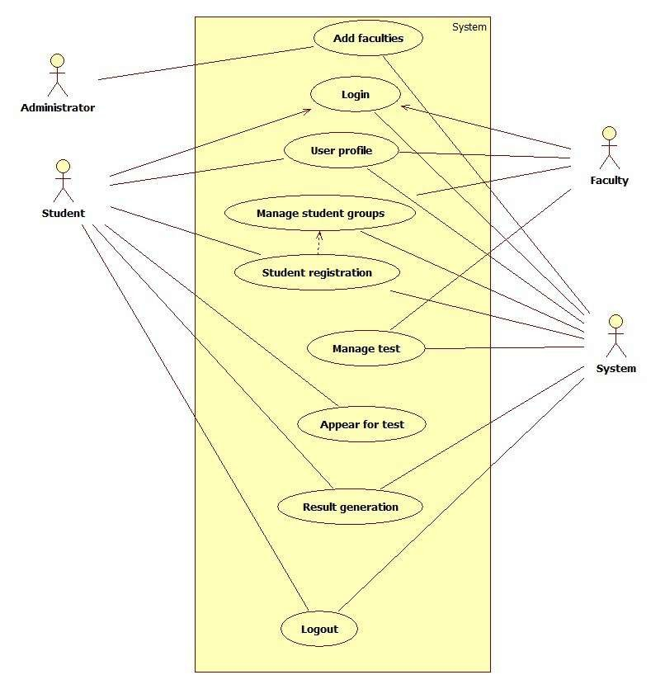

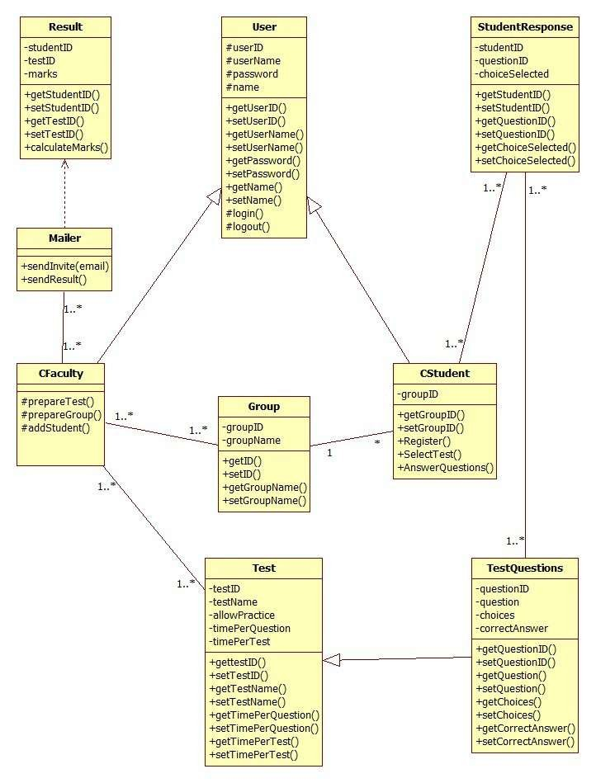

2.1 User Manual

This System should Help option in which how to operate the system should be explained. Also hard copy of this document should be given to the user in item form server.

3. Functional Requirements

3.1 Description

The Online Examination System is developed for handling the activities for various users such as student, staff, exam staff. Every teacher should have laptop with wireless internet connection.

3.2 Technical Issues

This product will work on client-server architecture. It will be require an internet server and which will be able to run PHP application. The product should be support some commonly used browsers such as Internet Explorer, Mozilla Firefox. External interfaces include key board and mouse, enabling navigation s across the screens

4. Interface Requirements
Various Interfaces for the products could be

Login form Examination form Result form
C Language exam form C++ language exam form Operating system exam form Registration form
Reports form

4.1 GUI

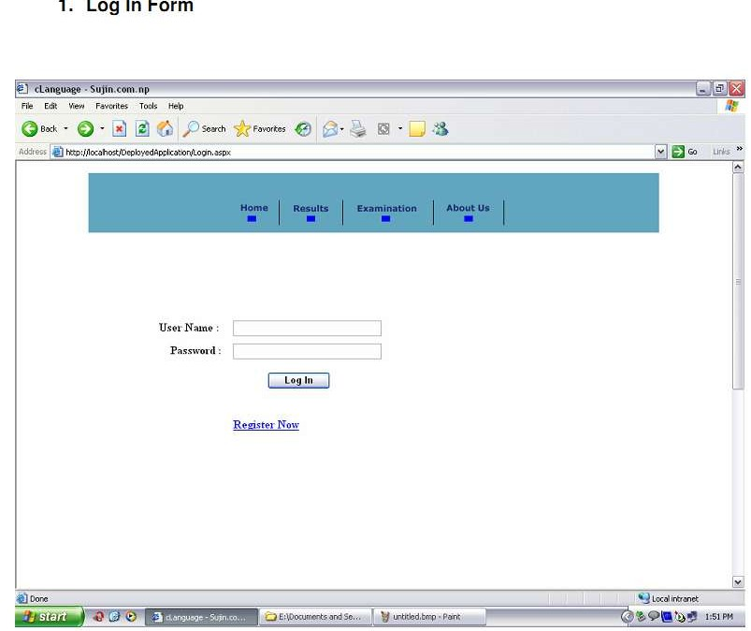

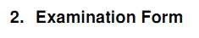

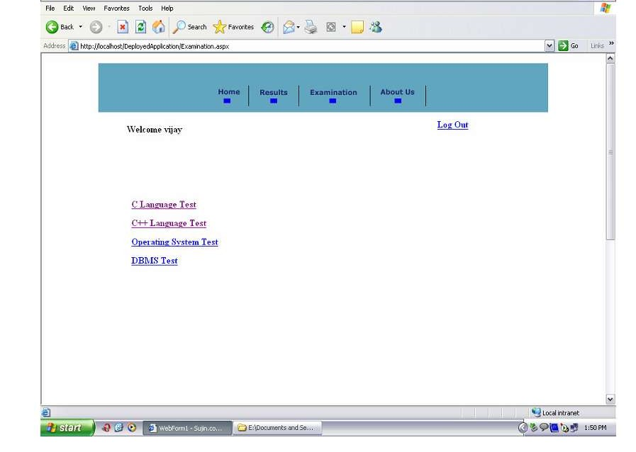

3. Result Form

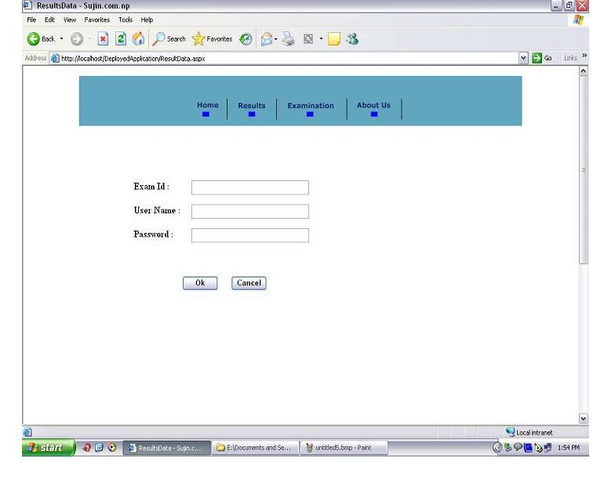

4. C language exam form
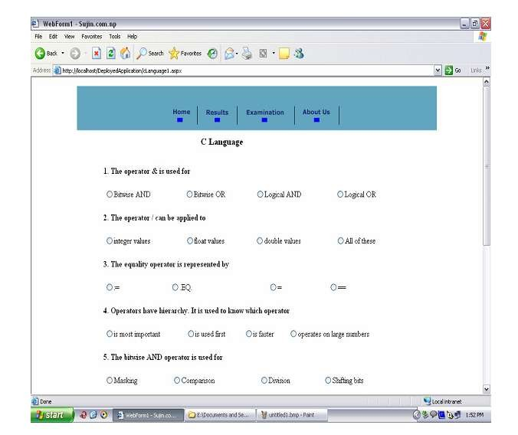

5. C++ LANGUAGE EXAM FORM :

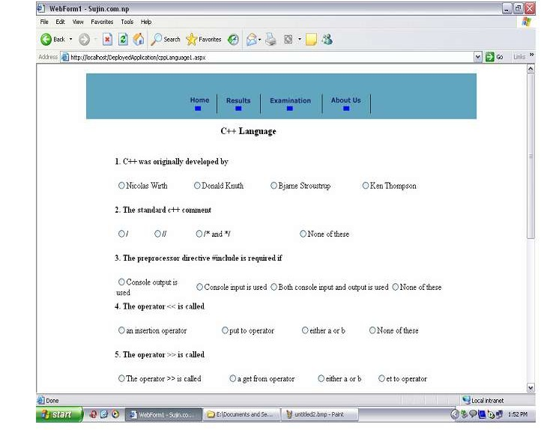

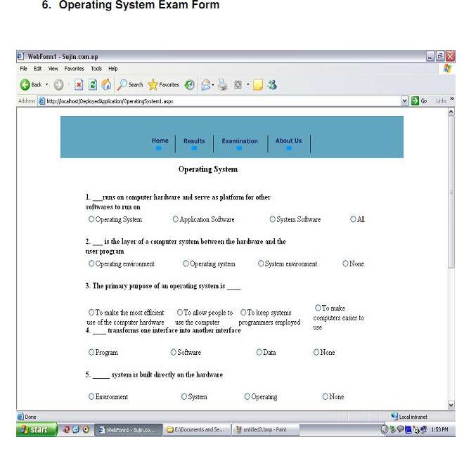

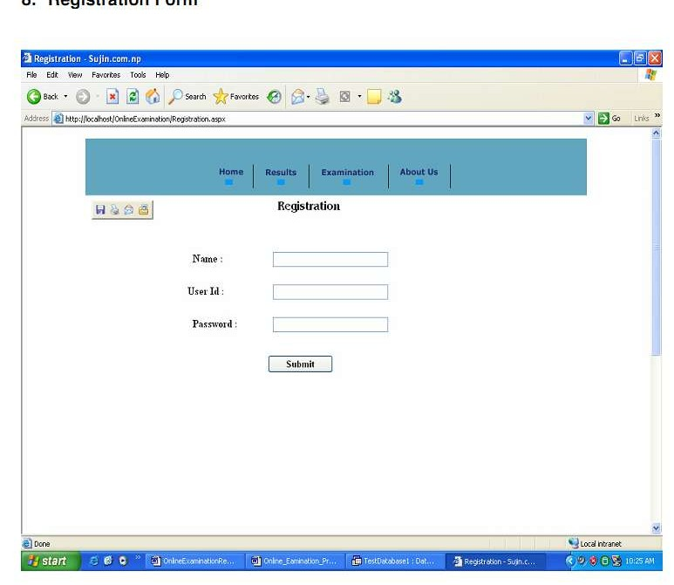

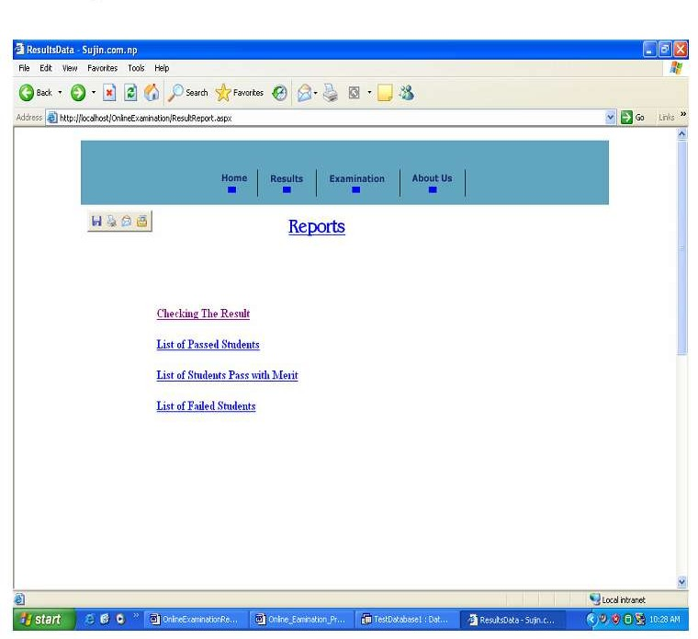
4.2 Hard ware Requirements

1. The application demands that all the PCs must be present in the internet
.
2. Pc should be sufficiently fast with adequate memory at least 64 MB RAM
and 2 GB hard –disk space is required to run this application.

3. Screen resolution of at least 800*600 required to properly view the screen.

4. It should be support the printers

4.3 Software Requirements

1. Any Window Operating System.

2. The PHP must be installed. For the database handling MYSQL must be installed.

3. The final application must be packaged in a set up program, so that the product can be easily installed on the clients-machine.

5. Performance Requirements

- The E-mail should be sent within one hour after the registration.

- The system should support registration for examination maximum of
Students.
6. Design Constraints

The system should be designed within in 7 months.

7. Other Non Functional Attributes

7.1 Security

Application will allow only valid users to access the system. Access to any will application resource depend upon user’s designation. There are two types
of users namely Administrator and Student . Security is based upon the individual user ID and Password.

7.2 Reliability

The application should be highly reliable and it should generate all the updated information in correct order.

7.3 Availability

System will be available around the clock except for the time required for the back up of data.

7.4 Maintainability

The installation and operation manual of examination management system will be provided to user.

7.5 Portability

The application should be portable on any windows based system

8. Operational Scenarios

There will be student database, examination database. The student database will contain students name, e-mail address, address, phone number, qualification.

The examination database contain exam date, time, exam hall ticket for student.

9. Preliminary Schedule

This Product must be completed within 7 months.

