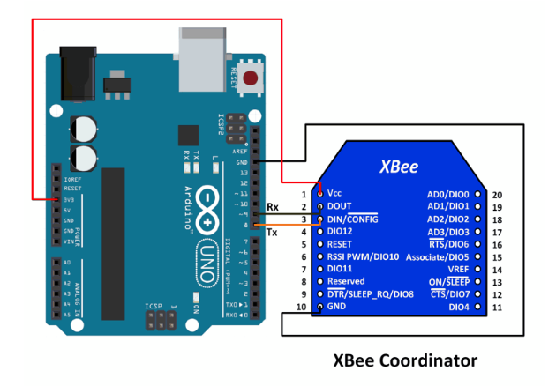

Figure 1: XBee-Arduino Interface (ElectronicWings 2019).

To wire your LCD screen to your board, connect the following pins:

* LCD RS pin to digital pin 9
* LCD Enable pin to digital pin 8
* LCD D4 pin to digital pin 7
* LCD D5 pin to digital pin 6
* LCD D6 pin to digital pin 5
* LCD D7 pin to digital pin 4

Furthermore, wire a 10k pot to +5V and GND, with its output to LCD screens VO pin (pin3). A 220ohm resistor is used to power the backlight of the display, usually on pin 15 and 16 of the LCD connector.

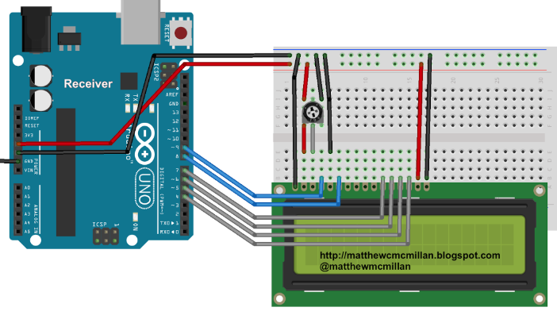

Figure 2: LCD-Arduino interface (Matthew McMillan 2019).

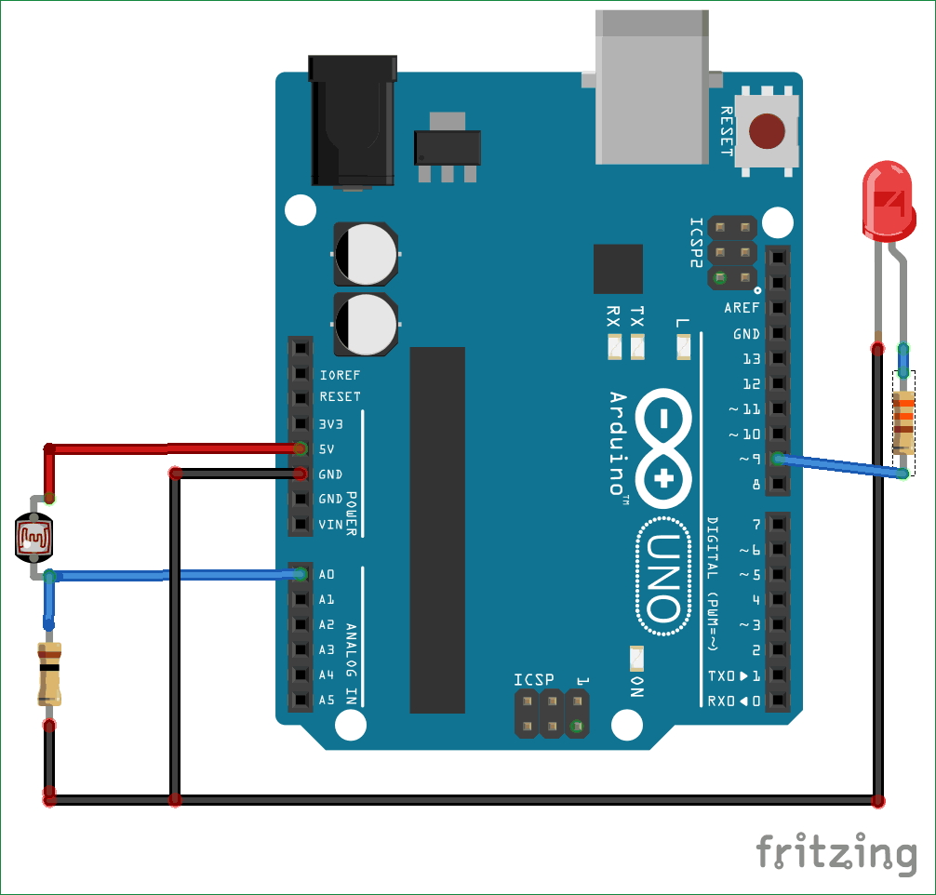

Figure 3: LDR-Arduino interface (Pankaj Khatri 2018).

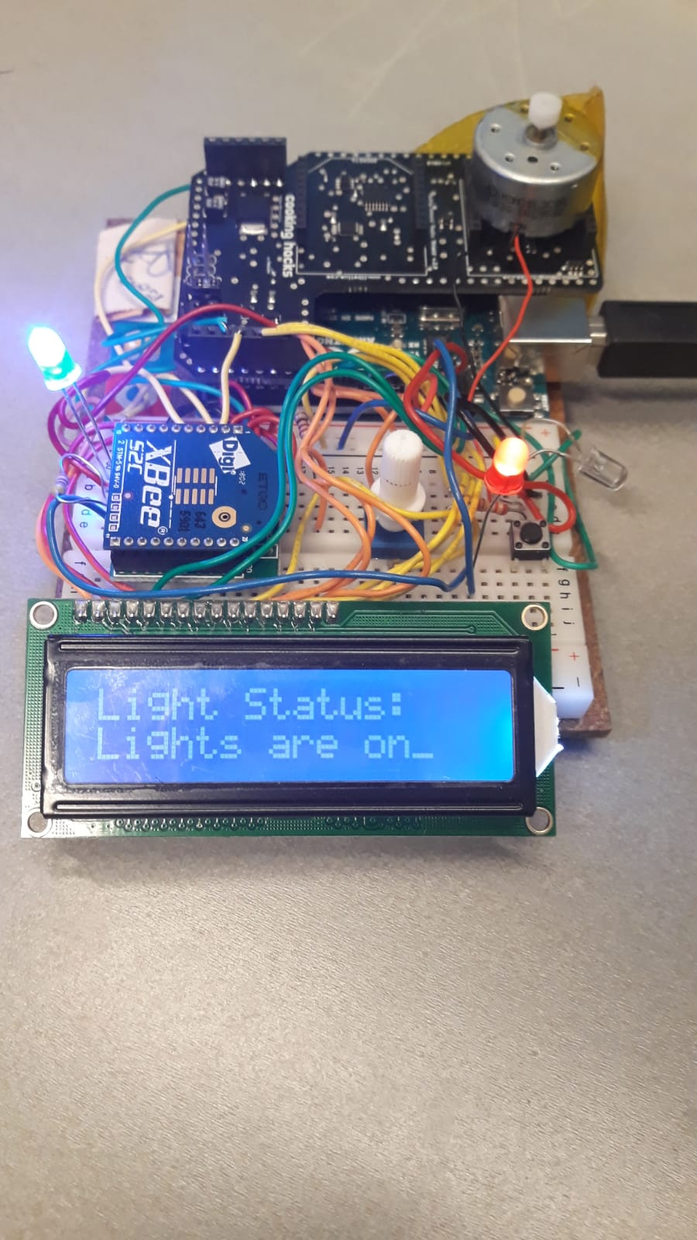

**References:**

ElectronicWings (2019). *XBee S2 (ZigBee) Interfacing with Arduino UNO.* Available online: https://www.electronicwings.com/arduino/xbee-s2-zigbee-interfacing-with-arduino-uno.

Matthew McMillan (2019). *Arduino - Sending data over a CAN bus.* Available online: http://matthewcmcmillan.blogspot.com/2013/10/arduino-sending-data-over-can-bus.html.

Pankaj Khatri (2018). *Arduino Light Sensor Circuit using LDR.* circuitdigest 2019. Available online: https://circuitdigest.com/microcontroller-projects/arduino-light-sensor-using-ldr.