PRDA-04
Customer Data Analysis Report
Shopping behaviour in 10 Istanbul malls by gender, age, category and payment method
Dataset: project_customer_segmentation.customer (MySQL) · 99,457 transactions · 10 attributes
Period: 1 January 2021 to 8 March 2023
Tools used: MySQL Workbench, Microsoft Excel, Power BI Desktop, Tableau
Submitted by: ________________________
Date: October 2026

1. Introduction
This project analyses shopping data from 10 shopping malls in Istanbul between January 2021 and March 2023. The goal is to understand who the customers are (gender and age), what they buy (product categories), how they pay, and which groups bring the most sales and revenue. The findings are used to give practical suggestions to the business.
The data was taken from the MySQL database project_customer_segmentation (table customer). Each row is one shopping transaction.
Column | Meaning
invoice_no | Unique invoice number (I + 6 digits)
customer_id | Customer number (C + 6 digits)
gender | Female or Male
age | Age of the customer (18 to 69)
category | Product category (8 categories)
quantity | Number of items in the transaction (1 to 5)
price | Amount paid in Turkish Lira (TL); see note in Section 2
payment_method | Cash, Credit Card or Debit Card
invoice_date | Date of the transaction
shopping_mall | Mall where the purchase was made (10 malls)

Project questions: shopping distribution, products sold and revenue by gender (Q1–Q3) and by age category (Q5–Q7); distribution of purchase categories relative to other columns (Q4, Q8); the relation of payment method with other columns and its distribution (Q9, Q10); and a Power BI / Tableau dashboard with insights and suggestions (Q11).

2. Data Preparation
The data was checked for quality before analysis. All 99,457 rows were downloaded (MySQL Workbench's 1,000-row limit was switched off).
Check | Result | Action
Missing values | None in any column | No action needed
Duplicates | No duplicate rows or invoice numbers | No action needed
Data types | Dates, numbers and text all read correctly | Confirmed types in Power Query
Price column | Each category has one unit price, and price = quantity × unit price | Used price directly as Revenue; did not multiply by quantity again
Customer ID | Every customer_id appears only once | Counted transactions, not repeat customers
Date range | March 2023 has only 8 days of data | Noted on the monthly trend chart

Important finding: the brief describes price as the price per unit, but the data shows it is already the total amount of the transaction. For example, one Clothing item costs 300.08 TL, and a 5-item Clothing purchase is recorded as 1,500.40 TL. Multiplying quantity × price would count quantity twice and give a wrong revenue of 251.5M TL instead of 68.55M TL.

New columns and measures
Name | Logic
Revenue | price (already the transaction total)
Unit Price | Revenue ÷ quantity
Age Group | 18-29, 30-39, 40-49, 50-59, 60-69
Year, Month | From invoice_date, for the trend chart
Total Transactions | Count of rows (invoices)
Total Quantity | Sum of quantity
Total Revenue | Sum of Revenue
Avg Order Value | Total Revenue ÷ Total Transactions

3. Key Figures
KPI | Value
Total transactions | 99,457
Total items sold | 298,712
Total revenue | 68,551,366 TL (68.55M)
Average order value | 689.26 TL
Average items per transaction | 3.0
Average customer age | 43.4 years
Revenue 2021 / 2022 | 31.32M TL / 31.37M TL

4. Dashboards
The dashboard was built in Power BI (3 pages: gender and payment overview, age and category, payment method relations) and rebuilt in Tableau.
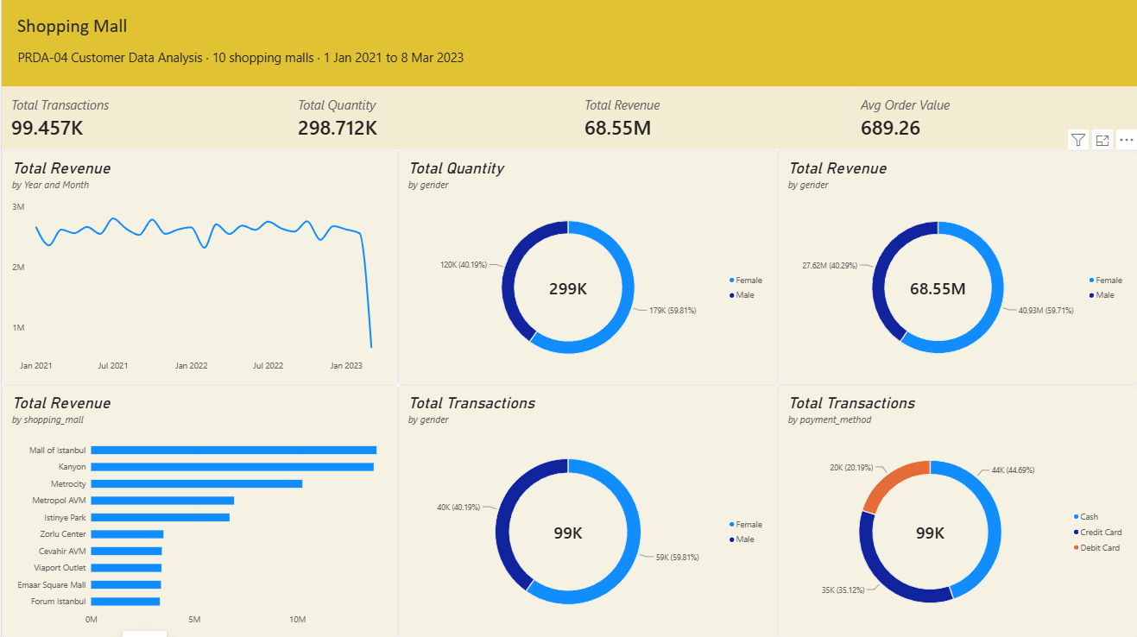
Figure 1. Power BI page 1: KPIs, monthly revenue, gender, malls and payment method
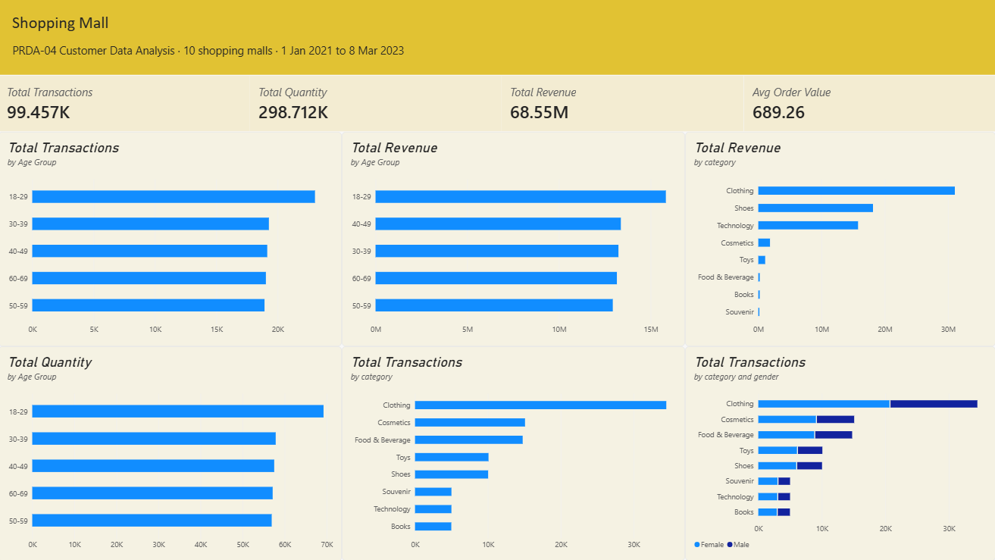
Figure 2. Power BI page 2: age groups and product categories
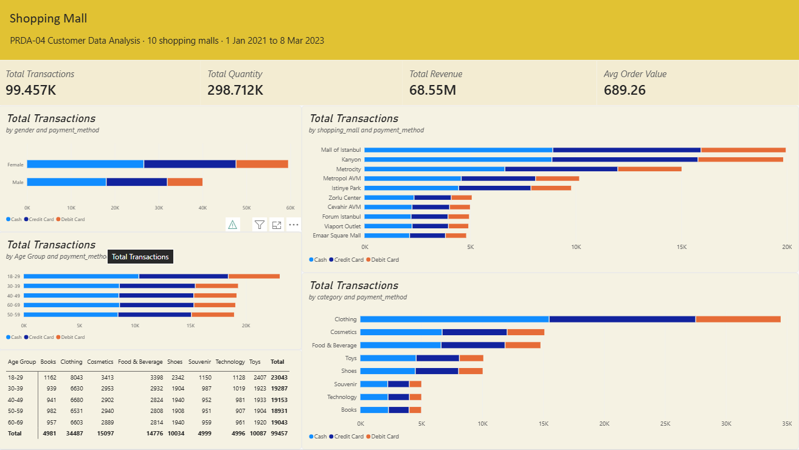
Figure 3. Power BI page 3: payment method by gender, age, mall and category
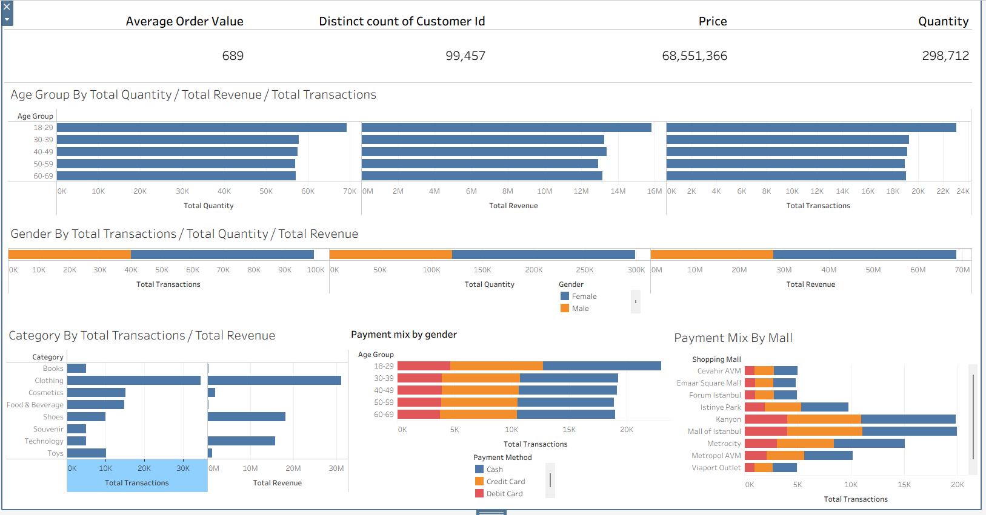
Figure 4. Tableau page 1: KPIs, age, gender, category and payment mix
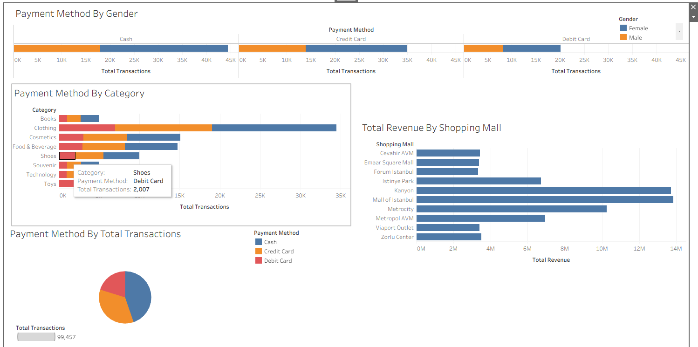
Figure 5. Tableau page 2: payment method, category and revenue by mall

5. Answers to the Project Questions

Q1. Shopping distribution by gender
Finding: Female customers made 59,482 transactions (59.8%) and male customers 39,975 (40.2%).
Answer: Women make 6 out of every 10 purchases.

Q2. Which gender bought more products?
Finding: Women bought 178,659 items (59.8%) and men 120,053 items (40.2%). Both buy about 3 items per transaction.
Answer: Women bought more products, because there are more female shoppers, not because they buy more items per visit.

Q3. Which gender generated more revenue?
Finding: Women generated 40.93M TL (59.7%) and men 27.62M TL (40.3%). The average order value is almost the same: 688 TL for women and 691 TL for men.
Answer: Women generated more revenue. Men and women spend the same amount per purchase.

Q4 and Q8. Distribution of purchase categories relative to other columns
Finding: Clothing is the largest category with 34.7% of transactions and 45.3% of revenue (31.08M TL). Shoes (18.14M TL) and Technology (15.77M TL) follow. Clothing, Shoes and Technology together make 94.8% of revenue. Food & Beverage has 14.9% of transactions but only 0.3% of revenue, because one item costs 5.23 TL, compared with 1,050 TL for Technology. Every category is 58–60% female, every age group buys the same category mix (within 1 point), and Clothing is 34–35% of purchases in every mall.
Answer: Category volumes and revenue are very different, but the category mix does not change with gender, age, payment method or mall. All customer groups buy the same kinds of products.

Q5. Shopping distribution by age
Finding: The 18-29 group made 23,043 transactions. The other groups each made about 19,000 (30-39: 19,287; 40-49: 19,153; 50-59: 18,931; 60-69: 19,043). Note that 18-29 covers 12 ages while the other groups cover 10. Looking at single ages, every age from 18 to 69 has between 1,830 and 2,057 transactions.
Answer: Shopping is spread evenly across all ages. The 18-29 group looks largest only because it covers more ages.

Q6. Which age category bought more products?
Finding: 18-29: 69,245 items; 30-39: 57,875; 40-49: 57,517; 60-69: 57,153; 50-59: 56,922.
Answer: 18-29 bought the most products, for the same reason as Q5. Per year of age, all groups are similar.

Q7. Which age category generated more revenue?
Finding: 18-29: 15.83M TL; 40-49: 13.38M TL; 30-39: 13.25M TL; 60-69: 13.16M TL; 50-59: 12.94M TL. Average order value is 683–698 TL in every group.
Answer: 18-29 generated the most revenue. Spending per purchase is the same for all ages.

Q9. Does payment method relate to other columns?
Finding: The payment mix is about 45% Cash, 35% Credit Card and 20% Debit Card for every gender, every age group, every category and every mall; no group differs by more than about 1.5 points. The average order value is also the same for each method (687–691 TL).
Answer: No. Payment method has no real relation with gender, age, category, mall or order size.

Q10. Distribution of payment method
Finding: Cash: 44,447 transactions (44.7%); Credit Card: 34,931 (35.1%); Debit Card: 20,079 (20.2%).
Answer: Cash is the most common method, but card payments together make up 55.3% of transactions.

Additional insights
- Malls: Mall of Istanbul (13.85M TL) and Kanyon (13.71M TL) bring 40% of total revenue. Five malls each bring only about 3.3–3.5M TL.
- Trend: monthly revenue is stable at about 2.6M TL. Revenue in 2022 (31.37M TL) was almost the same as in 2021 (31.32M TL). February is slightly lower each year. The low value in March 2023 is because data stops on 8 March.
- Customers: every customer ID appears only once, so repeat-customer behaviour cannot be measured with this data.

6. Suggestions for the Company
- Focus on the high-value categories. Clothing, Shoes and Technology bring 95% of revenue. Keep these well stocked, give them the best store space and run promotions on them.
- Use low-price categories to bring people in. Food & Beverage and Cosmetics are bought often but earn little. Use them for cross-selling, such as bundles or vouchers that lead customers to Clothing and Shoes.
- Grow the male customer base. Men are only 40% of shoppers but spend as much per order as women. Campaigns aimed at men could raise revenue without lowering order value.
- Keep marketing broad across ages. All ages shop and spend the same, so there is no need to target one age group; age can guide the choice of channel (social media for younger shoppers, for example) rather than the offer.
- Start a loyalty programme. Customers cannot be followed over time, and 45% pay in cash, which is anonymous. A loyalty card or app would track repeat visits and allow personal offers.
- Encourage card and digital payments. Card payments are already 55%. Small card or app rewards would speed up checkout and give better customer data.
- Learn from the top malls. Study what makes Mall of Istanbul and Kanyon successful (brands, location, events) and apply it to the five smaller malls, or review their store mix.
- Plan for February. Revenue dips slightly each February. A seasonal campaign can fill this gap.
- Improve the data. Correct the description of the price column (it is a total, not a unit price) and keep adding data after March 2023 so trends can be followed.

7. Conclusion
The 10 malls made 99,457 sales worth 68.55M TL between January 2021 and March 2023, with steady monthly revenue of about 2.6M TL. Women make about 60% of purchases and revenue, but both genders spend the same per order. Shoppers are spread evenly across all ages, and all customer groups buy the same mix of products and pay in the same way.
Revenue depends heavily on three categories (Clothing, Shoes and Technology) and two malls (Mall of Istanbul and Kanyon). The biggest opportunities are to protect and grow these high-value categories, attract more male shoppers, use low-price categories to drive cross-selling, and introduce a loyalty programme so the company can understand and keep its customers over time.

