PRDA-03
HR Analytics Project Report
Workforce overview, attrition analysis and recommendations
Dataset: project_hr_analytics.HR (MySQL) · 22,214 employees · 13 attributes
Tools used: MySQL Workbench, Power BI Desktop, Tableau, Microsoft Excel
Submitted by: ________________________
Date: October 2026

1. Introduction
HR analytics helps a company understand its workforce: who works there, where, how hiring has changed over time, and why people leave. This project analyses the HR table of a company with 22,214 employees to build a dashboard and give data-driven suggestions to the company.
The data was taken from the MySQL database project_hr_analytics (table HR) using the credentials given in the project brief. It holds one row per employee with these attributes:
Column | Meaning
id | Employee identification number
first_name, last_name | Employee name
birthdate, Age | Date of birth and age of the employee
gender | Male, Female or Non-Conforming
race | Race of the employee (7 groups)
department, jobtitle | Department (13) and job title (185)
location | Headquarters or Remote
hire_date | Date the employee joined (Oct 2000 to Dec 2020)
termdate | Date the employee left; blank if still employed
location_city, location_state | City and state of the office or work site (7 states)

Project tasks: (1) get the data from the database, (2) build 3 KPIs: number of employees, % remote vs HQ, and average age, (3) a line chart of hiring by year, (4) a donut chart of gender, (5) bar charts by state, department and race, (6) analyse all features and derive insights, and (7) build a Power BI / Tableau dashboard and give suggestions to the company.

2. Data Cleaning and Preparation
The data was checked for completeness and quality before analysis. All 22,214 rows were loaded (MySQL Workbench's default 1,000-row limit was switched off), and there were no duplicate employee IDs.
Issue found | Detail | Action taken
Missing values | Only termdate is empty (18,285 rows, 82%). All other columns are complete. | Kept. A blank termdate means the employee is still working (Active).
Date format | hire_date and birthdate are text in day-month-year format (e.g. 20-01-2002). | Converted to Date using the English (United Kingdom) locale in Power Query.
termdate format | Stored as text with time and time zone, e.g. 2029-10-29 06:09:38 UTC. | Kept the first 10 characters (Extract → First Characters) and converted to Date.
Future termdates | 1,030 termdates are after today (up to 2041). | Treated as Active, because the employee has not left yet.
Duplicate query | The table was loaded twice (HR and HR (2)). | Deleted the copy and kept one HR table.

New columns created (DAX)
Column | Logic
Employee Status | Active if termdate is blank or in the future, otherwise Terminated
Age Group | 20-29, 30-39, 40-49, 50+
Hire Year | Year of hire_date
Term Year | Year of termdate, for terminated employees only
Tenure (Years) | Full years from hire_date to termdate (or to today if active)
Tenure Group | 0-5, 6-10, 11-15, 16+ years (sorted with a helper column, Tenure Order)

Measures created (DAX)
- % HQ and % Remote: employees at each location ÷ total employees
- Attrition Rate: terminated employees ÷ total employees
- Employees Left: count of employees with status Terminated

3. KPI Values
KPI | Value
Total employees | 22,214
Working at Headquarters | 75.2% (16,715)
Working remotely | 24.8% (5,499)
Average age | 38.4 years
Active employees | 19,313
Employees who left | 2,901
Attrition rate | 13.1%
Average tenure of leavers | 8.0 years

Note: attrition counts termdates up to the date of analysis (end of September 2026). Because it depends on the current date, the value can differ slightly (13.05%–13.06%) between tools.

4. Dashboard
The dashboard was built in Power BI with two pages: Workforce Overview (KPIs and the required charts) and Attrition Analysis. Power BI pages are shown in Figures 1 and 2, and the Tableau version in Figure 3.
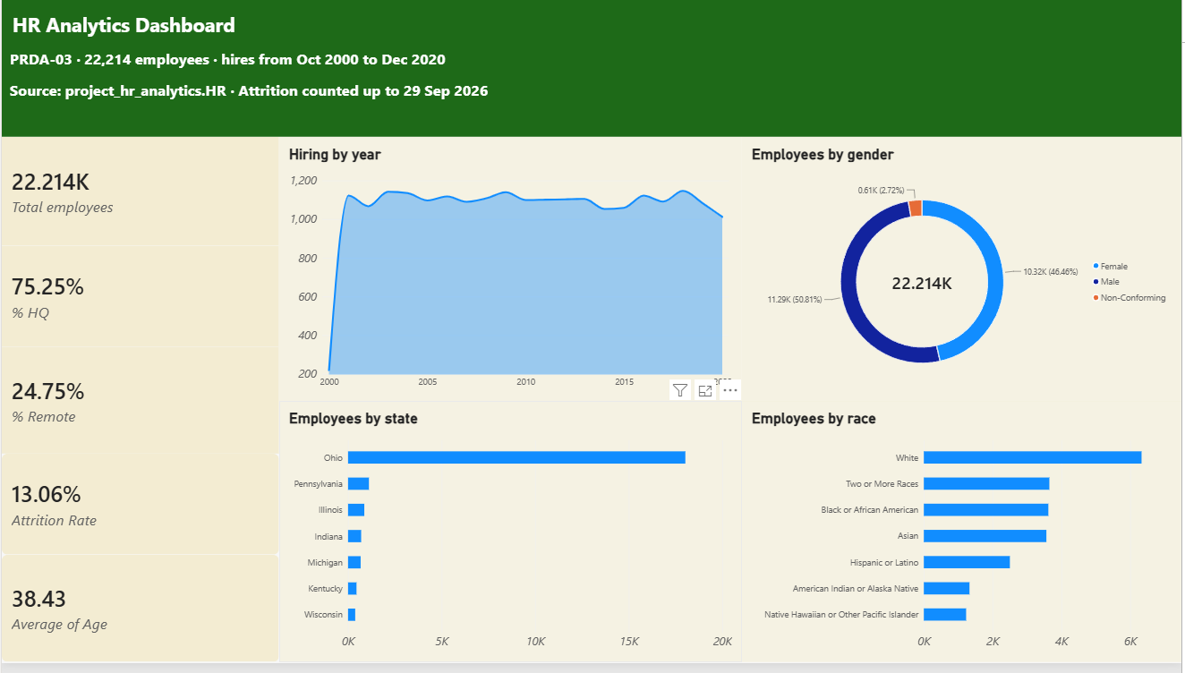
Figure 1. Page 1: KPIs, hiring by year, gender, state and race
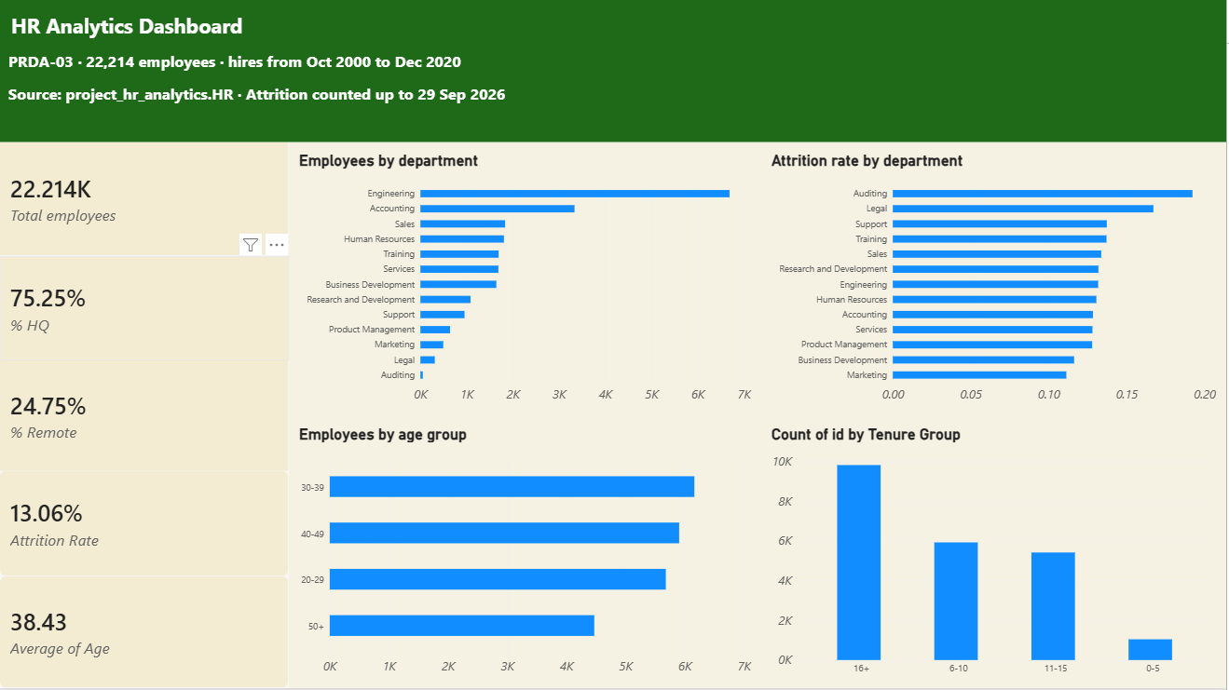
Figure 2. Page 2: department, attrition by department, age group and tenure

Tableau dashboard
The same KPIs and charts were rebuilt in Tableau using calculated fields (Employee Status, Age Group, Hire Year, Tenure Group, % HQ, % Remote and Attrition Rate). The KPI values match the Power BI dashboard.
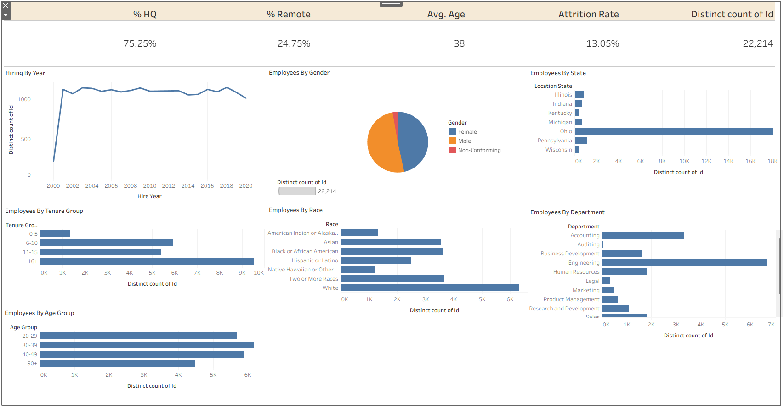
Figure 3. Tableau dashboard: KPIs, hiring by year, gender, state, tenure, race, department and age group

5. Insights

5.1 Hiring by year (line chart)
Finding: Hiring is very stable at about 1,000 to 1,150 employees every year from 2001 to 2020. The low value in 2000 (220) is only because the data starts in October 2000.
What it means: The company has a steady hiring pipeline, with no years of sharp growth or freezes.

5.2 Employees by gender (donut chart)
Finding: Male 11,288 (50.8%), Female 10,321 (46.5%), Non-Conforming 605 (2.7%).
What it means: The gender split is nearly balanced. Every department has 43–48% women: Product Management has the lowest share (43.2%) and Human Resources the highest (47.6%).

5.3 Employees by state (bar chart)
Finding: Ohio has 18,025 employees (81%). The other six states are much smaller: Pennsylvania 1,115, Illinois 868, Indiana 700, Michigan 673, Kentucky 451 and Wisconsin 382.
What it means: The company is concentrated around its headquarters in Cleveland, Ohio (16,871 employees). Branch offices are small.

5.4 Employees by race (bar chart)
Finding: White is the largest group (6,328, 28.5%), followed by Two or More Races (3,648), Black or African American (3,619) and Asian (3,562). No group other than White is above 17%.
What it means: The workforce is diverse. Attrition is similar across races (12.2%–14.6%), which suggests no group leaves at a much higher rate.

5.5 Employees by department (bar chart)
Finding: Engineering has 6,686 employees (30%) and Accounting 3,333 (15%). Together they are almost half the company. Auditing is the smallest (52).
What it means: Engineering and Accounting are the core of the workforce, so retention problems there would have the biggest impact.

5.6 Remote vs Headquarters (KPI)
Finding: 75.2% of employees work at Headquarters and 24.8% work remotely. Remote employees have a lower attrition rate (12.3%) than HQ employees (13.3%).
What it means: Remote work does not increase attrition; if anything, remote employees stay slightly longer.

5.7 Average age and age groups
Finding: The average age is 38.4 years (range 20–57). Age groups are evenly spread: 20-29: 5,679, 30-39: 6,161, 40-49: 5,904, 50+: 4,470. Attrition is almost the same in every age group (12.5%–13.3%).
What it means: The workforce is mid-career on average. About 20% of employees are 50 or older and will retire in the coming years.

5.8 Attrition rate by department
Finding: Auditing (19.2%) and Legal (16.7%) have the highest attrition. Marketing (11.1%) and Business Development (11.6%) have the lowest. Most departments are between 12.8% and 13.7%.
What it means: Auditing has only 52 employees, so its rate can change a lot with a few people. Legal (311 employees) is the more reliable warning sign.

5.9 How long leavers stayed (tenure)
Finding: Of the 2,901 employees who left, 1,143 (39%) left within their first 5 years, 810 (28%) after 6–10 years, 592 (20%) after 11–15 years and 356 (12%) after 16+ years.
What it means: Early-career employees are the most likely to leave. The longer people stay, the more likely they are to stay.

5.10 Hires vs leavers by year
Finding: Hiring has stayed flat at about 1,100 a year, but the number of leavers has grown every year: from 7 in 2001 to 116 in 2010 and a peak of 205 in 2021. It has stayed at about 160–186 a year since.
What it means: Net growth of the company is slowing because more people leave each year while hiring stays the same.

6. Suggestions for the Company
- Improve early-career retention. 39% of leavers go within 5 years. Strengthen onboarding, assign mentors, hold check-ins at 6 months, 1 year and 3 years, and show clear career paths and promotion criteria.
- Investigate Legal and Auditing. Run exit interviews and engagement surveys in these departments to find the causes (workload, pay, growth). Treat the Auditing rate with care because the team is small.
- Plan hiring against rising attrition. Leavers have grown from under 100 to about 170 a year while hiring stayed flat. Track net headcount (hires minus leavers) each quarter and adjust hiring targets.
- Support remote and flexible work. Remote employees leave less often (12.3% vs 13.3%). Offering more flexible or hybrid options could help retention, especially in departments with high attrition.
- Prepare for retirements. About 20% of the workforce is 50 or older. Start succession planning and knowledge transfer for senior roles.
- Reduce dependence on one location. 81% of employees are in Ohio. Growing the branch offices or remote hiring would widen the talent pool and reduce risk.
- Keep diversity strong. Gender and race are well balanced and attrition is similar across groups. Keep monitoring these numbers every year.
- Improve HR data quality. Fix the 1,030 termdates set in the future, add hires after 2020, and calculate age from birthdate automatically so the dashboard stays accurate.

7. Conclusion
The company has a large (22,214), diverse and gender-balanced workforce, centred on its Ohio headquarters, with a quarter of employees working remotely and an average age of 38.4 years. Hiring has been steady for 20 years.
The main concern is attrition. 13.1% of employees have left, the number of leavers has risen every year, and most leave early in their careers. Legal and Auditing have the highest attrition. By focusing on early-career retention, investigating high-attrition departments and planning hiring against rising attrition, the company can keep its workforce stable and growing. The Power BI dashboard built in this project lets HR track these numbers and filter them by department, gender, location and age.

