

**Islamic University of Gaza**

**Computer Engineering**

بسم الله الرحمن الرحيم

**Embedded Systems**

**Homework #1**

Student Name **Akram Hatem Abo Jbara**

Student No.: **120200602**

Instructor Name: **Eng. Amal Abo Jaser**

Day: **Saturday**

Date: **16/Nov/2024**

**Implement a system that takes two buttons as input, if the first one is clicked you should shine 4 LEDs (the four LEDs should be connected to PORT2), then if you click the second one you should turn all the LEDs off.**

**Code:**

#define GPIO2DIR *((volatile unsigned long*)0x50028000)

#define GPIO2DATA *((volatile unsigned long*)0x50023FFC)

int main (void){

    GPIO2DIR &= 0b001111;

    GPIO2DIR |= 0b1111000000;

    while (1){

        if(GPIO2DATA& 0b010000){

            GPIO2DATA |= 0b1111000000;

            while(GPIO2DATA& 0b010000);

        }

        if(GPIO2DATA& 0b100000){

            GPIO2DATA &= 0b0000111111;

            while(GPIO2DATA& 0b100000);

        }

    }

   return 0;

}

**When pushing the first button:**

**When pushing the second button:**

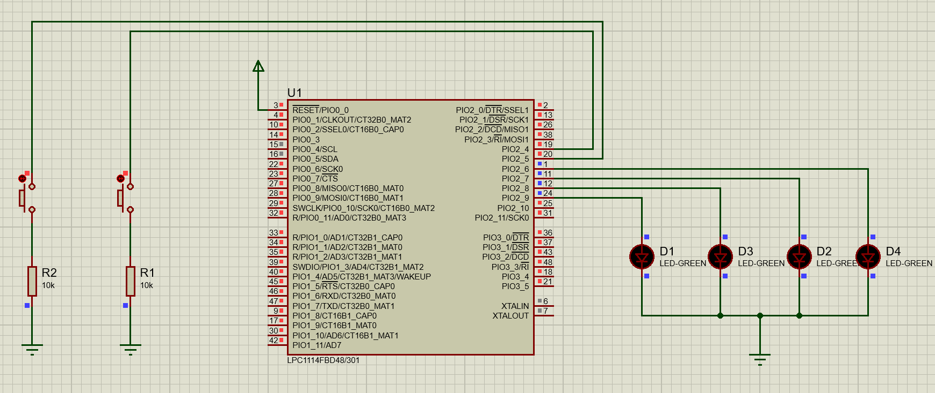

**Thank You**