

**Islamic University of Gaza**

**Computer Engineering**

بسم الله الرحمن الرحيم

**Embedded Systems**

**Homework #2**

Student Name **Akram Hatem Abo Jbara**

Student No.: **120200602**

Instructor Name: **Eng. Amal Abu Jasser**

Day: **Saturday**

Date: **29/Nov/2024**

**Use a Common- Anode 7-Segment Display for 4 digits to count from 555 to 0, when reaching to 0 a red led connected to port 1 must shine.**

**Code(Text and Screenshot):**

#include <LPC11xx.h>

#define GPIO0DIR (*((volatile unsigned long *)0x50008000))

#define GPIO0DATA (*((volatile unsigned long *)0x50003ffc))

#define GPIO1DIR (*((volatile unsigned long *)0x50018000))

#define GPIO1DATA (*((volatile unsigned long *)0x50013ffc))

#define GPIO2DIR (*((volatile unsigned long *)0x50028000))

#define GPIO2DATA (*((volatile unsigned long *)0x50023ffc))

int main (void){

   int seven_seg_encoder [] = {

    0x40,

    0x79,

    0x24,

    0x30,

    0x19,

    0x12,

    0x02,

    0x78,

    0x00,

    0x10

   };

   int num=555;

   int i =0;

   GPIO2DIR |= 0b1111111;

   GPIO0DIR |= 0b111100;

   GPIO1DIR |= 0b10000;

   GPIO1DATA = 0b00000;

   while (1) {

      GPIO0DATA=0b000100;

      GPIO2DATA = 0x40;

      for (i =0; i<20000; i++);

      GPIO0DATA=0b001000;

      GPIO2DATA = seven_seg_encoder[(num/100) %10];

      for (i =0; i<20000; i++);

      GPIO0DATA=0b010000;

      GPIO2DATA = seven_seg_encoder[(num/10) %10];

      for (i =0; i<20000; i++);

      GPIO0DATA=0b100000;

      GPIO2DATA = seven_seg_encoder[(num) %10];

      for (i =0; i<20000; i++);

      num--;

      if(num==0){

     GPIO1DATA = 0b10000;

     GPIO2DATA = 0b1000000;

     break;

      }

   }

   return 0;

}

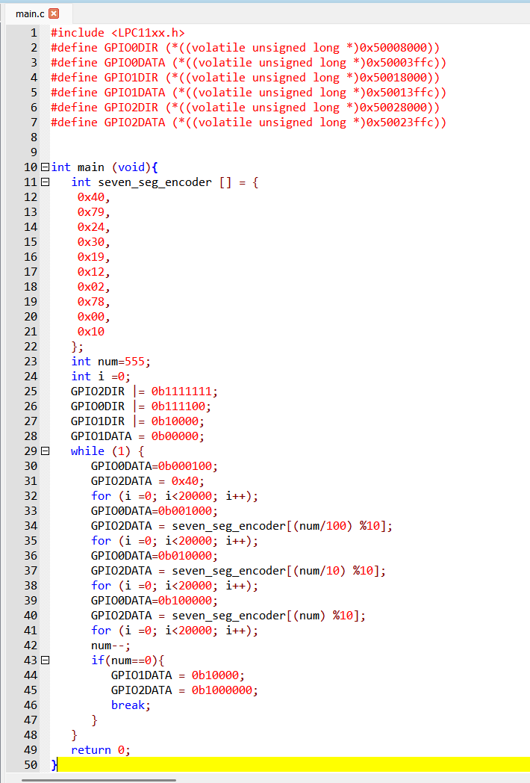

**Result**

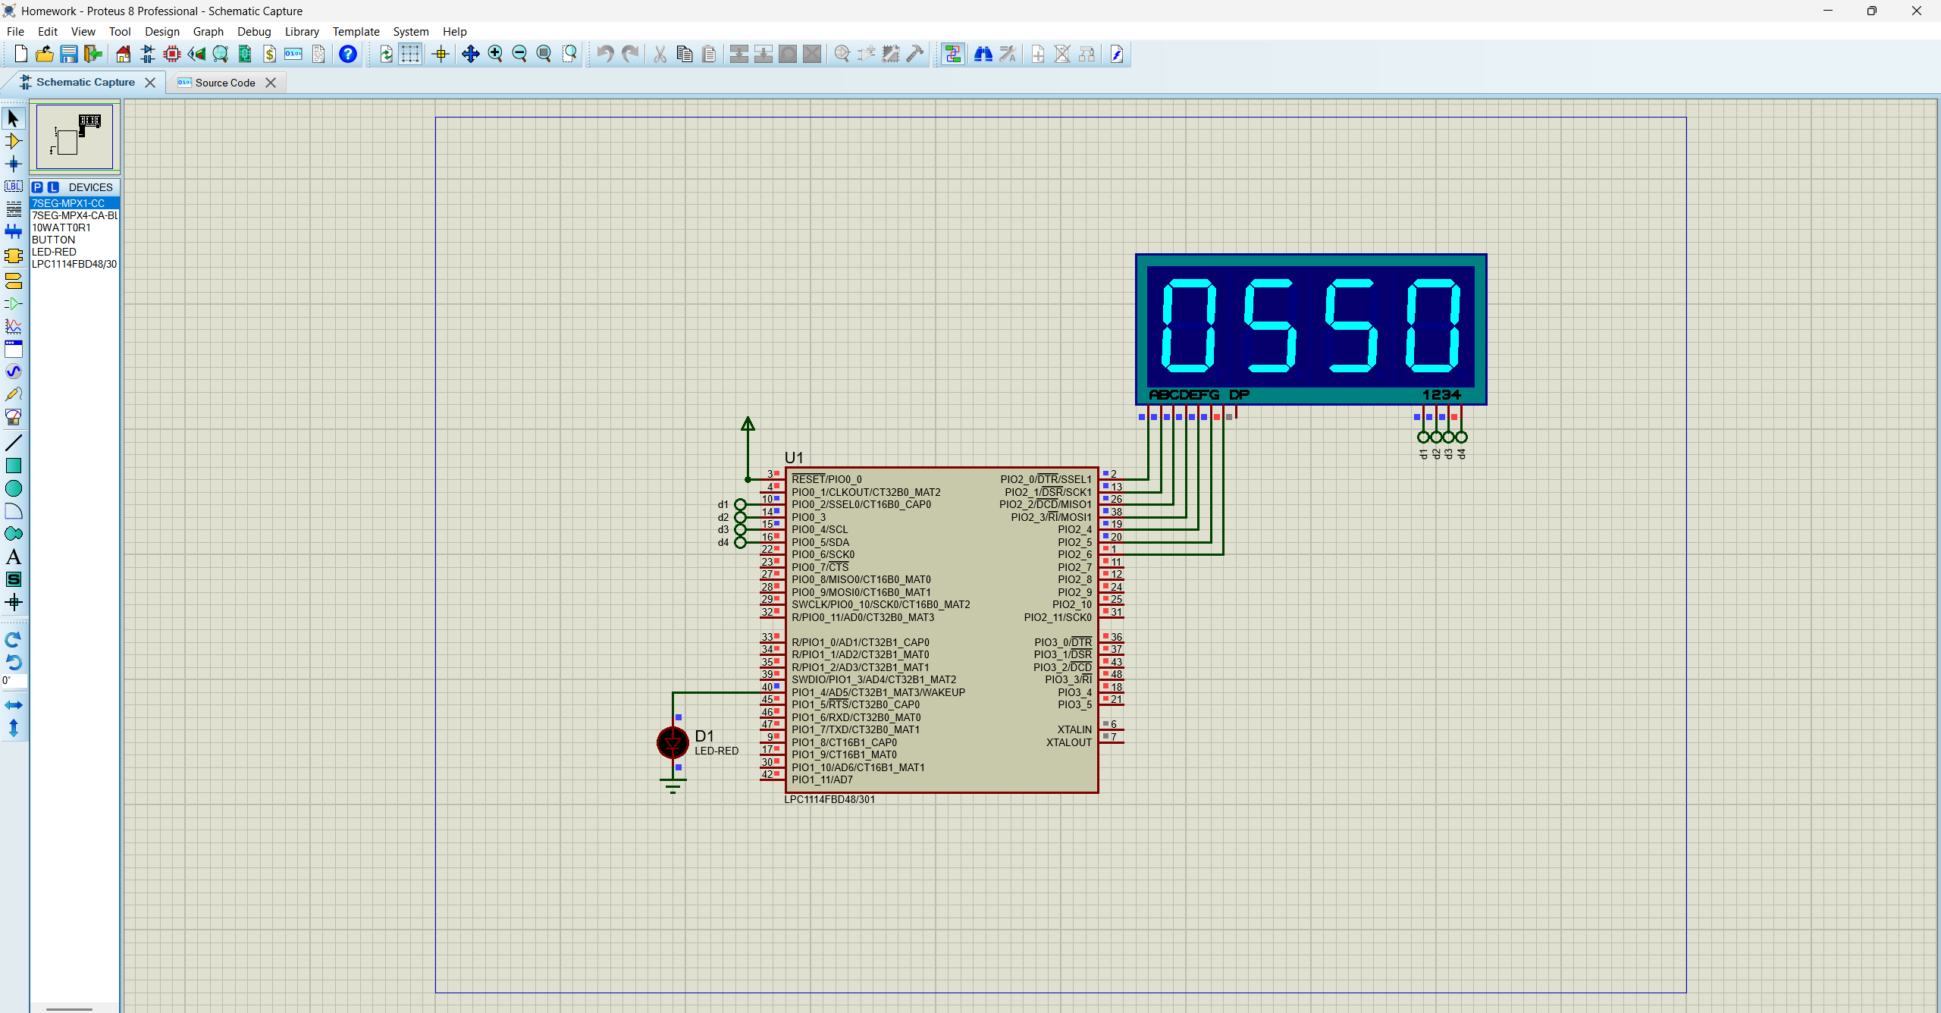

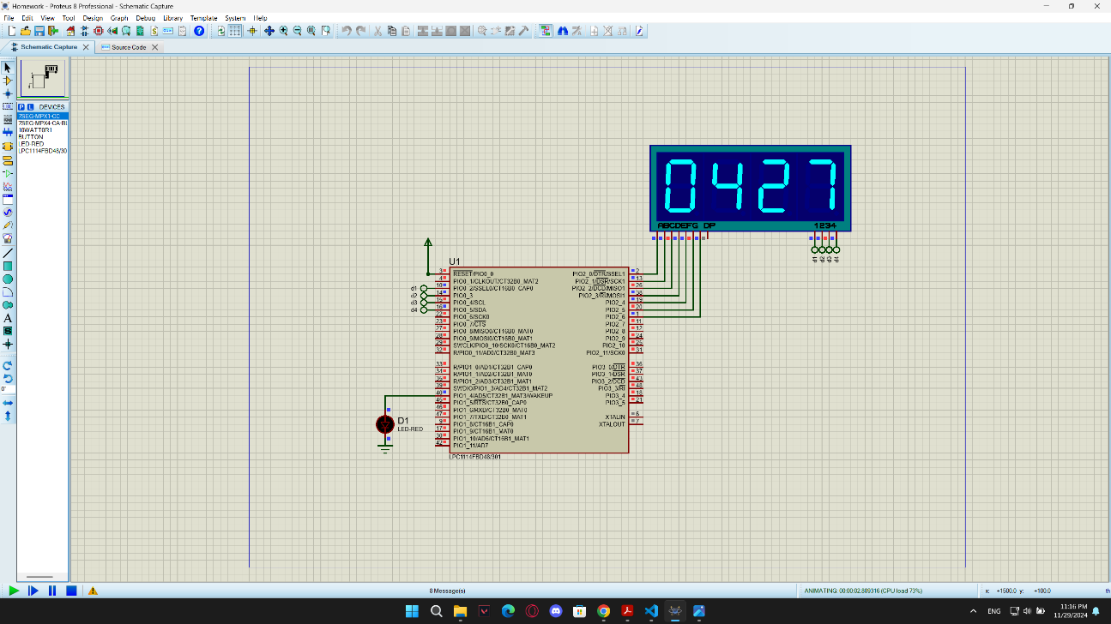

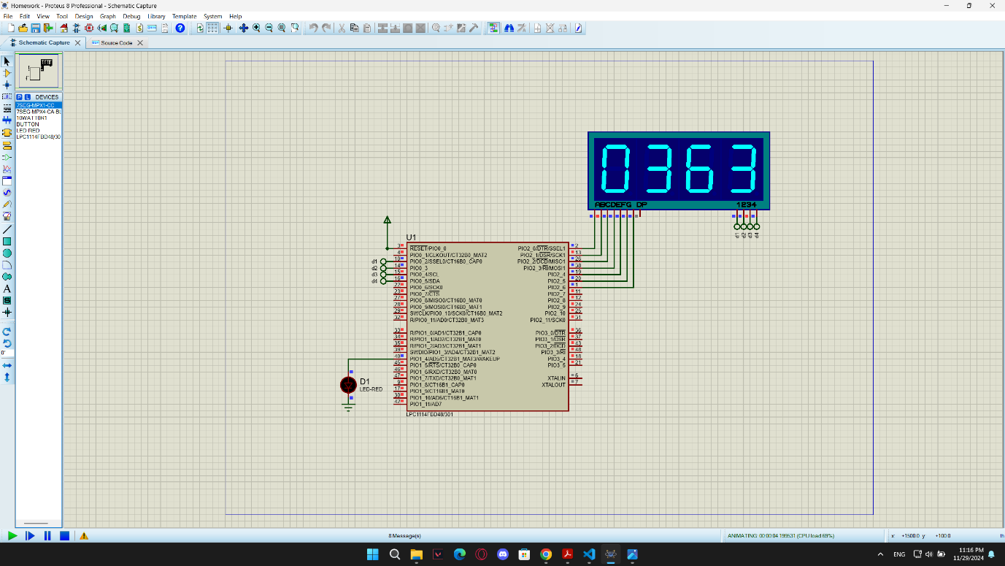

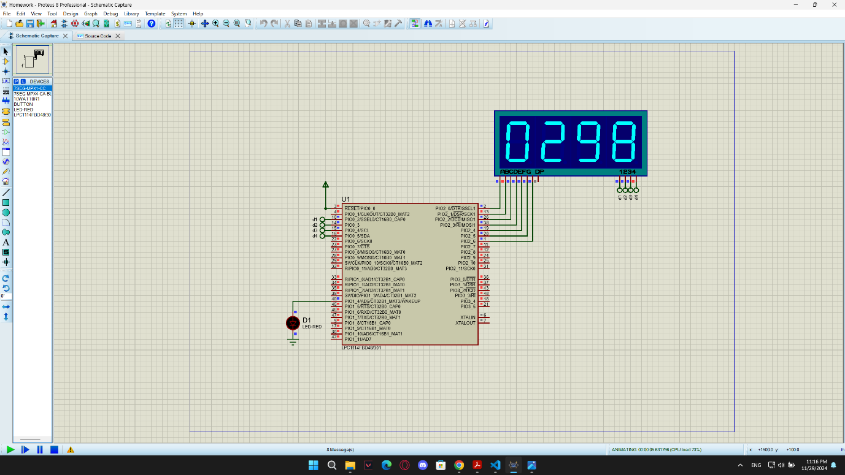

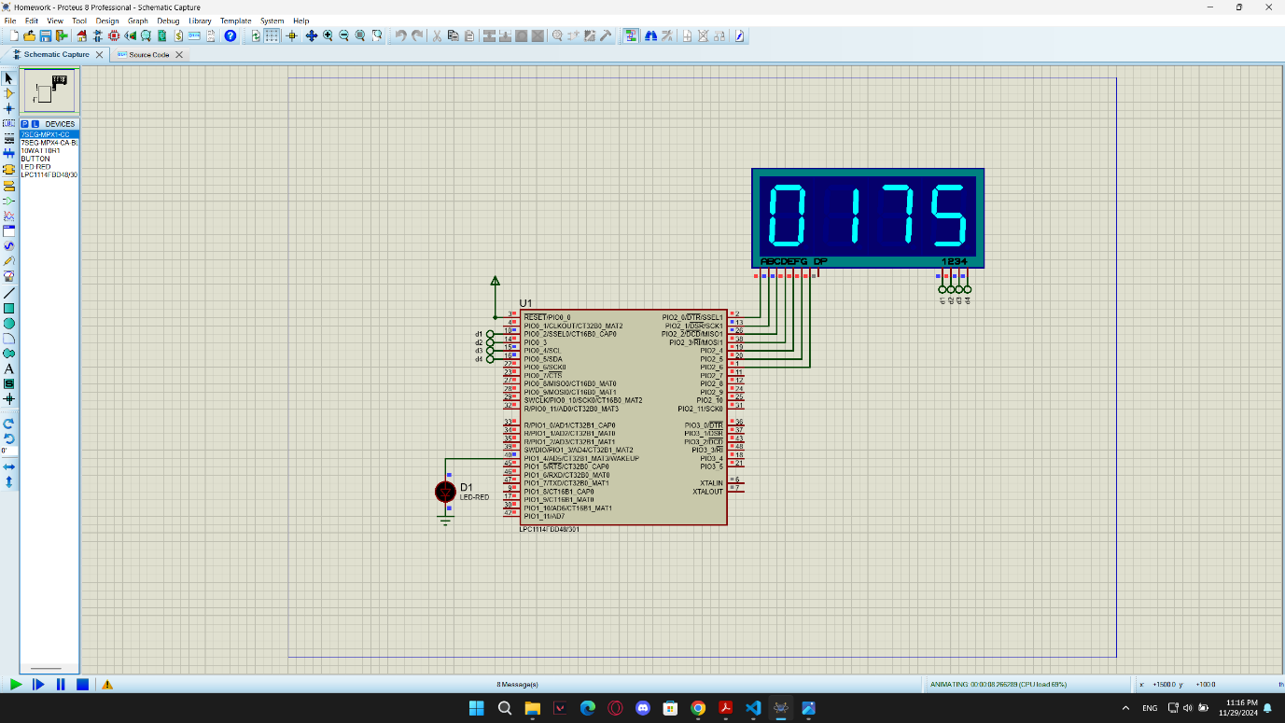

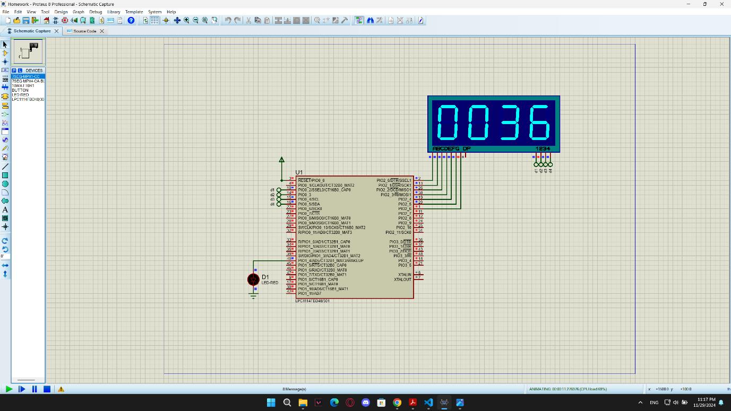

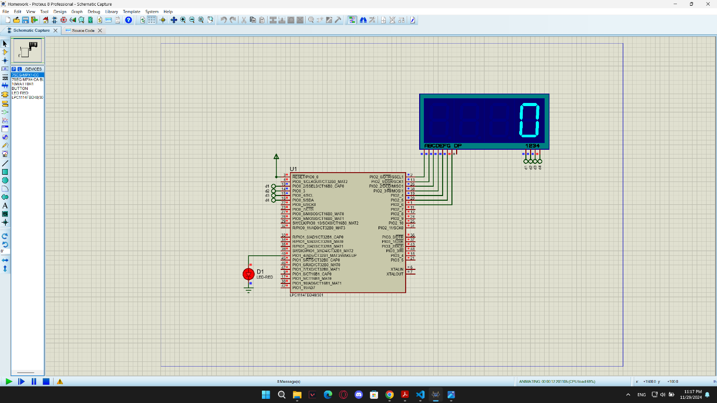

**Thank You**