**Packages**

Every Go program is made up of packages.

Programs start running in package main.

This program is using the packages with import paths "fmt" and "math/rand".

By convention, the package name is the same as the last element of the import path. For instance, the "math/rand" package comprises files that begin with the statement package rand.

**Note:** The environment in which these programs are executed is deterministic, so each time you run the example program rand.Intn will return the same number.

(To see a different number, seed the number generator; see [rand.Seed](https://go.dev/pkg/math/rand/" \l "Seed" \t "_self). Time is constant in the playground, so you will need to use something else as the seed.)

## Exported names

In Go, a name is exported if it begins with a capital letter. For example, Pizza is an exported name, as is Pi, which is exported from the math package.

pizza and pi do not start with a capital letter, so they are not exported.

When importing a package, you can refer only to its exported names. Any "unexported" names are not accessible from outside the package.

Run the code. Notice the error message.

To fix the error, rename math.pi to math.Pi and try it again.

## Functions

A function can take zero or more arguments.

In this example, add takes two parameters of type int.

Notice that the type comes *after* the variable name.

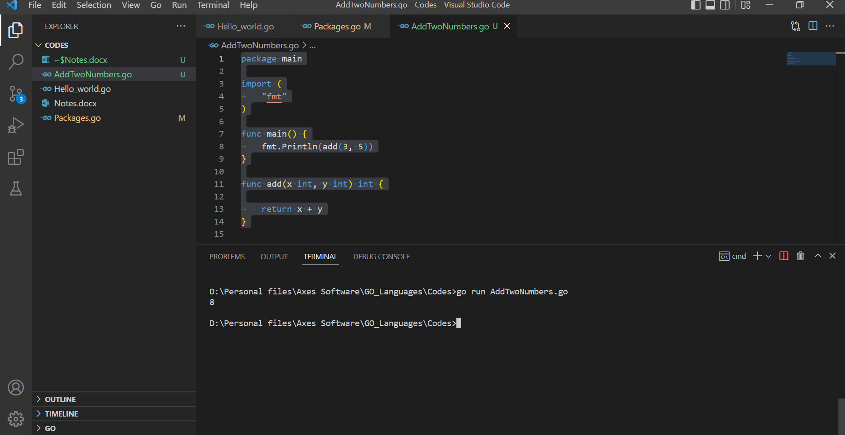

Return Multiple Result from function

## Multiple results

A function can return any number of results.

The swap function returns two strings.

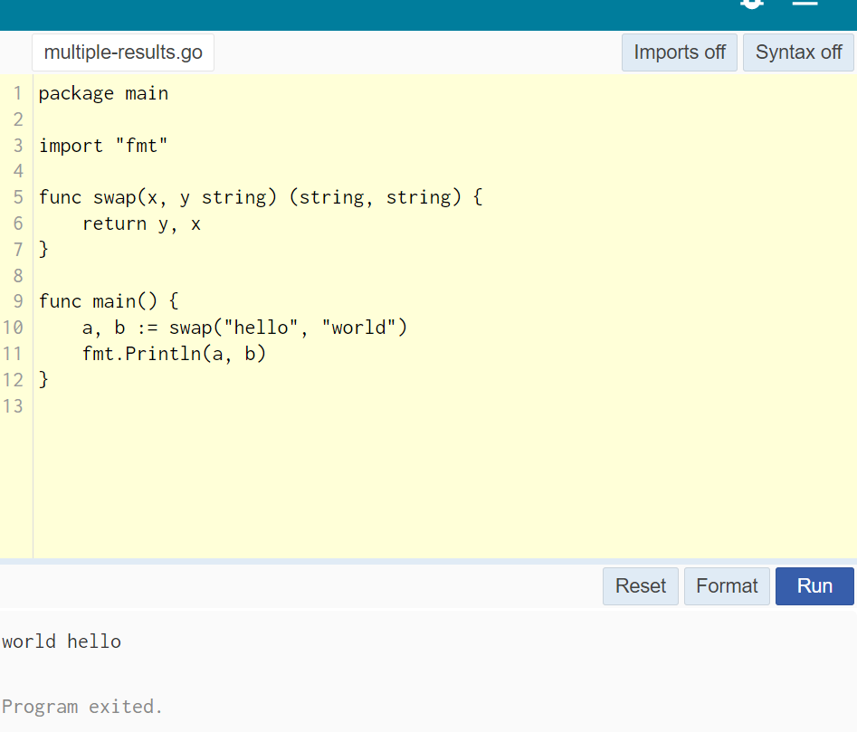

# Naked Return Function

A return statement without arguments returns the named return values. This is known as a **"naked"** return. used in short function package main

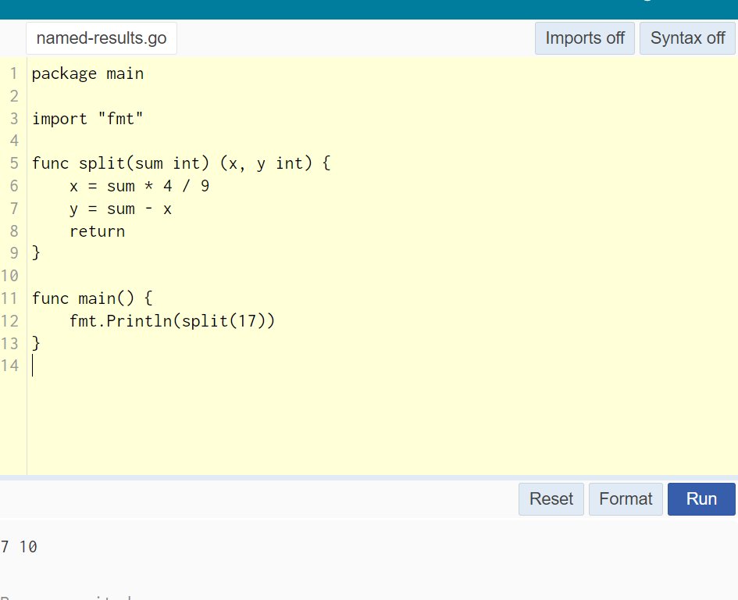

## Variables

The var keywords declare list of variables as in function argument lists, the type is last.

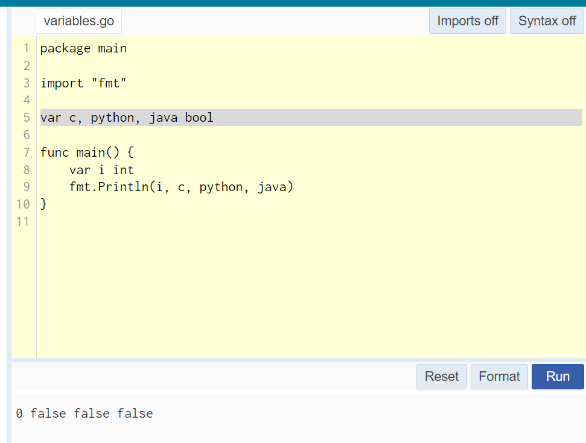

## Short variable declarations

Inside a function, the := short assignment statement can be used in place of a var declaration with implicit type.

Outside a function, every statement begins with a keyword (var, func, and so on) and so the := construct is not available.

