AI-Assisted Assingment 5.1 Using GitHub Copilot
Name: Mohammed Akramuddin
Batch : 11
Rollno: 2303A510F6
Task 1: Privacy in API Usage
Scenario
Use an AI tool to generate a Python program that connects to a weather API.

Copilot Prompt Used

Code:
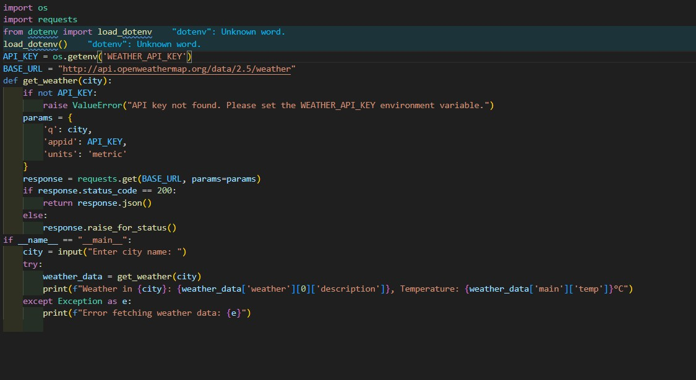

Task 2: Privacy & Security in File Handling

Scenario
Use an AI tool to generate a Python script that stores user data (name, email, password) in a file Check if the AI stores sensitive data in plain text or without encryption. .

Copilot Prompt Used

Code:
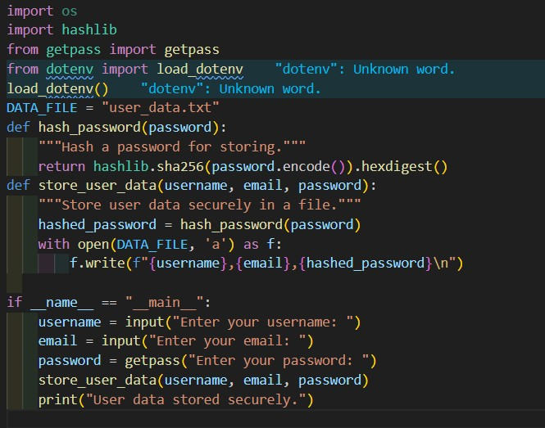

Sample Output

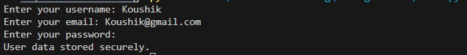

Explanation
The slicing method simplifies the logic and removes unnecessary variables and loops.
The slicing method is faster in practice due to internal optimizations in Python.
Readability is significantly improved.

Task 3: Transparency in Algorithm Design)
Scenario
The string reversal logic is reused in multiple parts of an application

Copilot Prompt Used
Code:
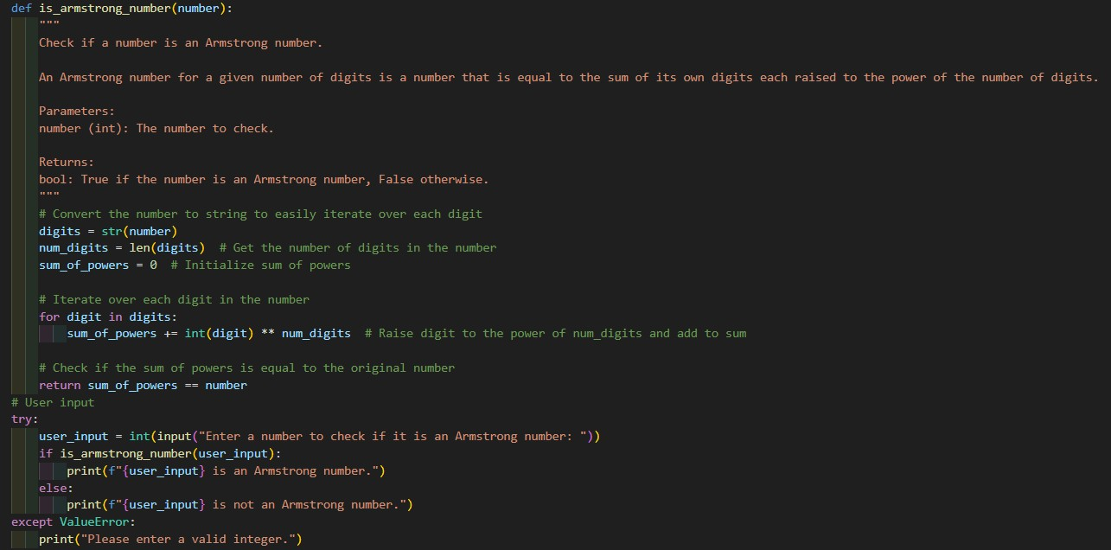

Sample Output
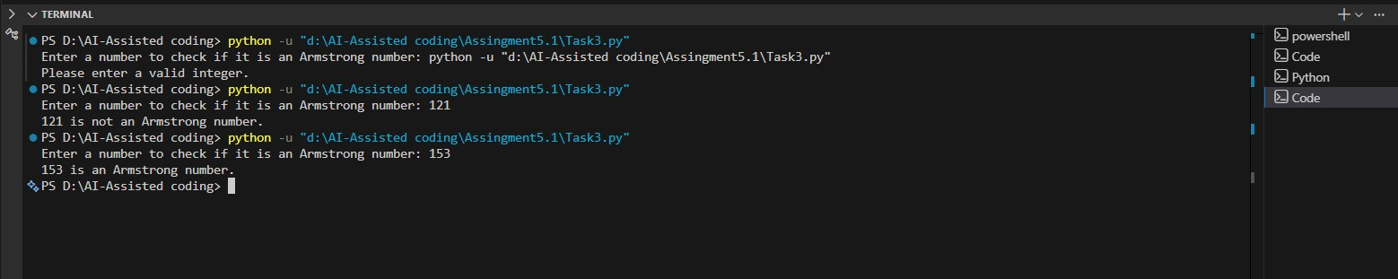

Explanation
- The function is_armstrong_number takes an integer input number.
- It converts the number to a string to easily access each digit and calculates the number of digits. 3. It initializes a variable sum_of_powers to store the sum of each digit raised to the power of the number of digits.
4. It iterates through each digit, converts it back to an integer, raises it to the power of num_digits, and adds it to sum_of_powers.
5.Finally, it checks if sum_of_powers is equal to the original number and returns True or False accordingly.
6. The user is prompted to input a number, and the program checks if it is an Armstrong number, printing the result.

Task 4: Transparency in Algorithm Comparison
Scenario: Use AI to create a product recommendation system

Copilot Prompt Use

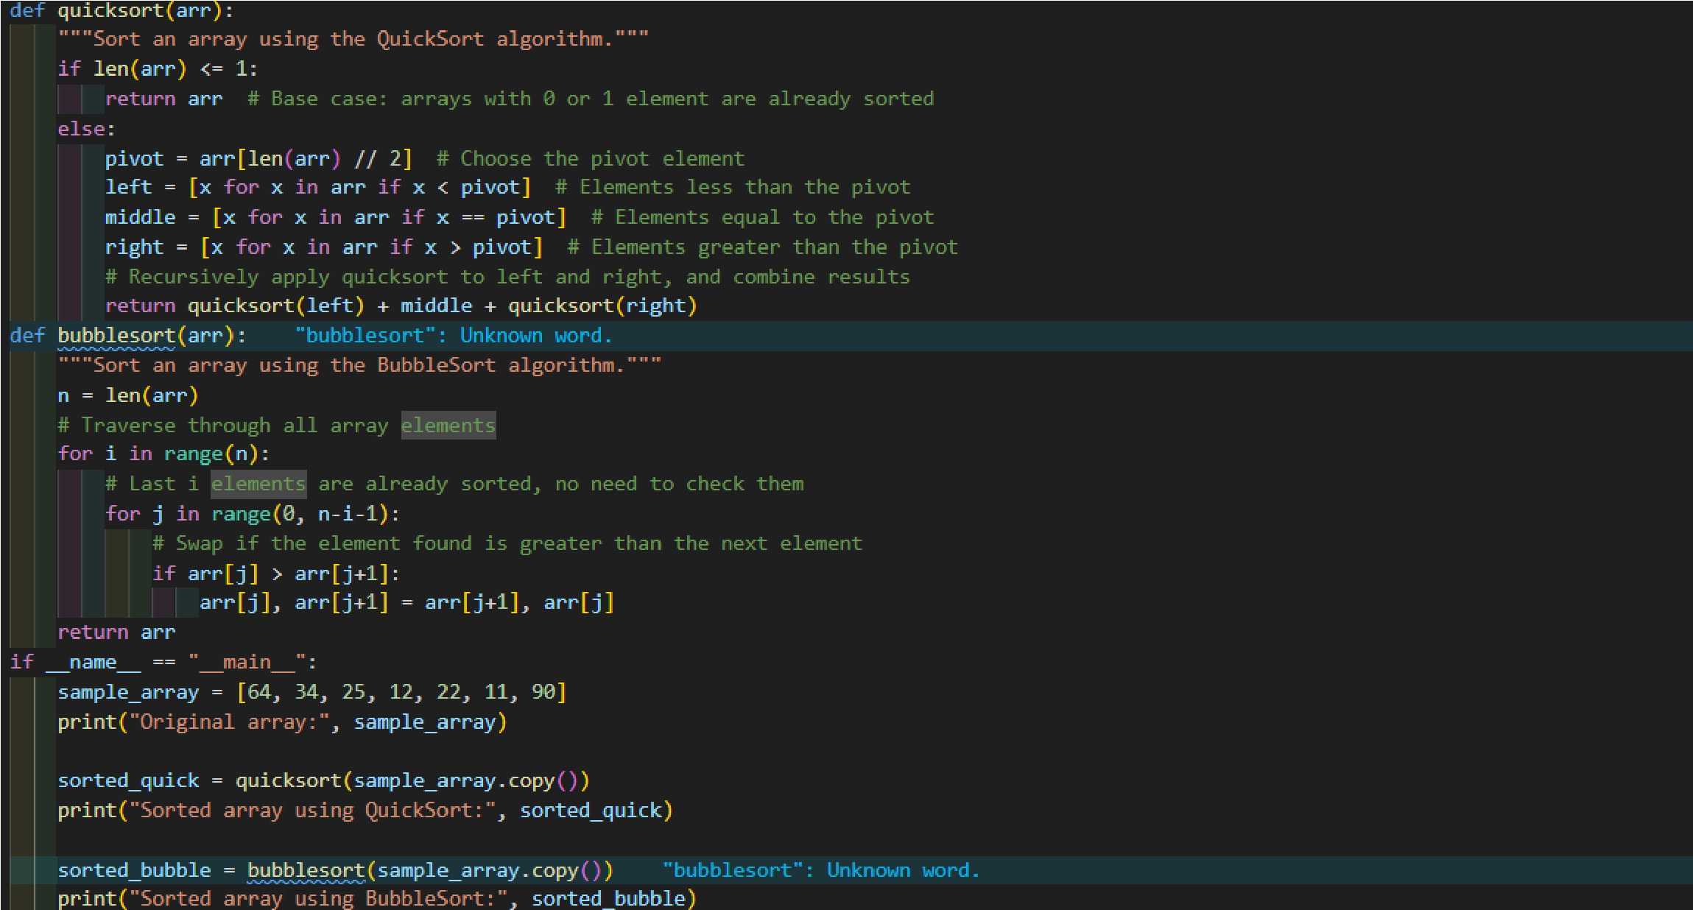
Code:
Output :

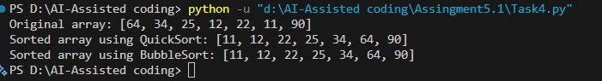
Explanation:
QuickSort works by selecting a 'pivot' element and partitioning the other elements into two sub-arrays according to whether they are less than or greater than the pivot.

Task 5: Transparency in AI Recommendations

Scenario: Use AI to create a product recommendation system.
Copilot Prompt Use:

Code:

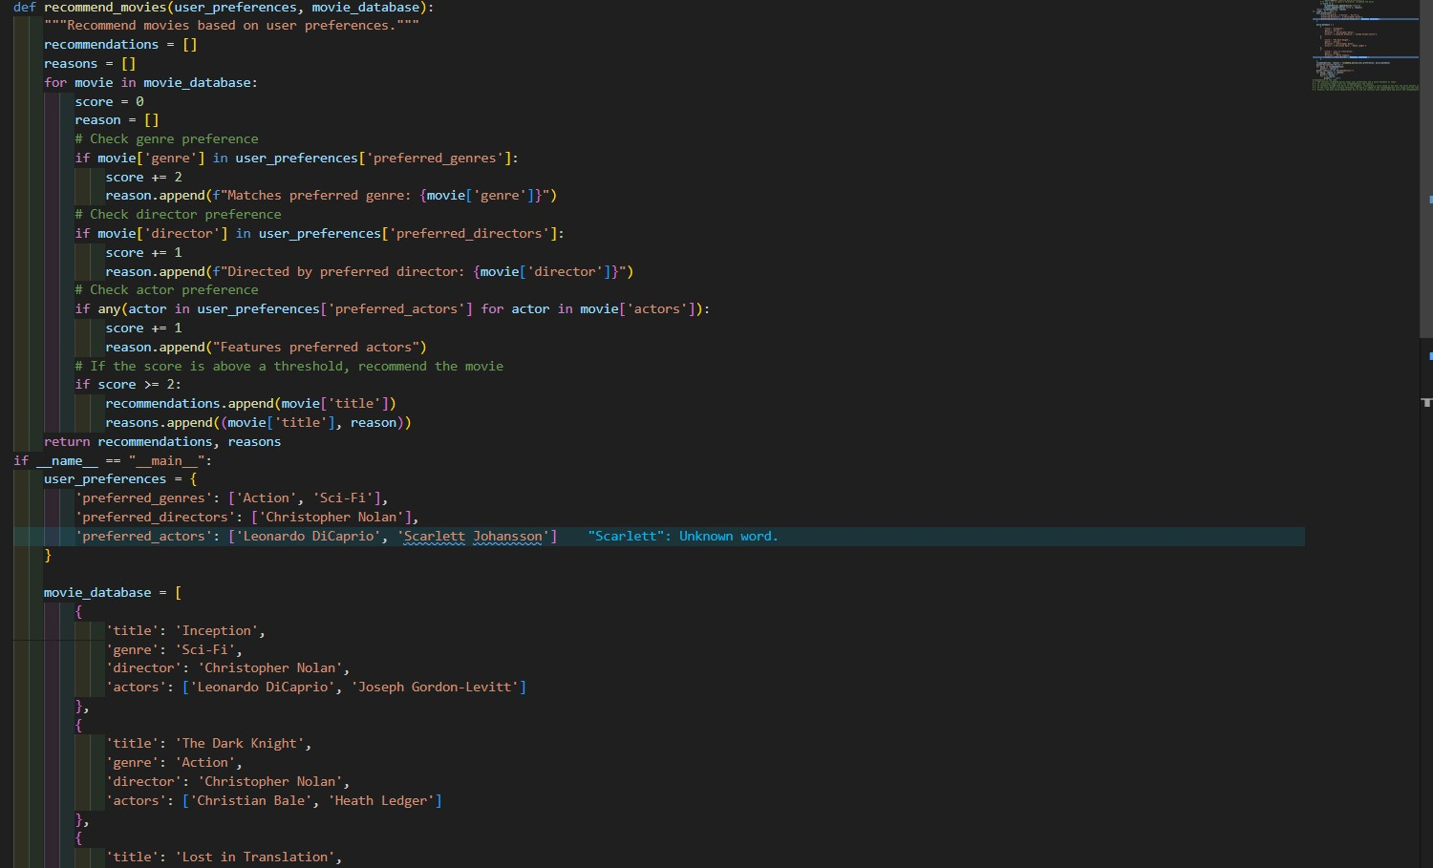

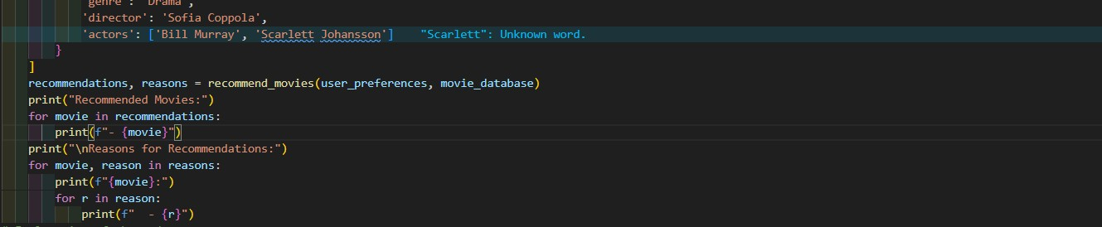

Sample output:
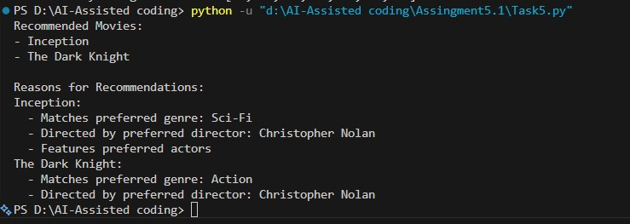

Explanation: The function recommend_movies takes user preferences and a movie database as input. It initializes empty lists for recommendations and reasons. It iterates through each movie in the database, calculating a score based on how well the movie matches user preferences. If the score meets a certain threshold, the movie is added to the recommendations list along the reasons for its recommendation. Finally, the main block demonstrates how to use the function with sample data and prints the recommendations along with their reasons.

