No correlation regrest Bell and LS;

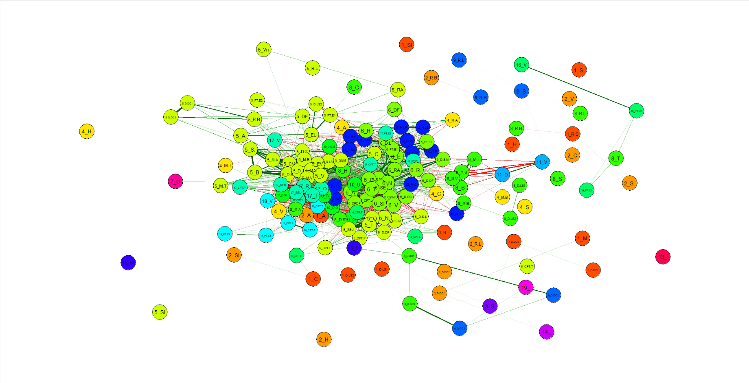

1 alpha

2 beta

3 chi

4 delta

5 epsilon

6 gamma

7 iota

8 kappa

9 lambda

10 mu

11 nu

12 omega

13 phi

14 psi

15 rho

16 sigma

17 tau

18 theta

19 upsilon

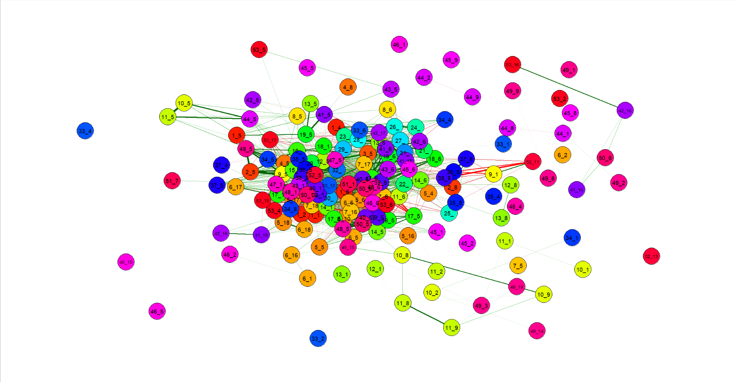

Aspiration

Below.mean.Semivariance

Certainty.Equivalence

CoefVar

CPT.LBW

CPT.Prelec

CPT.TK

DFT

Disappointment.Bell

Disappointment.DC1

Disappointment.DC2

Disappointment.LS1

Disappointment.LS2

Distracted.DFT

Dual.1

Dual.2

Dual.System.LOB

Dual.System.M

EUT

EV

Heuristic.BTA

Heuristic.CC

Heuristic.EP

Heuristic.LEPE"

[25] "Heuristic.LL" "Heuristic.LPE" "Heuristic.Minimax.Regret"

[28] "Heuristic.Minimax" "Heuristic.ML" "Heuristic.MPW"

[31] "Heuristic.Priority" "Heuristic.RELM" "Heuristic.Similarity.Leland"

[34] "Mean.Alpha.target" "Mean.Below.target" "Mean.StdDev"

[37] "Mean.Target.Semivariance" "Mean.Variance" "Noisy.Retrieval"

[40] "Odds.based.SWU" "PT.Edit1" "PT.Edit2"

[43] "RAM" "Regret.Bell" "Regret.LS"

[46] "Salience" "SEM" "SEU"

[49] "Subjective.Expected.Pleasure" "TAX" "UWS"

[52] "Variance.Skewness" "Venture"

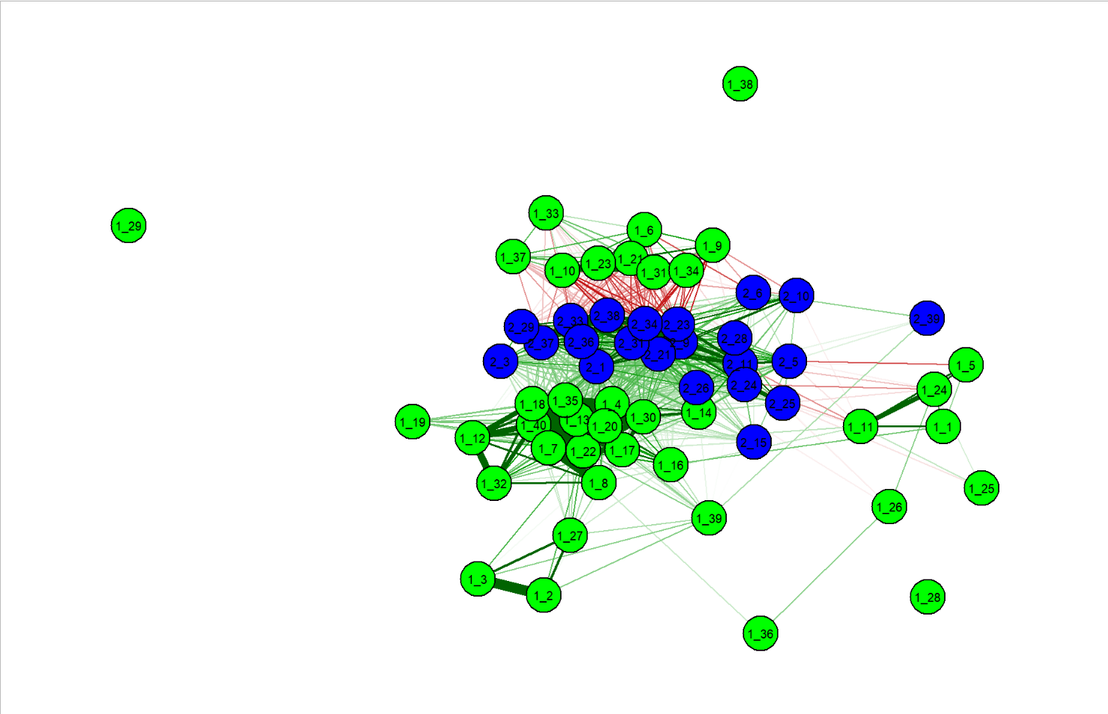

Partial correlation

