MVP Evaluation Report

- Team Name: Risky 5
- Startup Name: Infracore Systems LLP
- Name of Team Leader: Kalrav Mathur
- Email ID of Team Lead: km257@snu.edu.in
- Contact Number of Team Lead: +91-96345-93284
- Address for Correspondence: Dept. of Electrical Engg, Shiv Nadar Institution of Eminence, NH91, Tehsil Dadri, Greater Noida, Uttar Pradesh - 201314.
- Name of Institute: Shiv Nadar Institution of Eminence, Delhi NCR.
- Team Member Details:
Name of Team Members | Email ID | Contact Number | Branch
Kalrav Mathur | km257@snu.edu.in | +91-96345-93284 | B.Tech ECE
Tushar Juneja | tj860@snu.edu.in | +91-74960-96711 | B.Tech ECE
Akhil Sriram | as830@snu.edu.in | +91-86101-70712 | B.Tech ECE
Akansh Saraf | as925@snu.edu.in | +91-81303-48548 | B.Tech ECE
Saksham Mahajan | sm938@snu.edu.in | +91-99884-57959 | B.Tech ECE

- Mentor Details:
Name of Mentor | Email ID | Contact Number | Designation | Department
Dr.  Venkatnarayan  Hariharan | venkatnarayan.h@snu.edu.in | +91-97401-04109 | Associate  Professor | Electrical  Engineering

Introduction
India’s growing emphasis on strategic autonomy and self‑reliance in defence and semiconductor technology highlights a critical gap in indigenous precision‑guidance capabilities. Modern precision‑guided munitions (PGMs) rely heavily on Imaging Infrared (IIR) seekers for accurate terminal‑phase targeting, especially in GPS‑denied or electronically contested environments. At present, such seekers remain largely dependent on imported, closed‑source hardware and proprietary algorithms, which introduces long‑term strategic, security, and supply‑chain risks.
Team Risky 5 aims to address this gap by designing and demonstrating a fully indigenous terminal‑phase precision guidance system emulator. The project is built end‑to‑end on India‑designed compute platforms, centering around the SHAKTI ‘Yamuna’ RISC‑V processor synthesized on an Artix‑7 FPGA. The intent is not to develop a complete weapon system, but to create a functional seeker‑level prototype that validates the feasibility of real‑time image‑based target acquisition, tracking, and guidance command generation using Indian hardware.
This MVP evaluation stage focuses on demonstrating core functionality: real‑time image acquisition, hardware‑accelerated preprocessing, target matching, error computation, and generation of correction commands. The system reflects a realistic architectural split between FPGA‑based acceleration and embedded processor‑based decision logic, closely mirroring how operational IIR seekers are structured, while remaining safe, modular, and suitable for academic and competitive evaluation.

Problem Statement
Precision-guided systems in the terminal phase of flight require fast and autonomous target identification under strict latency and power constraints. Imaging Infrared (IIR) seekers enable target lock using thermal signatures in low visibility, nighttime, and GPS-denied environments, but are difficult to implement due to real-time processing demands and tight integration between sensing, computation, and control.
India lacks widely deployed indigenous IIR seeker solutions and remains dependent on imported black-box platforms, limiting transparency, scalability, and technology sovereignty.
Technically, such systems must handle high-bandwidth image data, perform intensive preprocessing operations such as contrast enhancement, noise reduction, and edge detection, and execute target-matching algorithms within strict real-time deadlines. Software-only execution introduces unacceptable latency, while rigid hardware-only approaches reduce flexibility and upgradeability for evolving mission requirements.
This necessitates a hardware–software co-designed architecture that balances performance with flexibility on an indigenous compute stack. The absence of accessible Indian reference implementations for seeker-class systems further motivates this work. This project delivers a functional MVP demonstrating the feasibility of SHAKTI-based embedded vision for terminal-phase precision guidance.

Proposed Approach
The proposed solution is a modular, real-time precision guidance system emulator that mirrors the architecture of a terminal-phase IIR seeker while remaining safe for academic demonstration. It is built around a tightly integrated FPGA-based processing pipeline and an embedded SHAKTI ‘Yamuna’ RISC-V control core, enabling efficient division of computational responsibilities.
A thermal or grayscale camera simulates an LWIR sensor by streaming image frames into the FPGA fabric. A custom Verilog-based image-processing IP performs the complete target-matching pipeline directly in hardware, including preprocessing and feature or correlation-based matching, exploiting FPGA parallelism and deterministic latency. Upon successful detection, the IP computes the target’s positional error relative to the image center and forwards this data to the SHAKTI RISC-V core. The processor, running bare-metal C/C++, handles higher-level control logic and guidance computation.
This error is fused with inertial data from an IMU and processed through PID control loops to generate pitch and yaw correction commands. For the MVP stage, the focus is on correctness and real-time timing of command generation rather than physical actuation. By offloading preprocessing to FPGA hardware while retaining decision logic in software, the system achieves substantial performance gains over a software-only approach while remaining flexible and extensible. Its modular architecture supports sensor substitution, algorithm upgrades, and further IP optimization, making it suitable for both the MVP and a foundation for future research and real-world deployment.

System Architecture and Design Rationale
The system follows a hardware‑software co‑design philosophy. High‑bandwidth, data‑parallel tasks are assigned to FPGA fabric, while control‑oriented and algorithmic decision‑making is handled by the embedded RISC‑V processor. This separation minimizes latency, reduces processor load, and enables deterministic performance. The use of the SHAKTI processor ensures complete transparency of the compute stack, while the Artix‑7 FPGA enables rapid prototyping and iterative optimization of custom IP. Standard communication interfaces such as UART, SPI, and I2C are used to interface sensors and peripherals, keeping the design realistic and industry‑aligned.

Relevance to MVP Evaluation
For the MVP evaluation stage, the project demonstrates:
- Implementation of image correlation algorithm using C in software on SHAKTI SoC.
- Capturing a single frame from the camera and passing it to the SHAKTI core processor using UART.
- Verified functional correctness of a prototype of the custom verilog image‑processing IP.
- NCC logic flow working on Shakti in loop. (Frame capture -> Receive -> Compute NCC).
This positions the project as a credible proof of concept that balances technical ambition with practical demonstrability, aligning strongly with the goals of the ideation and MVP evaluation stages.
This document presents a comprehensive progress report of the project, summarizing the work completed so far, ongoing development, deviations from the original proposal, achieved and pending MVP milestones, challenges encountered, and the measures adopted to address them.

Current Status of the Project
The project has reached an advanced development stage with successful progress across algorithm development, hardware acceleration, system-level testing, and control logic implementation. The following summarizes the work completed and currently in progress:

Hardware and FPGA Development
- The targeted FPGA board has been successfully tested and interfaced, confirming correct power-up, configuration, and basic functionality.

- A test program was executed on the SHAKTI RISC-V SoC to validate the toolchain, execution flow, and system stability.

- Required hardware components were researched in detail and successfully procured to support development and integration.

Algorithm Development and Validation
- The target matching algorithm was implemented in C and tested successfully on the SHAKTI RISC-V platform.

- The algorithm demonstrated correct detection of predefined targets under test conditions.

- This validated C implementation was converted into Verilog to enable hardware acceleration.

- Established UART bridge between the ESP32 (acting as the high-speed camera interface) and the Shakti Yamuna (RISC-V) microcontroller.

- Optimized UART settings to achive baud rate (153,600 baud) to maximize throughput while maintaining zero framing errors.
- Designed and implemented an application to receive frames from camera module, process NCC algorithm on each frame and output score and x,y coordinates for each frame.

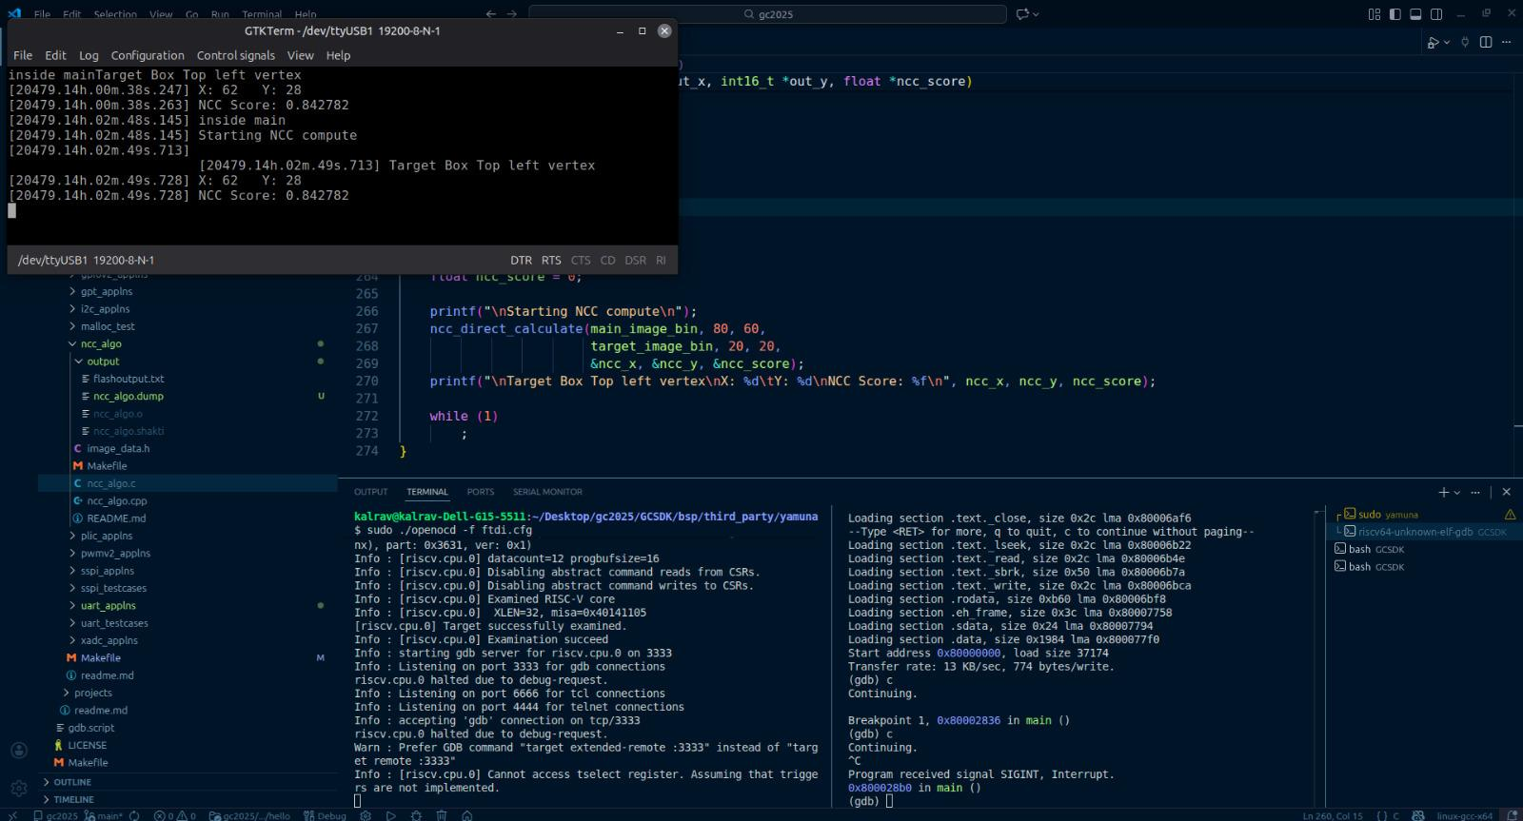
Figure 1(a): Execution profiling of the template-matching algorithm on the SHAKTI RISC-V processor using a reduced-resolution input (80×80), used primarily for functional validation.
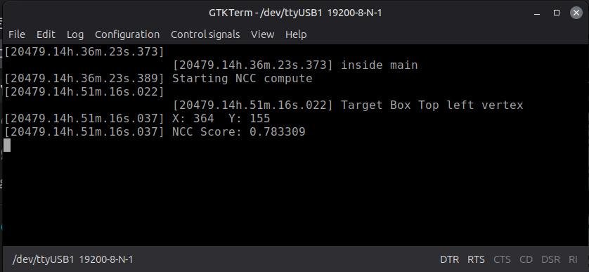
Figure 1(b): Execution profiling of the target-matching algorithm on the SHAKTI RISC-V processor using a higher-resolution input representative of realistic operating conditions.
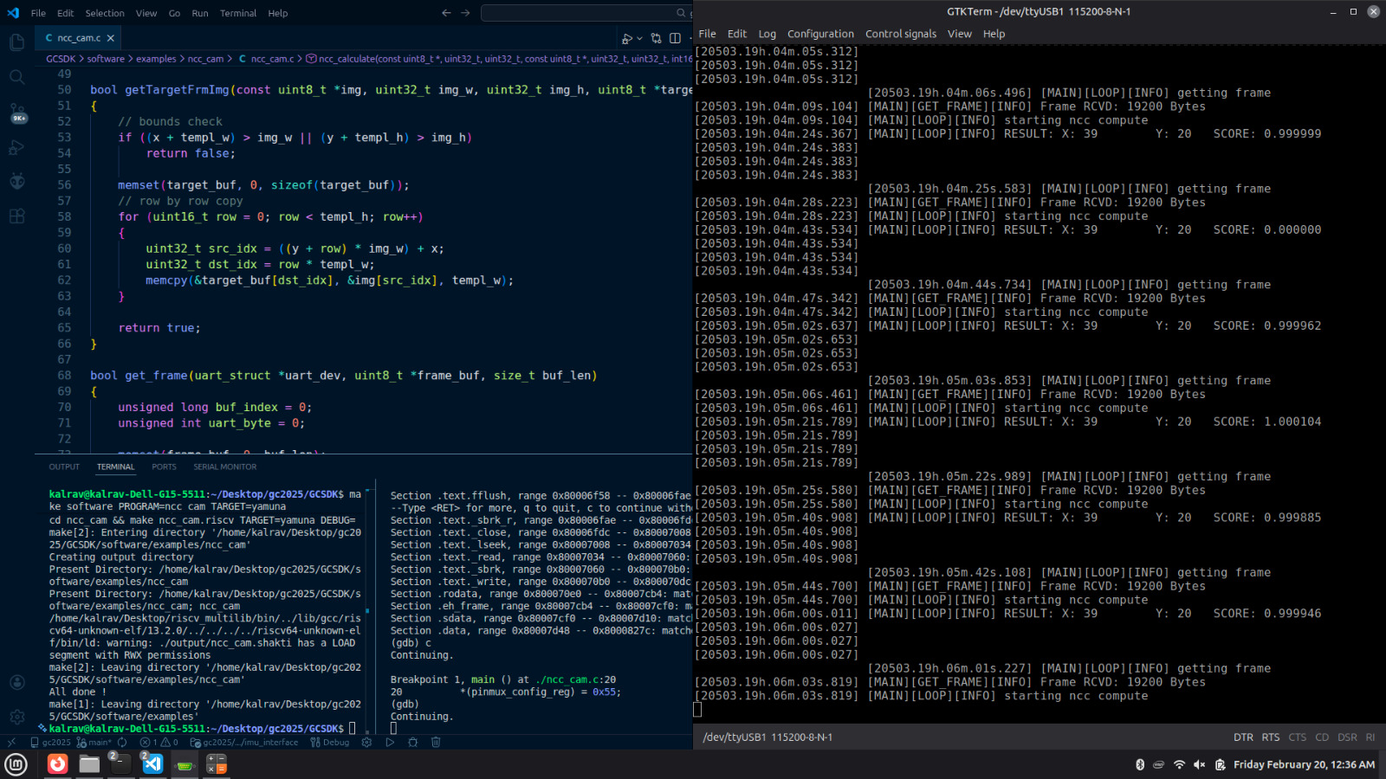
Figure 2: Continuous Frame capturing and NCC compute for each frame.

Custom IP Core Development
During early validation, the target-matching algorithm was first executed entirely in software on the SHAKTI RISC-V processor to establish a functional baseline. While correct detections were achieved, the execution exhibited prohibitively high computation latency when processing realistic image resolutions. This clearly highlighted the limitations of a software-only approach for seeker-class, real-time workloads on embedded processors.
This observation directly motivated the development of a custom FPGA-based image-processing IP to offload the target-matching pipeline into hardware. Hardware acceleration enabled deterministic execution and a substantial reduction in processing latency, validating the hardware–software co-design strategy adopted in this project.
To further analyze the scalability limitations of a processor-only implementation, the target-matching algorithm was evaluated on the SHAKTI RISC-V core using different input image resolutions. Both reduced-size inputs and more realistic image dimensions were tested to observe how computational complexity scales with image size.
The results reveal a sharp increase in computation effort as image resolution increases, despite identical algorithmic structure. While smaller image sizes allow functional verification, higher-resolution inputs introduce significant processing overhead, making pure software execution impractical for terminal-phase guidance scenarios that demand deterministic and time-bounded execution.
Based on the above observations and experiments, the following development and implementation tasks were carried out as part of the custom hardware acceleration effort:
- A custom Verilog IP core implementing the target matching algorithm was designed and developed.

- The custom IP was functionally tested on the FPGA, using .mem files to store image data, and its output was verified against the software implementation to ensure correctness.

- Initial optimization of the custom IP was carried out, resulting in a performance improvement compared to running the algorithm purely on the SHAKTI processor.

- Further optimization efforts are ongoing, with the current implementation optimized up to a certain practical limit.

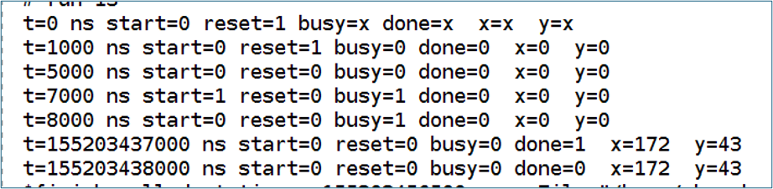
Figure 3: Custom IP Behavioral Simulation Result in Vivado

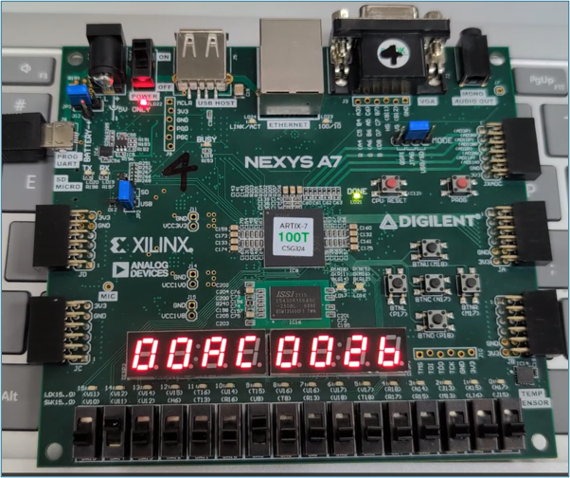
Figure 4: Custom IP FPGA Implementation

AXI-Based Frame Transfer Modeling and Validation
One of the key MVP milestones involves validating reliable data transfer between the embedded processor and the custom image-processing IP. To address this, a behavioral AXI-based simulation model was developed to emulate processor-to-accelerator communication in a controlled and verifiable manner.
The model consists of three primary components. An AXI-Lite slave module (axi_adder_lite.v) represents the hardware accelerator and implements a simple deterministic computation to validate correctness of write and read transactions. An AXI master module (axi_traffic_gen.v) emulates the processor behavior by initiating write and read operations. A system-level testbench (tb_axi_system.v) interconnects the master and slave modules and generates the required clock and reset signals.
In the simulated transaction flow, the AXI master writes a test value to the slave, the slave performs a predefined operation on the received data, and the master subsequently reads back the result to verify correctness. Successful completion of this sequence validates address decoding, data transfer integrity, and protocol compliance of the AXI interface.
The AXI protocol handshaking behavior follows standard AXI-Lite semantics: write transactions occur only when both WVALID and WREADY signals are asserted, and read transactions occur only when both RVALID and RREADY signals are asserted. Read and write channels are exercised sequentially and do not overlap, simplifying verification and ensuring deterministic behavior.
This simulation framework serves as a functional proof-of-concept for processor-to-IP communication and forms the foundation for extending the interface to full image frame transfer in subsequent integration stages.
A wrapper module (ncc_axi_wrapper.v) is used to add the AXI-lite slave logic for the control signals to the custom verilog IP. The development of the complete AXI4 based interfacing for the control signals and image data with the SHAKTI SoC is ongoing.

Communication and Interfacing
- Bare-metal helper functions for UART, SPI, and I2C communication have been implemented to support peripheral and sensor interfacing.

- Development of interfaces for the camera module (CAM), IMU, and Image Processing IP is currently in progress.

- Camera to SHAKTI SoC has been implemented using UART. The interfacing to IMU is an active area of development and remains one of the key integration tasks.

Control System Development
- PID control loops for pitch and yaw error correction have been successfully implemented.

- Logic for calculating correction commands based on PID outputs has been completed.

- While correct output commands are being generated, communication with the flight controller has been temporarily paused to prioritize core processing stability and optimization.
Overall, the core computational pipeline from image acquisition to target detection and control command generation is largely functional, with remaining work focused on sensor interfacing and system integration.

Deviations from the Originally Proposed Plan
During development, certain deviations from the original proposal were necessary due to practical and technical constraints:
- The originally proposed LWIR (thermal) sensor has been temporarily replaced with a standard camera sensor. This decision was made because, given the current resolution limitations of the target matching algorithm, processing thermal images would be significantly more complex and less reliable at this stage.

- To maintain progress toward MVP goals, the standard camera is planned to be mounted on an ESP32 for initial integration and testing.

- Interfacing and communication with the flight controller have been put on hold temporarily, even though correct control commands are being generated, in order to focus on optimizing the custom IP and stabilizing the core system.

These deviations are considered interim design choices and do not affect the long-term objectives or extensibility of the system.

Comparison of MVP Milestones: Proposed vs Achieved
The following table summarizes the comparison between the MVP milestones proposed in the original proposal and their current status:

Proposed MVP Milestone | Current Status
Environment setup for Artix-7 FPGA and SHAKTI RISC-V | Completed
Interface LWIR sensor to capture a single thermal frame | Completed (using an alternative standard camera sensor)
Frame transfer from Camera to SHAKTI processor | Completed
C matching algorithm for predefined target detection | Completed

Almost all the core MVP milestones have been achieved, with minor adaptations to the sensor interface.

Pending or Incomplete Milestones
The following milestones are partially incomplete:
- Full Verilog-based frame transfer between the processor and custom image-processing IP. Currently being validate through an AXI-Lite master–slave simulation model emulating processor–accelerator communication.

Challenges Encountered
Several technical challenges were encountered during the course of development:

Custom IP Optimization
- While the custom Verilog IP provides a performance improvement over executing the target matching algorithm directly on the SHAKTI processor, achieving performance levels suitable for competition-scale, professional, or commercial deployment has been challenging.

- Optimization opportunities beyond the current implementation require deeper architectural changes.

- Free LUT count on the FPGA board apart from the SHAKTI core remains as a significant constraint for a parallelized custom IP for faster compute

System Interfacing and Integration
- Interfacing the SHAKTI SoC with the custom IP and the camera sensor introduced complexity in terms of data transfer, synchronization, and reliability.

- Camera interfacing with the SHAKTI SoC has been done through UART as challenges were faced with SPI.

Measures Taken to Address Challenges
To address the identified challenges, the following measures have been undertaken:
- Multiple optimization strategies were explored and applied to the custom IP, leading to measurable performance improvements up to a certain extent.

- Extensive functional testing was performed to validate the correctness of the custom IP before and after optimization.

- Incremental and modular development was adopted for communication interfaces (UART, SPI, I2C) to simplify future integration.

- Sensor-related development was parallelized to allow continued progress despite challenges with the originally proposed LWIR sensor.

- Design decisions were taken with flexibility in mind, allowing future upgrades to higher-performance sensors and further IP optimization.

