***NAME - AKRITI CHOUDHARY***

***ROLL NUMBER - 2005776***

***SUBJECT - DSA LAB***

***DATE - 16/11/2021***

***CLASS - B14***

***BRANCH - CSE***

**Bubble Sort**

#include <stdio.h>

int main()

{

int i, j, temp, n;

printf("\nEnter the max no.of Elements to Sort: \n");

scanf("%d", &n);

int a[n];

puts("\nEnter the Elements : ");

for (i = 0; i < n; i++)

{

scanf("%d", &a[i]);

}

for (i = 0; i < n; i++)

for (j = i + 1; j < n; j++)

{

if (a[i] > a[j])

{

temp = a[i];

a[i] = a[j];

a[j] = temp;

}

}

for (i = 0; i < n; i++)

{

printf("%d ", a[i]);

}

return 0;

}

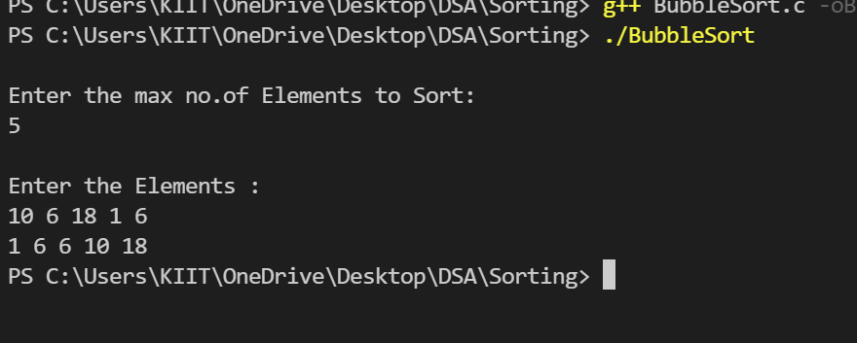

**Insertion Sort**

#include <stdio.h>

int main()

{

int n;

int key, temp, j;

puts("Enter size of an array");

scanf("%d", &n);

int arr[n];

puts("Enter elements of an array");

for (int i = 0; i < n; ++i)

{

scanf("%d", &arr[i]);

}

puts("");

//sorting

for (int i = 0; i < n; ++i)

{

key = arr[i];

j = i - 1;

while ((j >= 0) && (arr[j] > key))

{

arr[j + 1] = arr[j];

j--;

arr[j + 1] = key;

}

}

//printing

puts("Sorted elements of an array :");

for (int i = 0; i < n; ++i)

{

printf("%d ", arr[i]);

}

return 0;

}

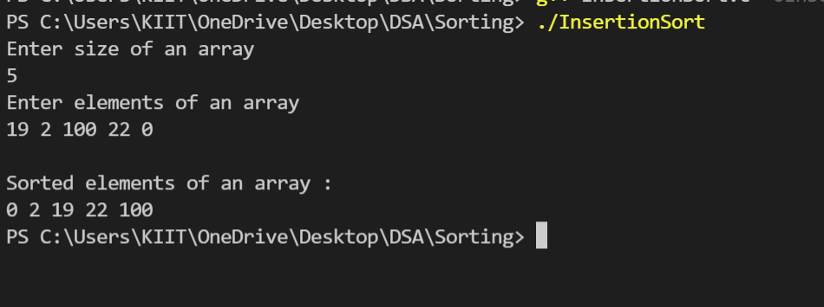

**Selection Sort**

**#**include <stdio.h>

int main()

{

int n, i, j, position, t;

puts("Enter number of elements");

scanf("%d", &n);

int array[n];

puts("Enter the elements\n");

for (i = 0; i < n; i++)

scanf("%d", &array[i]);

for (i = 0; i < (n - 1); i++)

{

position = i;

for (j = i + 1; j < n; j++)

{

if (array[position] > array[j])

position = j;

}

if (position != i)

{

t = array[i];

array[i] = array[position];

array[position] = t;

}

}

puts("Sorted list in ascending order:");

for (i = 0; i < n; i++)

printf("%d ", array[i]);

puts(" ");

return 0;

}

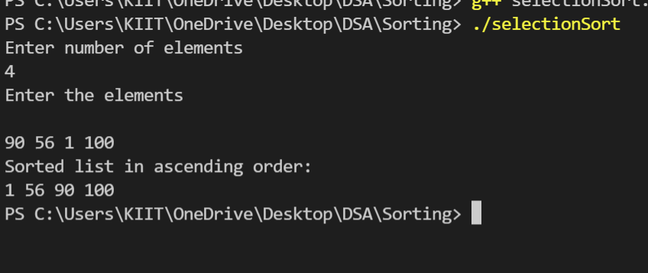

**Merge Sort**

#include <stdio.h>

#include <stdlib.h>

int n;

int *arr;

int *brr;

void input()

{

int i;

printf("Enter %d numbers into the array : \n", n);

for (i = 0; i < n; i++)

{

scanf("%d", &arr[i]);

}

}

void display()

{

int i;

for (i = 0; i < n; i++)

{

printf("%d ", arr[i]);

}

printf("\n");

}

void merge(int low, int mid, int high)

{

int l1, l2, i;

for (l1 = low, l2 = mid + 1, i = low; l1 <= mid && l2 <= high; i++)

{

if (arr[l1] <= arr[l2])

brr[i] = arr[l1++];

else

brr[i] = arr[l2++];

}

while (l1 <= mid)

{

brr[i++] = arr[l1++];

}

while (l2 <= high)

{

brr[i++] = arr[l2++];

}

for (i = low; i <= high; i++)

{

arr[i] = brr[i];

}

}

void sort(int low, int high)

{

int mid;

if (low < high)

{

mid = (low + high) / 2;

sort(low, mid);

sort(mid + 1, high);

merge(low, mid, high);

}

}

int main()

{

puts("Enter the size of the array :");

scanf("%d", &n);

arr = (int *)malloc(n * sizeof(int));

brr = (int *)malloc(n * sizeof(int));

input();

sort(0, n - 1);

puts("After Sorting : ");

display();

return 0;

}

