***NAME - AKRITI CHOUDHARY***

***ROLL NUMBER - 2005776***

***SUBJECT - DSA LAB 3***

***DATE - 17/8/2021***

***CLASS - B14***

***BRANCH - CSE***

/*Addition , multiplication and display are include in a single program*/

***Question1:***

***WAP to create an array that represents a polynomial expression with single variable (i.e. 5x7-3x5+x2+9) and display the polynomial by using user defined functions for creation ,***

***Display , addition of two polynomials and multiplication of the two polynomials.***

#include <stdio.h>

void print(int poly[], int n);

void add(int A[], int B[], int m, int n);

void multi(int A[], int B[], int m, int n);

int main()

{

int m, n;

puts("Creation of Polynomial P");

printf("Enter number of terms in poly1: ");

scanf("%d", &m);

puts("");

int A[m];

puts("Enter the terms in poly1 in increasing order :");

for (int i = 0; i < m; ++i)

{

scanf("%d", &A[i]);

}

printf("Enter number of terms in poly2: ");

scanf("%d", &n);

puts("");

int B[n];

puts("Enter the terms in poly2 in increasing order :");

for (int i = 0; i < n; ++i)

{

scanf("%d", &B[i]);

}

add(A, B, m, n);

multi(A, B, m, n);

return 0;

}

void print(int poly[], int n)

{

for (int i = 0; i < n; i++)

{

printf("%d", poly[i]);

if (i != 0)

printf("x^%d", i);

if (i != n - 1)

printf(" + ");

}

puts("");

}

void add(int A[], int B[], int m, int n)

{

int size = (m > n) ? m : n;

int sum[size];

if (m > n)

{

for (int i = 0; i < m; i++)

sum[i] = A[i];

for (int i = 0; i < n; i++)

sum[i] += B[i];

}

else

{

for (int i = 0; i < n; i++)

sum[i] = B[i];

for (int i = 0; i < m; i++)

sum[i] += A[i];

}

puts("The addition of polynomial is :");

print(sum, size);

}

void multi(int A[], int B[], int m, int n)

{

int size = m + n - 1;

int P[size];

for (int i = 0; i < size; i++)

P[i] = 0;

for (int i = 0; i < m; i++)

{

for (int j = 0; j < n; j++)

P[i + j] += A[i] * B[j];

}

puts("The multiplication of polynomial is :");

print(P, size);

}

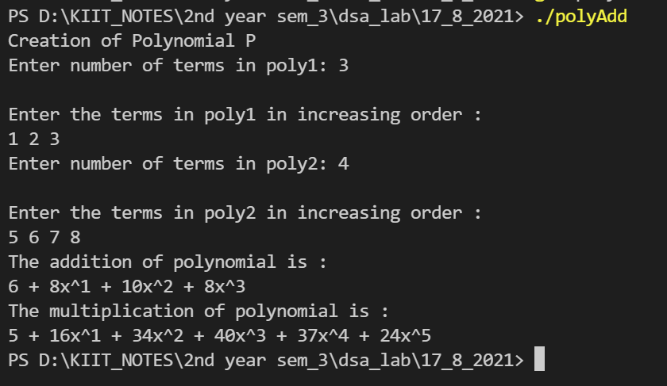

***Question2:***

***A matrix m × n that has relatively few non-zero entries is called sparse matrix. WAP to represent a sparse matrix in 3-tuple format by using***

***array.***

#include <stdio.h>

int main()

{

int r, c;

int count = 0;

puts("Enter the number of rows and columns :");

scanf("%d%d", &r, &c);

int arr[r][c];

int numEle = r * c;

puts("Enter the elements of the matrix :");

for (int i = 0; i < r; ++i)

{

for (int j = 0; j < c; ++j)

{

scanf("%d", &arr[i][j]);

if (arr[i][j] == 0)

count++;

}

}

//printing the entered matrix

puts("printing the entered matrix :");

for (int i = 0; i < r; ++i)

{

for (int j = 0; j < c; ++j)

{

printf("%d ", arr[i][j]);

}

puts("");

}

//check for sparse matrix

if (count < 0.5 * numEle)

{

puts("The entered matrix is not a sparse matrix ");

}

else

{

printf("ROW\tCOLUMN\tELEMENT\n");

for (int i = 0; i < r; ++i)

{

for (int j = 0; j < c; ++j)

{

if (arr[i][j] != 0)

{

printf("%d \t %d \t %d \n", i, j, arr[i][j]);

}

}

}

}

return 0;

}

