***NAME - AKRITI CHOUDHARY***

***ROLL NUMBER - 2005776***

***SUBJECT - DSA LAB***

***DATE - 27/10/2021***

***CLASS - B14***

***BRANCH - CSE***

**Question 1)Write a menu driven program to implement queue operations such as Insert, Delete, Display,**

**whether queue is empty etc by using array.**

#include <stdio.h>

#include <stdlib.h>

#define MAX 5

typedef struct

{

int data[MAX];

int front;

int rear;

} Queue;

int insert(Queue *q, int v)

{

if (q->rear == MAX - 1)

{

printf("Queue Overflow\n");

return 1;

}

else if (q->rear == -1)

{

q->front = q->rear = 0;

q->data[q->rear] = v;

}

else

{

q->data[++(q->rear)] = v;

}

return 0;

}

int del(Queue *q, int *d)

{

if (q->front == -1)

{

printf("Queue is empty\n");

return 1;

}

else if (q->rear == q->front)

{

*d = q->data[q->front];

q->front = q->rear = -1;

return 0;

}

else

{

*d = q->data[q->front];

q->front++;

return 0;

}

}

void init(Queue *q)

{

q->front = -1;

q->rear = -1;

}

void traverse(Queue *q)

{

if (q->front == q->rear == -1)

printf("queue is empty\n");

else

{

printf("queue elements are:\n");

for (int i = (q->front); i <= q->rear; i++)

printf("%d\n", q->data[i]);

puts(" ");

}

}

int main()

{

Queue q1;

int d, k, c;

init(&q1);

do

{

printf("1 - to insert an element in the queue\n");

printf("2 - to delete an element from the queue\n");

printf("3 - to traverse the stack\n");

printf("4 - quit\n\n");

printf("enter your choice\n");

scanf("%d", &c);

switch (c)

{

case 1:

{

int n;

printf("enter the number to be insert\n");

scanf("%d", &n);

k = insert(&q1, n);

if (k == 0)

printf("Number is inserted in the queue\n");

break;

}

case 2:

{

k = del(&q1, &d);

if (k == 0)

printf("Number is deleted from the queue\n");

break;

}

case 3:

{

traverse(&q1);

break;

}

case 4:

puts("Program Terminated");

break;

}

} while (c != 4);

}

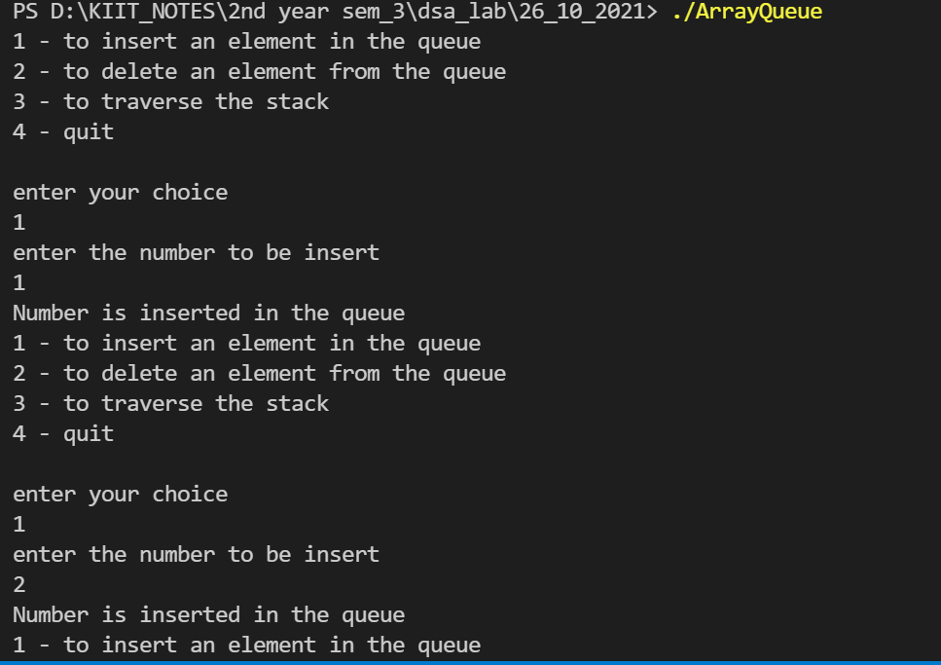 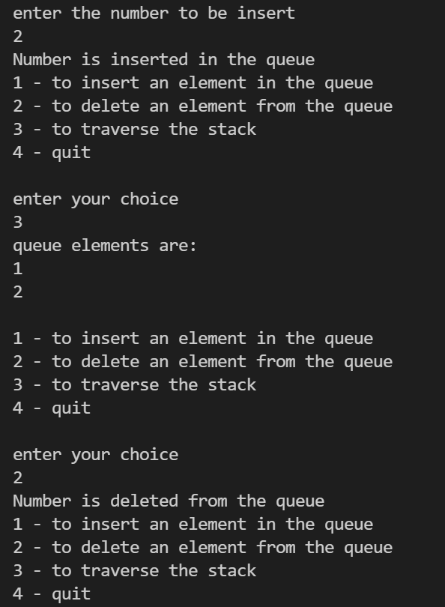

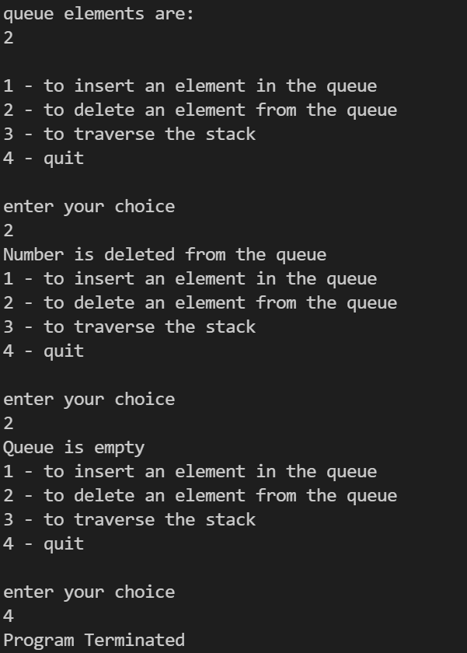

**Question 2)Write a menu driven program to implement queue operations such as Insert, Delete, Display,**

**whether queue is empty etc by using dynamic array.**

#include <stdio.h>

#include <stdlib.h>

typedef struct

{

int front;

int rear;

int data[];

} Queue;

int insert(Queue *q, int v)

{

if (q->rear == -1)

{

q->front = q->rear = 0;

q->data[q->rear] = v;

}

else

{

q->data[++(q->rear)] = v;

}

return 0;

}

int del (Queue *q, int *d)

{

if (q->front == -1)

{

printf("Queue is empty");

return 1;

}

else if (q->rear == q->front)

{

*d = q->data[q->front];

q->front = q->rear = -1;

return 0;

}

else

{

*d = q->data[q->front];

q->front++;

return 0;

}

}

void init(Queue *q)

{

q->front = -1;

q->rear = -1;

}

void traverse(Queue *q)

{

if (q->front == q->rear == -1)

printf("queue is empty\n");

else

{

printf("queue elements are:\n");

for (int i = (q->front); i <= q->rear; i++)

printf("%d\n", q->data[i]);

}

}

int main()

{

struct Queue *data = malloc(sizeof(int));

Queue q1;

int d, k, c;

init(&q1);

do

{

printf("1 - insert an element in the queue\n");

printf("2 - delete an element from the queue\n");

printf("3 - traverse the stack\n");

printf("4 - quit\n");

printf("enter your choice\n");

scanf("%d", &c);

switch (c)

{

case 1:

{

int n;

printf("enter the number you want to insert\n");

scanf("%d", &n);

k = insert(&q1, n);

if (k == 0)

printf("number is inserted in the queue\n");

break;

}

case 2:

{

k = del (&q1, &d);

if (k == 0)

printf("%d is deleted from the queue\n", d);

break;

}

case 3:

{

traverse(&q1);

break;

}

case 4:

break;

}

} while (c != 4);

}

 



**Question 3)Write a menu driven program to implement queue operations such as Insert, Delete, Display,**

**whether queue is empty etc by using linked list.**

#include <stdio.h>

#include <stdlib.h>

struct node

{

int data;

struct node *next;

};

typedef struct

{

struct node *front;

struct node *rear;

} Queue;

int insert(Queue *q, int v)

{

struct node *cur = (struct node *)malloc(sizeof(struct node));

if (cur == NULL)

{

return 1;

}

cur->data = v;

cur->next = NULL;

if (q->front == NULL)

{

q->front = q->rear = cur;

}

else

{

q->rear->next = cur;

q->rear = cur;

}

return 0;

}

int delete (Queue *q, int *d)

{

if (q->front == NULL)

{

printf("Queue underflow\n");

return 1;

}

else

{

struct node *temp = q->front;

if (q->rear == q->front)

{

*d = q->front->data;

q->front = NULL;

temp == NULL;

return 0;

}

else

{

*d = q->front->data;

q->front = q->front->next;

temp == NULL;

return 0;

}

}

}

void init(Queue *q)

{

q->front = NULL;

q->rear = NULL;

}

void traverse(Queue *q)

{

struct node *temp;

if (q->front == NULL)

printf("queue is empty\n");

else

{

printf("queue elements are:\n");

for (temp = (q->front); temp->next != NULL; temp = temp->next)

printf("%d\n", temp->data);

printf("%d\n", temp->data);

puts(" ");

}

}

int main()

{

Queue q1;

int d, k, c;

init(&q1);

do

{

printf("1 - insert an element in the queue\n");

printf("2 - delete an element from the queue\n");

printf("3 - traverse the stack\n");

printf("4 - quit\n");

printf("enter your choice\n");

scanf("%d", &c);

switch (c)

{

case 1:

{

int n;

printf("enter the number to insert\n");

scanf("%d", &n);

k = insert(&q1, n);

if (k == 0)

printf("number is inserted in the queue\n");

break;

}

case 2:

{

k = delete (&q1, &d);

if (k == 0)

printf("%d is deleted from the queue\n", d);

break;

}

case 3:

{

traverse(&q1);

break;

}

case 4:

break;

}

} while (c != 4);

}

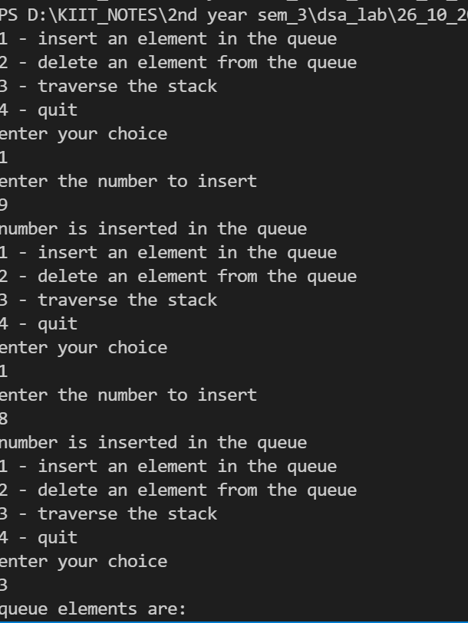 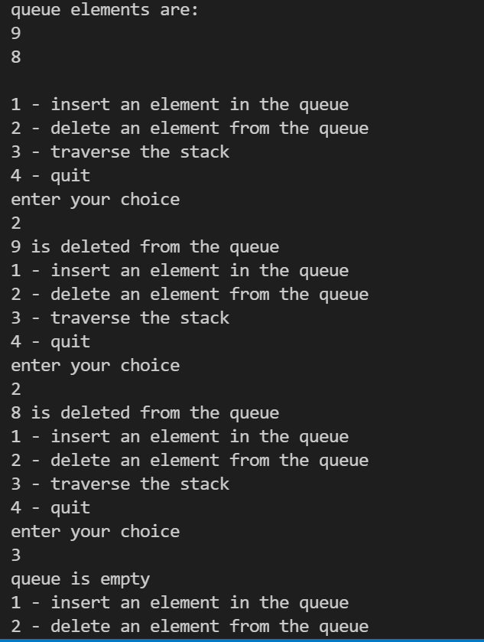

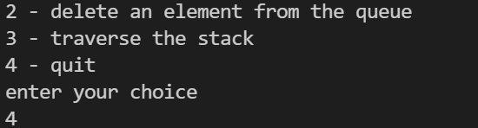

**Question 4)Write a menu driven program to implement circular queue operations such as Insert, Delete,**

**Display, whether queue is empty etc by using array.**

#include <stdio.h>

#define MAX 5

typedef struct

{

int data[MAX];

int f;

int R;

} Cqueue;

void init(Cqueue *q1);

int insert(Cqueue *q, int v);

int del(Cqueue *q, int *d);

int main()

{

int ch = 0;

while (ch != 4)

{

puts("Enter your choice");

puts("1 - Insert");

puts("2 - Delete");

puts("3 - Display");

puts("4 - Exit");

scanf("%d", &ch);

Cqueue q1;

init(&q1);

switch (ch)

{

case 1:

{

int val;

puts("Enter the value to be inserted");

scanf("%d", &val);

int k = insert(&q1, val);

if (k == 1)

{

puts("Queue overflow");

}

else

{

puts("Value is inserted in queue");

}

break;

}

case 2:

{

int d = 0;

int p = del(&q1, &d);

if (p == 1)

{

puts("Queue underflow");

}

else

{

puts("Value is deleted from the queue");

}

break;

}

case 3:

{

}

case 4:

{

puts("Program Terminated");

break;

}

default:

{

puts("Invalid choice");

break;

}

}

}

return 0;

}

void init(Cqueue *q1)

{

q1->f = -1;

q1->R = -1;

}

int insert(Cqueue *q, int v)

{

if (q->f == (q->R + 1) % MAX)

return 1;

if (q->R == -1)

{

q->f = q->R = 0;

q->data[q->R] = v;

}

else

{

q->R = (q->R + 1) % MAX;

q->data[q->R] = v;

}

return 0;

}

int del(Cqueue *q, int *d)

{

if (q->f == -1)

return 1;

if (q->f == q->R)

{

*d = q->data[q->f];

q->f = q->R = -1;

}

else

{

*d = q->data[q->f];

q->f = (q->f + 1) % MAX;

}

}

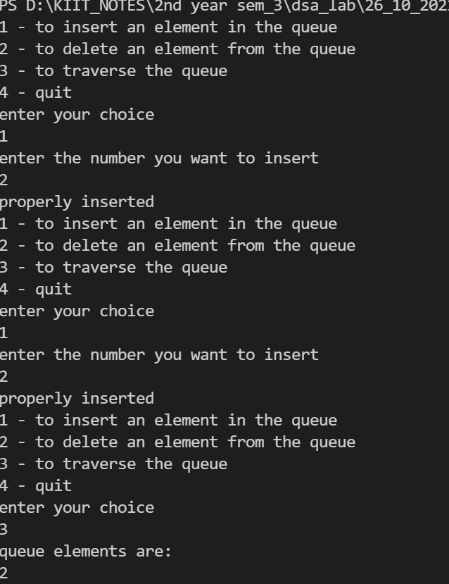 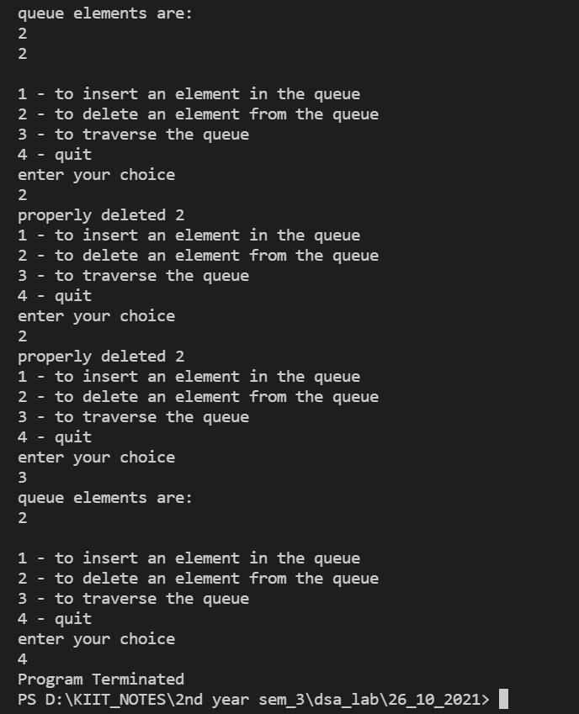

**Question 5)WAP to implement the double ended queue using array.**

#include <stdio.h>

#define MAX 5

int deque_arr[MAX];

int left = -1;

int right = -1;

void insert_right()

{

int added_item;

if ((left == 0 && right == MAX - 1) || (left == right + 1))

{

printf("Queue Overflow\n");

return;

}

if (left == -1)

{

left = 0;

right = 0;

}

else if (right == MAX - 1)

right = 0;

else

right = right + 1;

puts("Enter the element : ");

scanf("%d", &added_item);

deque_arr[right] = added_item;

}

void insert_left()

{

int added_item;

if ((left == 0 && right == MAX - 1) || (left == right + 1))

{

puts("Queue Overflow ");

return;

}

if (left == -1)

{

left = 0;

right = 0;

}

else if (left == 0)

left = MAX - 1;

else

left = left - 1;

puts("Enter the element : ");

scanf("%d", &added_item);

deque_arr[left] = added_item;

}

void delete_left()

{

if (left == -1)

{

puts("Queue Underflow\n");

return;

}

printf("Element deleted from queue is : %d\n", deque_arr[left]);

if (left == right)

{

left = -1;

right = -1;

}

else if (left == MAX - 1)

left = 0;

else

left = left + 1;

}

void delete_right()

{

if (left == -1)

{

puts("Queue Underflow\n");

return;

}

printf("Element deleted from queue is : %d\n", deque_arr[right]);

if (left == right)

{

left = -1;

right = -1;

}

else if (right == 0)

right = MAX - 1;

else

right = right - 1;

}

void display_queue()

{

int front_pos = left, rear_pos = right;

if (left == -1)

{

puts("Queue is empty");

return;

}

puts("Queue elements :");

if (front_pos <= rear_pos)

{

while (front_pos <= rear_pos)

{

printf("%d ", deque_arr[front_pos]);

front_pos++;

}

}

else

{

while (front_pos <= MAX - 1)

{

printf("%d ", deque_arr[front_pos]);

front_pos++;

}

front_pos = 0;

while (front_pos <= rear_pos)

{

printf("%d ", deque_arr[front_pos]);

front_pos++;

}

}

printf("\n");

}

void input_que()

{

int choice;

do

{ printf("1.Insert at right\n");

printf("2.Delete from left\n");

printf("3.Delete from right\n");

printf("4.Display\n");

printf("5.Quit\n");

printf("Enter your choice : ");

scanf("%d",&choice);

switch(choice)

{ case 1:

insert_right();

break;

case 2:

delete_left();

break;

case 3:

delete_right();

break;

case 4:

display_queue();

break;

case 5:

break;

default:

printf("Wrong choice\n");

}

}while(choice!=5);

}

void output_que()

{

int choice;

do

{

printf("1.Insert at right\n");

printf("2.Insert at left\n");

printf("3.Delete from left\n");

printf("4.Display\n");

printf("5.Quit\n");

printf("Enter your choice : ");

scanf("%d", &choice);

switch (choice)

{

case 1:

insert_right();

break;

case 2:

insert_left();

break;

case 3:

delete_left();

break;

case 4:

display_queue();

break;

case 5:

break;

default:

printf("Wrong choice\n");

}

} while (choice != 5);

}

main()

{

int choice;

printf("1.Input restricted dequeue\n");

printf("2.Output restricted dequeue\n");

printf("Enter your choice : ");

scanf("%d", &choice);

switch (choice)

{

case 1:

input_que();

break;

case 2:

output_que();

break;

default:

printf("Wrong choice\n");

}

}

