***NAME - AKRITI CHOUDHARY***

***ROLL NUMBER - 2005776***

***SUBJECT - DSA LAB***

***DATE - 2/11/2021***

***CLASS - B14***

***BRANCH - CSE***

**Question 1)WAP to create a binary search tree and traverse the tree with in-order, pre order and post order by proving suitable menu for the user.**

#include <stdio.h>

#include <stdlib.h>

struct Node

{

int data;

struct Node *left;

struct Node *right;

};

struct Node *newNode(int item)

{

struct Node *temp = (struct Node *)malloc(sizeof(struct Node));

temp->data = item;

temp->left = temp->right = NULL;

return temp;

}

struct Node *create(struct Node *root, int val)

{

if (root == NULL)

{

return newNode(val);

}

if (val < root->data)

{

root->left = create(root->left, val);

}

else

{

root->right = create(root->right, val);

}

return root;

}

void inorder(struct Node *root)

{

if (root == NULL)

{

return;

}

inorder(root->left);

printf("%d ", root->data);

inorder(root->right);

}

void preorder(struct Node *root)

{

if (root == NULL)

{

return;

}

printf("%d ", root->data);

preorder(root->left);

preorder(root->right);

}

void postorder(struct Node *root)

{

if (root == NULL)

{

return;

}

postorder(root->left);

postorder(root->right);

printf("%d ", root->data);

}

int main()

{

struct Node *root = NULL;

int n;

int a;

int b;

printf("BST-");

do{

printf("\n1 -> Create\n2 -> In-order\n3 -> Postorder\n4 -> Preorder\n5 -> Quit");

printf("\nEnter your choice : ");

scanf("%d", &b);

switch (b)

{

case 1:

printf("\nEnter total numbers of nodes to be created : ");

scanf("%d", &n);

printf("\nEnter root : ");

scanf("%d", &a);

root = create(root, a);

for (int i = 0; i < n - 1; i++)

{

printf("\nEnter value of root to be inserted : ");

scanf("%d", &a);

create(root, a);

}

break;

case 2:

inorder(root);

break;

case 3:

postorder(root);

break;

case 4:

preorder(root);

break;

case 5:

puts("--------Program Terminated-------");

break;

default:

break;

}

}while(b!=5);

}

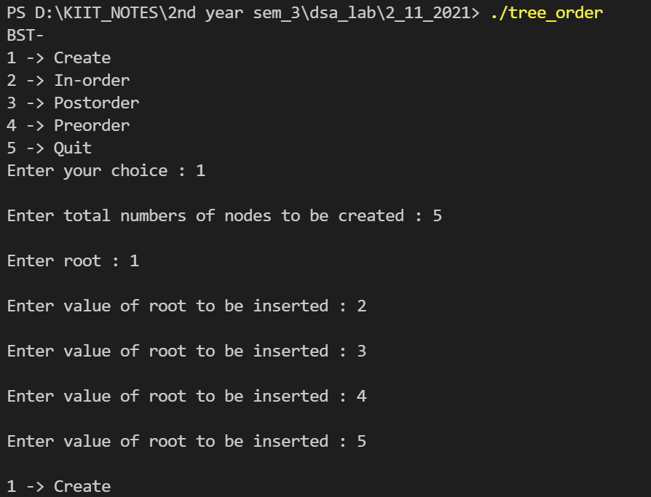

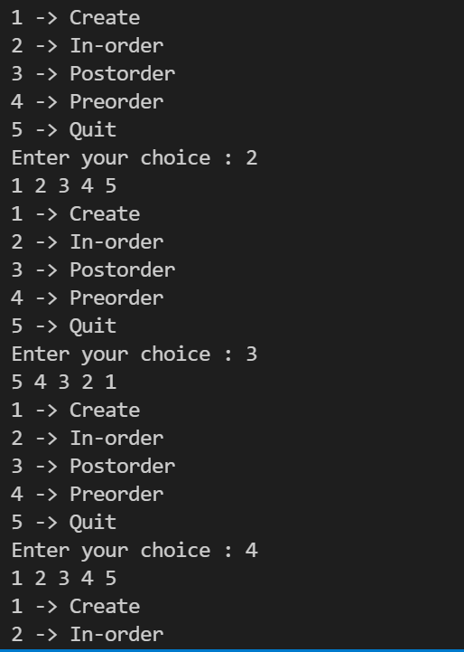

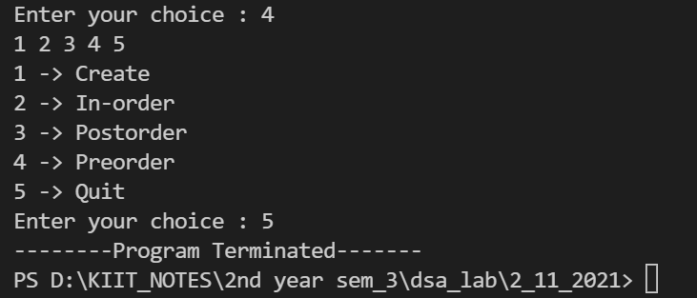

**Question 2) Modify the program LE8.1 by providing suitable user define functions separately to find the smallest and largest elements in the binary search tree.**

#include <stdio.h>

#include <stdlib.h>

struct Node

{

int data;

struct Node *left;

struct Node *right;

};

struct Node *createNode(int data)

{

struct Node *n;

n = (struct Node *)malloc(sizeof(struct Node));

n->data = data;

n->left = NULL;

n->right = NULL;

}

struct Node *insert(struct Node *root, int val)

{

if (root == NULL)

{

return createNode(val);

}

if(val == root->data)

{

puts("BST Tree cannot have duplicate values");

}

if (val < root->data)

{

root->left = insert(root->left, val);

}

if (val > root->data)

{

root->right = insert(root->right, val);

}

return root;

}

void smallest(struct Node *root)

{

while (root->left != NULL)

{

root = root->left;

}

printf("Smallest element of the Tree = %d \n", root->data);

}

void largest(struct Node *root)

{

while (root->right != NULL)

{

root = root->right;

}

printf("Largest element of the Tree = %d \n", root->data);

}

void preOrder(struct Node *root)

{

if (root != NULL)

{

printf("%d ", root->data);

preOrder(root->left);

preOrder(root->right);

}

}

void inOrder(struct Node *root)

{

if (root != NULL)

{

inOrder(root->left);

printf("%d ", root->data);

inOrder(root->right);

}

}

void postOrder(struct Node *root)

{

if (root != NULL)

{

postOrder(root->left);

postOrder(root->right);

printf("%d ", root->data);

}

}

int main()

{

int choice, i, n, num, c;

struct Node *root = NULL;

do

{

printf("Binary Search Tree ( BST ) Menu \n");

printf("0. Quit \n");

printf("1. Create \n");

printf("2. Inorder Traversal \n");

printf("3. PreOrder Traversal \n");

printf("4. PostOrder Traversal \n");

printf("5.Find smallest element \n");

printf("6. Find largest element \n");

printf("Enter your choice : \n");

scanf("%d", &choice);

switch (choice)

{

case 0:

exit(0);

break;

case 1:

printf("Enter the number of Nodes : \n");

scanf("%d", &n);

printf("Enter %d elements : \n", n);

for (i = 1; i <= n; i++)

{

scanf("%d", &num);

root = insert(root, num);

}

break;

case 2:

if (root == NULL)

printf("Tree is Empty \n");

else

{

printf("Inorder Traversal : \n");

inOrder(root);

}

printf("\n");

break;

case 3:

if (root == NULL)

printf("Tree is Empty \n");

else

{

printf("PreOrder Traversal : \n");

preOrder(root);

}

printf("\n");

break;

case 4:

if (root == NULL)

printf("Tree is Empty \n");

else

{

printf("PostOrder Traversal : \n");

postOrder(root);

}

printf("\n");

break;

case 5:

smallest(root);

break;

case 6:

largest(root);

break;

default:

printf("Wrong input .... \n");

}

} while (1);

return 0;

}

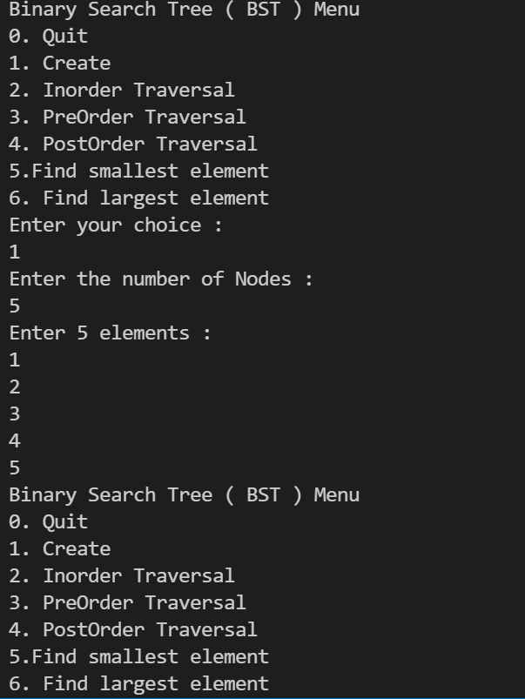

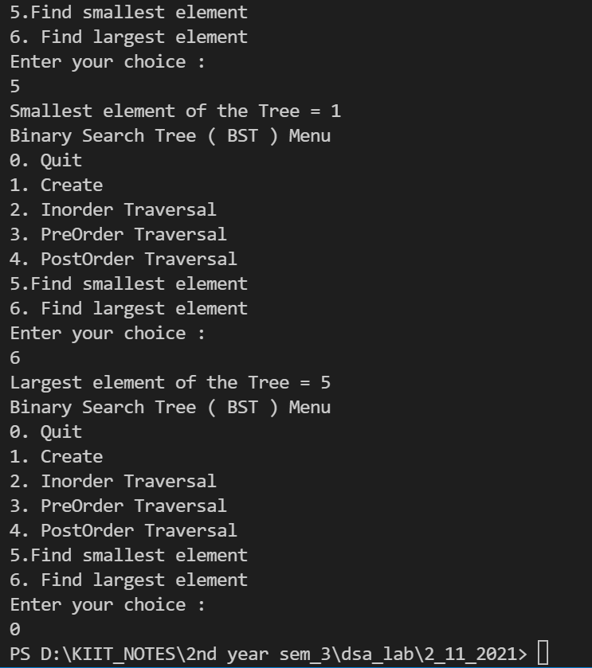

**Question 3) Modify the program LE8.2 by providing suitable user defined functions to insert and delete elements from the binary search tree.**

#include <stdio.h>

#include <stdlib.h>

struct BST

{

int data;

struct BST *left;

struct BST *right;

};

typedef struct BST NODE;

NODE *node;

NODE *createtree(NODE *node, int data)

{

if (node == NULL)

{

NODE *temp;

temp = (NODE *)malloc(sizeof(NODE));

temp->data = data;

temp->left = temp->right = NULL;

return temp;

}

if (data < (node->data))

{

node->left = createtree(node->left, data);

}

else if (data > node->data)

{

node->right = createtree(node->right, data);

}

return node;

}

void inorder(NODE *node)

{

if (node != NULL)

{

inorder(node->left);

printf("%d\t", node->data);

inorder(node->right);

}

}

void preorder(NODE *node)

{

if (node != NULL)

{

printf("%d\t", node->data);

preorder(node->left);

preorder(node->right);

}

}

void postorder(NODE *node)

{

if (node != NULL)

{

postorder(node->left);

postorder(node->right);

printf("%d\t", node->data);

}

}

NODE *smallest(NODE *node)

{

while (node != NULL && node->left != NULL)

node = node->left;

printf("smallest value is %d\n", node->data);

return node;

}

void largest(NODE *node)

{

while (node != NULL && node->right != NULL)

node = node->right;

printf("largest value is %d\n", node->data);

}

NODE *del(NODE *node, int data)

{

NODE *temp;

if (node == NULL)

{

printf("\nElement not found");

}

else if (data < node->data)

{

node->left = del(node->left, data);

}

else if (data > node->data)

{

node->right = del(node->right, data);

}

else

{

if (node->right && node->left)

{

temp = smallest(node->right);

node->data = temp->data;

node->right = del(node->right, temp->data);

}

else

{

temp = node;

if (node->left == NULL)

node = node->right;

else if (node->right == NULL)

node = node->left;

free(temp);

}

}

return node;

}

NODE *insert(NODE *node, int key)

{

if (node == NULL)

{

return createtree(node, key);

}

if (key < node->data)

{

node->left = insert(node->left, key);

}

else if (key > node->data)

{

node->right = insert(node->right,key);

}

return node;

}

int main()

{

int data, ch, i, n;

NODE *root = NULL;

do

{

printf("\n----------------------");

printf("Binary Search Tree Menu");

printf("-----------------------\n");

printf("\n0. Quit");

printf("\n1. Create");

printf("\n2. Inorder Traversal");

printf("\n3. Preorder Traversal");

printf("\n4. Postorder Traversal");

printf("\n5. Find smallest element");

printf("\n6. Find largest element");

printf("\n7. Insert an element");

printf("\n8. Delete an element");

printf("\nEnter your choice: ");

scanf("%d", &ch);

switch (ch)

{

case 0:

printf("-------Program Terminated---------\n");

break;

case 1:

printf("\nEnter number of nodes: ");

scanf("%d", &n);

printf("\nEnter %d elements \n", n);

for (i = 0; i < n; i++)

{

scanf("%d", &data);

root = createtree(root, data);

}

printf("The BST is created\n");

break;

case 2:

printf("\nThe Inorder Traversal is: ");

inorder(root);

break;

case 3:

printf("\nThe Preorder Traversal is: ");

preorder(root);

break;

case 4:

printf("\nThe Postorder Traversal is: ");

postorder(root);

break;

case 5:

smallest(root);

break;

case 6:

largest(root);

break;

case 7: printf("\nEnter the element to insert: ");

scanf("%d", &data);

root=insert(root, data);

break;

case 8:

printf("\nEnter the element to delete: ");

scanf("%d", &data);

root = del(root, data);

break;

default:

printf("\nWrong option");

break;

}

} while (ch != 0);

}

