***NAME - AKRITI CHOUDHARY***

***ROLL NUMBER - 2005776***

***SUBJECT - DSA LAB***

***DATE - 3/8/2021***

***CLASS - B14***

***BRANCH - CSE***

***Question1:WAP to find out the smallest and largest element stored in an array of n integers.***

#include <stdio.h>

#include <stdlib.h>

int main()

{

int *arr;

int n;

puts("Enter the size of array \n");

scanf("%d", &n);

arr = (int *)(malloc(n * sizeof(int)));

puts("Enter the elements of array \n");

for (int i = 0; i < n; ++i)

{

scanf("%d", &arr[i]);

}

int max = arr[0];

int min = arr[0];

for (int i = 0; i < n; ++i)

{

if (max < arr[i])

{

max = arr[i];

}

if (min > arr[i])

{

min = arr[i];

}

}

printf("Maximum value = %d \nMinimum value = %d \n", max, min);

free(arr);

puts("The dynamic memory has been freed");

}

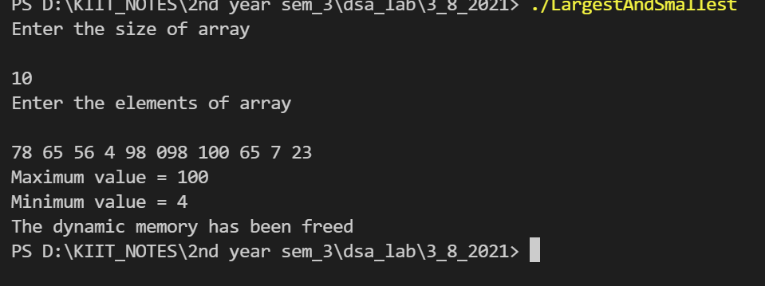

***Question2: WAP to reverse the contents of an array of n elements.***

#include <stdio.h>

#include <stdlib.h>

int main()

{

int *arr;

int n;

puts("Enter the size of array \n");

scanf("%d", &n);

arr = (int *)(malloc(n * sizeof(int)));

puts("Enter the elements of array \n");

for (int i = 0; i < n; ++i)

{

scanf("%d", &arr[i]);

}

int temp = 0;

for(int i = 0 ; i < n/2 ; ++i){

temp = arr[i];

arr[i] = arr[n - i - 1];

arr[n - i - 1] = temp;

}

puts("The reversed array :");

for (int i = 0; i < n; ++i)

{

printf("%d ", arr[i]);

}

puts("");

free(arr);

puts("The dynamic memory has been freed");

}

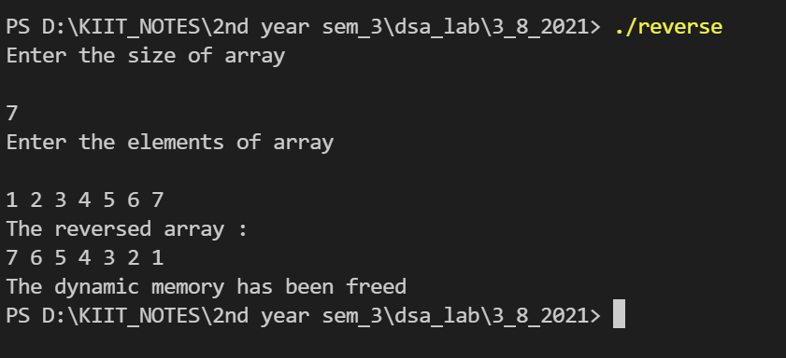

***Question3: WAP to search an element in an array of n numbers.***

#include <stdio.h>

#include <stdlib.h>

int main()

{

int *arr;

int n;

puts("Enter the size of array ");

scanf("%d", &n);

arr = (int *)(malloc(n * sizeof(int)));

puts("Enter the elements of array ");

for (int i = 0; i < n; ++i)

{

scanf("%d", &arr[i]);

}

int key;

puts("Enter the value to search for :");

scanf("%d" ,&key);

for (int i = 0; i < n; ++i)

{

if(arr[i] == key){

printf("%d was found at index %d \n" ,key , i + 1);

}

}

free(arr);

puts("The dynamic memory has been freed");

}

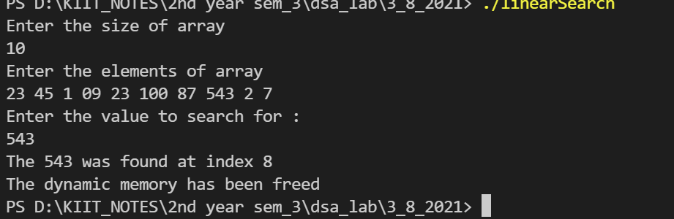

***Question4: WAP to sort an array of n numbers.***

#include <stdio.h>

#include <stdlib.h>

int main()

{

int *arr;

int n;

puts("Enter the size of array ");

scanf("%d", &n);

arr = (int *)(malloc(n * sizeof(int)));

puts("Enter the elements of array ");

for (int i = 0; i < n; ++i)

{

scanf("%d", &arr[i]);

}

//Sorting

int temp = 0;

for(int i = 0 ; i < n ; ++i){

for(int j = 0; j < n - i -1 ; ++j){

if(arr[j] > arr[j+1]){

temp = arr[j];

arr[j] = arr[j+1];

arr[j+1] = temp;

}

}

}

puts("The sorted array in ascending order :");

for (int i = 0; i < n; ++i)

{

printf("%d ", arr[i]);

}

puts("");

free(arr);

puts("The dynamic memory has been freed");

}

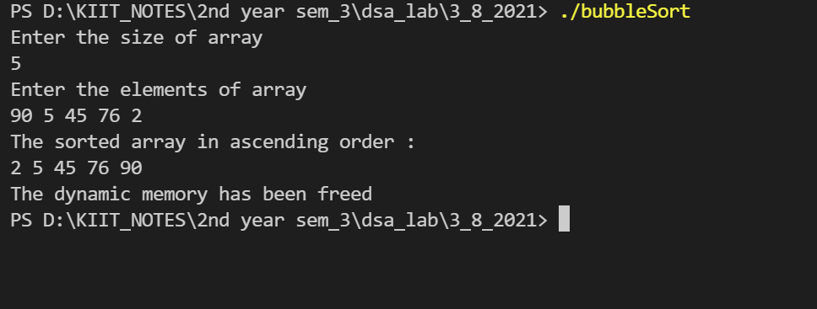

***Question5: Given an unsorted array of size n, WAP to find number of elements between two elements a and b (both***

***inclusive).***

***Input : arr = [1, 2, 2, 7, 5, 4]***

***a=2 b=5***

***Output : 4***

#include<stdio.h>

#include<stdlib.h>

int main()

{

int n;

int i;

int x,y;

int index_x=0,index_y=0;

printf("Enter the size of the array :\n");

scanf("%d",&n);

int *arr=(int*)malloc(n*sizeof(int));

puts("Enter the elements into the array :");

for(i=0;i<n;i++)

scanf("%d",&arr[i]);

puts("Enter the number x :");

scanf("%d",&x);

puts("Enter the number y :");

scanf("%d",&y);

for(i=0;i<n;i++)

{

if(arr[i]==x)

{

index_x=i;

break;

}

}

for(i=n-1;i>=0;i--)

{

if(arr[i]==y)

{

index_y=i;

break;

}

}

printf("Number of integers from x to y : %d \n",((index_y - index_x) + 1));

free(arr);

puts("The dynamic memory has been freed");

return 0;

}

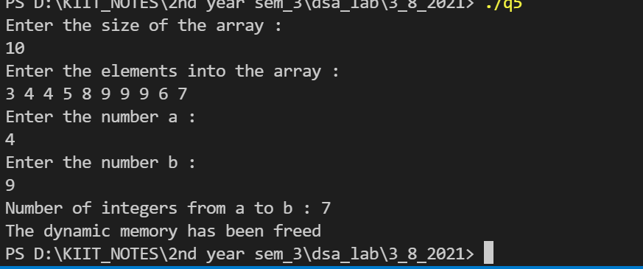

***Question6: Given an array, WAP to print the next greater element (NGE) for every element. The Next greater***

***Element for an element x is the first greater element on the right side of x in array. Elements for which***

***no greater element exist, consider next greater element as -1.***

***Sample Input & Output***

***For the input array [2, 5, 3, 9, 7}, the next greater elements for each element are as follows.***

***Element NGE***

***2 5***

***5 9***

***3 9***

***7 -1***

#include <stdio.h>

#include <stdlib.h>

int main()

{

int *arr;

int n;

puts("Enter the size of array ");

scanf("%d", &n);

arr = (int *)(malloc(n * sizeof(int)));

puts("Enter the elements of array ");

for (int i = 0; i < n; ++i)

{

scanf("%d", &arr[i]);

}

puts("Displaying the next greater element :");

printf("element\tNGE\n");

for (int i = 0; i < n; ++i)

{

for (int j = i; j < n; ++j)

{

if (arr[i] < arr[j])

{

printf("%d\t%d\n", arr[i], arr[j]);

break;

}

if(j == n-1){

printf("%d\t%d\n", arr[i], -1);

}

}

}

puts("");

free(arr);

puts("The dynamic memory has been freed");

}

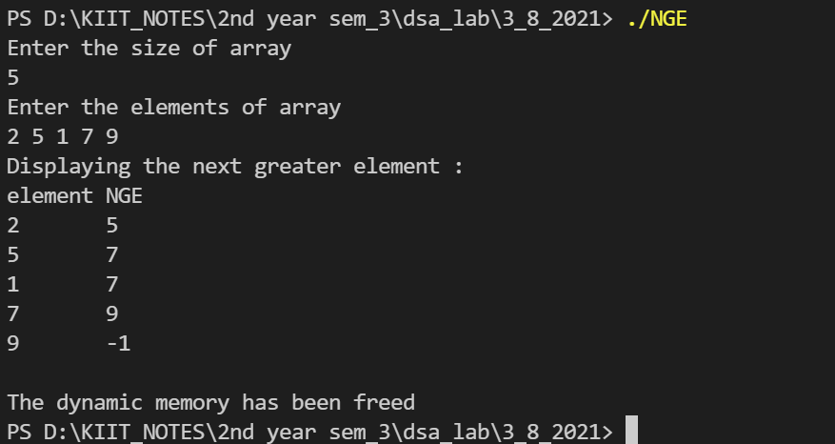

***Question7: WAP to swap three numbers in cyclic order using Call by Reference. In other words, WAP that takes***

***three variable (a, b, c) in as separate parameters and rotates the values stored so that value a goes to be,***

***b, to c and c to a.***

#include <stdio.h>

void swap(int *x , int *y){

int temp;

temp = *x;

*x = *y;

*y = temp;

}

int main(){

int a , b , c;

puts("Enter the three values ");

scanf("%d%d%d" ,&a ,&b ,&c);

swap(&a ,&b);

swap(&a ,&c);

puts("The three swaped values ");

printf("a = %d \nb = %d \nc = %d \n",a , b ,c);

}

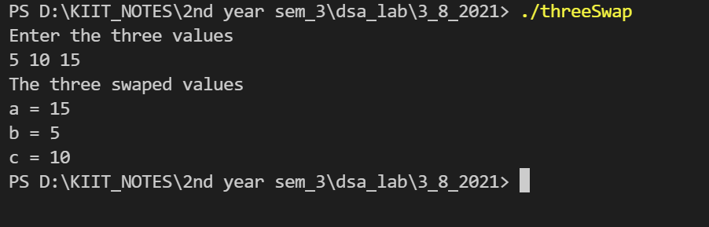

***Question8:Let A be n*n square matrix array. WAP by using appropriate user defined functions for the following:***

***a) Find the number of nonzero elements in A***

***b) Find the sum of the elements above the leading diagonal.***

***c) Display the elements below the minor diagonal.***

***d) Find the product of the diagonal elements***

#include <stdio.h>

#include <stdlib.h>

int countNonZero(int *s[], int size)

{

int count = 0;

for (int i = 0; i < size; ++i)

{

for (int j = 0; j < size; ++j)

{

if (s[i][j] != 0)

{

count++;

}

}

}

return count;

}

int SumAboveLeadingDiagonal(int *s[], int size)

{

int sum = 0;

for (int i = 0; i < size; ++i)

{

for (int j = i + 1; j < size; ++j)

{

sum += s[i][j];

}

}

return sum;

}

void DisplayBelowMinorDiagonal(int *s[], int size)

{

int sum = 0;

for (int i = 1; i < size; ++i)

{

for (int j = size - i; j < size; ++j)

{

printf("%d ", s[i][j]);

}

puts(" ");

}

}

void ProductOfDiagonal(int *s[], int size)

{

int leadingPro = 1;

int MinorPro = 1;

for (int i = 0; i < size; ++i)

{

for (int j = 0; j < size; ++j)

{

if (i == j)

{

leadingPro *= s[i][j];

}

if (i == (size - j - 1))

{

MinorPro *= s[i][j];

}

}

}

printf("Product of leading diagonal = %d\n", leadingPro);

printf("Product of Minor diagonal = %d\n", MinorPro);

}

int main()

{

puts("Enter the number of elements in a square matrix");

int n;

scanf("%d", &n);

int **arr = (int **)malloc(n * sizeof(int *));

for (int i = 0; i < n; i++)

arr[i] = (int *)malloc(n * sizeof(int));

puts("Enter the elements in the square matrix");

for (int i = 0; i < n; ++i)

{

for (int j = 0; j < n; ++j)

{

scanf("%d", &arr[i][j]);

}

}

printf("Menu: \n 1 : Number of non zero elements in the matrix \n 2 : Sum of the elements above the leading diagonal \n 3 :Elements below the minor diagonal\n 4: Product of diagonals\n");

int ch;

printf("Enter choice :\n");

scanf("%d", &ch);

switch (ch)

{

case 1:

printf("Number of non zero elements in the matrix : %d \n", countNonZero(arr, n));

break;

case 2:

printf("Sum of the elements above the leading diagonal : %d \n", SumAboveLeadingDiagonal(arr, n));

break;

case 3:

printf("Elements below the minor diagonal \n");

DisplayBelowMinorDiagonal(arr, n);

break;

case 4:

printf("Product of diagonals: \n");

ProductOfDiagonal(arr, n);

break;

default:

printf("The choice is invalid \n");

break;

}

free(arr);

return 0;

}

