***NAME - AKRITI CHOUDHARY***

***ROLL NUMBER - 2005776***

***SUBJECT - DSA LAB***

***DATE - 7/9/2021***

***CLASS - B14***

***BRANCH - CSE***

***Question 1 :WAP to create a linked list that represents a polynomial expression with single variable (i.e.5x7-3x5+x2+9) and display the polynomial by using user defined functions for creation and display.***

#include <stdio.h>

#include <stdlib.h>

struct node

{

int p;

int data;

struct node *next;

};

/*Traversal of the list*/

void traverse(struct node *h)

{

if (h == NULL)

{

printf("\nThe list is empty\n");

}

else

{

while (h != NULL)

{

if (h->data >= 0)

printf("+ %dx^%d ", h->data, h->p);

else

printf("%dx^%d ", h->data, h->p);

h = h->next;

}

}

puts("");

}

/*To check whether the list is empty or not*/

void isEmpty(struct node *h)

{

if (h == NULL)

{

printf("\n The list is empty\n");

}

else

{

printf("\n The list is not empty\n");

}

puts("");

}

/*To insert a node at a given position in the list*/

void insert(struct node **h, int pos)

{

struct node *cur = NULL;

cur = (struct node *)malloc(sizeof(struct node));

if (cur == NULL)

{

puts("Memory is not allocated");

}

printf("\nEnter the coefficient for the created node \n");

scanf("%d", &cur->data);

printf("\nEnter the power for the created node \n");

scanf("%d", &cur->p);

cur->next = NULL;

if (*h == NULL) //to insert a node in an empty list

{

*h = cur;

}

else if (pos == 0) //to insert a node at the beginning of the list

{

cur->next = *h;

*h = cur;

}

else

{

struct node *tmp = *h;

int i = 0;

while ((i < pos - 1) && (tmp->next != NULL))

{

tmp = tmp->next;

++i;

}

cur->next = tmp->next;

tmp->next = cur;

}

puts("");

}

/*To delete a node at a given position from the list*/

void deleteNode(struct node **h, int pos)

{

if (*h == NULL)

{

puts("The list is empty");

}

else if ((pos == 0) && ((*h)->next == NULL))

{

free(*h);

*h = NULL;

}

else

{

struct node *tmp = *h, *cur = *h;

int i = 0;

while ((i <= pos - 1) && (cur->next != NULL))

{

++i;

tmp = cur;

cur = cur->next;

}

if (pos == 0)

{

*h = cur->next;

free(cur);

}

else if ((*h)->next == NULL)

{

free(*h);

*h = NULL;

}

else

{

tmp->next = cur->next;

free(cur);

}

}

puts("");

}

int main()

{

struct node *head = NULL;

int position;

int ch = 0;

while (ch != -1)

{

puts("Enter the choice :");

puts("1 - Traversal of the list\n"

"2 - Check if the list is empty\n"

"3 - Insert a node at the certain position (at beginning/end/any position)\n"

"4 - Delete a node at the certain position (at beginning/end/any position)\n"

"-1 - To exit");

puts("");

scanf("%d", &ch);

switch (ch)

{

case 1:

traverse(head);

break;

case 2:

isEmpty(head);

break;

case 3:

puts("Enter the position at which the node is to be inserted");

scanf("%d", &position);

insert(&head, position);

break;

case 4:

puts("Enter the position at which the node is to be deleted");

scanf("%d", &position);

deleteNode(&head, position);

break;

case -1:

puts("-------------------------Terminated-----------------------------");

break;

default:

puts("Wrong choice");

break;

}

}

return 0;

}

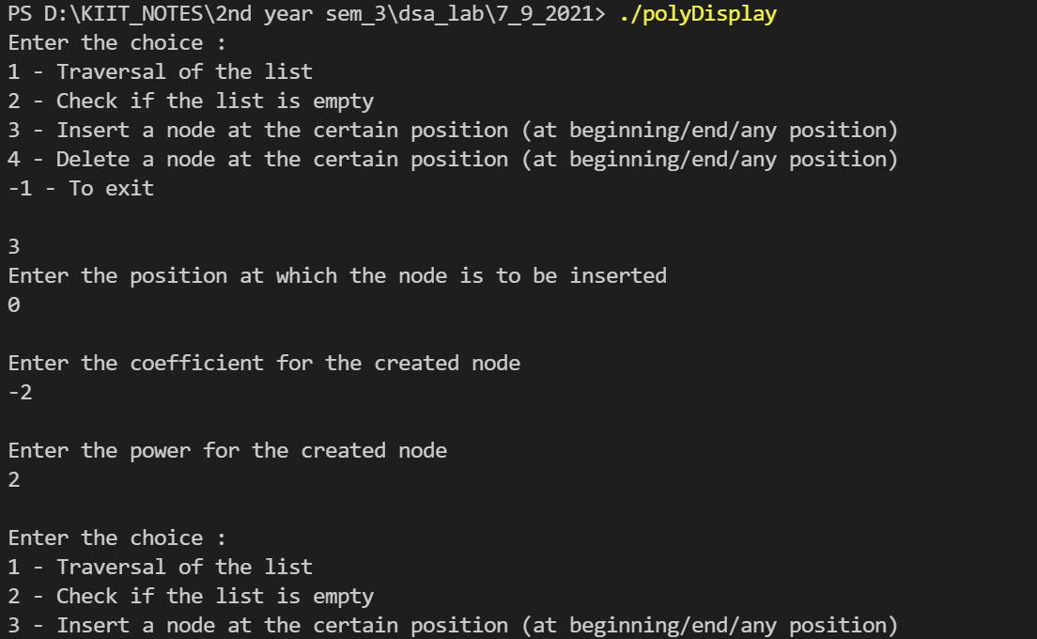

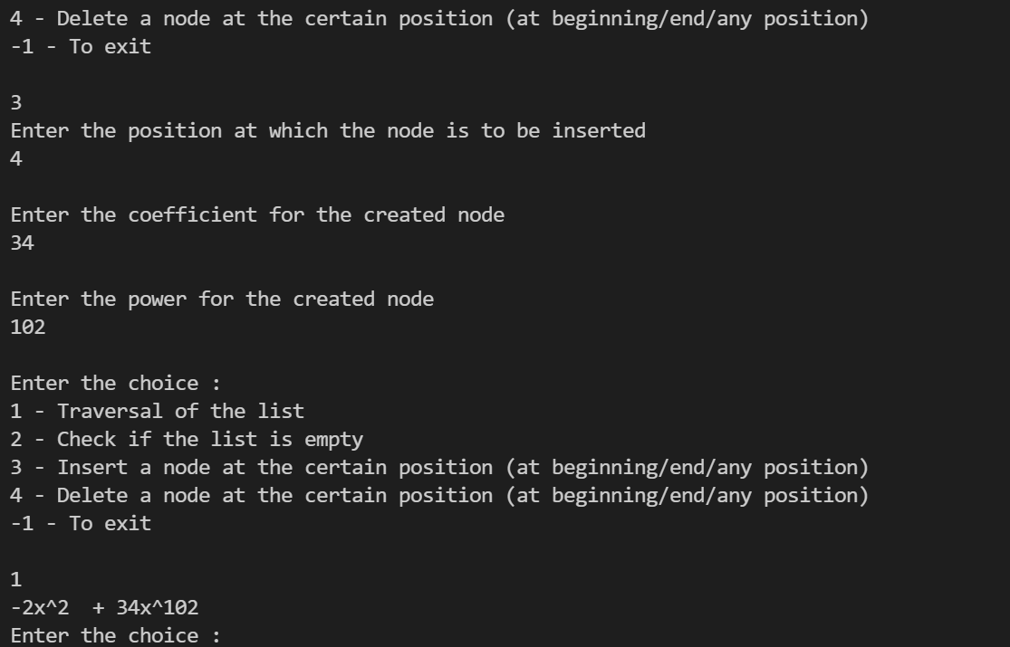

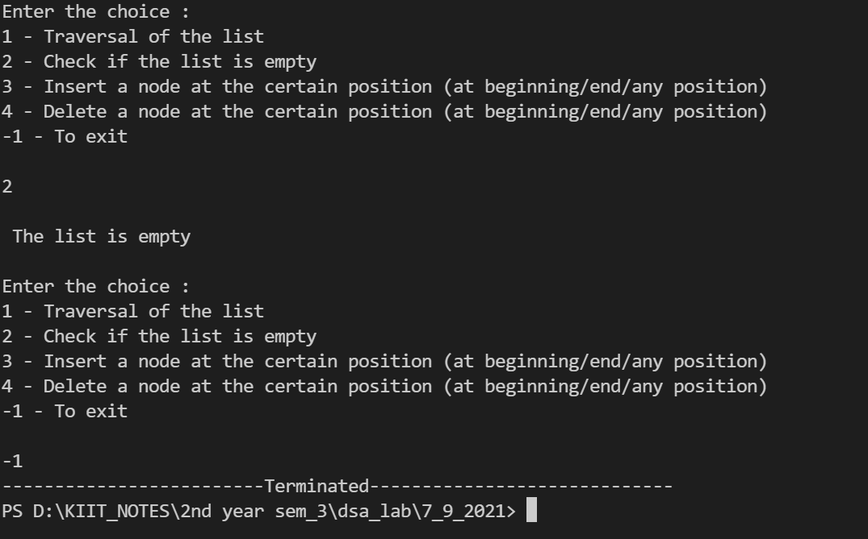

***Question2 : WAP to add two polynomials with single variable.***

#include <stdio.h>

#include <stdlib.h>

struct node

{

int exp;

int cof;

struct node *next;

};

void create(struct node **h)

{

int n;

struct node *cur, *ptr;

printf("enter the no. of terms in the polynomial");

scanf("%d", &n);

for (int i = 0; i < n; i++)

{

cur = (struct node *)malloc(sizeof(struct node));

printf("enter the coefficient and the exponent of the %dth term", i + 1);

scanf("%d%d", &cur->cof, &cur->exp);

cur->next = NULL;

if (*h == NULL)

{

*h = cur;

ptr = cur;

}

else

{

ptr->next = cur;

ptr = cur;

}

}

}

void join(struct node **h1, struct node *h2)

{

if (*h1 == NULL)

*h1 = h2;

else

{

struct node *ptr;

for (ptr = *h1; ptr->next != NULL; ptr = ptr->next)

;

ptr->next = h2;

}

}

void simplify(struct node **h)

{

struct node *ptr, *ptr1, *prev;

ptr = *h;

while (ptr != NULL)

{

prev = ptr;

ptr1 = ptr->next;

while (ptr1 != NULL)

{

if (ptr1->exp == ptr->exp)

{

ptr->cof += ptr1->cof;

prev->next = ptr1->next;

free(ptr1);

ptr1 = prev;

}

prev = ptr1;

ptr1 = ptr1->next;

}

ptr = ptr->next;

}

}

void display(struct node *h)

{

struct node *ptr;

ptr = h;

if (h == NULL)

{

printf("list is empty");

return;

}

for (; ptr != NULL; ptr = ptr->next)

{

if (ptr->cof >= 0)

{

if (ptr != NULL)

printf("+");

}

printf("%dX^%d\t", ptr->cof, ptr->exp);

}

printf("\n\n");

}

int main()

{

struct node *h1, *h2;

h1 = h2 = NULL;

create(&h1);

create(&h2);

printf("the 1st polynoial is\n");

display(h1);

printf("the 2nd polynoial is\n");

display(h2);

join(&h1, h2);

simplify(&h1);

printf("the polynomial after adding is\n");

display(h1);

}

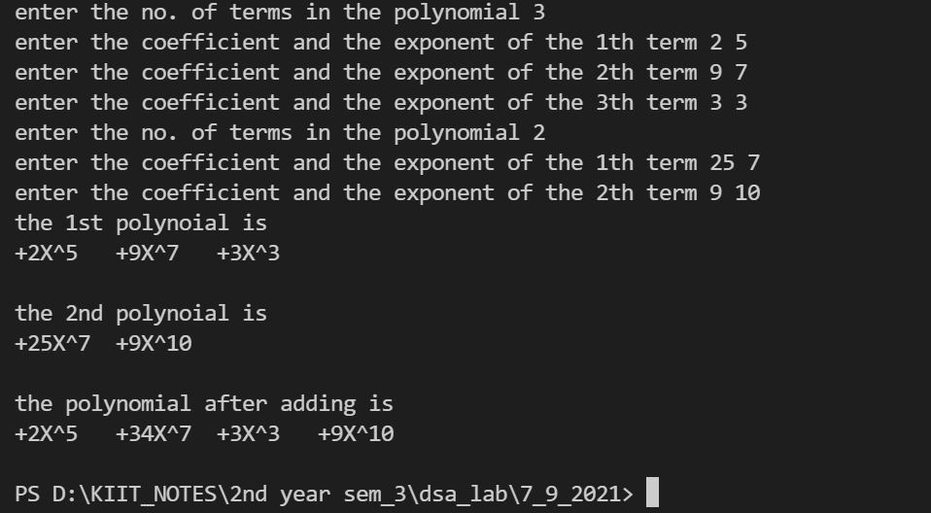

***Question3 : A matrix m × n that has relatively few non-zero entries is called sparse matrix. It may be represented in much less than m × n space. An m × n matrix with k non-zero entries is sparse if k << m × n. It may be faster to represent the matrix compactly as a list of the non-zero indexes and associated entries. WAP to represent a sparse matrix in 3-tuple format by using***

***array.***

#include <stdio.h>

#include <stdlib.h>

struct Node

{

int row;

int col;

int data;

struct Node *next;

};

struct Node *insertNodeAtTail(struct Node *head, int r, int c, int d)

{

struct Node *ptr = (struct Node *)malloc(sizeof(struct Node));

ptr->row = r;

ptr->col = c;

ptr->data = d;

ptr->next = NULL;

if (head == NULL)

{

head = ptr;

}

else

{

struct Node *p = head;

while (p->next != NULL)

{

p = p->next;

}

p->next = ptr;

}

return head;

}

void display(struct Node *head)

{

struct Node *ptr = head;

printf("Printing the matrix in triplet form :\n");

printf("Row Column Element \n");

while (ptr != NULL)

{

printf("%d\t%d\t%d\n", ptr->row, ptr->col, ptr->data);

ptr = ptr->next;

}

}

int main()

{

struct Node *head = NULL;

int row, col, n, i, r, c, num;

printf("Enter the dimension of the matrix :\n");

printf("Enter the no. of row :\n");

scanf("%d", &row);

printf("Enter the no. of columns :\n");

scanf("%d", &col);

printf("Enter the number of non-zero inputs to be given to the matrix :\n");

scanf("%d", &n);

if (n < (row * col) / 2)

{

for (i = 0; i < n; i++)

{

printf("Enter the row index :\n");

scanf("%d", &r);

printf("Enter the column index :\n");

scanf("%d", &c);

printf("Enter the element :\n");

scanf("%d", &num);

head = insertNodeAtTail(head, r, c, num);

}

display(head);

}

else

{

printf("Matrix is not sparse\n");

}

return 0;

}

