**NAME - AKRITI CHOUDHARY**

**ROLL NO. - 2005776**

**CLASS - B14**

**DSA LAB ENDSEM**

**Question 1)WAP to reverse the first m elements of a linked list of n nodes.**

#include <stdio.h>

#include <stdlib.h>

struct node

{

int num;

struct node *next;

};

void createList(struct node **);

void reverseList(struct node **, int);

void releaseNode(struct node **);

void displayList(struct node *);

int main()

{

struct node *p = NULL;

int n;

puts("Enter the data : ");

createList(&p);

puts("Displaying the nodes : ");

displayList(p);

puts("Enter the number of nodes to be reversed: ");

scanf("%d", &n);

if (n > 1)

{

reverseList(&p, n - 2);

}

puts("The reversed list(first m elements of n nodes): ");

displayList(p);

releaseNode(&p);

return 0;

}

void reverseList(struct node **head, int n)

{

struct node *p, *q, *r, *rear;

p = q = r = *head;

if (n == 0)

{

q = q->next;

p->next = q->next;

q->next = p;

*head = q;

}

else

{

p = p->next->next;

q = q->next;

r->next = NULL;

rear = r;

q->next = r;

while (n > 0 && p != NULL)

{

r = q;

q = p;

p = p->next;

q->next = r;

n--;

}

*head = q;

rear->next = p;

}

}

void createList(struct node **head)

{

int c, ch;

struct node *temp, *rear;

do

{

printf("Enter number: ");

scanf("%d", &c);

temp = (struct node *)malloc(sizeof(struct node));

temp->num = c;

temp->next = NULL;

if (*head == NULL)

{

*head = temp;

}

else

{

rear->next = temp;

}

rear = temp;

puts("Enter 1 - to continue and 0 - to stop creation of the list");

scanf("%d", &ch);

} while (ch != 0);

printf("\n");

}

void displayList(struct node *p)

{

while (p != NULL)

{

printf("%d\t", p->num);

p = p->next;

}

printf("\n");

}

void releaseNode(struct node **head)

{

struct node *temp = *head;

*head = (*head)->next;

while ((*head) != NULL)

{

free(temp);

temp = *head;

(*head) = (*head)->next;

}

}

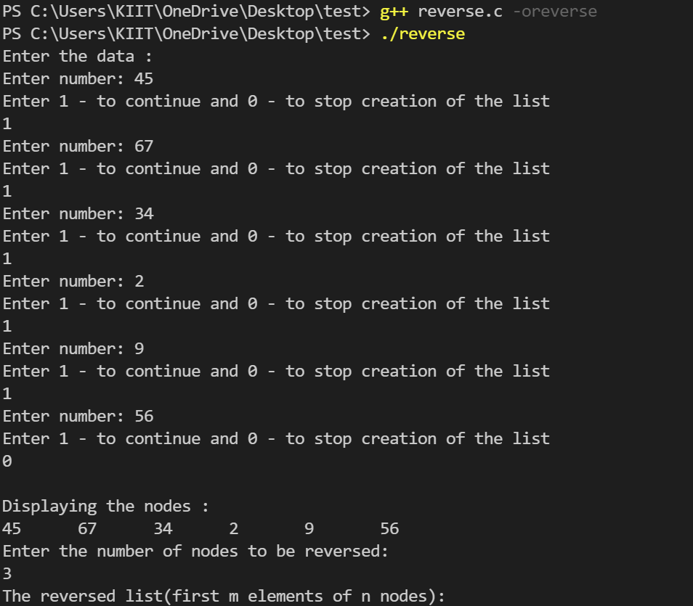

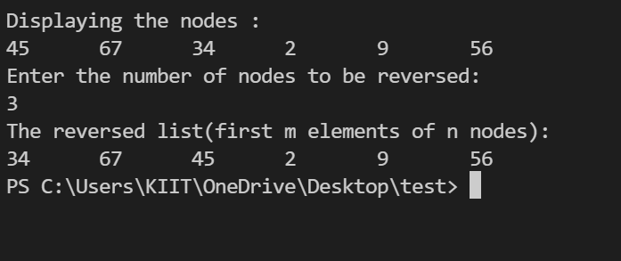

**Question 2)WAP to sort an array of n integers in an ascending order by using quicksort.**

#include <stdio.h>

#include <stdlib.h>

int *arr;

int n;

void display()

{

printf("Elements of the array : \n");

for (int i = 0; i < n; i++)

{

printf("%d ", arr[i]);

}

printf("\n");

}

int partition(int *A, int low, int high)

{

int pivot = A[low];

int i = low + 1;

int j = high;

int temp;

do

{

while (A[i] <= pivot)

{

i++;

}

while (A[j] > pivot)

{

j--;

}

if (i < j)

{

temp = A[i];

A[i] = A[j];

A[j] = temp;

}

} while (i < j);

temp = A[low];

A[low] = A[j];

A[j] = temp;

return j;

}

void quickSort(int *A, int low, int high)

{

int partitionIndex;

if (low < high)

{

partitionIndex = partition(A, low, high);

quickSort(A, low, partitionIndex - 1);

quickSort(A, partitionIndex + 1, high);

}

}

int main()

{

printf("Enter the size of the array : \n");

scanf("%d", &n);

arr = (int *)malloc(n * sizeof(int));

for (int i = 0; i < n; i++)

{

printf("Enter %d element : \n", i + 1);

scanf("%d", &arr[i]);

}

quickSort(arr, 0, n - 1);

display();

return 0;

}

