***Name - Akriti Choudhary***

***Roll number - 2005776***

***Lab11***

***Subject - OOP lab***

***Class - B14***

***Branch - CSE***

***Date- 11/11/2021***

**Question 1) Create a class shape. Derive three classes from it; Circle, Square and Triangle. Find area of each shape and display it, using virtual function.**

#include <iostream>

#include <cstring>

using namespace std;

class Shape

{

public:

virtual void input()

{

cout << "Shape's input called";

}

virtual void area()

{

cout << "Shape's area";

}

};

class Circle : public Shape

{

int radius;

public:

void input()

{

cout << "Enter radius of circle: ";

cin >> radius;

}

void area()

{

cout << "\nArea of Circle is:" << 3.14 * radius * radius << endl;

}

};

class Triangle : public Shape

{

int b, h;

public:

void input()

{

cout << "Enter base of triangle: ";

cin >> b;

cout << "Enter height of triangle: ";

cin >> h;

}

void area()

{

cout << "Area of triangle is: " << 0.5 * h * b << endl;

}

};

class square : public Shape

{

int l;

public:

void input()

{

cout << "Enter the side of square : ";

cin >> l;

}

void area()

{

cout << "Area of square is: " << l * l << endl;

}

};

int main()

{

Shape *p1, *p2, *p3;

Circle c;

Triangle t;

square r;

p1 = &c;

p2 = &t;

p3 = &r;

p1->input();

p2->input();

p3->input();

p1->area();

p2->area();

p3->area();

}

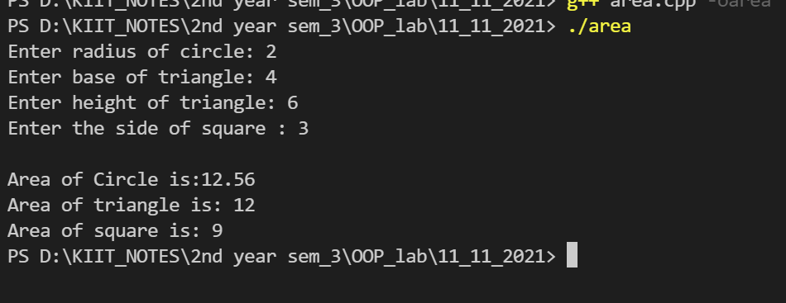

**Question 2) Create a class which stores employee name,id and salary Derive two classes from ‘Employee’ class: ‘Regular’ and ‘Part-Time’. The ‘Regular’ class stores DA, HRA and basic salary. The ‘Part-Time’ class stores the number of hours and pay per hour.**

**Calculate the salary of a regular employee and a par-time employee, using virtual function.**

#include <iostream>

using namespace std;

class employee

{

public:

char name[25];

int id, salary, DA, HRA, hr, pph;

void info()

{

cout << "Enter name : ";

cin >> name;

cout << "Enter ID : ";

cin >> id;

}

void regular()

{

cout << "Enter salary : ";

cin >> salary;

cout << "Enter DA : ";

cin >> DA;

cout << "Enter HRA : ";

cin >> HRA;

}

void part()

{

cout << "Enter number of hours : ";

cin >> hr;

cout << "Enter pay per hour : ";

cin >> pph;

}

virtual void sal() = 0;

};

class regular : public employee

{

public:

void sal()

{

cout << "\nSalary of regular employee : " << salary + DA + HRA << endl;

}

};

class part : public employee

{

public:

void sal()

{

cout << "\nSalary of Part-time employee : " << pph * hr * 30 << endl;

}

};

int main()

{

regular r;

employee *er = &r;

er->info();

er->regular();

er->sal();

part p;

employee *ep = &p;

ep->info();

ep->part();

ep->sal();

return 0;

}

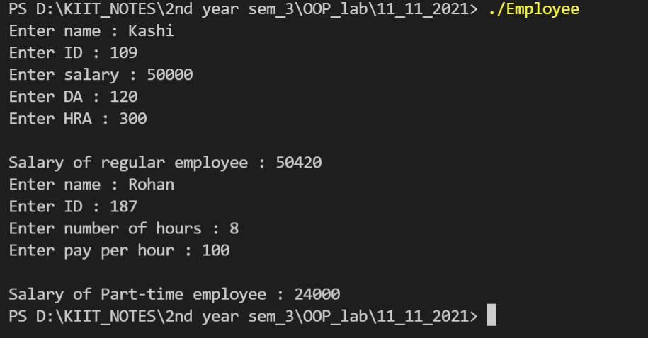

**Question 3)Create a class which stores account number, customer name and balance. Derive two**

**classes from ‘Account’ class: ‘Savings’ and ‘Current’. The ‘Savings’ class stores minimum balance. The ‘Current’ class stores the over-due amount. Include member functions in the appropriate class for**

**-deposit money**

**-withdraw [For saving account minimum balance should be checked.]**

**[For current account overdue amount should be calculated.]**

**-display balance**

**Display data from each class using virtual function**

#include <iostream>

using namespace std;

class account

{

public:

int acn, balance, minbal, wd, dp, bal;

char name[25];

void info()

{

cout << "Enter account number : ";

cin >> acn;

cout << "Enter name : ";

cin >> name;

cout << "Enter balance : ";

cin >> balance;

cout << "Enter amount to withdraw : ";

cin >> wd;

cout << "Enter amount to deposit : ";

cin >> dp;

}

void saving()

{

minbal = 1000;

bal = balance - wd + dp;

cout << "Minimum balance is : " << minbal << endl;

}

void current()

{

bal = balance - wd + dp;

cout << "Current balance is : " << bal << endl;

}

virtual void data() = 0;

};

class savings : public account

{

public:

void data()

{

cout << "Account number : " << acn << endl;

cout << "Customer name : " << name << endl;

if (bal < minbal)

cout << "You cannow withdraw below minimum balance, which is Rs. " << minbal << endl;

else

cout << "Balance is : " << bal << endl;

}

};

class current : public account

{

public:

void data()

{

cout << "Account number : " << acn << endl;

cout << "Customer name : " << name << endl;

if (bal < 0)

{

cout << "Amount Overdued." << endl;

}

else

{

cout << "Balance is : " << bal << endl;

}

}

};

int main()

{

int ch;

savings s;

account *as = &s;

current c;

account *ac = &c;

while (1)

{

cout << "1. Savings" << endl;

cout << "2. Current" << endl;

cout << "3. Exit" << endl;

cout << "Enter choice : ";

cin >> ch;

switch (ch)

{

case 1:

cout << "Savings Account." << endl;

as->info();

as->saving();

as->data();

break;

case 2:

cout << "Current Account." << endl;

ac->info();

ac->current();

ac->data();

break;

case 3:

return 0;

break;

default:

cout << "Wrong Choice!!" << endl;

break;

}

}

}

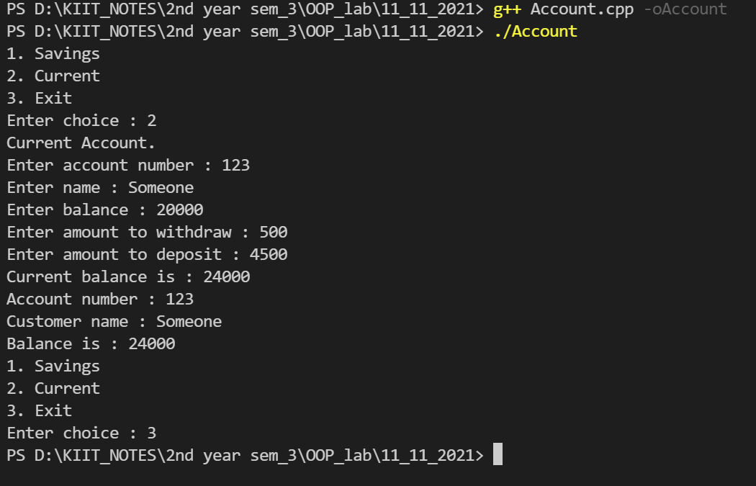

**Question 4) WAP to demonstrate use of pure virtual function and abstract base class.**

#include <iostream>

using namespace std;

class Shape

{

protected:

float dimension;

public:

void Dimension()

{

cin >> dimension;

}

virtual float calculateArea() = 0;

};

class Square : public Shape

{

public:

float calculateArea()

{

return dimension * dimension;

}

};

class Circle : public Shape

{

public:

float calculateArea()

{

return 3.14 * dimension * dimension;

}

};

int main()

{

Square square;

Circle circle;

cout << "enter the side of the square : ";

square.Dimension();

cout << "\narea of square:" << square.calculateArea() << endl;

cout << "enter the radius of the circle : ";

circle.Dimension();

cout << "\narea of circle:" << circle.calculateArea() << endl;

return 0;

}

