***Name - Akriti Choudhary***

***Roll number - 2005776***

***Lab3***

***Subject - OOP lab***

***Class - B14***

***Branch - CSE***

***Date- 12/08/2021***

***Question1: WAP to display from 10 to 1 using for loop.***

#include <iostream>

using namespace std;

class display

{

public:

void dis()

{

for (int i = 10; i >= 1; --i)

{

cout << i << endl;

}

}

};

int main()

{

display d;

d.dis();

}

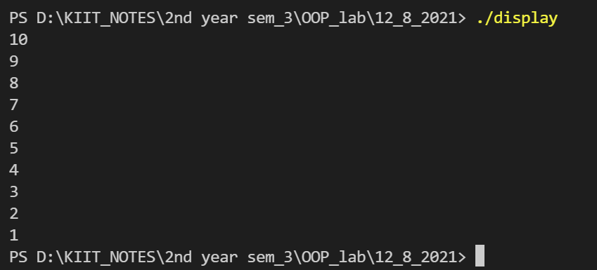

***Question 2: WAP to calculate factorial.***

#include <iostream>

using namespace std;

class factorial

{

public:

factorial(int n)

: a(n)

{

}

int fact(int a);

private:

int a;

};

int factorial::fact( int a){

if(a==1 || a==0){

return 1;

}

else

return (a*fact(a-1));

}

int main()

{

int n;

cout << "Enter the number to calculate factorial " << endl;

cin >> n;

factorial num(n);

cout<<"Result = "<<num.fact(n)<<endl;

}

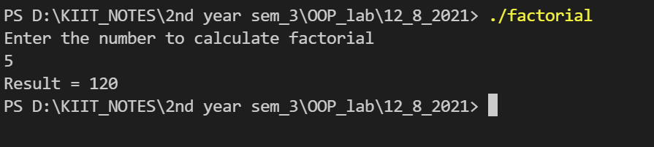

***Qusetion 3: WAP to display even numbers between 1 to 150.***

#include <iostream>

using namespace std;

class displayEven

{

public:

void dis()

{

for (int i = 1; i <= 150; ++i)

{

if (i % 2 == 0)

{

cout << i <<"\t";

count++;

}

if (count % 6 == 0)

{

cout << endl;

}

}

}

private:

int count = 0;

};

int main()

{

displayEven d;

cout << "Even numbers between 1 to 150 :" << endl;

d.dis();

}

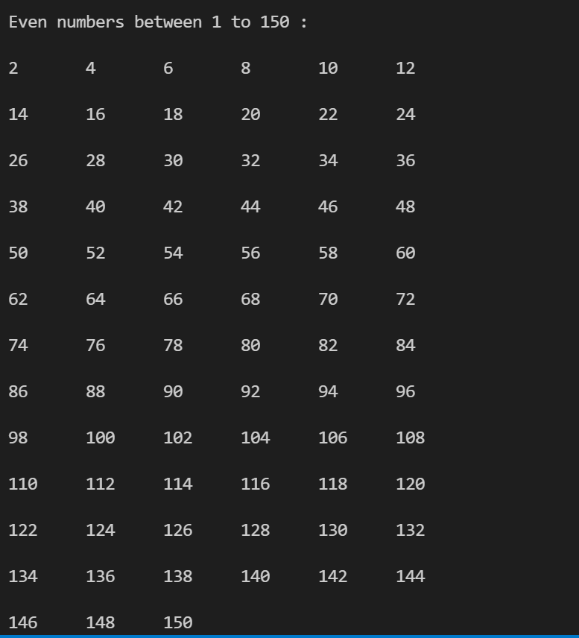

***Question 4: WAP to calculate the sum of numbers between 1 to N.The user should input N.***

#include <iostream>

using namespace std;

class sum

{

public:

sum()

: total(0)

{

}

void input()

{

cout << "Enter the Number : " << endl;

cin >> num;

}

void calculate();

private:

int num;

int total;

};

void sum::calculate()

{

for (int i = 1; i <= num; ++i)

{

total += i;

}

cout<<"Total = "<<total<<endl;

}

int main()

{

sum obj;

obj.input();

obj.calculate();

return 0;

}

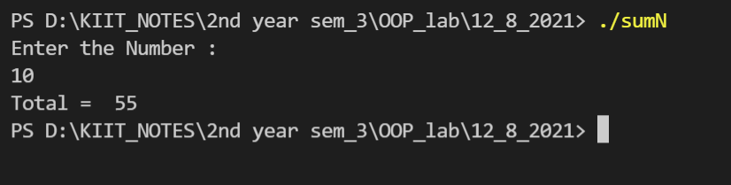

***Question5: WAP to overload area function to calculate area of a triangle , area of a rectangle , area of a circle , area of a cylinder.***

#include <iostream>

using namespace std;

class A

{

public:

float area(int height, int base); //area of triangle

float area(float l, float b); //area of rectangle

float area(int h, float r); //area of cylinder

float area(int r); //area of circle

void output()

{

cout << "Result : " << res << endl;

}

private:

float res;

};

float A::area(int height, int base)

{

res = 0.5 * base * height;

}

float A::area(float l, float b)

{

res = l * b;

}

float A::area(int h, float r)

{

res = (2 * 3.14 * r * h) + (2 * 3.14 * r * r);

}

float A::area(int r)

{

res = 3.14 * r * r;

}

int main()

{

cout << "1: Area of triangle \n2: Area of Rectangle \n3:Area of cylinder \n4: Area of circle " << endl;

int ch;

cin >> ch;

A obj;

int height, base, radius ;

float l ,b ,r;

switch (ch)

{

case 1:

cout << "Enter the (int)height and (int)base" << endl;

cin >> height >> base;

obj.area(height, base);

obj.output();

break;

case 2:

cout << "Enter the (float)length and (float)width" << endl;

cin >> l >> b;

obj.area(l, b);

obj.output();

break;

case 3:

cout << "Enter the (int)height and (float)radius" << endl;

cin >> height >> r;

obj.area(height, r);

obj.output();

break;

case 4:

cout << "Enter the (int)radius" << endl;

cin >> radius;

obj.area(radius);

obj.output();

break;

default:

cout << "Invalid choice" << endl;

}

return 0;

}

