***Name - Akriti Choudhary***

***Roll number - 2005776***

***Lab8***

***Subject - OOP lab***

***Class - B14***

***Branch - CSE***

***Date- 16/09/2021***

***Question1) WAP to demonstrate all types of inheritance.***

#include <iostream>

#include <bits/stdc++.h>

using namespace std;

class A

{

protected:

    int a;

public:

    void display()

    {

        a = 1 + rand() % 100;

        cout << "a = " << a << endl;

    }

};

class A1

{

protected:

    int a1;

public:

    void display1()

    {

        a1 = 1 + rand() % 100;

        cout << "a1 = " << a1 << endl;

    }

};

class B : public A

{

protected:

    int b;

public:

    void display2()

    {

        b = 1 + rand() % 100;

        ;

        cout << "b = " << b << endl;

    }

};

class C : public A

{

protected:

    int c;

public:

    void display3()

    {

        c = 1 + rand() % 100;

        ;

        cout << "c = " << c << endl;

    }

};

class D : public B

{

protected:

    int d;

public:

    void display4()

    {

        d = 1 + rand() % 100;

        ;

        cout << "d = " << d << endl;

    }

};

class E : public A, public A1

{

protected:

    int e;

public:

    void dispe()

    {

        e = 1 + rand() % 100;

        ;

        cout << "e = " << e << endl;

    }

};

class F : public B

{

protected:

    int f;

public:

    void dispf()

    {

        f = 1 + rand() % 100;

        ;

        cout << "f  = " << f << endl;

    }

};

int main()

{

    B obb;

    C obc;

    D obd;

    E obe;

    F obf;

    cout << "Single : \n";

    obb.display();

    cout << "Multilevel : \n";

    obd.display4();

    cout << "Hybrid : \n";

    obd.display4();

    obf.display2();

    cout << "Multiple : \n";

    obe.display();

    obe.display1();

    cout << "Hierarchical : \n";

    obb.display2();

    obc.display3();

}

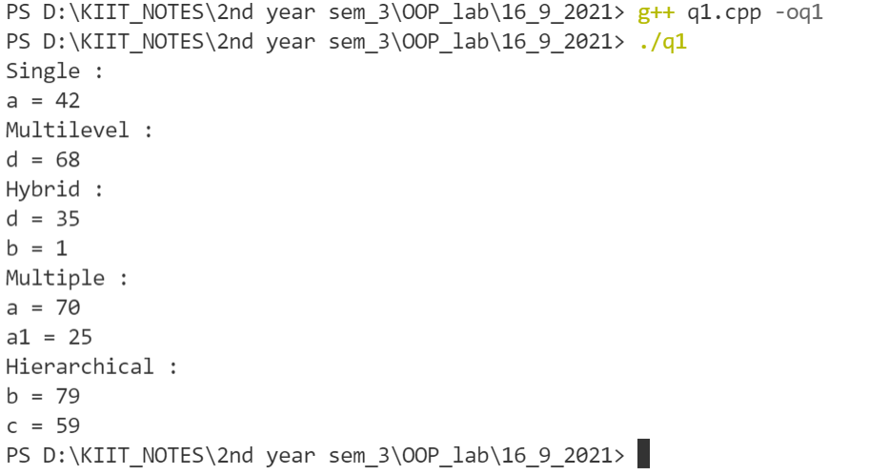

***Question 2) Create a class student which stores name, roll number and age of a student. Derive a class test from student class, which stores marks in 5 subjects. Input and display the details of a student.***

#include <iostream>

#include <string>

using namespace std;

class student

{

protected:

    string n;

    int rollnum;

    int age;

public:

    void input1()

    {

        cout << "Enter roll number :";

        cin >> rollnum;

        cout << endl;

        cout << "Enter name :";

        cin >> n;

        cout << endl;

        cout << "enter age :";

        cin >> age;

        cout << endl;

    }

    void display1()

    {

        cout << "roll number : " << rollnum << endl;

        cout << "name :" << n << endl;

        cout << "age :" << age << endl;

    }

};

class test : public student

{

protected:

    int sub1, sub2, sub3, sub4, sub5;

public:

    void input2()

    {

        cout << "Enter marks of subject1 :";

        cin >> sub1;

        cout << endl;

        cout << "Enter marks of subject2 :";

        cin >> sub2;

        cout << endl;

        cout << "Enter marks of subject3 :";

        cin >> sub3;

        cout << endl;

        cout << "Enter marks of subject4 :";

        cin >> sub4;

        cout << endl;

        cout << "Enter marks of subject5 :";

        cin >> sub5;

        cout << endl;

    }

    void display2()

    {

        cout << "Marks of subject1 : " << sub1 << endl;

        cout << "Marks of subject2 : " << sub2 << endl;

        cout << "Marks of subject3 : " << sub3 << endl;

        cout << "Marks of subject4 : " << sub4 << endl;

        cout << "Marks of subject5 : " << sub5 << endl;

    }

};

int main()

{

    test ob;

    ob.input1();

    ob.input2();

    ob.display1();

    ob.display2();

    return 0;

}

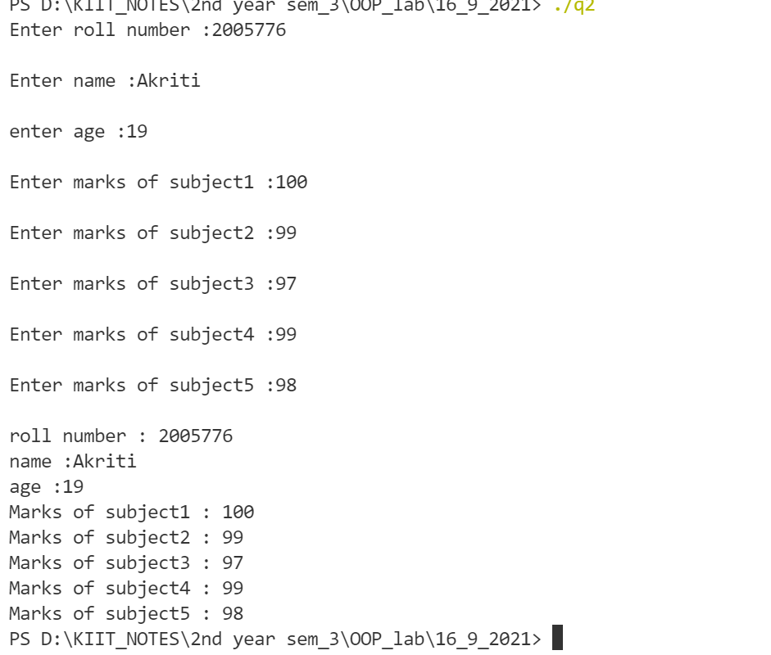

***Question 3) Extend the program ii. to derive a class from result from classs ‘test’ which includes member function to calculate total marks and percentage of a student. Input the data for a student and display its total marks and percentage.***

#include <iostream>

#include <string>

using namespace std;

class student

{

protected:

    string n;

    int rollnum;

    int age;

public:

    void input1()

    {

        cout << "Enter roll number :";

        cin >> rollnum;

        cout << endl;

        cout << "Enter name :";

        cin >> n;

        cout << endl;

        cout << "enter age :";

        cin >> age;

        cout << endl;

    }

    void display1()

    {

        cout << "roll number : " << rollnum << endl;

        cout << "name :" << n << endl;

        cout << "age :" << age << endl;

    }

};

class test : public student

{

protected:

    int sub1, sub2, sub3, sub4, sub5;

public:

    void input2()

    {

        cout << "Enter marks of subject1 :";

        cin >> sub1;

        cout << endl;

        cout << "Enter marks of subject2 :";

        cin >> sub2;

        cout << endl;

        cout << "Enter marks of subject3 :";

        cin >> sub3;

        cout << endl;

        cout << "Enter marks of subject4 :";

        cin >> sub4;

        cout << endl;

        cout << "Enter marks of subject5 :";

        cin >> sub5;

        cout << endl;

    }

    void display2()

    {

        cout << "Marks of subject1 : " << sub1 << endl;

        cout << "Marks of subject2 : " << sub2 << endl;

        cout << "Marks of subject3 : " << sub3 << endl;

        cout << "Marks of subject4 : " << sub4 << endl;

        cout << "Marks of subject5 : " << sub5 << endl;

    }

};

class result : public test

{

public:

    int total;

    float per;

    void display()

    {

        input1();

        input2();

        total = sub1 + sub2 + sub3 + sub5 + sub4;

        per = (total / 5.0);

        display1();

        display2();

        cout << "total : " << total;

        cout << endl;

        cout << "Percentage : " << per <<"%"<< endl;

    }

};

int main()

{

    result ob;

    ob.display();

    return 0;

}

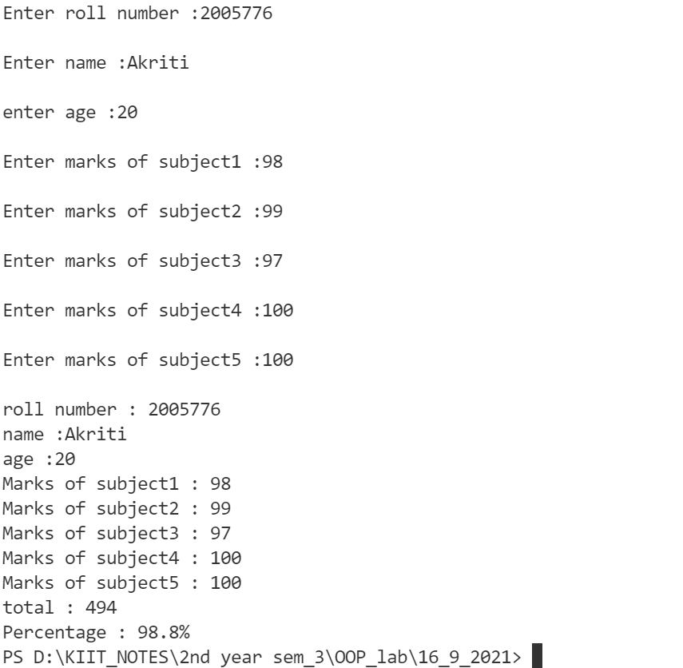

***Question 4)Extend the program ii. to include a class sports, which stores the marks in sports activity.Derive the result class from the classes ‘test’ and ‘sports’. Calculate the total marks and percentage of a student.***

#include <iostream>

using namespace std;

class student

{

protected:

    char name[20];

    int roll;

public:

    void getdata()

    {

        cout << "Enter name " << endl;

        cin >> name;

        cout << "Enter roll number " << endl;

        cin >> roll;

    }

};

class test : public student

{

protected:

    int sub1;

    int sub2;

    int sub3;

    int sub4;

    int sub5;

public:

    void getmark()

    {

        cout << "Enter marks of subject1 :";

        cin >> sub1;

        cout << endl;

        cout << "Enter marks of subject2 :";

        cin >> sub2;

        cout << endl;

        cout << "Enter marks of subject3 :";

        cin >> sub3;

        cout << endl;

        cout << "Enter marks of subject4 :";

        cin >> sub4;

        cout << endl;

        cout << "Enter marks of subject5 :";

        cin >> sub5;

        cout << endl;

    }

    void details()

    {

        cout << "\n\nName : " << name << endl

             << " Roll number : " << roll << endl;

        cout << "Marks of subject1 : " << sub1 << endl;

        cout << "Marks of subject2 : " << sub2 << endl;

        cout << "Marks of subject3 : " << sub3 << endl;

        cout << "Marks of subject4 : " << sub4 << endl;

        cout << "Marks of subject5 : " << sub5 << endl;

    }

};

class sports

{

protected:

    int msports;

public:

    void getspo()

    {

        cout << "Enter marks in sports : ";

        cin >> msports;

    }

};

class result : public sports, public test

{

    int total;

    float percent;

public:

    void display()

    {

        cout << "Marks in sports = " << msports << endl;

        total = sub1 + sub2 + sub3 + sub4 + sub5 + msports;

        percent = (total /6.0);

        cout << "Total marks : " << total <<endl<< "Percent = " << percent << endl;

    }

};

int main()

{

    result ob1;

    ob1.getdata();

    ob1.getmark();

    ob1.getspo();

    ob1.display();

    ob1.details();

    ob1.display();

}

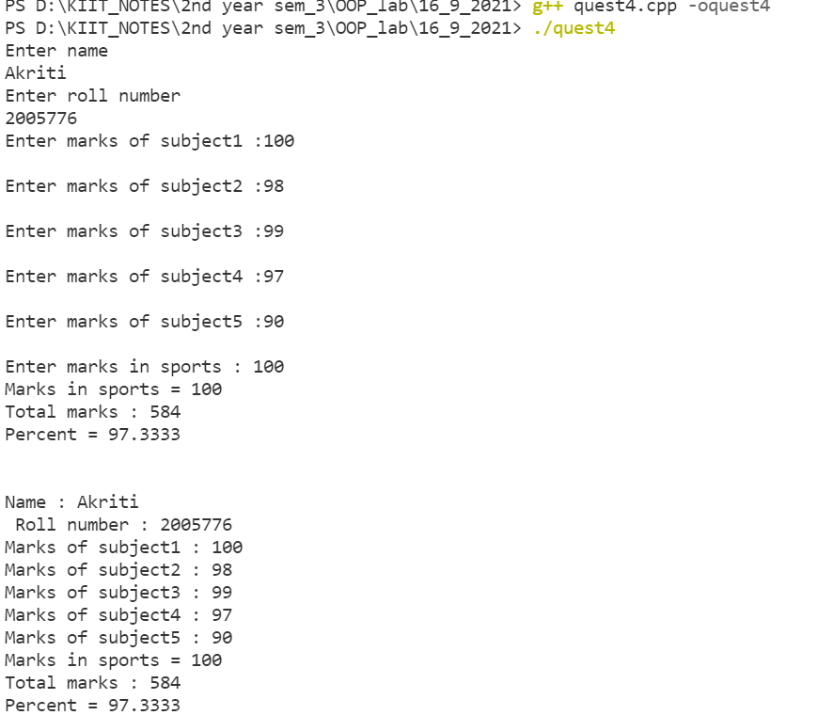

***Question 5) Define a class Employee . Display the personal and salary details of five employee using single inheritance.***

#include <iostream>

#include <string>

using namespace std;

class employee

{

protected:

    string n;

    int id;

    int age;

    int salary;

public:

    void input1()

    {

        cout << "Enter employee id :";

        cin >> id;

        cout << endl;

        cout << "Enter employee name :";

        cin >> n;

        cout << endl;

        cout << "enter age :";

        cin >> age;

        cout << endl;

        cout << "enter salary :";

        cin >> salary;

        cout << endl;

    }

};

class test : public employee

{

public:

    void display()

    {

        cout << "employee id :"<< id<<endl;

        cout << "employee name :"<< n<<endl;

        cout << "age :"<<age<<endl;

        cout << "salary :"<< salary << endl;

    }

};

int main()

{

    test ob1 , ob2 , ob3 , ob4 , ob5;

    ob1.input1();

    ob2.input1();

    ob3.input1();

    ob4.input1();

    ob5.input1();

    ob1.display();

    ob2.display();

    ob3.display();

    ob4.display();

    ob5.display();

    return 0;

}

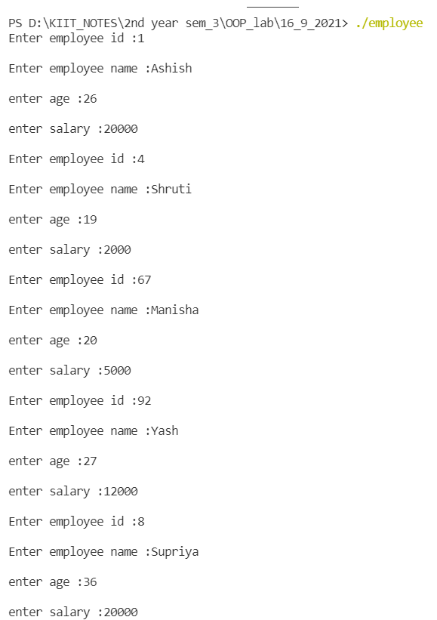

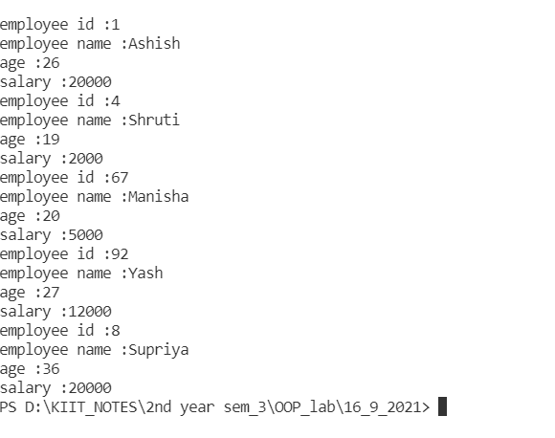

***Question 6) Define a Class student with data members as rollno and name. Derive a class Fee from student that has a data member fees and function to submit fees and generate receipt.Derive another class Result from Student that displays the marks and grade obtained by the student.***

#include <iostream>

#include <string>

using namespace std;

class student

{

protected:

    string n;

    int rollnum;

public:

    void input1()

    {

        cout << "Enter roll number :";

        cin >> rollnum;

        cout << endl;

        cout << "Enter name :";

        cin >> n;

        cout << endl;

    }

    void display1()

    {

        cout << "roll number : " << rollnum << endl;

        cout << "name :" << n << endl;

    }

};

class Result : public student

{

protected:

    int sub1, sub2, sub3, sub4, sub5, total;

    float per;

public:

    void input2()

    {

        cout << "Enter marks of subject1 :";

        cin >> sub1;

        cout << endl;

        cout << "Enter marks of subject2 :";

        cin >> sub2;

        cout << endl;

        cout << "Enter marks of subject3 :";

        cin >> sub3;

        cout << endl;

        cout << "Enter marks of subject4 :";

        cin >> sub4;

        cout << endl;

        cout << "Enter marks of subject5 :";

        cin >> sub5;

        cout << endl;

    }

    void display2()

    {

        cout << "Marks of subject1 : " << sub1 << endl;

        cout << "Marks of subject2 : " << sub2 << endl;

        cout << "Marks of subject3 : " << sub3 << endl;

        cout << "Marks of subject4 : " << sub4 << endl;

        cout << "Marks of subject5 : " << sub5 << endl;

        total = sub1 + sub2 + sub3 + sub5 + sub4;

        per = (total / 5.0);

        cout << "total : " << total;

        cout << endl;

        cout << "Percentage : " << per << "%" << endl;

    }

};

class Fee : public student

{

protected:

    int F;

public:

    void input3()

    {

        cout << "Enter the fees amount to be paid" << endl;

        cin >> F;

    }

    void receipt()

    {

        if (F == 0)

        {

            cout << "Fees is not paid" << endl;

            cout << "Receipt cannot be generated" << endl;

        }

        else

        {

            cout << "Fees is paid" << endl;

        }

    }

};

int main()

{

    Result ob;

    Fee ob1;

    ob.input1();

    ob.input2();

    ob1.input3();

    ob.display1();

    ob.display2();

    ob1.receipt();

    return 0;

}

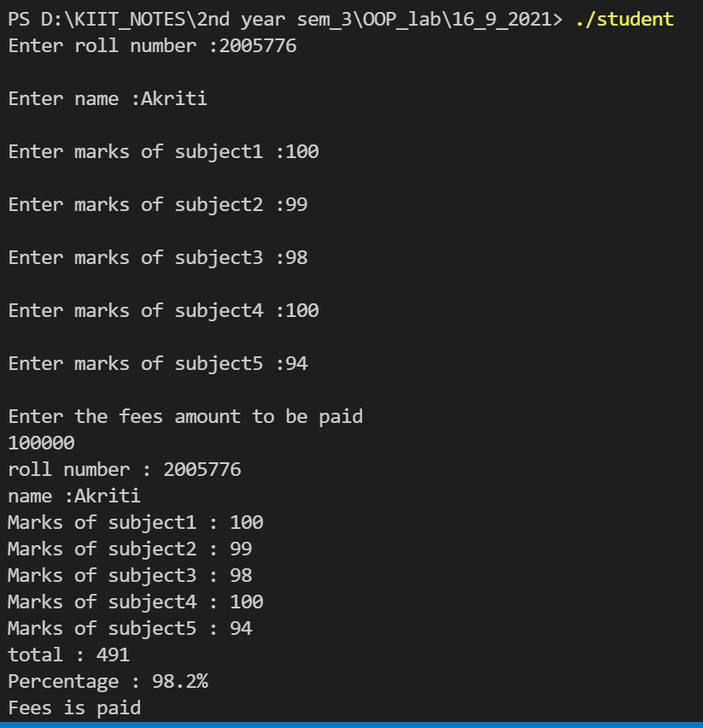

***Question 7)Define a class Employee with data members as empno, name, and designation. Derive a class Qualification from Employee that has data members UG , PG , and experience. Create another class Salary which is derived from both these classes to display the details of the employee and compute their investment based on their experience and educational qualification.***

#include <iostream>

#include <string>

using namespace std;

class employee

{

protected:

string name;

string designation;

int empno;

public:

void input1()

{

cout << "Enter employee id :"; cin >> empno;

cout << endl;

cout << "Enter employee name :";

cin >> name;

cout << endl;

cout << "enter designation :";

cin >> designation;

cout << endl;

}

void display1()

{

cout << "employee id :" << empno << endl;

cout << "employee name :" << name << endl;

cout << "designation :" << designation << endl;

}

};

class qualification : public employee

{

protected:

string ug, pg;

int exp;

public:

void input2()

{

input1();

cout << "Enter NA if degree is not completed" << endl;

cout << "Enter ug course :";

cin >> ug;

cout << endl;

cout << "Enter pg course:";

cin >> pg;

cout << endl;

cout << "enter experience :";

cin >> exp;

cout << endl;

}

void display2()

{

display1();

cout << "ug course :" << ug << endl;

cout << "pg course:" << pg << endl;

cout << "experience(int) :" << exp;

cout << endl;

}

};

class salary : public qualification

{

public:

int sal;

int incre_sal;

void input3()

{

input2();

cout << "Enter salary" << endl;

cin >> sal;

if (exp)

{

incre_sal = sal + 20000;

}

else if (pg != "NA")

{

incre_sal = sal + 10000;

}

else if (ug != "NA")

{

incre_sal = sal + 5000;

}

else

{

incre_sal = sal;

cout << "No increment in salary" << endl;

}

}

void display3()

{

display2();

cout << "Increment salary :" << incre_sal << endl;

}

};

int main()

{

salary obj;

obj.input3();

obj.display3();

return 0;

}

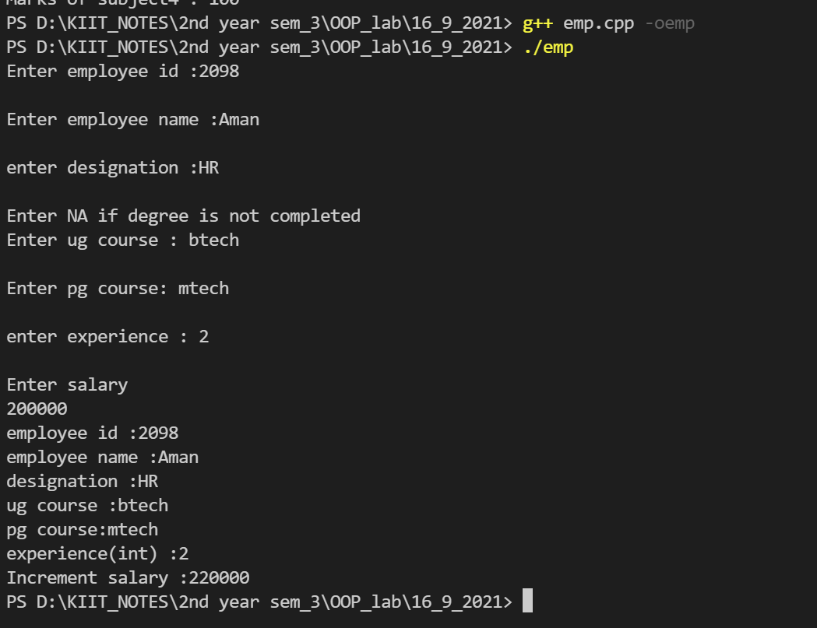

***Question 8) WAP that has a class student to store the details of students in a class. Derive another class Toppers from the student that stores record of only top three students.***

#include<iostream>

#include<string.h>

using namespace std;

class student

{

public:

char name[20];

int rollno;

int percentage;

void getdata()

{

cout<<"\nenter the name of the student";

cin>>name;

cout<<"\nenter the roll no.";

cin>>rollno;

cout<<"\nenter the percentage of the student";

cin>>percentage;

}

};

class topper:public student

{

public:

void display()

{

cout<<"\nname:"<<name;

cout<<"\nroll no.:"<<rollno;

cout<<"\npercentage:"<<percentage;

}

};

int main()

{

int j,k,l,i,n;

cout<<"enter the number of students"<<endl;

cin>>n;

student s[n];

for(i=0;i<n;i++)

s[i].getdata();

for(i=0;i<n;i++)

{

if(s[i].percentage>s[i+1].percentage)

j=i;

}

topper t[3];

strcpy(t[0].name,s[j].name);

t[0].rollno=s[j].rollno;

t[0].percentage=s[j].percentage;

for(i=0;i<n;i++)

{

if((s[i].percentage>s[i+1].percentage) && i!=j)

k=i;

}

strcpy(t[1].name,s[k].name);

t[1].rollno=s[k].rollno;

t[1].percentage=s[k].percentage;

for(i=0;i<n;i++)

{

if((s[i].percentage>s[i+1].percentage) && i!=j && i!=k)

l=i;

}

strcpy(t[2].name,s[l].name);

t[2].rollno=s[l].rollno;

t[2].percentage=s[l].percentage;

cout<<"the top 3 scorers are:\n";

for(i=0;i<3;i++)

t[i].display();

}

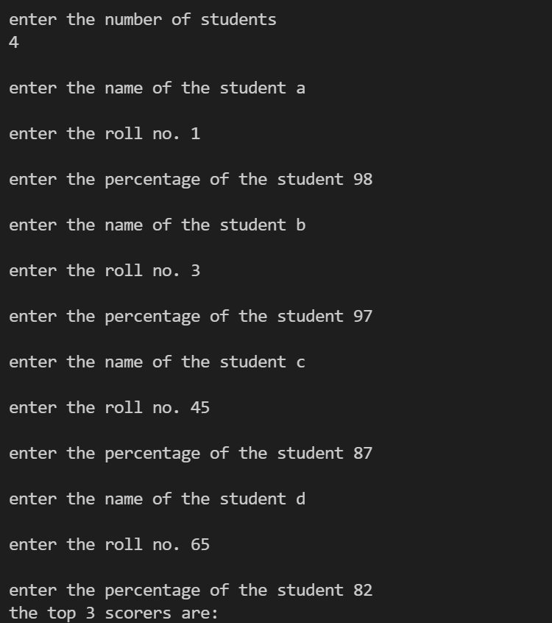

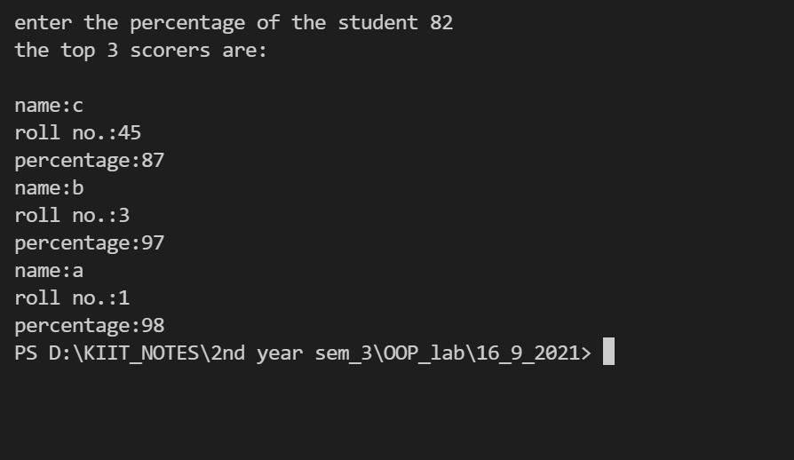

***Question 9) WAP that has a class Person . Derive a class Baseball_Player from Person and display all the details of the baseball player.***

#include <iostream>

#include <string>

using namespace std;

class Person

{

protected:

string n;

int jersey_no;

int age;

public:

void input1()

{

cout << "Enter jersey_no :";

cin >> jersey_no;

cout << endl;

cout << "Enter name :";

cin >> n;

cout << endl;

cout << "enter age :";

cin >> age;

cout << endl;

}

void display1()

{

cout << "roll number : " << jersey_no << endl;

cout << "name :" << n << endl;

cout << "age :" << age << endl;

}

};

class baseball : public Person

{

public:

void display2()

{

display1();

}

};

int main()

{

baseball ob;

ob.input1();

ob.display2();

return 0;

}

