***Name - Akriti Choudhary***

***Roll number - 2005776***

***Lab12***

***Subject - OOP lab***

***Class - B14***

***Branch - CSE***

***Date- 18/11/2021***

**Question 1) WAP to throw and handle ‘division by zero’ exception.**

#include <iostream>

using namespace std;

int main()

{

int a, b, c;

float d;

cout << "a = ";

cin >> a;

cout << "b = ";

cin >> b;

cout << "c = ";

cin >> c;

try

{

if ((a - b) != 0)

{

d = c / (a - b);

cout << "Result = " << d;

}

else

{

throw(a - b);

}

}

catch (int i)

{

cout<<"catch is called \n";

cout << "Result is infinite because a-b is = " << i;

}

return 0;

}

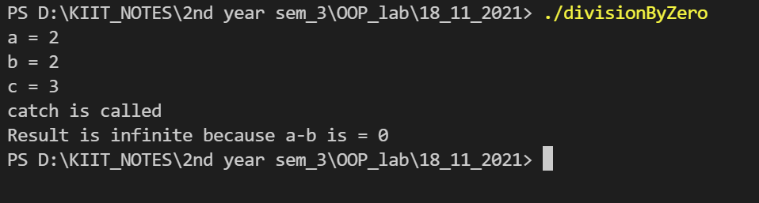

**Question 2) WAP to throw and handle ‘array out of bound’ exception.**

#include <iostream>

using namespace std;

int main()

{

int n;

cout << "Enter the size of array : ";

cin >> n;

int a[n];

for (int i = 0; i < n + 2; i++)

{

try

{

if (i <= n)

{

cout << "Enter the element :";

cin >> a[i];

}

else

throw i;

}

catch (int i)

{

cout << "out of bond exception caught" << endl;

}

}

return 0;

}

}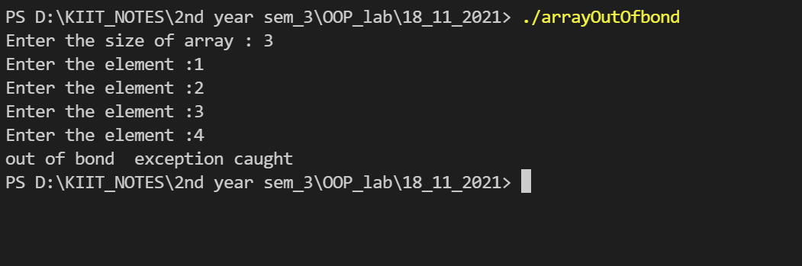

**Question 3)WAP to demonstrate multiple catch and catch all.**

#include <iostream>

using namespace std;

void test(int x)

{

try

{

if (x > 0)

throw x;

else

throw 'x';

}

catch (int x)

{

cout << "An integer is caught " << endl;

}

catch (char x)

{

cout << "A character is caught" << endl;

}

}

int main()

{

test(27);

test(0);

return 0;

}

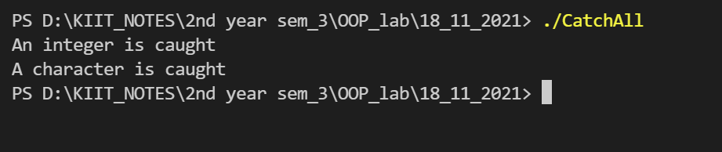

**Question 4)WAP to accept 10 integers in an array . Check all numbers in an array.When any negative number is found,throw an exception and take corrective measure.**

#include <iostream>

using namespace std;

int main()

{

int n;

cout << "Enter size of array : ";

cin >> n;

int a[n];

try

{

for (int i = 0; i < n; i++)

{

cout << "Enter the element "<< " = ";

cin >> a[i];

try

{

if (a[i] < 0)

{

throw a[i];

}

}

catch (int i)

{

throw;

}

}

}

catch (int i)

{

cout << "Negative value is caught" << endl;

}

return 0;

}

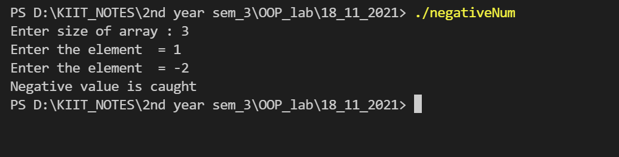

**Question 5)WAP to accept a String . When any space is encountered , throw exception.**

#include <iostream>

#include <string.h>

#define MAX 50

using namespace std;

int main()

{

char a[MAX];

cout << "Enter the string : ";

cin.getline(a, MAX);

int l = strlen(a);

try

{

for (int i = 0; i < l; i++)

{

try

{

if (a[i] == ' ')

{

cout << endl;

throw a[i];

}

else

{

cout << a[i];

}

}

catch (char c)

{

throw;

}

}

}

catch (char c)

{

cout << "Space is caught" << endl;

}

return 0;

}

