***Name - Akriti Choudhary***

***Roll number - 2005776***

***Lab4***

***Subject - OOP lab***

***Class - B14***

***Branch - CSE***

***Date- 19/08/2021***

***Question 1 :-WAP to calculate area of a triangle using default and actual values (Area of a triangle =0.5 * h *b)***

#include <iostream>

#include <iomanip>

using namespace std;

class area

{

public:

float areaTri(float h = 1.0, float b = 1.0)

{

return (0.5 * h * b);

}

};

int main()

{

float h, b;

cout << "enter the height and base of the triangle : " << endl;

cin >> h;

cin >> b;

area obj;

cout << "Area using default values : " << obj.areaTri() << endl;

cout << "Area using b as default value and h as actual values : " << obj.areaTri(h) << endl;

cout << "Area using actual values : " << obj.areaTri(h, b) << endl;

return 0;

}

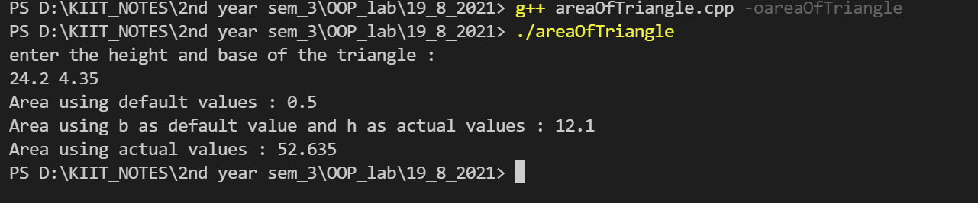

***Question 2 :- WAP to define a function as inline to calculate area of a cube.***

#include <iostream>

#include <iomanip>

using namespace std;

class area

{

public:

inline float areaCube(float a)

{

return (6 * a * a);

}

};

int main()

{

float a;

cout << "enter the side of a cube : ";

cin >> a;

area obj;

cout << "Surface Area : " << obj.areaCube(a) << endl;

return 0;

}

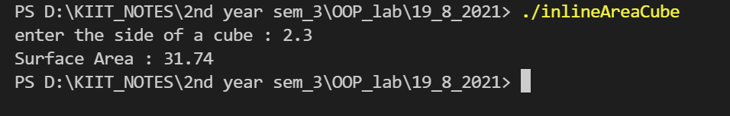

***Question 3 :-WAP to create a class student with data members yearOfAdmission ,yearOfPassout. Calculate average marks of student for n number of subjects through function with arguments initialized and display the corresponding value of data members.***

#include <iostream>

using namespace std;

class student

{

public:

student(int yA, int yP)

: yearOfAdmission(yA), yearOfPassout(yP)

{

}

float avgMarks(int marks[], int n);

void display(int n);

private:

int yearOfAdmission;

int yearOfPassout;

int avg;

};

float student::avgMarks(int marks[], int n)

{

int sum = 0;

cout << "Enter the marks of " << n << " subjects :" << endl;

for (int i = 0; i < n; ++i)

{

cout << "marks of subject " << i + 1 << " ";

cin >> marks[i];

sum += marks[i];

}

avg = sum / n;

}

void student::display(int n)

{

cout << endl;

cout << "Displaying student details :" << endl;

cout << "year Of Admission : " << yearOfAdmission << endl;

cout << "year Of Passout : " << yearOfPassout << endl;

cout << "Number of subjects : " << n << endl;

cout << "Average marks : " << avg << endl;

}

int main()

{

int yA;

int yP;

int n;

cout << "enter year Of Admission : ";

cin >> yA;

cout << "year Of Passout : ";

cin >> yP;

cout << "Enter Number of subjects : ";

cin >> n;

int marks[n];

student obj(yA, yP);

obj.avgMarks(marks,n);

obj.display(n);

return 0;

}

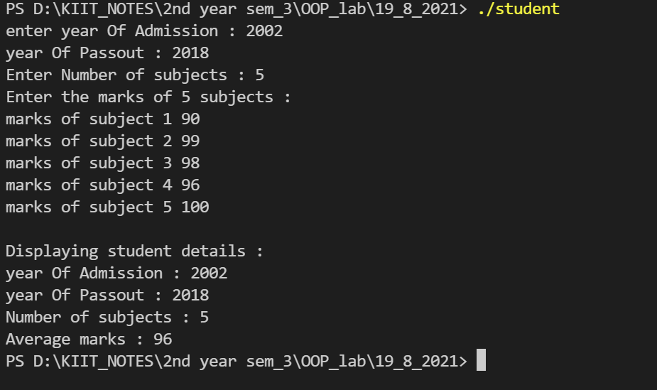

***Question 4 :- WAP to define a class to represent a bank account.***

***Include the following-***

***Data members :***

***Name of the depositor , account number , type of account , Balance amount in account***

***Member functions:***

***To assign initial values ,to deposit an amount ,to withdraw an amount after checking balance ,to display name and balance.***

#include <iostream>

#include <string>

using namespace std;

class Account

{

public:

Account()

: accNum(0), balance(0.0)

{

}

Account(string n, int accn, string t, double b)

: name(n), accNum(accn), type(t), balance(b)

{

}

void deposit(double amt)

{

balance += amt;

}

void withdraw(double amt)

{

if (balance <= 1000)

{

cout << "Balance cannot be withdrawn" << endl;

}

else if ((balance - amt) < 1000)

{

cout << "After performing the operation Balance will be below 1000" << endl;

cout << "Balance cannot be withdrawn" << endl;

}

else

balance -= amt;

}

void display()

{

cout << "--------------------------------------------------" << endl;

cout << "Displaying the details" << endl;

cout << "Name : " << name << endl;

cout << "Account Type : " << type << endl;

cout << "Account num : " << accNum << endl;

cout << "Updated Balance : " << balance << endl;

cout << "--------------------------------------------------" << endl;

}

private:

string name;

int accNum;

string type;

double balance;

};

int main()

{

double amt;

double w_amt;

string n;

cout << "Enter Name : " << endl;

cin >> n;

cout << "Enter Account num : " << endl;

int accn;

cin >> accn;

cout << "Enter Type of account : " << endl;

string t;

cin >> t;

cout << "Enter the current Balance : " << endl;

double b;

cin >> b;

Account obj(n, accn, t, b);

int ch = 0;

while (ch != -1)

{

cout << "enter choice \n1 - Deposit \n2 - Withdraw\n-1 - exit" << endl;

cin >> ch;

switch (ch)

{

case 1:

cout << "Amount to be deposited : " << endl;

cin >> amt;

obj.deposit(amt);

obj.display();

break;

case 2:

cout << "Amount to be withdrawn : " << endl;

cin >> w_amt;

obj.withdraw(w_amt);

obj.display();

break;

case -1:

break;

default:

cout << "Invalid choice" << endl;

}

}

cout << "Exit" << endl;

return 0;

}

