***Name - Akriti Choudhary***

***Roll number - 2005776***

***Lab13***

***Subject - OOP lab***

***Class - B14***

***Branch - CSE***

***Date- 25/11/2021***

**Question 1) WAP to find sort an integer array and a float array, using function template.**

#include <iostream>

using namespace std;

template <class T>

void sorting(int size, T arr[])

{

T temp;

for (int i = 0; i < size; i++)

{

for (int j = 0; j < size - 1; j++)

{

if (arr[j] > arr[i])

{

temp = arr[i];

arr[i] = arr[j];

arr[j] = temp;

}

}

}

}

template <class T>

void DisplayArray(int size, T arr[])

{

for (int i = 0; i < size; i++)

cout << arr[i] << " ";

}

int main()

{

int n;

cout << "Enter size of the (int)array: ";

cin >> n;

int arr1[n];

cout << "Enter the elements: \n";

for (int i = 0; i < n; i++)

cin >> arr1[i];

sorting(n, arr1);

DisplayArray(n, arr1);

cout << "\nEnter size of the (float)array: ";

cin >> n;

float arr2[n];

cout << "Enter the elements: \n";

for (int i = 0; i < n; i++)

cin >> arr2[i];

sorting(n, arr2);

DisplayArray(n, arr2);

return 0;

}

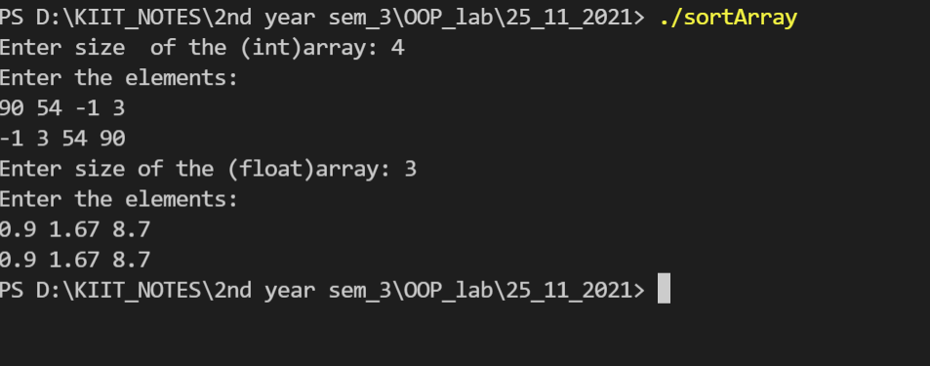

**Question 2)WAP to display data of two different types using function template with multiple arguments.**

#include <iostream>

using namespace std;

template <class T, class U>

void display(T a, U b)

{

cout << a << "\t" << b << endl;

}

int main()

{

cout<<"\nDisplaying the first set \n";

display(1.89, "Akriti");

cout<<"\nDisplaying the second set \n";

display('A', 108);

return 0;

}

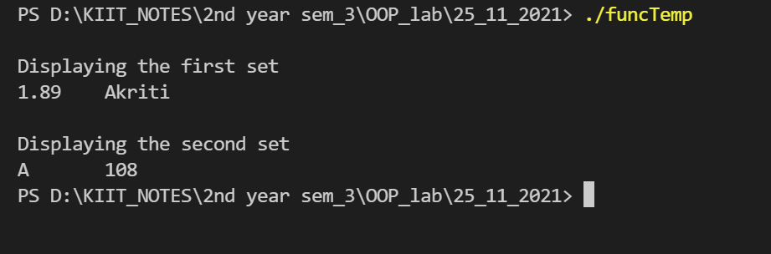

**Question 3)Rewrite program 1 using class template**

#include <iostream>

using namespace std;

template <class T>

class Arr

{

private:

T *arr;

int size;

public:

Arr(int n)

{

size = n;

arr = new T[size];

}

void getData()

{

for (int i = 0; i < size; i++)

cin >> arr[i];

}

void sorting()

{

T temp;

for (int i = 0; i < size; i++)

{

for (int j = 0; j < size - 1; j++)

{

if (arr[j] > arr[i])

{

temp = arr[i];

arr[i] = arr[j];

arr[j] = temp;

}

}

}

}

void display()

{

for (int i = 0; i < size; i++)

cout << arr[i] << " ";

cout << "\n";

}

};

int main()

{

int n;

cout << "Enter the size of the array: ";

cin >> n;

Arr<int> arr1(n);

Arr<float> arr2(n);

cout << "Enter elements of the integer array: \n";

arr1.getData();

cout << "Enter elements of the floating number array: \n";

arr2.getData();

//sorting

arr1.sorting();

arr2.sorting();

cout << "\nResulting integer array:" << endl;

arr1.display();

cout << "\nResulting float number array:" << endl;

arr2.display();

return 0;

}

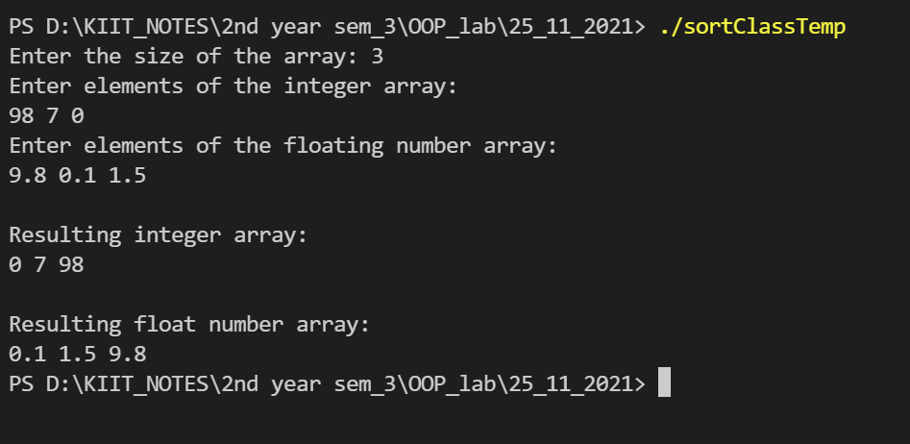

**Question 4)Rewrite program 2 using class template**

#include <iostream>

using namespace std;

template <class T1, class T2>

class data

{

public:

T1 num1;

T2 num2;

data(T1 a, T2 b)

{

num1 = a;

num2 = b;

}

void display()

{

cout << num1 << " \t" << num2;

}

};

int main()

{

data<double, string> ob1(1.89, "Akriti");

data<char, int> ob2('A', 108);

cout << "\nDisplaying the first set \n";

ob1.display();

cout << "\nDisplaying the second set \n";

ob2.display();

return 0;

}

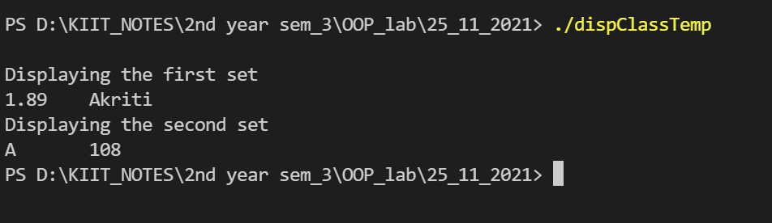

**Question 5) WAP to find reverseof given number using template based function.**

#include <iostream>

using namespace std;

template <class T>

class data

{

private:

T n;

public:

data()

{

n = 0;

}

data(T x)

{

n = x;

}

T reve(T x)

{

T rem;

T num = x;

T revNum = 0;

while (num != 0)

{

rem = num % 10;

revNum = (revNum * 10) + rem;

num = num / 10;

}

return revNum;

}

};

int main()

{

int x;

cout << "Enter the (int)number to be reversed : \n";

cin >> x;

data<int> obj(x);

cout << obj.reve(x);

return 0;

}

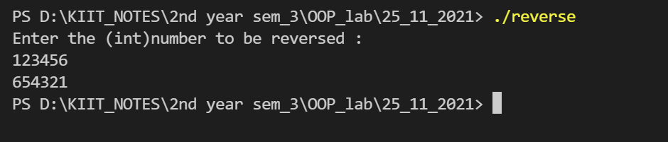

**Question 6) WAP to create a template to find the maximum value stored in an array.**

#include <iostream>

using namespace std;

template <class T>

T max(T t[], int size)

{

T temp = t[0];

for (int i = 0; i < size; i++)

{

if (temp < t[i])

{

temp = t[i];

}

}

return temp;

}

int main()

{

int N;

cout<<"Enter size of the array : \n";

cin>>N;

int Arr[N];

cout << "Enter elements of the array : " << endl;

for (int i = 0; i < N; i++)

{

cin >> Arr[i];

}

cout << "Maximum number in the array = " << max(Arr, N) << endl;

return 0;

}

