***Name - Akriti Choudhary***

***Roll number - 2005776***

***Lab6***

***Subject - OOP lab***

***Class - B14***

***Branch - CSE***

***Date- 2/09/2021***

***Question 1 : WAP to swap private data member of two classes.***

***[The classes have no relation with each other].***

#include <iostream>

using namespace std;

class two;

class one

{

int x;

public:

void input(int i)

{

x = i;

}

void display()

{

cout << " x=" << x << " ";

}

friend void swap(one, two);

};

class two

{

int y;

public:

void input(int j)

{

y = j;

}

void display()

{

cout << " y=" << y;

}

friend void swap(one, two);

};

void swap(one a, two b)

{

int temp;

temp = a.x;

a.x = b.y;

b.y = temp;

cout << " x=" << a.x << " y=" << b.y;

}

int main()

{

one on;

two tw;

cout << "\nBefore swapping";

on.input(99);

tw.input(23);

on.display();

tw.display();

cout << "\nAfter swapping";

swap(on, tw);

}

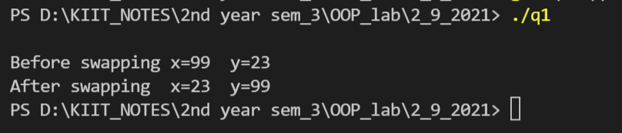

***Question2 :Create two classes which stores distance in feet, inches and meter, centimeter format respectively. Write a function which compares distance in object of these classes and***

***displays the larger one.***

#include<iostream>

using namespace std;

class Metre;

class inch

{

float feet, inches;

public:

float total;

void details()

{

cout<<"Enter the distance in feet and inches: ";

cin>>feet;

cin>>inches;

total = (feet * 12) + inches;

total = total * 2.54;

}

friend void calculation(Metre, inch);

};

class Metre

{

float met, cent;

public:

float total;

void details()

{

cout<<"Enter the distance in metres and centimetres: ";

cin>>met;

cin>>cent;

total = met * 100 + cent;

}

friend void calculation(Metre, inch);

};

void calculation(Metre m, inch i)

{

if(m.total > i.total)

{

cout<<"The larger of distances is "<<m.met<<" metres and "<<m.cent<<" centimetres.";

}

else

{

cout<<"The larger of distances is "<<i.feet<<" feet and "<<i.inches<<"inches";

}

}

int main()

{

Metre m;

inch i;

m.details();

i.details();

calculation(m, i);

return 0;

}

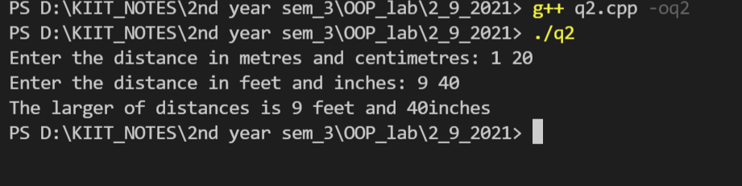

***Question 3 :Create a class with an integer data member. Include functions for input and output in class. Count the number of times each function is called and display it.***

#include <iostream>

using namespace std;

class book

{

static int a;

static void count1()

{

c++;

}

static void count2()

{

d++;

}

public:

static int c, d;

static void input()

{

count1();

cout << "enter an number\n";

cin >> a;

}

static void output()

{

count2();

cout << "the entered number is " << a << "\n";

;

}

};

int book ::c;

int book ::d;

int book ::a;

int main()

{

book b;

b.input();

b.output();

b.output();

b.input();

b.output();

b.output();

b.output();

b.output();

b.output();

cout << "The input function is called " << book::c << " times \nThe output function is called " << book::d << " times\n";

return 0;

}

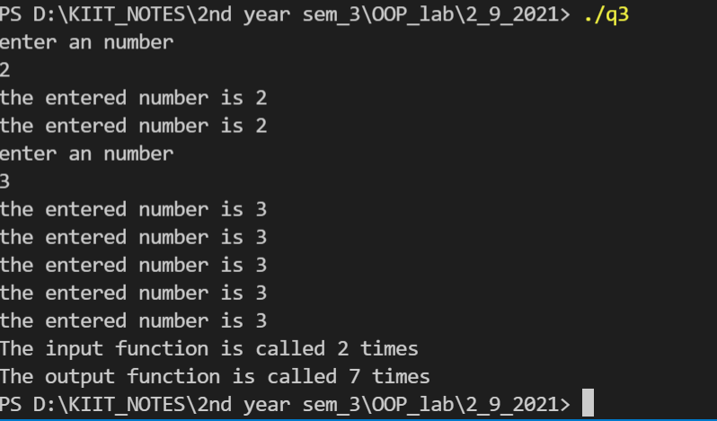

***Question 4 :Create a class which stores name, roll number and total marks for a student. Input data for n students. Find the average marks scored by n students, store it as a data member of the class and display it using a function which may be called without object.***

#include <iostream>

using namespace std;

class students

{

string name;

int roll;

int tmarks;

static int avgMarks;

public:

void getdata()

{

cout << "Enter Name: ";

cin >> name;

cout << "Enter Roll: ";

cin >> roll;

cout << "Enter Total Marks: ";

cin >> tmarks;

}

static void display(students obj[], int n)

{

for (int i = 0; i < n; i++)

{

avgMarks = avgMarks + obj[i].tmarks;

}

cout << "\nAverage marks of the students : " << (avgMarks / n);

}

};

int students::avgMarks = 0;

int main()

{

int n;

cout << "Enter number of students: ";

cin >> n;

students ob[n];

for (int i = 0; i < n; i++)

{

ob[i].getdata();

}

cout << "\n";

students::display(ob, n);

return 0;

}

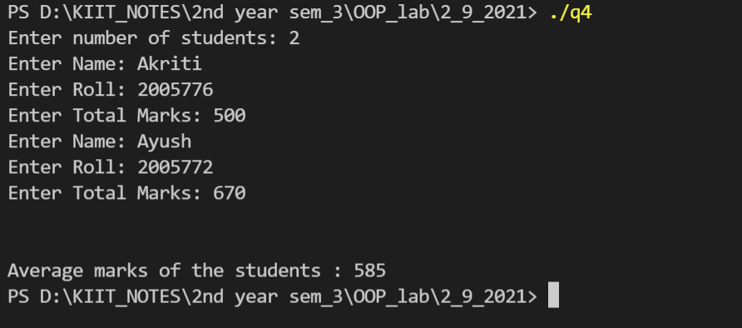

***Question 5 :Create a class which stores name, author and price of a book. Store information for n***

***number of books. Display information of all the books in a given price range using***

***friend function.***

#include <iostream>

#include <iomanip>

#include <string.h>

using namespace std;

class bookstore

{

string name;

string author;

float price;

public:

void getbooks()

{

cout << "Enter the name of the book: ";

cin >> name;

cout << "Enter the author: ";

cin >> author;

cout << "Enter the price: ";

cin >> price;

}

friend void check(bookstore b[], int n);

};

void check(bookstore b[], int n)

{

int i;

int low, up, c = 0;

cout << "Enter the lower index of the price range: ";

cin >> low;

cout << "Enter the upper index of the price range: ";

cin >> up;

cout << "\nThe books in the range " << low << " to " << up << " are: ";

for (i = 0; i < n; i++)

{

if (b[i].price >= low && b[i].price <= up)

{

cout << "\nName of the book"

<< " : " << b[i].name<<endl;

cout << "Author of the book"

<< " : " << b[i].author<<endl;

cout << "Price of the book "

<< " : " << b[i].price << "\n";

c = 1;

}

}

if (c == 0)

{

cout << "No books are in this price range.\n";

}

}

int main()

{

int n, i;

cout << "Enter the number of books: ";

cin >> n;

bookstore b[n];

for (i = 0; i < n; i++)

{

b[i].getbooks();

}

check(b, n);

return 0;

}

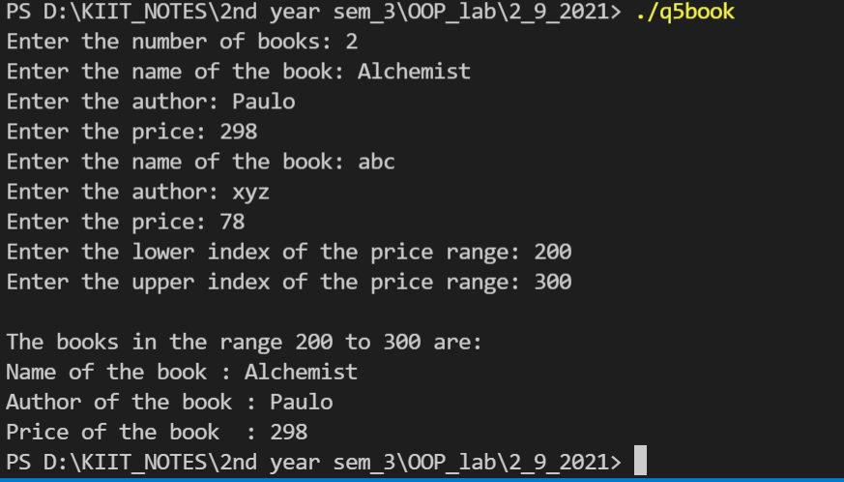

***Question 6 : Write a Program to declare three classes S1,S2 and S3.The classes have private data member variable of character data type. Read strings for the classes S1 and S2.Concatenate the strings read and assign it to the data member of class S3.Use New and delete operator.***

#include <iostream>

#include <string.h>

using namespace std;

class S2;

class S3;

class S1

{

string *a = new string;

friend class S3;

public:

void input()

{

cout << "enter the 1 st string : ";

cin >> *a;

}

void show()

{

cout << "1st string =" << *a << "\n";

}

};

class S2

{

string *b = new string;

friend class S3;

public:

void input()

{

cout << "enter the 2nd string: ";

cin >> *b;

}

void show()

{

cout << "2nd string =" << *b << "\n";

}

};

class S3

{

string *c = new string;

public:

void join(S1 ob1, S2 ob2)

{

*c = *ob1.a + *ob2.b;

delete ob1.a;

delete ob2.b;

}

void show()

{

cout << *c << "\n";

delete c;

}

};

int main()

{

S1 ob1;

S2 ob2;

S3 ob3;

ob1.input();

ob2.input();

ob1.show();

ob2.show();

cout << "final string : " ;

cout<<endl;

ob3.join(ob1, ob2);

ob3.show();

return 0;

}

