***Name - Akriti Choudhary***

***Roll number - 2005776***

***Lab1***

***Subject - OOP lab***

***Class - B14***

***Branch - CSE***

***Question1 - WAP to input name,roll number and marks in 5 subjects for a student , and display it.***

#include <iostream>

#include <string>

using namespace std;

struct student

{

string name;

int roll;

int marks[5];

};

struct student input(struct student s1){

cout<<"Enter the name of the student : "<<endl;

getline(cin,s1.name);

cout<<"Enter the roll number of the student : "<<endl;

cin>>s1.roll;

cout<<"Enter the marks of the student : "<<endl;

for(int i = 0 ; i < 5 ; ++i){

cout<<"Enter the marks of subject"<<i+1<<endl;

cin>>s1.marks[i];

}

return s1;

}

void display(struct student s1){

cout<<"The name of the student : "<<s1.name<<endl;

cout<<"The roll number of the student : "<<s1.roll<<endl;

for(int i = 0 ; i < 5 ; ++i){

cout<<"The marks of subject"<<i+1<<" is : "<<s1.marks[i]<<endl;

}

}

int main(){

struct student s1;

//input the details of the student

s1 = input(s1);

//display the details of the student

display(s1);

return 0;

}

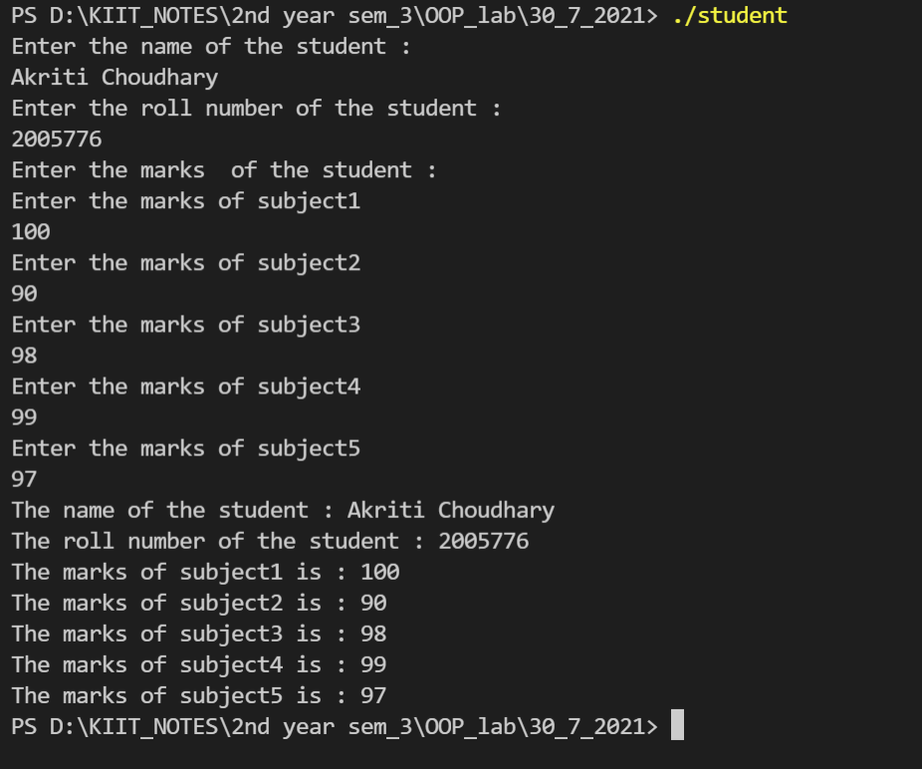

***Question2 - WAP to input name,roll number and marks in 5 subjects for n number of students .Write functions to :-***

1. ***Find total marks and percentage of all n students***
2. ***Display details of a student with a given roll number***
3. ***Display details for all students having percentage in a given range.***
4. ***Sort the array in ascending order of marks***

#include <iostream>

using namespace std;

struct student1

{

char name[20];

int roll;

int marks[5];

int total;

float percent;

};

struct student1 *input(struct student1 *s)

{

cout << "Enter name : " << endl;

cin >> s->name;

cout << "Enter roll number :" << endl;

cin >> s->roll;

for (int i = 0; i < 5; ++i)

{

cout << "Enter marks of subject" << i + 1 << " : " << endl;

cin >> s->marks[i];

}

}

void totPer(struct student1 *s)

{

int sum = 0;

for (int i = 0; i < 5; ++i)

{

sum += s->marks[i];

}

s->total = sum;

s->percent = (sum / 500.0) * 100;

}

void sort(int arrSum[], int size)

{

int temp;

for (int i = 0; i < size; ++i)

{

for (int j = 0; j < size - 1 - i; ++j)

{

if (arrSum[j] < arrSum[j + 1])

{

temp = arrSum[j];

arrSum[j] = arrSum[j + 1];

arrSum[j + 1] = temp;

}

}

}

}

void display(struct student1 *s)

{

cout << "name :" << s->name << endl;

cout << "roll number :" << s->roll << endl;

for (int i = 0; i < 5; ++i)

{

cout << "marks of subject" << i + 1 << " : " << s->marks[i] << endl;

}

cout << "Total marks :" << s->total << endl;

cout << "Percentage :" << s->percent << "%" << endl;

}

void displayRankWise(struct student1 *s)

{

cout << "name : " << s->name << " "

<< "Roll number : " << s->roll << " "

<< "Percentage : " << s->percent << "%" << endl;

}

int main()

{

int n;

cout << "Enter number of students" << endl;

cin >> n;

struct student1 arr[n];

int sortSum[n];

for (int i = 0; i < n; ++i)

{

cout<<endl;

input(&arr[i]);

totPer(&arr[i]);

}

//To display the details of the student of a particular roll

int rollNum;

cout << "Enter the roll number of student to display details :" << endl;

cin >> rollNum;

for (int i = 0; i < n; ++i)

{

if (rollNum == arr[i].roll)

{

display(&arr[i]);

}

}

cout<<endl;

//To display the details of students in a particular range

int perBegin, perEnd;

cout << "Enter the range of percent to display details :" << endl;

cin >> perBegin >> perEnd;

for (int i = 0; i < n; ++i)

{

if (perBegin < arr[i].percent && perEnd >= arr[i].percent)

{

display(&arr[i]);

cout<<endl;

}

}

//filling the array sortSum with the total marks of the students

for (int i = 0; i < n; ++i)

{

sortSum[i] = arr[i].total;

}

//sorting total marks

sort(sortSum, n);

//Displaying the rank of students

cout << "Rank of students according to the total marks :" << endl;

for (int i = 0; i < n; ++i)

{

cout << "-----------------------------------------------------------" << endl;

cout << "Rank " << i + 1 << " : ";

for (int j = 0; j < n; ++j)

{

{

if (sortSum[i] == arr[j].total)

{

displayRankWise(&arr[j]);

}

}

}

}

cout << "---------------------------------------------------------------" << endl;

return 0;

}

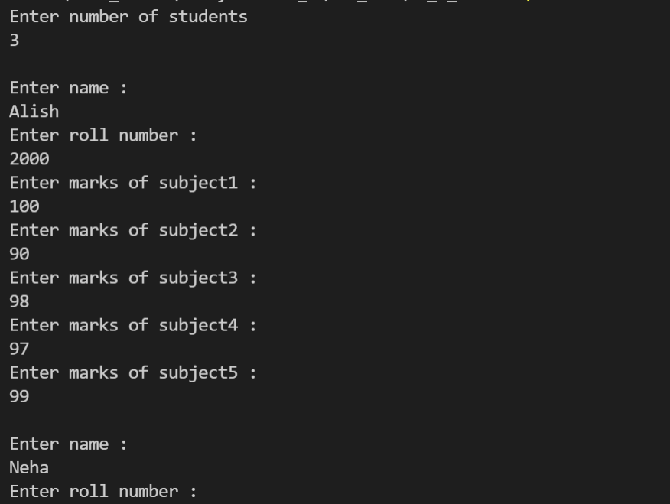

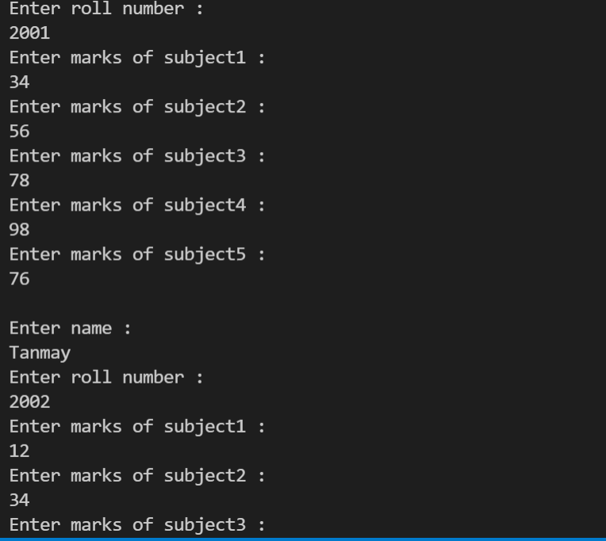

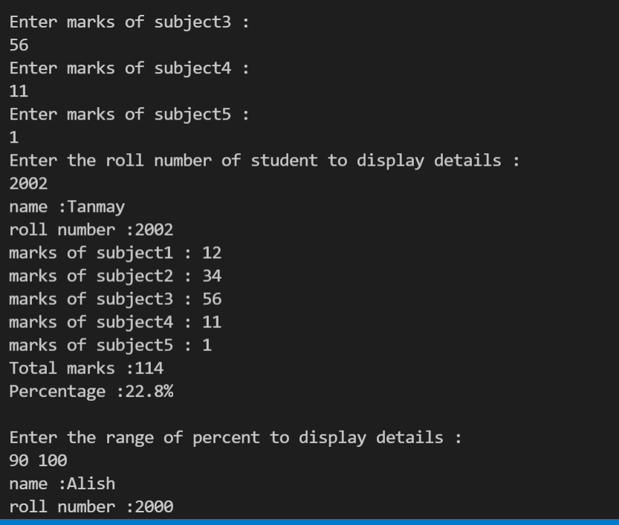

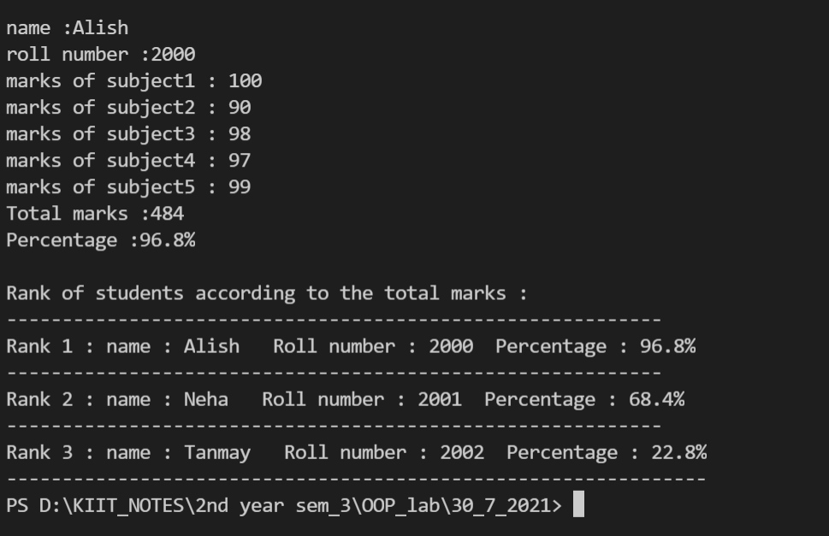

***Question3 -WAP to store n employees data such as employee name, id, age, basic salary . Calculate the gross pay of all employees and display it along with all other details in a tabular form,using pointer to structure.***

***employees as follows:***

***Gross pay=basic pay + HR + DA***

***HRA=10% of basic, DA=80% of basic***

***#***include <iostream>

#include <string>

using namespace std;

struct employee

{

int id;

string name;

int age;

double basicSal;

double grossSal;

};

void input(struct employee *s)

{

cout << "Enter the name of the employee : ";

cin >> s->name;

cout << endl;

cout << "Enter the employee id : ";

cin >> s->id;

cout << endl;

cout << "Enter the employee age : ";

cin >> s->age;

cout << endl;

cout << "Enter the employee basic salary : ";

cin >> s->basicSal;

cout << endl;

}

void calculate(struct employee *s)

{

double DA , HRA ;

DA = 0.8 * s->basicSal;

HRA = 0.1 * s->basicSal;

s->grossSal = s->basicSal + DA + HRA;

}

void display(struct employee *s){

cout<< s->name <<" "<< s->id<<" "<< s->age<<" "<< s->basicSal<<" "<<s->grossSal<<endl;

}

int main()

{

int n;

cout << "Enter the number of employees : ";

cin >> n;

cout << endl;

struct employee arr[n];

for (int i = 0; i < n; ++i)

{

input(&arr[i]);

calculate(&arr[i]);

}

cout<<"Displaying the details of the employees :"<<endl;

cout<<"-----------------------------------------------------------------------"<<endl;

cout<<"Name "<<"ID "<<"Age "<<"Basic Salary "<<"Gross Salary"<<endl;

for (int i = 0; i < n; ++i)

{

display(&arr[i]);

}

cout<<"-----------------------------------------------------------------------"<<endl;

}

