***Name - Akriti Choudhary***

***Roll number - 2005776***

***Lab2***

***Subject - OOP lab***

***Class - B14***

***Branch - CSE***

***Date- 5/08/2021***

***Question1- WAP to display the message “hello” followed by your name on screen.***

#include <iostream>

#include <string>

using namespace std;

int main(){

string name;

cout<<"Enter name :"<<endl;

cin>>name;

cout<<"Hello World "<<name<<endl;

return 0;

}

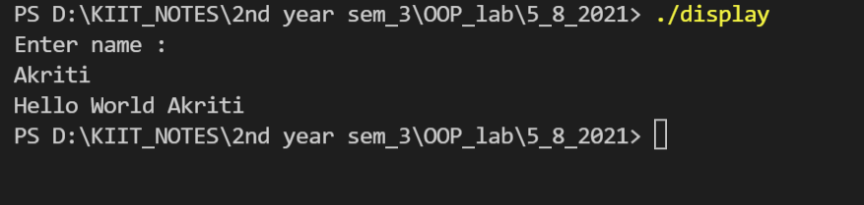

***Question2 - Create a class which stores name,roll number and total marks for a student .Input the data for a student and display it.***

#include <iostream>

#include <string>

using namespace std;

class student

{

public:

string name;

int roll;

int marks[5];

int total;

};

student input(student s1){

cout<<"Enter the name of the student : "<<endl;

getline(cin,s1.name);

cout<<"Enter the roll number of the student : "<<endl;

cin>>s1.roll;

cout<<"Enter the marks of the student : "<<endl;

for(int i = 0 ; i < 5 ; ++i){

cout<<"Enter the marks of subject"<<i+1<<endl;

cin>>s1.marks[i];

}

int sum = 0;

for(int i = 0 ; i < 5 ; ++i){

sum += s1.marks[i];

}

s1.total = sum;

return s1;

}

void display(student s1){

cout<<"The name of the student : "<<s1.name<<endl;

cout<<"The roll number of the student : "<<s1.roll<<endl;

for(int i = 0 ; i < 5 ; ++i){

cout<<"The marks of subject"<<i+1<<" is : "<<s1.marks[i]<<endl;

}

cout<<"Total marks of the student : "<<s1.total<<endl;

}

int main(){

student s1;

//input the details of the student

s1 = input(s1);

//display the details of the student

display(s1);

return 0;

}

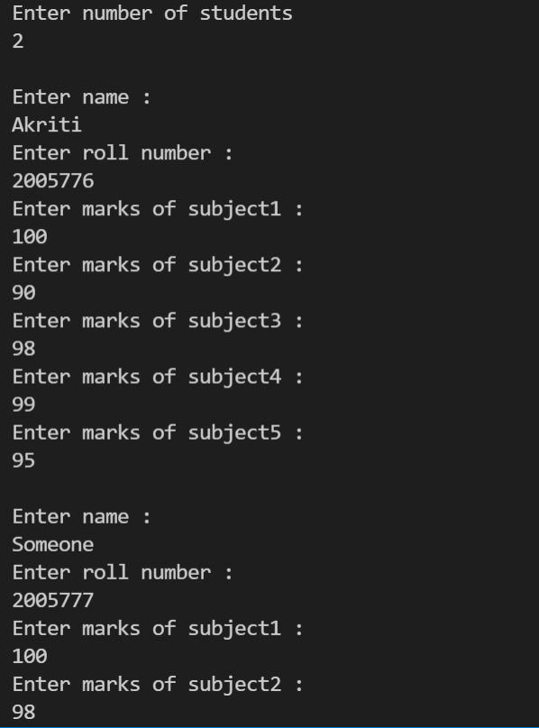 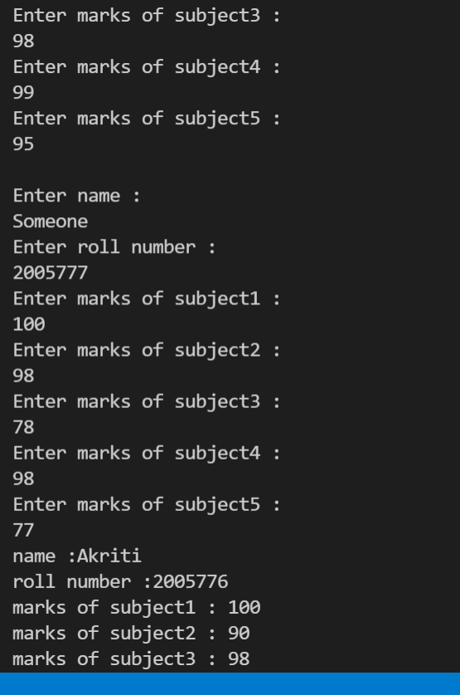

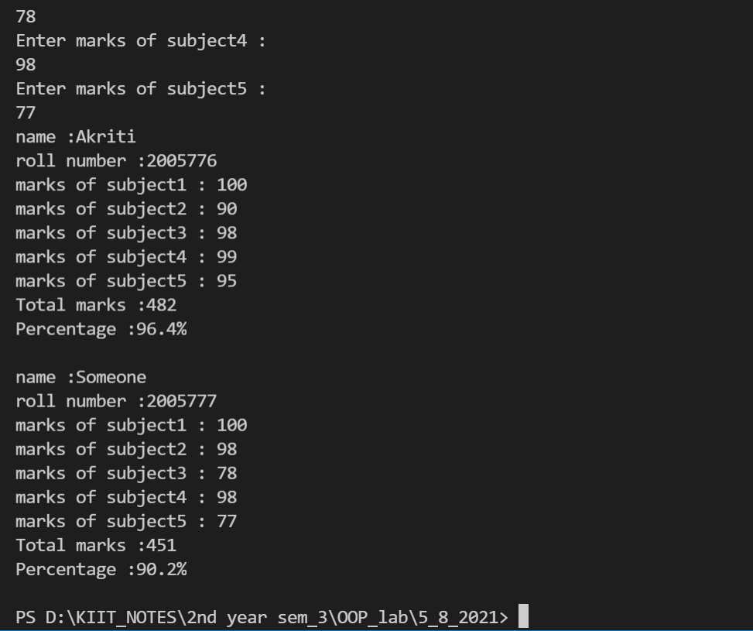

***Question3- Modify the program in question 2 to store marks in 5 subjects.Calculate the total marks and percentage of a student and display it.***

#include <iostream>

using namespace std;

class student1

{

public:

char name[20];

int roll;

int marks[5];

int total;

float percent;

};

student1 *input(student1 *s)

{

cout << "Enter name : " << endl;

cin >> s->name;

cout << "Enter roll number :" << endl;

cin >> s->roll;

for (int i = 0; i < 5; ++i)

{

cout << "Enter marks of subject" << i + 1 << " : " << endl;

cin >> s->marks[i];

}

}

void totPer(student1 *s)

{

int sum = 0;

for (int i = 0; i < 5; ++i)

{

sum += s->marks[i];

}

s->total = sum;

s->percent = (sum / 500.0) * 100;

}

void display(student1 *s)

{

cout << "name :" << s->name << endl;

cout << "roll number :" << s->roll << endl;

for (int i = 0; i < 5; ++i)

{

cout << "marks of subject" << i + 1 << " : " << s->marks[i] << endl;

}

cout << "Total marks :" << s->total << endl;

cout << "Percentage :" << s->percent << "%" << endl;

}

int main()

{

int n;

cout << "Enter number of students" << endl;

cin >> n;

student1 arr[n];

for (int i = 0; i < n; ++i)

{

cout << endl;

input(&arr[i]);

totPer(&arr[i]);

}

for (int i = 0; i < n; ++i)

{

display(&arr[i]);

cout << endl;

}

return 0;

}

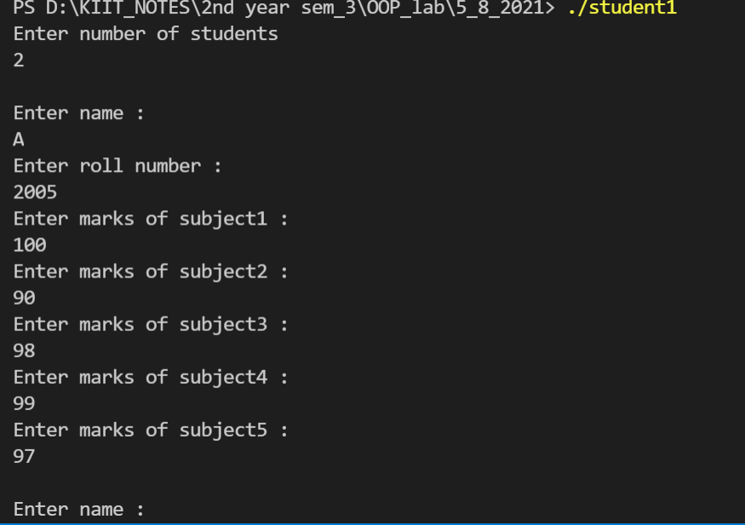 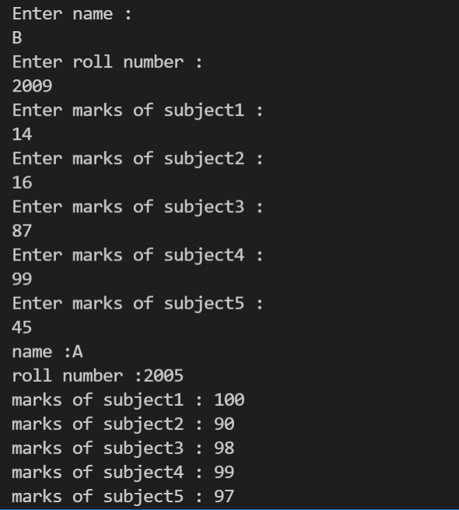

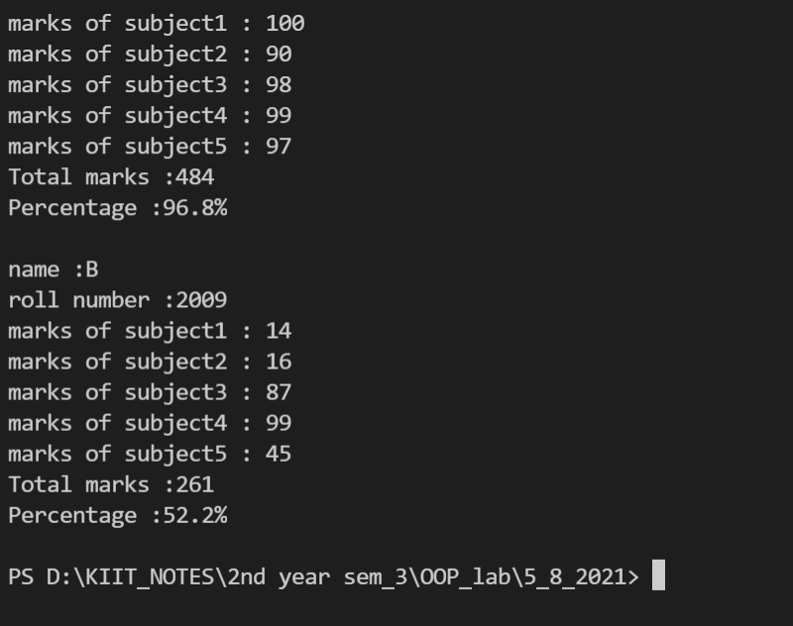

***Question 4 - Create a class complex which stores real and imaginary part of a complex number. Input n complex numbers and display them.***

#include <iostream>

using namespace std;

class complex

{

public:

int real;

int img;

void input()

{

cout << "Enter real part : " << endl;

cin >> real;

cout << "Enter imaginary part :" << endl;

cin >> img;

}

void display()

{

if (img > 0)

{

cout << real << " + i" << img << endl;

}

else

cout << real << " - i" << -img << endl;

}

};

int main()

{

int n;

cout << "Enter number of complex numbers to be entered :" << endl;

cin >> n;

complex arr[n];

for (int i = 0; i < n; ++i)

{

cout << "Enter the " << i + 1 << " complex number :" << endl;

arr[i].input();

}

for (int i = 0; i < n; ++i)

{

arr[i].display();

}

return 0;

}

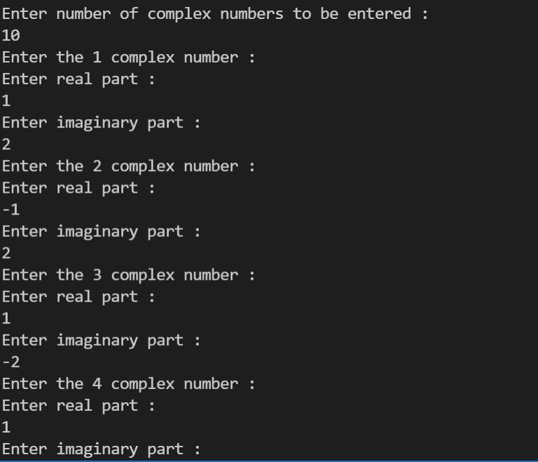 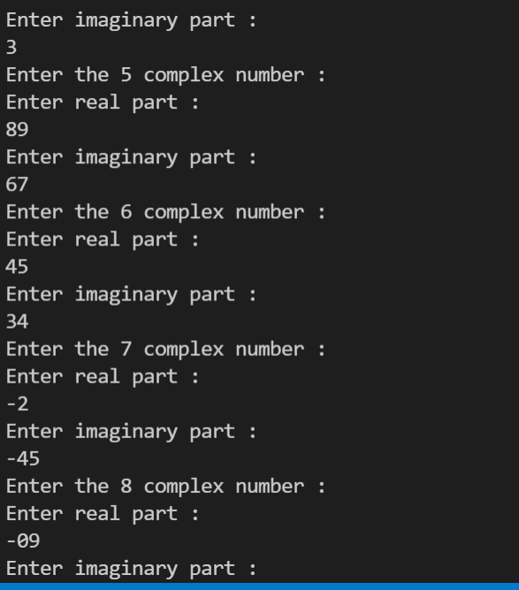

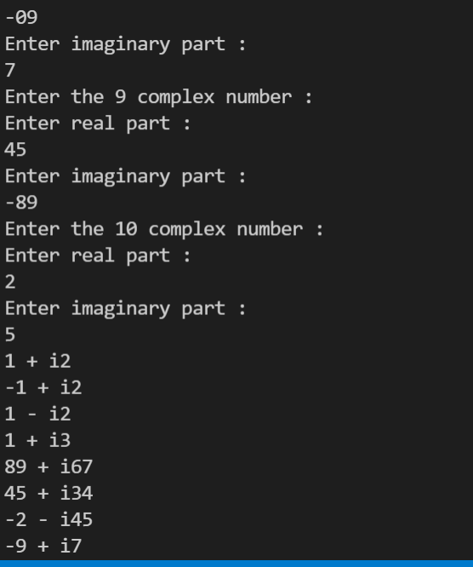 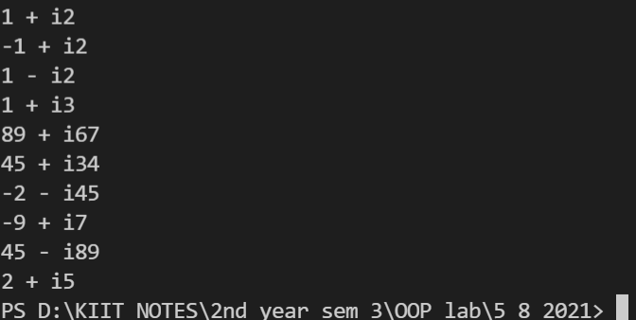

***Question 5- Create a class distance which stores a distance in feet and inches.Input 2 distance values in objects , add them,store the resultant distance in the object and display them.***

#include <stdio.h>

#include <iostream>

using namespace std;

class dist

{

int d_feet;

double d_inch;

public:

void input()

{

cin>>d_feet>>d_inch;

}

void add(dist d1,dist d2){

d_feet = d1.d_feet + d2.d_feet;

d_inch = d1.d_inch + d2.d_inch;

while (d_inch >= 12)

{

d_inch = d_inch - 12;

d_feet = d_feet + 1;

}

}

void display()

{

cout<<"Distance in feet :"<<d_feet<<" \nDistance in feet :"<<d_inch;

}

};

int main()

{

dist d1, d2, d3;

puts("Enter the distance in feet and inch for distance :");

d1.input();

puts("Enter the distance in feet and inch for distance :");

d2.input();

d3.add(d1,d2);

d3.display();

return 0;

}

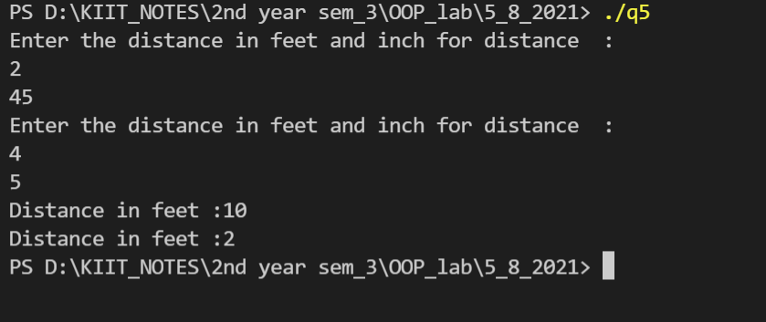

***Question 6 -Create a class which stores id, name,age and basic salary of an employee. Input data for n number of employees.Calculate the gross salary of all the employees and display it along with all other details in a tabular form.***

***[Gross salary = Basic salary + DA + HRA,***

***DA = 80 % of Basic salary***

***HRA = 10 % of Basic salary]***

#include <iostream>

#include <string>

using namespace std;

class employee

{

private:

int id;

string name;

int age;

double basicSal;

double grossSal;

public:

void input()

{

cout << "Enter the name of the employee : ";

cin >> name;

cout << endl;

cout << "Enter the employee id : ";

cin >> id;

cout << endl;

cout << "Enter the employee age : ";

cin >> age;

cout << endl;

cout << "Enter the employee basic salary : ";

cin >> basicSal;

cout << endl;

}

void calculate()

{

double DA, HRA;

DA = 0.8 * basicSal;

HRA = 0.1 * basicSal;

grossSal = basicSal + DA + HRA;

}

void display()

{

cout << name << " \t" << id << " \t" << age << " \t" << basicSal << " \t\t" << grossSal << endl;

}

};

int main()

{

int n;

cout << "Enter the number of employees : ";

cin >> n;

cout << endl;

employee arr[n];

for (int i = 0; i < n; ++i)

{

arr[i].input();

arr[i].calculate();

}

cout << "Displaying the details of the employees :" << endl;

cout << "-----------------------------------------------------------------------" << endl;

cout << "Name\t"

<< "ID\t"

<< "Age\t"

<< "Basic Salary\t"

<< "Gross Salary" << endl;

for (int i = 0; i < n; ++i)

{

arr[i].display();

}

cout << "-----------------------------------------------------------------------" << endl;

}

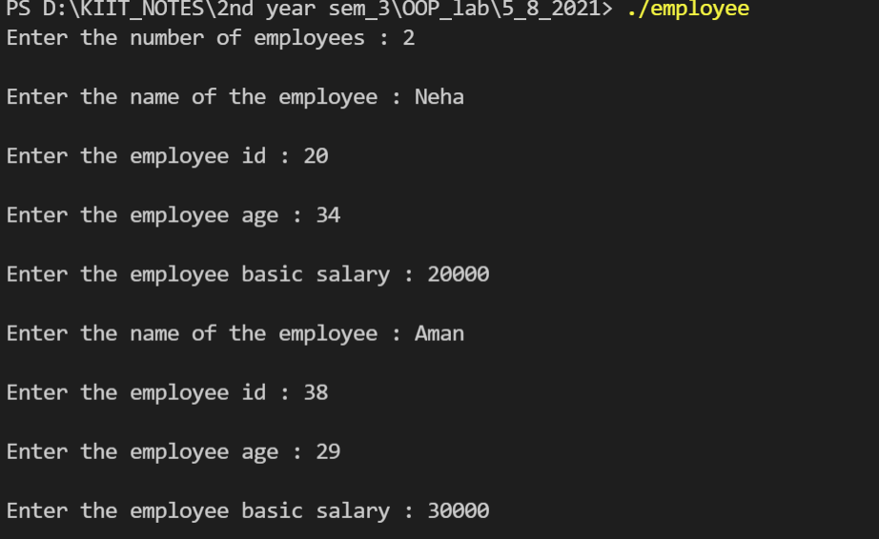

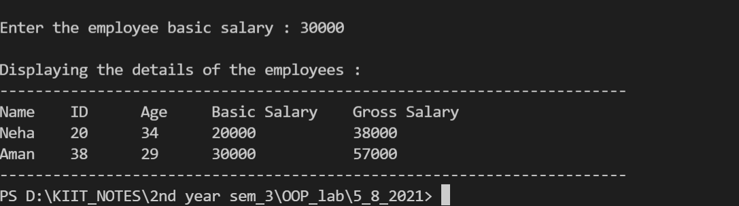

***Question 7 - Create a class which stores x and y coordinates of a point. Calculate distance between two given points and display it.***

#include <iostream>

#include <math.h>

using namespace std;

class Distance

{

int x;

int y;

public:

void input()

{

cout << "enter x" << endl;

cin >> x;

cout << "enter y" << endl;

cin >> y;

}

void calculate(Distance point2)

{

cout << sqrt((x - point2.x) * (x - point2.x) + (y - point2.y) * (y - point2.y)) << endl;

}

};

int main()

{

Distance point1;

Distance point2;

cout << "Enter the coordinates of point1 :" << endl;

point1.input();

cout << "Enter the coordinates of point2 :" << endl;

point2.input();

cout << "Distance between point1 and point2 :" << endl;

point1.calculate(point2);

}

