***Name - Akriti Choudhary***

***Roll number - 2005776***

***Lab7***

***Subject - OOP lab***

***Class - B14***

***Branch - CSE***

***Date- 9/09/2021***

***Question 1:Create a class complex which stores real and imaginary part of a complex number. Include all types of constructors and destructor. The destructor should display a message about the destructor being invoked. Create objects using different constructors and display them.***

#include <iostream>

using namespace std;

class complex

{

private:

int real;

int img;

float *realPtr;

float *imgPtr;

public:

complex() //default constructor

{

real = 0;

img = 0;

cout << "default constructor is called" << endl;

}

complex(int r, int i) //parameterized constructor

: real(r), img(i)

{

cout << "parameterized constructor is called" << endl;

}

complex(int a) //dynamic constructor

{

realPtr = new float;

*realPtr = 5.1;

imgPtr = new float;

*imgPtr = 10.2;

cout << "dynamic constructor is called" << endl;

}

complex(float re, float im) //dynamic parameterized constructor

{

realPtr = new float;

*realPtr = re;

imgPtr = new float;

*imgPtr = im;

cout << "dynamic parameterized constructor is called" << endl;

}

complex(complex &ob) //copy constructor

{

real = ob.real;

img = ob.img;

cout << "copy constructor is called obj5(obj2) " << endl;

}

void display()

{

cout << "Result : " << endl;

if (img >= 0)

cout << real << " + i" << img << endl;

else

cout << real << " - i" << -(img) << endl;

cout<<endl;

}

void display(int a)

{

cout << "Result : " << endl;

if (*imgPtr >= 0)

cout << *realPtr << " + i" << *imgPtr << endl;

else

cout << *realPtr << " - i" << -(*imgPtr) << endl;

cout<<endl;

}

~complex()

{

delete (realPtr);

delete (imgPtr);

cout << "Destructor is invoked" << endl;

}

};

int main()

{

int r, i;

cout << "\nEnter the real part : ";

cin >> r;

cout << endl;

cout << "\nEnter the imaginary part : ";

cin >> i;

cout << endl;

float ree, imm;

cout << "\nEnter float real part : ";

cin >> ree;

cout << endl;

cout << "\nEnter float imaginary part : ";

cin >> imm;

cout << endl;

complex obj1; //default constructor

obj1.display();

complex obj2(r, i); //parameterized constructor

obj2.display();

complex obj3(0); //dynamic constructor

obj3.display(0);

complex obj4(ree, imm); //dynamic parameterized constructor

obj4.display(0);

complex obj5(obj2); //copy constructor

obj5.display();

return 0;

}

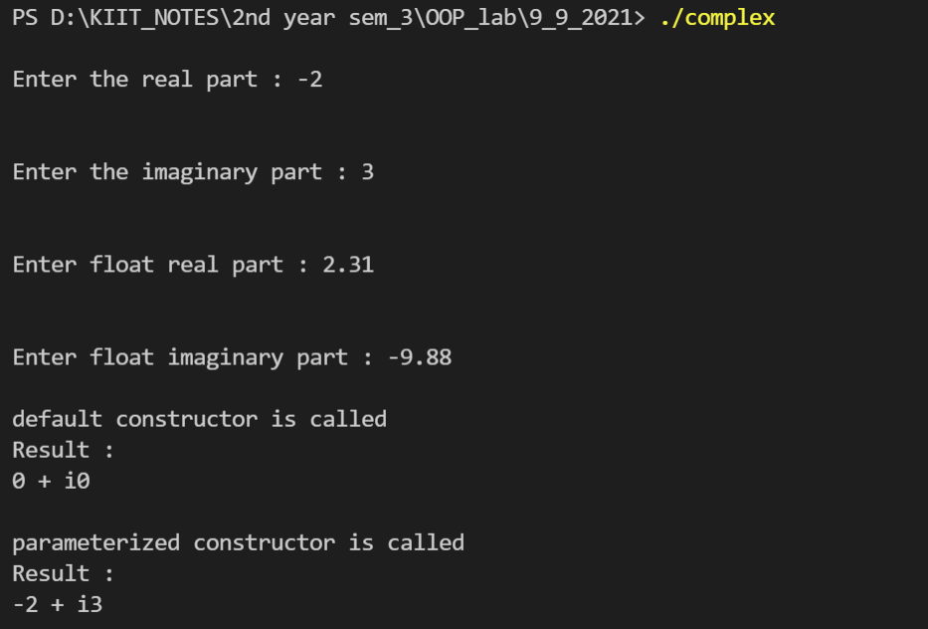

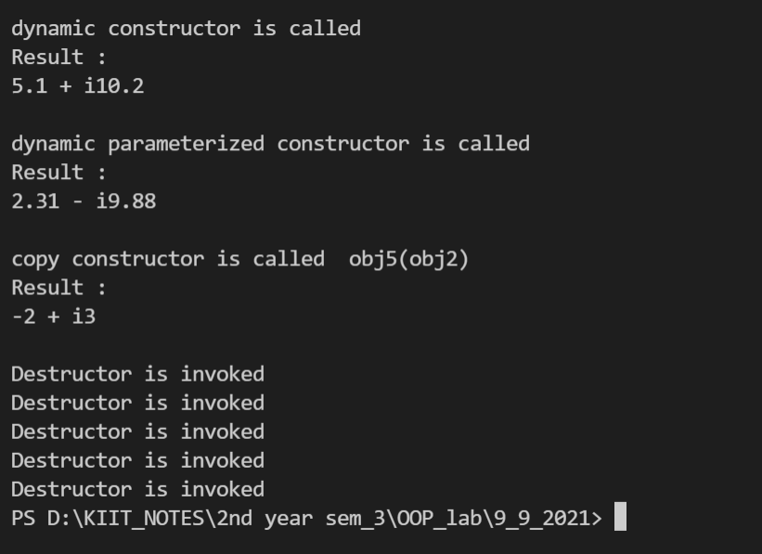

***Question2 : Create a class which stores time in hh:mm format. Include all the constructors. The parameterized constructor should initialize the minute value to zero, if it is not provided.***

#include <iostream>

using namespace std;

class timeFormat

{

private:

int hour;

int minute;

int *hPtr;

int *mPtr;

public:

timeFormat() //default constructor

{

hour = 0;

minute = 0;

cout << "default constructor is called" << endl;

}

timeFormat(int h, int m = 0) //parameterized constructor

: hour(h), minute(m)

{

cout << "parameterized constructor is called" << endl;

}

timeFormat(int a, int b, int c) //dynamic constructor

{

hPtr = new int;

*hPtr = 5;

mPtr = new int;

*mPtr = 10;

cout << "dynamic constructor is called" << endl;

}

timeFormat(unsigned int h, unsigned int m) //dynamic parameterized constructor

{

hPtr = new int;

*hPtr = h;

mPtr = new int;

*mPtr = m;

cout << "dynamic parameterized constructor is called" << endl;

}

timeFormat(timeFormat &ob) //copy constructor

{

hour = ob.hour;

minute = ob.minute;

cout << "copy constructor is called obj5(obj2) " << endl;

}

void display()

{

cout << "Result : " << endl;

if (minute <= 60)

cout << hour << " : " << minute << endl;

else

cout << hour + 1 << " : " << minute - 60 << endl;

cout << endl;

}

void display(int a)

{

cout << "Result : " << endl;

if (*mPtr <= 60)

cout << *hPtr << " : " << *mPtr << endl;

else

cout << *hPtr + 1 << " : " << *mPtr - 60 << endl;

cout << endl;

}

~timeFormat()

{

delete (hPtr);

delete (mPtr);

cout << "Destructor is invoked" << endl;

}

};

int main()

{

int h, m;

cout << "\nEnter hour : ";

cin >> h;

cout << endl;

cout << "\nEnter minute : ";

cin >> m;

cout << endl;

unsigned int hh, mm;

cout << "\nEnter hour : ";

cin >> hh;

cout << endl;

cout << "\nEnter minute : ";

cin >> mm;

cout << endl;

timeFormat obj1; //default constructor

obj1.display();

timeFormat obj2(h, m); //parameterized constructor

obj2.display();

cout<<"default argument of minute"<<endl;

timeFormat obj6(h); //parameterized constructor with one default argument

obj6.display();

timeFormat obj3(0, 0, 0); //dynamic constructor

obj3.display(0);

timeFormat obj4(hh, mm); //dynamic parameterized constructor

obj4.display(0);

timeFormat obj5(obj2); //copy constructor

obj5.display();

return 0;

}

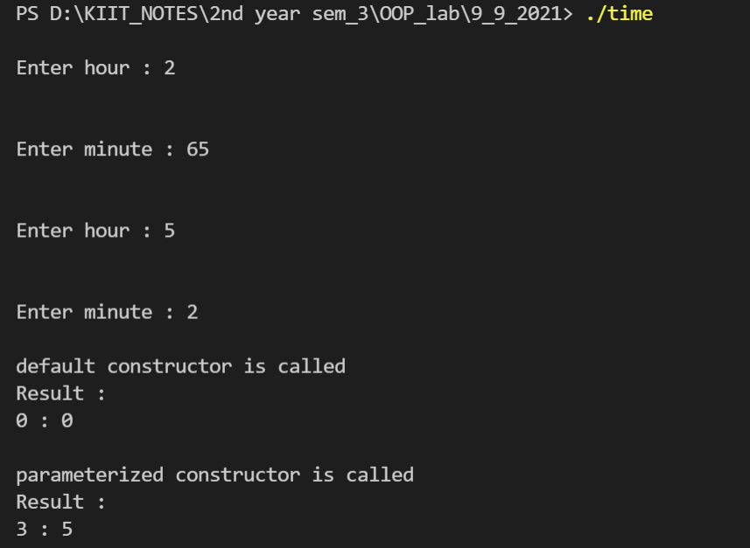

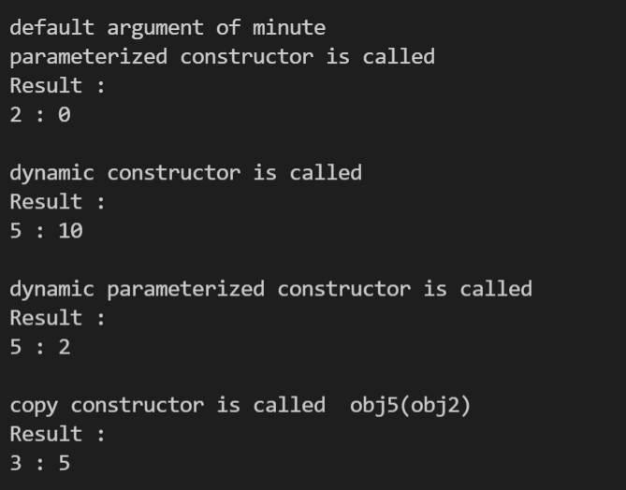

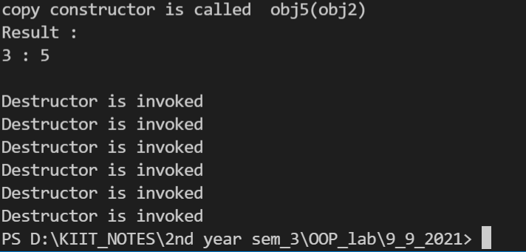

***Question3 : Create a class which stores a sting and its length as data members. Include all the constructors. Include a member function to join two strings and display the concatenated string.***

#include <iostream>

#include <string>

using namespace std;

class stringLength

{

private:

string s;

string s1;

int len;

string *sPtr;

int *lenPtr;

public:

stringLength() //default constructor

{

s = "";

len = 0;

cout << "default constructor is called" << endl;

}

stringLength(string S, int l) //parameterized constructor

: s(S), len(l)

{

cout << "parameterized constructor is called" << endl;

}

stringLength(string S, string ss) //parameterized constructor

{

s = S;

s1 = ss;

cout << "parameterized constructor is called" << endl;

}

stringLength(int a) //dynamic constructor

{

sPtr = new string;

*sPtr = "Hello";

lenPtr = new int;

*lenPtr = (*sPtr).length();

cout << "dynamic constructor is called" << endl;

}

stringLength(string S, float L) //dynamic parameterized constructor

{

sPtr = new string;

*sPtr = S;

lenPtr = new int;

*lenPtr = L;

cout << "dynamic parameterized constructor is called" << endl;

}

stringLength(stringLength &ob) //copy constructor

{

s = ob.s;

len = ob.len;

cout << "copy constructor is called obj5(obj2) " << endl;

}

~stringLength();

void display()

{

cout << "string = " << s << endl;

cout << "string length= " << len << endl;

cout << endl;

}

void display(int a)

{

cout << "string = " << *sPtr << endl;

cout << "string length= " << *lenPtr << endl;

cout << endl;

}

void add()

{

string s3 = s.append(s1);

int ll = s3.length();

cout << "resulted string = " << s3 << endl;

cout << "resulted string length= " << ll << endl;

cout << endl;

}

};

stringLength::~stringLength()

{

cout << "Destructor is invoked" << endl;

delete (sPtr);

delete (lenPtr);

}

int main()

{

string r;

int i;

cout << "\nEnter the string : ";

cin >> r;

i = r.length();

string ree;

float imm;

cout << "\nEnter another string : ";

cin >> ree;

imm = ree.length();

stringLength obj1; //default constructor

obj1.display();

stringLength obj2(r, i); //parameterized constructor

obj2.display();

stringLength obj3(0); //dynamic constructor

obj3.display(0);

stringLength obj4(ree, imm); //dynamic parameterized constructor

obj4.display(0);

stringLength obj5(obj2); //copy constructor

obj5.display();

stringLength obj6(r, ree); //parameterized constructor

obj6.add();

return 0;

}

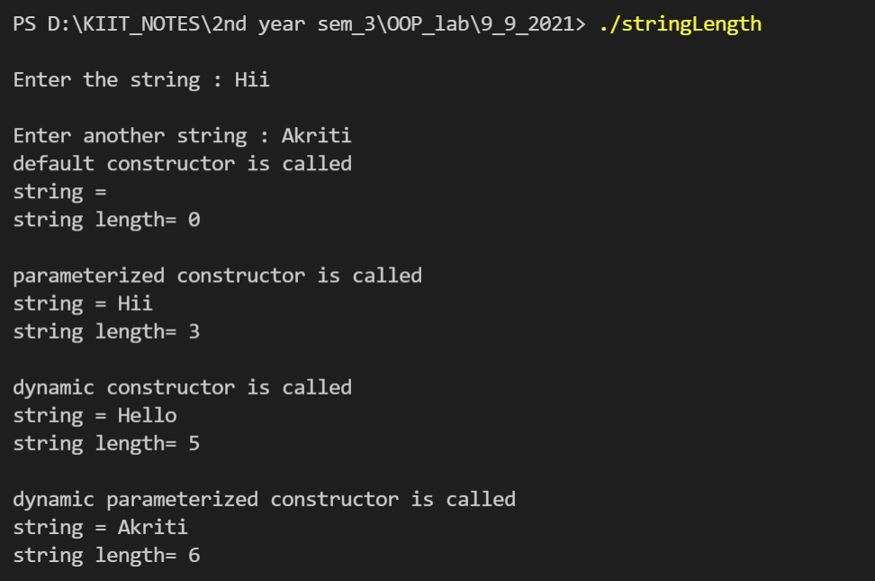

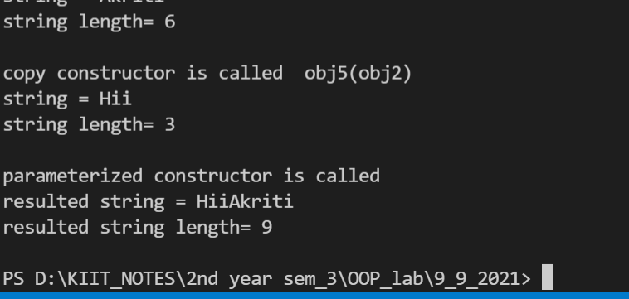

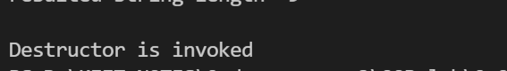

***Question4 :WAP to demonstrate the order of call of constructors and destructors for a class.***

#include <iostream>

#include <string>

using namespace std;

class createAndDestroy

{

public:

createAndDestroy(int, string); //constructor

~createAndDestroy(); //destructor

private:

int objectID;

string message;

};

createAndDestroy::createAndDestroy(int ID, string messageString)

: objectID(ID), message(messageString)

{

cout << "Object " << objectID << " constructor runs " << message << endl;

}

createAndDestroy::~createAndDestroy()

{

cout << "Object " << objectID << " destructor runs " << message << endl;

}

void create();

createAndDestroy first(1, "(global before main)");

int main()

{

cout << "\nMain function execution begins" << endl;

createAndDestroy second(2, "(local automatic in main)");

static createAndDestroy third(3, "(local static in main)");

create();

cout << "\nMain function execution resumes" << endl;

createAndDestroy fourth(4, "(local automatic in main)");

cout << "\nMain function execution ends" << endl;

return 0;

}

void create()

{

cout << "\ncreate function execution begins" << endl;

createAndDestroy fifth(5, "(local automatic in create)");

static createAndDestroy sixth(6, "(local static in create)");

createAndDestroy seventh(7, "(local automatic in create)");

cout << "\ncreate function execution ends" << endl;

}

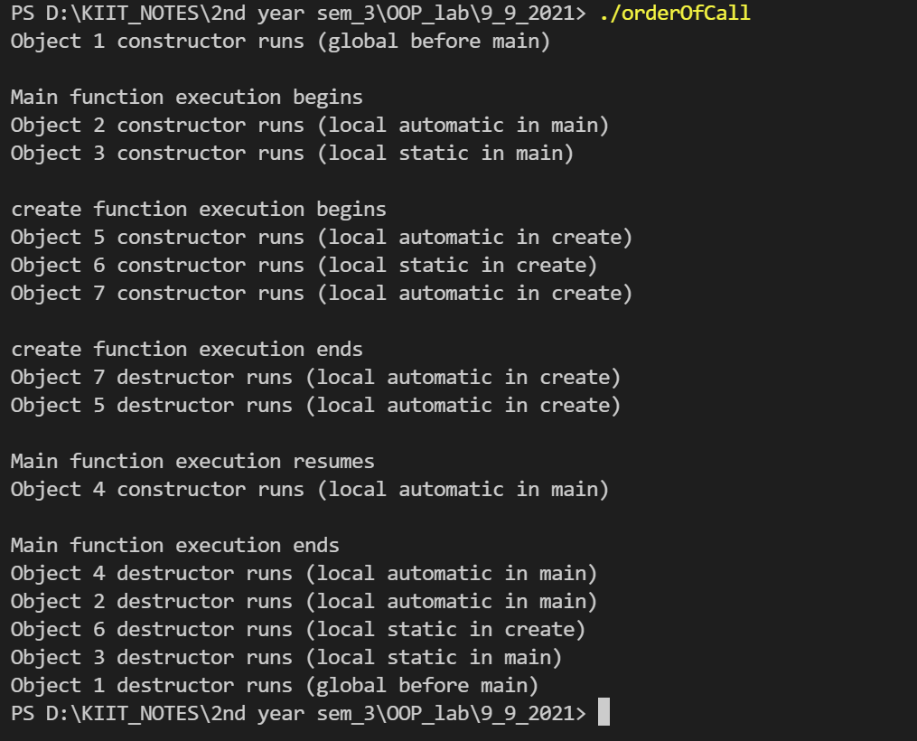

***Question5 :WAP*** ***to count number of objects created from a class using concept of static data members and static member function.***

#include <iostream>

using namespace std;

class book

{

static int a;

public:

book()

{

a++;

}

static void display()

{

cout << "the number of times object is created = " << book::a << endl;

}

};

int book ::a;

int main()

{

book obj1, obj2, obj3, obj4, obj5;

obj1.display();

return 0;

}

