**Name - Akriti Choudhary**

**Roll number - 2005776**

**Class - B14**

**Subject - OOP Lab Exam**

**Date - 2/12/2021**

**Question 1)Write a program in C++ that creates a class parcel containing private member variable weight (of the parcel), protected variable shipping_cost, write a parameterized constructor that initializes these variables. Write a member function with name Cal_shipping () to calculate the shipping cost according to formula Rs. 10/Kg. Create a class called Box, which is publicly inheriting Parcel class. It should have private member variable no_of_boxes which will be initialized using a constructor based on the weight data member of parcel class( if weight exceeds 30 kg then no.of boxes requires 2 and if exceeds 50 kg no.of boxes required 5, otherwise 1 box required). Override class Cal_shipping () function defined in the class Parcel and add Rs. 30 to the shipping_cost variable if the volume of the box exceeds 3 units. Display all the information with the final shipping cost.**

**Solution:**

// Akriti Choudhary

// 2005776

#include <iostream>

using namespace std;

class parcel_776

{

int weight_776;

protected:

float shipping_cost_776;

public:

parcel_776()

{

weight_776 = 0;

}

parcel_776(int we_776)

{

weight_776 = we_776;

}

void calshipping_776()

{

shipping_cost_776 = 10 * weight_776;

}

};

class box_776 : public parcel_776

{

int no_of_boxes_776;

public:

box_776(int we_776) : parcel_776(we_776)

{

if ((we_776 > 30) && (we_776 < 50))

{

no_of_boxes_776 = 2;

}

else if (we_776 >= 50)

{

no_of_boxes_776 = 5;

}

else

{

no_of_boxes_776 = 1;

}

}

void calshipping_776()

{

parcel_776::calshipping_776();

if (no_of_boxes_776 > 3)

{

shipping_cost_776 += 30;

}

}

void display()

{

cout << "number of boxes : " << no_of_boxes_776 << endl;

cout << "Shipping cost : " << shipping_cost_776 << endl;

}

};

int main()

{

int we_776;

cout << "enter the weight : ";

cin >> we_776;

box_776 Akriti(we_776);

Akriti.calshipping_776();

Akriti.display();

return 0;

}

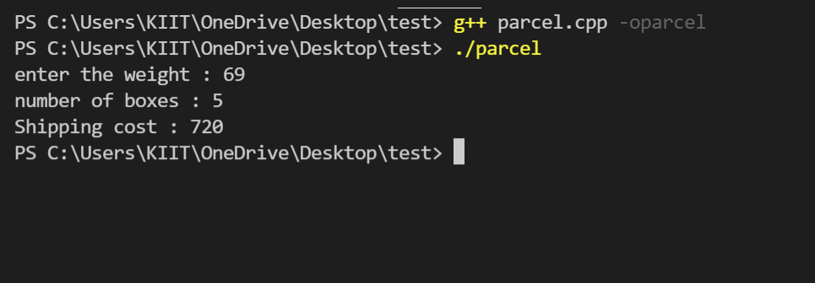

**SET A**

**Question 2)Write a program in C++ that creates a class vect, which contains a pointer to an integer (int *ptr) and an integer (size).The integer pointer (ptr) will point to a dynamic array of integers and size represents the total capacity of that dynamic array. The class vect should behave as an array with practically unlimited entries.  
  
a) Write a default constructor that will initialize integer pointer (ptr) to NULL and integer variable (size) to zero.  
  
b) Write a parameterized constructor that will initialize integer variable (size) to a value passed as parameter. Initialize the integer pointer (ptr) to a dynamic array of size that equals to the parameter that is passed to constructor.**

**Solution:**

//Akriti Choudhary(2005776)

#include <iostream>

using namespace std;

class vect_776

{

private:

int size_776;

int *ptr_776;

public:

vect_776()

{

cout << "Default Constructor is called\n";

size_776 = 0;

ptr_776 = NULL;

}

vect_776(int s_776)

{

cout << "Parameterized Constructor is called\n";

size_776 = s_776;

ptr_776 = new int(size_776);

}

void input()

{

cout << "Enter the elements of the array : \n";

for (int i = 0; i < size_776; ++i)

{

cout << "Enter the " << i + 1 << " element of the array : ";

cin >> ptr_776[i];

}

}

void display()

{

for (int i = 0; i < size_776; ++i)

{

cout << ptr_776[i] << "\t";

}

cout << "\n";

}

~vect_776()

{

cout << "Destructor is called\n";

free(ptr_776);

}

};

int main()

{

int s_776;

cout << "Enter the size of the dynamic array : ";

cin >> s_776;

vect_776 Akriti(s_776);

Akriti.input();

Akriti.display();

return 0;

}

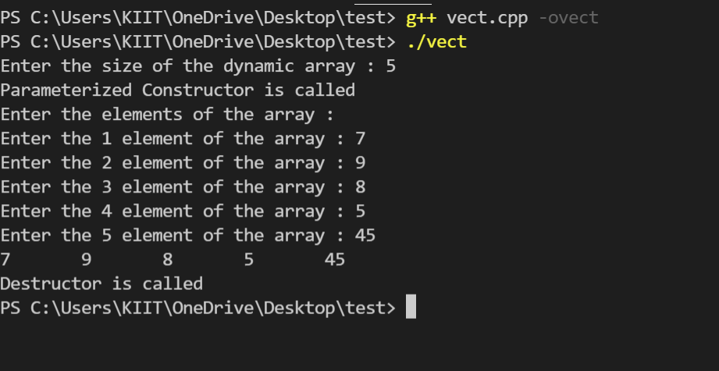

**Question 3)Write a program to declare three classes a1, a2, a3. The classes have private data member variable of string type. Assign the first name and surname of a student to member variable of class a1 and a2 respectively. Perform concatenation of  two strings using overloading of + operator and store it to data member variable of class a3. Print the full name to the output screen using member function.**

**Solution:**

//Akriti Choudhary(2005776)

#include <iostream>

using namespace std;

class a1_776

{

private:

string first_name_776;

public:

a1_776()

{

first_name_776 = " ";

}

a1_776(string s_776)

{

first_name_776 = s_776;

}

string get_first_name()

{

return first_name_776;

}

};

class a2_776 : public a1_776

{

private:

string last_name_776;

public:

a2_776()

{

last_name_776 = " ";

}

a2_776(string l)

{

last_name_776 = l;

}

void set_last_name(string l)

{

last_name_776 = l;

}

string get_last_name()

{

return last_name_776;

}

friend string operator+(a2_776 &ob2);

};

class a3_776 : public a2_776

{

private:

string name_776;

string l_776;

a2_776 ob2;

public:

a3_776()

{

cout << "Enter last name : ";

cin >> l_776;

ob2.set_last_name(l_776);

name_776 = +ob2;

}

void display()

{

cout << name_776 << "\n";

}

};

string operator+(a2_776 &ob2)

{

string s_776;

cout << "Enter first name : ";

cin >> s_776;

a1_776 ob1(s_776);

string n_776;

n_776 = ob1.get_first_name() + " " + ob2.last_name_776;

return n_776;

}

int main()

{

a1_776 obj1_776;

a2_776 obj2_776;

a3_776 ob3_776;

ob3_776.display();

return 0;

}

